To: Dr. Michael Stanisic
From: Jeffrey Berning (Senior Design Team 8)
Date: January 17, 2020
Subject: Individual Concept Memo

Design Specifications:
DS 1. The OHC travels between way stations in under 4 seconds.
DS 2. There is 2.5 inches gap between the floor and the lowest point of the OHC.
DS 3. The OHC drive system is capable of transporting a load of 15 lbf.
DS 4. The OHC travels a range of 75 inches.
DS 5. The OHC position has a maximum error of 0.1 inches.
DS 6. The track is 82 inches long to account for the additional length of the trolley.
DS 7. At any point along the range, the OHC can move forward or in reverse to any desired way station with an accuracy of 0.1 inches.
DS 8. Every component can be purchased or manufactured to at least 5,000% of its size.
DS 9. The only input needed is the desired sequence of way stations stops.
DS 10. There exists a user interface with the capability of receiving any sequence of way stations.
DS 11. There is a button or key to initiate and stop the OHC.
DS 12. The payload does not deviate more than 25 degrees from the vertical.
DS 13. The OHC stops last between 2.8 and 3.2 seconds at each way station.
DS 14. The load oscillates less than 0.6 degrees within 2 seconds of arrival at each stop.
DS 15. The OHC must have an availability of .98 through 100 cycles.
DS 16. The user interface displays real time plots with no more than 1.0 second of delay.
DS 17. Each plot includes lines indicating the acceptable ranges of values.
DS 18. The dimensions of each component or subsystem does not exceed a volume of 8 ft by 1 ft by 1 ft.
DS 19. The supporting structure for the crane does not exceed 39 inches in height.
DS 20. The individual components each weigh less than 50 lbf.
Concepts:
The first three concepts generated focus on the means of transportation of the overhead crane (OHC). This is a difficult problem to address because of the accuracy required for control as well as the constrain that a load must be held below the crane. This seems to eliminate simple track options that do not provide a space for the load to hang. The three options presented here were generated with that constraint in mind.
The first concept takes inspiration from train tracks, but the tracks are inverted. A sketch of this concept can be seen below in Figure 1. As can be seen in this figure, there are two guides, similar to that of a train track, connected above in one solid sheet. The guides provide a place for the wheels to role as well as support the crane. This single sheet that the crane hangs from would be supported by posts sitting on the ground arranged in a manner to assure stability while minimizing materials.

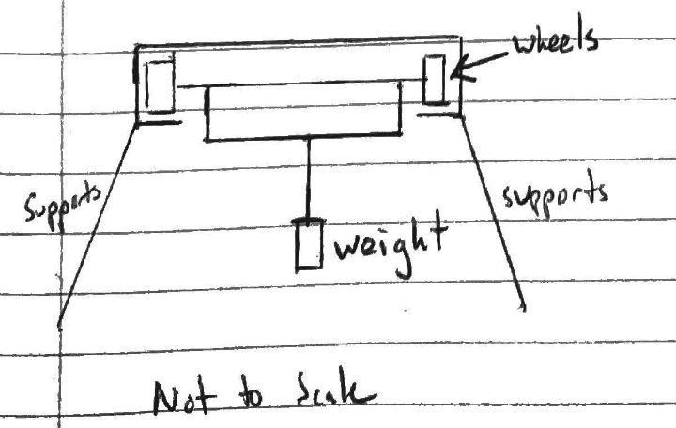
Figure 1: A sketch of the first concept generated. This concept consists of a track with a cart inverted rolling along the track.
One of the main advantages of this concept is the stability that the overall structure would maintain. Because the structure the OHC hangs from would consist of a single sheet, concerns about a lateral shift in weight would not be as great as compared to two disparate structures, which will be proposed later. Another advantage of this concept is that similar systems are already used, and it could be easily scaled. Above, it was mentioned that the inspiration came from train tracks which shows the potential for this to be scaled to a full size OHC.
One of the weaknesses of this concept is the use of wheels to move the OHC. While wheels provide a standard means of transportation, control of the OHC could prove difficult with wheels. While it is often assumed wheels roll without slipping, this is not actually the case. This means that tracking the rotations of the wheels might not provide accurate information on the position of the OHC.
The second concept pertaining to the transportation of the OHC consists of a conveyor system that the OHC rests on. A sketch of this concept can be seen in Figure 2. As can be seen, this concept consists of two separate structures that each have a conveyor belt on the top. The OHC would rest on these conveyors and as the conveyors rotated, the OHC would move. In
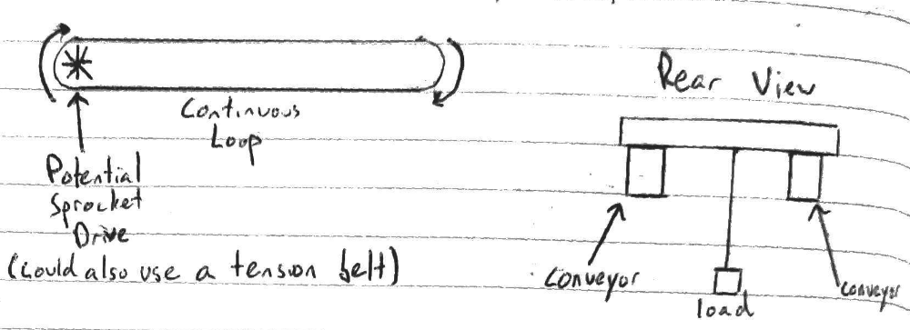
Figure 2: A sketch of the second concept generated. This concept utilizes two conveyor belts in order to achieve the desired motion for the OHC.
Figure 2, the driver of the conveyor is a sprocket. This would be used for a specific type of conveyor belt. Presumably a tension belt could also be utilized instead of a sprocket system; however, this would lead to additional concerns. Increasing the tension would cause a safety risk, and a tension belt would be prone to slipping. Because of these two reasons, the concept presented focuses on using a sprocket to drive the conveyor belt.
One advantage of the conveyor system would be an increase in precision. With a sprocket, there would be little to negligible slip in the system, causing the concern presented above with the wheel driven system to be rendered void. There is the potential for slipping of the OHC resting on the conveyor, but materials could be selected such that the coefficients of friction are sufficiently large. Similar to the wheel driven concept, conveyor belts of various magnitudes are used in industry, so scalability likely would not be an issue.
In direct contrast to the advantage of the wheel driven concept, a disadvantage of the conveyor concept would be a lack of stability in the structure. A shift in weight on the OHC would potentially cause issues for the two distinct structures that contain the conveyor belts. The mechanism for attaching the structure to the ground would have to be rigorously chosen in order to achieve this method. Another disadvantage would be difficulty of manufacturing. Instead of folding a sheet of metal, this set up would require assembling a large conveyor belt. Even if a tension belt was not used, the assembly would require a greater precision in order to make sure the belt was taut and fit snuggly on the sprockets.
The third concept combines the positive elements of the first two concepts. The track is kept for stability purposes, but a wire or chain is used to approximate the conveyor system. A sketch of this system can be seen in Figure 3. Because Figure 3 shows a side view of the concept, the track system is hard to visualize. A note is made in the sketch that the track system would be identical to concept one shown in Figure 1. The main difference between concept one and three is that the actuation is through the wire instead of the wheels.
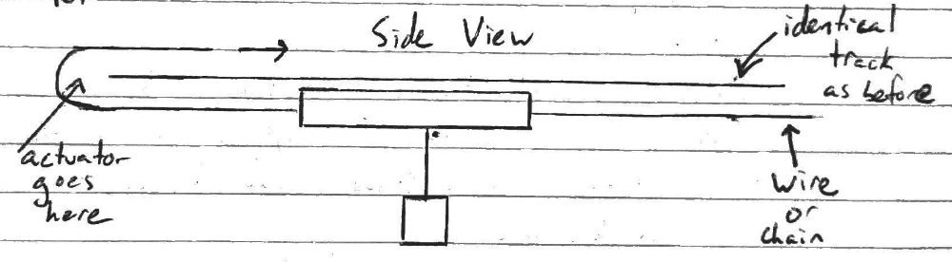
Figure 3: A sketch of the third concept presented. This concept utilizes the same tracks system shown in Figure 1; however, it relies on an actuated chain system rather than actuated wheels to move the OHC.
One benefit of this concept is that it would provide a more accurate means of measuring the position of the OHC, especially if a chain and sprocket was used. Slip would be eliminated, but the stability of the track would remain the same. Another benefit of this concept is that it would eliminate the need for wheel encoders on the OHC. One stationary encoder could be used on the actuated sprocket to determine the position of the OHC. A stationary encoder is likely more reliable than an encoder traveling with the OHC and is simpler to implement and manufacture.
While the stability of the OHC is no longer a disadvantage as with the conveyor system, there are still disadvantages to this concept. The main one is that if a tension wire was used to move the OHC, safety would be a concern as with the conveyor system. The use of a chain instead of a wire would eliminate this concern, but manufacturing would be more complex compared to the first concept.
Control Policies:
This section will shift the focus away from the mechanical transportation of the OHC and focus instead on concepts for the control policy to be used. Because of this shift, there will no longer be sketches of the concepts, but in lieu of sketches, high level algorithm descriptions will be provided. Preceding these concepts, an initial concept on the model used for the system will be presented. This specific concept treats the OHC as a cart-pole system where the wire is treated as a massless rigid body. The dynamic equations of the cart-pole system have been the study of many dynamics and controls classes. Often the dynamics will be linearized around the stable equilibrium point of the system, which in this case corresponds to the mass hanging vertically below the cart. The advantages of this linearization and simple model of the system are that it allows for more computationally efficient calculations and opens the door for specific control strategies that require a linear system. While a potential disadvantage is the inaccuracy of the model in relation to the physical system, around the equilibrium point, the linearized dynamics will be similar to the full dynamics of the system. The assumption of the wire behaving as a rigid body will likely lead to slight deviations in the model, but it is assumed that the wire will remain taut throughout the operation of the OHC.
With these preliminary model assumptions, the first control policy concept is a linear-quadratic regulator (LQR). In order for an LQR to be used, the dynamics of the system must be linear, which is the reason behind the linearization. The quadratic part of an LQR system refers to the cost function. It is quadratic in both the state and the control. The goal of LQR is to minimize the cost function over all possible control inputs in order to find the optimal control input for each possible state. The cost function focuses on minimizing the amount of control used as well as error in the state of the system. These two aspects can have various weights applied to them to achieve desired performance. The math behind solving an LQR problem is well defined and can be easily achieved in computer software such as Matlab. The minimization leads to a set of matrices that could be multiplied by the state in order to obtain the necessary control input. In this case, the LQR would be solved offline, and the matrices would be plugged into to the online software in order to control the OHC.
The benefits of LQR are that most of the computational power required would be offline. The control system located on the OHC would only need to sense the state to decide the next control input. LQR also provides easily tunable gains in the cost function to be minimized. For example, the deviation of the angle of load could be weighted highly, such that the controller decides to focus on minimizing that error instead of a linear position error. The weights of these values could be fine tuned until the desired behavior was achieved.
One disadvantage of LQR is that is does require a linearization of the system dynamics. While in this situation, there likely would not be a noticeable issue, the potential is there. Another disadvantage is that while the weights are easy to tune, there is not a defined process to do so. It requires almost a guess and check approach to find the optimal weights for the given system.
Another set of control policy concepts involve finding an optimal trajectory rather than an optimal control law for all of the state space. While there are many different methods for finding an optimal trajectory, the one presented as a concept is known as direct multiple shooting optimization. This method to find the optimal trajectory involves simulating the dynamics in multiple segments and constraining the segments to be continuous. As the dynamics are simulated, a cost function is minimized that is not necessarily quadratic as in the case of LQR. Instead of finding a control law as a function of state space in the optimization problem, multiple shooting finds an optimal trajectory for the states in order to minimize the cost function. From this trajectory, the optimal control inputs can be found. Similar to the LQR concept, the multiple shooting would be performed offline, but the trajectories would be supplied to the controller. Optimal trajectories would need to be identified for each possible distance and direction traveled, and the correct trajectory to follow would be dependent on the initial input by the user.
One benefit of this method is it provides a means for additional feedback once the optimal trajectory is determined. A PD controller or LQR could be used to correct any deviations from the optimal trajectory found. The LQR controller would function as described above, but instead of focusing on the final desired state, the cost function would include the optimal trajectory. A PD controller would allow for any deviations from the desired trajectory to be corrected through proportional and derivative control. The idea behind a PD controller is that the combination of distance from the desired trajectory and desired speed determines the amount of control applied to correct the course of the system. A secondary benefit of this concept is that it does not require a linearization of the dynamics. On top of this, if it was found a simple cart-pole model did not accurately describe the system, multiple shooting has the capabilities to handle a more complex system.
The main disadvantage of using a multiple shooting approach is the complexity of the problem formulation as well as the large computational power needed to solve the problem. Because the optimal trajectories will be determined offline, the computational power will likely not be an issue. While the problem formulation provides a slight concern, members of Group 8 have experience in multiple shooting methods, and that makes this concept feasible for the OHC.

