**DBQ 1: Evaluate the relative importance of greatest controversies during the ratification of the United States Constitution (1787–1788).**

**Document 1**

Source: Elbridge Gerry, letter to the Massachusetts legislature, October 18, 1787.

My principal objections to the plan [the United States Constitution] are, that there is no adequate provision for a representation of the people; that they have no security for the right of election; that some of the powers of the legislature are ambiguous, and others indefinite and dangerous; that the executive is blended with, and will have undue influence over, the legislature; that the judicial department will be oppressive; . . . and that the system is without the security of a bill of rights.

**Document 2**

Source: George Mason, from a debate in the Virginia Ratifying Convention, June 4, 1788.

Mr. Chairman, whether the Constitution be good or bad, the present clause clearly discovers that it is a national government, and no longer a Confederation. I mean that clause which gives the first hint of the general government laying direct taxes. The assumption of this power of laying direct taxes does, of itself, entirely change the confederation of the states into one consolidated government. This power, being at discretion, unconfined, and without any kind of control, must carry everything before it. The very idea of converting what was formerly a confederation to a consolidated government, is totally subversive of every principle which has hitherto governed us.

To designate or appoint the money or thing in which taxes are to be paid, is not only a proper, but a necessary exercise of the power of collecting them.

**Document 3**

Source: Article from *Gazette of the United States*, a pro-Federalist Philadelphia newspaper, August 10, 1794.

These [Democratic-Republican] Societies, strange as it may seem, have been formed in a free elective government for the sake of *preserving liberty*. And what is the liberty they are striving to introduce? It is the liberty of reviling the rulers who are chosen by the people and the government under which they live. It is the liberty of bringing the laws into contempt and persuading people to resist them. It is the liberty of condemning every system of Taxation because they have resolved that they will not be subject to laws—that they will not pay any taxes. To suppose that societies were formed with the purpose of opposing and with the hope of destroying government, might appear [unfair] provided they had not already excited resistance to the laws and provided some of them had not publicly avowed their opinions that they *ought not to pay any taxes.*

**Document 4**

Source: Edward Livingston, member of the House of Representatives from New York, addressing Congress, June 1798.

By [the Alien Act] the President alone is empowered to make the law; to fix in his own mind what acts, what words, what thoughts, or looks, shall constitute the crime contemplated by the bill; that is, the crime of being “suspected to be dangerous to the peace and safety of the United States.” This comes completely within the definition of despotism—a union of legislative, executive, and judicial powers.

each. . . .The judicial power of the United States is extended to all cases arising under the Constitution.

**Document 5**

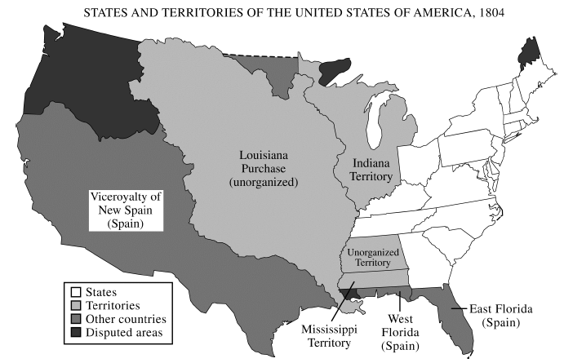

**DBQ 2: Evaluate the extent of change in United States foreign policy in the period 1783 to 1828.**

**Document 1**

Source: President George Washington, Neutrality Proclamation, April 1793.

Whereas it appears that a state of war exists between Austria, Prussia, Sardinia, Great Britain, and the United Netherlands, of the one part, and France on the other; and the duty and interest of the United States require, that they should with sincerity and good faith adopt and pursue a conduct friendly and impartial toward the belligerent powers:

I have therefore thought fit by these presents to declare the disposition of the United States to observe the conduct aforesaid towards those powers respectively; and to exhort and warn the citizens of the United States carefully to avoid all acts and proceedings whatsoever, which may in any manner tend to contravene such disposition.

**Document 2**

Source: Letter from Thomas Jefferson to James Monroe (United States minister to France), September 1795.

Mr. Jay’s treaty has at length been made public. So general a burst of dissatisfaction never before appeared against any transaction. Those who understand the particular articles of it, condemn these articles. Those who do not understand them minutely, condemn it generally as wearing a hostile face to France. This last is the most numerous class, comprehending the whole body of the people, who have taken a greater interest in this transaction than they were ever known to do in any other. It has, in my opinion, completely demolished the monarchical party here. The chamber of commerce in New York, against the body of the town, the merchants in Philadelphia, against the body of their town, also, and our town of Alexandria have come forward in its support.

**Document 3**

Source: James L. Cathcart, United States consul at Tripoli, letter to the Secretary of State, May 1800.

The only conclusion which can be drawn from the Bashaw’s [pasha of Tripoli, Yusuf Karamanli] proceedings is that he wants a present, and if he does not get one, he will forge pretences to commit depredations on the property of our fellow citizens; His letter to the President will be the means of keeping him quiet until he receives an answer....I therefore can see no alternative, but to station some of our Frigates in the Mediterranean, otherwise we will be continually subject to the same insults which the Imperials [Austria-Hungary], Danes, Swedes, and Ragusians [region in modern day Croatia] have already suffered and will still continue to suffer, if they do not keep a sufficient Naval force in this Sea to protect their trade.

**Document 4**

Source: United States Foreign Trade, 1790-1812, from *Historical Statistics of the United States, Colonial Times to 1970*.

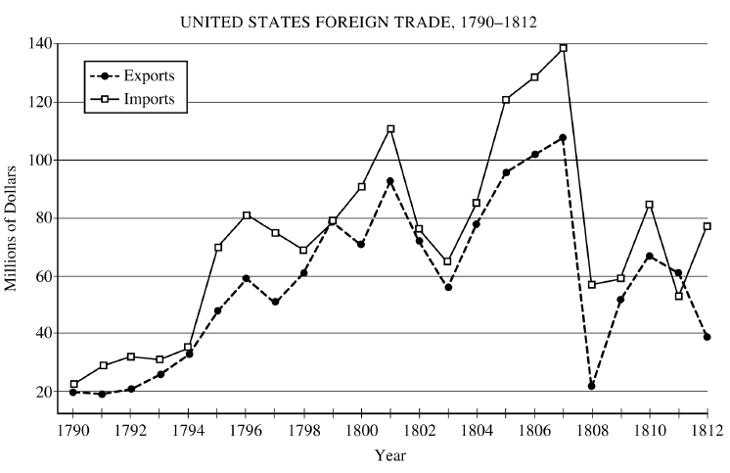

**Document 5**

Source: Secretary of State John Quincy Adams, an address delivered at the request of the Committee of the Citizens of Washington, on the occasion of reading the Declaration of Independence, July 4, 1821.

America, in the assembly of nations, since her admission among them, has invariably, though often fruitlessly, held forth to them the hand of honest friendship, of equal freedom, of generous reciprocity. She has uniformly spoken among them, though often to heedless and often to disdainful ears, the language of equal liberty, of equal justice, and of equal rights. She has, in the lapse of nearly half a century, without a single exception, respected the independence of other nations while asserting and maintaining her own. She has abstained from interference in the concerns of others, even when the conflict has been for principles to which she clings, as to the last vital drop that visits the heart....

But she goes not abroad, in search of monsters to destroy. She is the well-wisher to the freedom and independence of all. She is the champion and vindicator only of her own....

She well knows that by once enlisting under other banners than her own, were they even the banners of foreign Independence, she would involve herself, beyond the power of extrication, in all the wars of interest and intrigue, of individual avarice, envy, and ambition, which assume the colors and usurp the standard of freedom. The fundamental maxims of her policy would insensibly change from *liberty to force*....She might become the dictatress of the world. She would be no longer the ruler of her own spirit.

Evaluate the extent of difference between American women’s experiences in the First World War (1914–1918) and in the Second World War (1939–1945).

**Document 1**

Source: Jane Addams, statement before House Committee on Military Affairs, January 1916

Mr. Chairman, I am speaking this morning as president of the Woman’s Peace Party . . . [which] feels that it would be a great mistake if the United States did not take advantage of the opportunity which presents itself to turn the world . . . toward the beginning of an era of disarmament and the cessation of warfare.

. . . I am speaking for those women all over the country who cannot understand . . . why the Government should want to “prepare” before there is need to contemplate any war.

Perhaps our attitude indicates a survival of the old difference between the woman surrounded by a group of helpless children, who in case of supposed danger wants to move a little more slowly than the man who rushes out as soon as the bushes begin to move, quite convinced that an enemy is in ambush.

**Document 2**

Source: *For Every Fighter a Woman Worker*, circa 1918

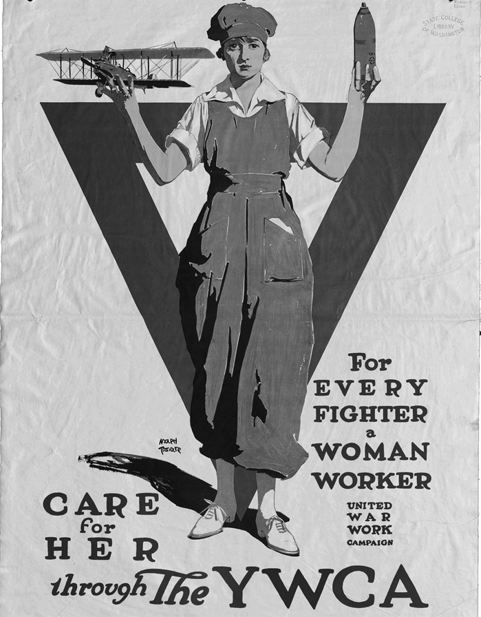

Courtesy of Manuscripts, Archives, and Special Collections, Washington State University Libraries

**Document 3**

Source: President Woodrow Wilson, Address to the Senate on the Nineteenth Amendment, September 1918

Gentlemen of the Senate:

We have made partners of the women in this war; shall we admit them only to a partnership of suffering and sacrifice and toil and not to a partnership of privilege and right? This war could not have been fought, either by the other nations engaged or by America, if it had not been for the services of the women—services rendered in every sphere—not merely in the fields of effort in which we have been accustomed to see them work, but wherever men have worked and upon the very skirts and edges of the battle itself. We shall not only be distrusted but shall deserve to be distrusted if we do not enfranchise them with the fullest possible enfranchisement, as it is now certain that the other great free nations will enfranchise them.

**Document 4**

Source: Ruth Matthews and Betty Hannah, “This Changing World for Women,” *Ladies Home Journal*, August 1942

When brisk Ginny Drummond and her cover-girl roommate of the silky black hair and gentian-blue eyes, Tommy Joseph, sink dog-tired into bed these evenings, often as not a lively jive party is just starting in the adjoining room. Getting eight hours’ sleep a night to bolster aching arms and feet for another eight hours’ stand on the Glenn Martin aircraft-assembly line is practically impossible when four girls, sharing the same cramped one-bedroom apartment on Baltimore’s sweltering Mt. Royal Avenue, keep working hours that stretch right around the clock. . . .

“You’ll do a man’s job and you’ll get a man’s pay check,” Glenn L. Martin tells his 4000 women employees, “but you’ll be treated as the men are treated.”. . .

And when the war is over? Some of the girls, and certainly the men they work beside, wonder just what all these women are going to do when the boys come home. Some, of course, will quit to get married. But not all of them will have husbands, because some of these boys aren’t coming back. Tommy has faced that stark possibility with grim and self-searching courage. She, like many other of the women workers, may go on to a big supervisory job in aircraft production. As for the younger girls, “When the war’s over we’ll probably go home again and wash dishes.”

“We’d better,” Ginny advises with a wry smile. “It’s the only way we’ll ever get our hands clean again.”

**Document 5**

Source: Photograph by African American photographer E. F. Joseph, taken for the Office of War Information between 1943 and 1945



Original caption: “One of the 1,000 skilled Negro women working at the Kaiser shipyards, at Richmond, California, who helped build the SS George Washington Carver, launched on May 7, 1943. Miss Odie Mae Embry mans the emergency switch for the protection of track workers as the huge crane swings 100 feet above.”