**Assignment 3: 3D Scene Editor**

**1.1 Scene Editor**

Press 1 to add a cube.

Press 2 to add a bunny_cube.

Press 3 to add a bunny.

All model will be rescaled so that their bounding boxes are unit cubes.

**1.2 Object Control**

Press X to switch between wireframe and solid mode.

Press Z to switch between flat and phong shading.

Click an object to mark it as selected. The selected object has a red color.

When an object is selected:

1. Use J, K and L to rotate it around global x, y, and z axis. Hold shift to rotate it in reversed direction.
2. Use U, I and O to translate it along x, y and z axis. Hold shift to translate it in reversed direction.
3. Use N and M to scale the object up and down by 20%.

**1.3 Camera Control**

Press W and S to move the camera along y axis. Press A and D to move the camera along x axis.

Scroll middle mouse button to zoom in and out. Moving along z axis is achieved using scrolling.

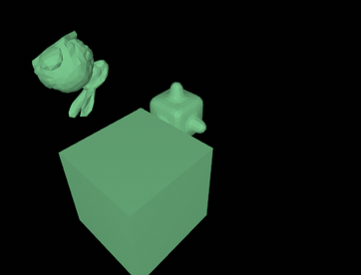

Left: Init camera position, Right: Rotated camera along the trackball

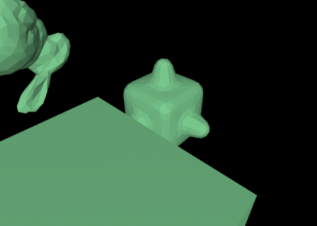

Camera zoom in and out

Press C to switch between perspective and orthographic projection.

Left: Orthographic, Right: Perspective

Resizing window can be properly handled.

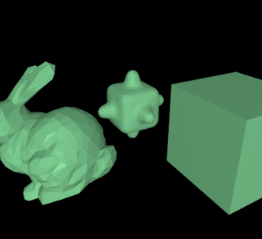

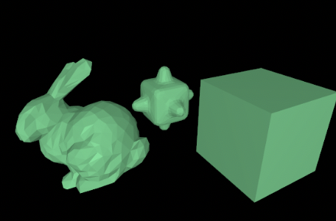

**1.6 Trackball (Optional)**

Hold left mouse button and drag to rotate camera around a trackball.

**Warning:** The trackball mode and keyboard translate mode for camera are not expected to be used simultaneously. You should always only use one mode through the running of the program!

The camera control is implemented using a trackball. The camera is fixed on a sphere and it always faces the origin. When left mouse button is hold while panning, it moves along the sphere. When scrolling the mouse, the radius of the sphere will change.