# Homework4

Jeff Cheng 410551012

Project repository [https://github.com/jeffchengtw/HW](https://github.com/jeffchengtw/HW3)4

## Input Data

x_data = [1,2,3,5,6,7,8,9,10,12,13,14,15,16,18,19,21,22]

y_label = [100,90,80,60,60,55,60,65,70,70,75,76,78,79,90,99,99,100]

## Output

* Case 1: n = 2, λ = 0

LSE:

Fitting line: 1.264545X^1 + 0.114976

Total error: 76725.768416

Newton's Method:

Fitting line: 0.997470X^1 + 66.972701

Total error: 3232.939805

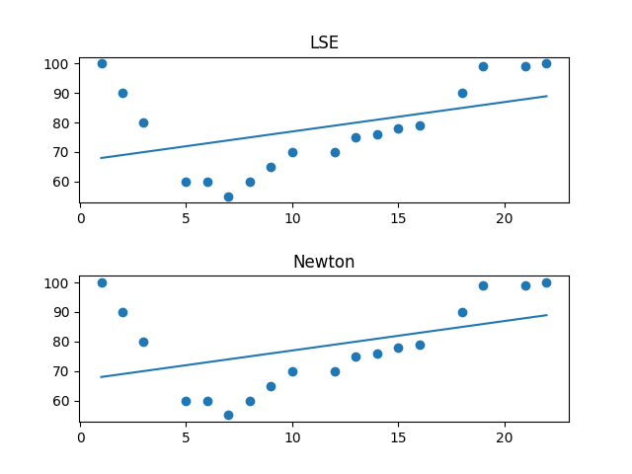

* Case 3: n = 2, λ = 0

LSE:

Fitting line: 0.300185X^2 + -5.858585X^1 + 94.018124

Total error: 949.787726

Newton's Method:

Fitting line: 0.300185X^2 + -5.858585X^1 + 94.018124

Total error: 949.787726

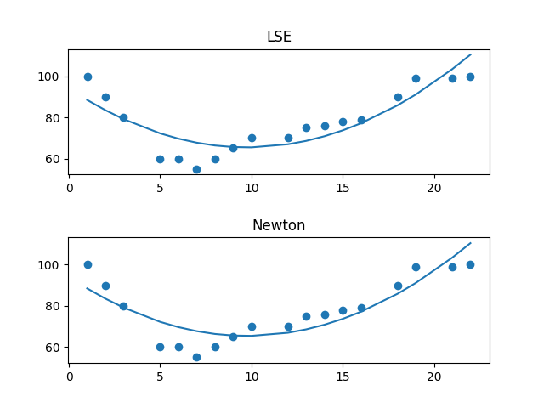

* Case 3: n = 2, λ = 10000

LSE:

Fitting line: 0.270819X^2 + 0.227608X^1 + 0.055519

Total error: 39343.640970

Newton's Method:

Fitting line: 0.300185X^2 + -5.858585X^1 + 94.018124

Total error: 949.787726