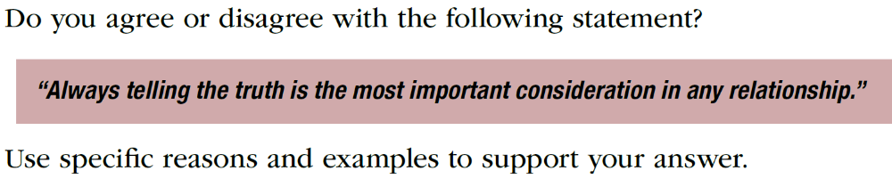

30分
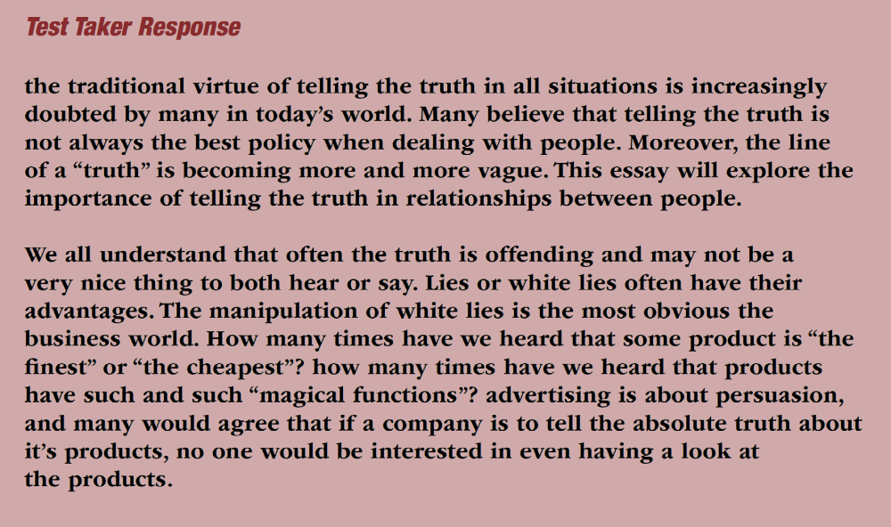

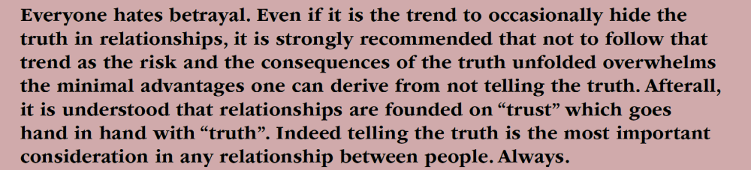

25分



题目：
Do you agree or disagree with the following statement?
Internet is a negative development for society.
Use specific reasons and examples to support your answer.

25分
People have always been worried about the impact when new technology is introduced. For instance, business people are worried about profits since a new technology can make their company obsolete. Yet, progress itself is not negative. The positive or negative impact technology results from how it is used. One recent technology, the Internet, has great positive and negative potential. However, overall, I feel that the Internet is postitive for society since it enables us to communicate more easily, save time, and save money.

One way that the Internet benefits society is that people can communicate much more easily. This is because email and instant messaging have changed the way that people communicate with each other. For example, I spent a month studying English in America. Even though I went by myself, I wasn’t homesick at all. I was able to send emails every day to my family and friends, and I could include pictures of my trip. In addition, when I used instant messaging, I could see my family as I talked with them, which is much better than just talking over the phone.

Another reason is that the Internet saves people time. To be more specific, people are able to get the information they need much more quickly. For instance, my dad told me that when he was young, it took him an hour to get to the library. Thus, when he needed to study, he would waste nearly the entire day travelling to and from the library to get the material he needed. In contrast, I can use the Internet and get the information I need in a matter of minutes.

The final reason is that the Internet saves people money. This is because people can shop online to purchase their goods. To illustrate this, think of a traditional store. The shopkeeper has to rent a large store in a nice neighborhood to attract customers. The money he spends on rent and his employees’ salaries is recover by charging more for the products. Yet, if the shopkeeper sold his goods online, he wouldn’t have to worry about those costs and so would be able to save money by shopping online.

For these reasons, I believe that society has been helped by the invention of the Internet. As the Internet spreads and becomes more common, its important to people’s lives cannot be overstated. But the Internet is nor a right, and not all people are able to access the Internet. Thus, the gulf between the rich and the poor will continue to expand unless people make a conscious effort to ensure that technology and education are made available for all people.

Do you agree or disagree with the following statement?
People will spend less time cooking and preparing food in twenty years than they do today.

Without doubt, eating is a intergral part in one's daily life. A person take three meals for a single day to ensure he has enough energy to finish all his tasks. However, when it comes to whether people will spend more or less time preparing for food in twenty years than today, they hold different ideas. Although some may believe that cooking will occupy more time in the future because people tend to pay more attention on health of their diets, I still maintain that people in twenty years will spend less time in cooking for several reasons.

Firstly, technological progress would make cooking less time-consuming than today. For instance, in the 20th century, we had to use old-fashioned oven and spend several hours to heat something. We had to pay attention to the oven to avoid overheating, which was quite exausted for the households. However, in the last two decades, the appearance of microoven makes it much easier to do the same task. Today we only need several minutes to finish heating some raw materials of our meals. Therefore, in the future, there will be more technology, such as micro oven, in our daily life and they will greatly reduce our time spent in cooking.

Moreover, in the future, the quick pace of life will not allow people to spend much time in cooking. For instance, my grandmother told me when she was in thirties, she just worked for about 6 hours on a day and went back home at 5.pm. Thus, she got enough time for cooking dinner. However, today the pace of life has been much quicker than that in the past. Today most young people spend more than 8 hours at work place, meaning they have to go back to home late. Therefore, it is impossible for them to start make traditional food at home in the evening because it would occupies a large part of their rest time.

Last, but not least, today people have changed their values about eating. Currently, some scientific research concluded eating dinner would make our stoma burden too much pressure, which is harmful for our body in the long term. Thus, some people begin to stop eating dinner. What's more, in order to keep fit, some young people, nowadays, do not eat traditional food during their lunch. Instead, they simply take salad with some fruit and vegetables to cut the amount of fat in their body. Therefore, there is no need to spend much time in preparing food for them.

In sum, people will spend less time in cooking in the future because of upcoming evolutoin of technology, quicker pace of life and change in value about the food and cooking.

Imagine that you are going to visit a new city, which one of the following ways do you think is the best way to know the city in a short time?
1.visit historic sites
2.go to shops and markets
3.enjoy the restaurant and spend time in café

Traveling is one of the favorite activities of people when they want to relax. During the trip, once they reach a new city, they would always try to know and discover the city in a short time. Knowing the city, in other words, is actually knowing the history, culture, and human behaviors of local society. Some say going to shops and markets or enjoying the restaurant and spending time in café is the best way to know the city. However, I would like to argue that visiting the historic sites is the best way to be familiar with the city within a short time.

Visiting historic sites will be the best choice since it provides opportunities for people to learn city’s history and culture which naturally orient the development of city and shape the thoughts of local people. This is because these historic sites are the essence of the city, and people can just focus on these sites to get the best knowing of the city within a short time. For example, when I was 7 years old, my parents brought me to Beijing, the capital of China, to have a look. Once we arrived in Beijing, we went to the Imperial Palace, which was the ancient Qing dynasty palace locating in the center of Beijing. During the visiting, I learned the history of how the kings position Beijing as central hub of the whole country, the cultural development of Beijing, the activities of local people, as well as the public recognition towards it. All these things helped perfect my understanding of Beijing efficiently. Having these important knowledge of its history, I didn’t even need to observe or discover the culture, function, and atmosphere of the city by myself, and I can directly know the instinct nature within less than 2 hours. Therefore, visiting the historic sites of a city is the best way to understand it fundamentally in a short time.

Going to shops and markets is not the best way to discover the nature of the city in a short time is mainly because it will take a long time to get a comprehensive knowing of the city. Shops and markets are spreading everywhere in the city, so it’s quite impossible for people to experience all the circumstance of markets and shops in a short time while they need to communicate with sellers for some times. I still remember the time I visited Singapore. All know that Singapore is a small city-state, so I optimistically thought that I can successfully knowing Singapore through going through the shops and markets quickly. However, after visiting only one supermarket, I realized that it was so time-consuming that even one market took more than one hour for me. As a result, I don’t think this way is feasible and available to know the city in a short time.

For enjoying the restaurants and spending time in café, it has a fatal flaw: people are likely devoured by comfortable environment so that they would lose the interest and energy to discover the city in a short time gradually. My cousin is a perfect example of this. I still remember that when I travelled with my cousin, he suggested that we could know more and learned different natures of cities through restaurants and café. Once we got to Paris, we tried his method. Nevertheless, the results and effects turned out badly. We couldn’t leave the restaurants and cafes within the planning time because some of them were so splendid and interesting, attracting us with our deep curiosities. We began to come up the thought of giving up knowing the city, and started enjoying our own lives. At the end, we not only didn’t learn much about the city itself, but also spent much most time on things to entertain ourselves. Therefore, I personally think this is a bad idea since it’s so easily to lose the focus of knowing the city, especially in a short time.

In conclusion, I think visiting the historic sites is the best way to be familiar with the city within a short time.

