DELETE THE FIRST TWO INSTRUCTION PAGES AFTER UPDATING YOUR SYLLABUS

# How to Use This Template to Update Your Syllabus

This template has been updated in January 2019. Text highlighted in yellow is the latest update. Information in ITALICIZED TEXT and HIGHLIGHTED IN GREY IS FOR YOUR REFERENCE only. YOU CAN REMOVE OR REPLACE IT WITH YOUR OWN WORDING, AS APPROPRIATE. You can use any font or font size you like, and add or rearrange the content to meet your needs. Please make sure any new important content paragraphs you have added are included in your document structure.

Please remove the first two instruction pages, the grey and yellow highlights, and any irrelevant or “Optional” information on the final version of your syllabus. Modify the footer information if you plan to include it.

## Key Components in a Syllabus

The [University Course Syllabi Policy S16-9](http://www.sjsu.edu/senate/docs/S16-9.pdf) at http://www.sjsu.edu/senate/docs/S16-9.pdf, dated April 5, 2016, has identified the following key components that you must include in all courses:

1. Course Information
   1. Basic information such as, San José State University, course title, number, and section, days and times taught, location of class, semester and year course is being taught, Professor’s contact information
   2. Office hours, days and location
   3. Course or section information such as, course description from the University catalog augmented by section-specific description, prerequisites, required and recommended texts, readers, or other reading materials, any other necessary equipment/materials/fees
   4. Student Learning Outcomes for the course, and if applicable, for General Education (GE), American Institutions (AI), and Graduation Writing Assessment Requirement (GWAR) courses Information may be found in [Guidelines for GE, AI, GWAR](http://www.sjsu.edu/senate/docs/2014geguidelines.pdf) (http://www.sjsu.edu/senate/docs/2014geguidelines.pdf per [University Policy S14-5](http://www.sjsu.edu/senate/docs/S14-5.pdf), at http://www.sjsu.edu/senate/docs/S14-5.pdf) effective Fall 2014
   5. Course requirements, e.g. papers, projects, exams, quizzes, homework, assignments, laboratory work, fieldwork, participations, etc.
   6. Tentative course calendar including assignment due dates, exam dates and date of final exam
   7. Grading information
2. University, College, or Department Policy information

Per University Policy S16-9, faculty are no longer required to include university level policy information. Instead, the following statement is required: “**The Office of Graduate and Undergraduate Programs hosts university-wide policy information relevant to all courses, such as academic integrity, accommodations, etc.**” You will find all syllabus related University Policies and resources information listed on GUP’s [Syllabus Information web page](http://www.sjsu.edu/gup/syllabusinfo/) at http://www.sjsu.edu/gup/syllabusinfo/ Please review them with your students.

## Guidelines for Accessible Documents

The [University Policy S16-9](http://www.sjsu.edu/senate/docs/S16-9.pdf), Course Syllabi (http://www.sjsu.edu/senate/docs/S16-9.pdf) requires faculty to follow [accessibility guidelines](http://www.sjsu.edu/cfd/teaching-learning/accessibility/accessible-guidelines/) (http://www.sjsu.edu/cfd/teaching-learning/accessibility/accessible-guidelines/) to create all instructional materials, including course syllabi. See page 4. Please make sure that you follow the guidelines below.

1. Include structure by using heading style feature in Word or using built-in layout except the blank layout in PowerPoint. See two screenshots from Word and PowerPoint below.

 In PowerPoint, the nine office themes will be displayed after you click the down arrow next to New Slide icon.

Use any one of these themes except the blank one will provide you with the structure for your slides.

1. Provide meaningful alternative text or description to explain the key message in any of your non-text graphics, charts, images, photos, text boxes, or objects.
2. Add a label or meaningful description for any web references, hyperlink the website labels and include the URL address. See example: the [Late Drop Policy](http://www.sjsu.edu/aars/policies/latedrops/policy/) is available at http://www.sjsu.edu/aars/policies/latedrops/policy/.
3. Note the logical reading order of the screen reader is to read information from left to right and from top to bottom, one line at a time. If you use the “Table” function to organize your information, do not nest tables within a table and make sure to repeat header row information if your table extends more than one page.

There are two methods to use this template to create your accessible syllabus.

## Copy and Paste Method

You can transfer text from your existing syllabus to this template with the Copy and Paste functions in Word.

1. Save this template on your desktop.
2. Open both your existing syllabus and this template in Word.
3. Copy the text from your existing syllabus.
4. Highlight the corresponding text or location on this template that you want to replace and paste your copied text over the highlighted text on this template.
5. After the paste function is complete, a **Paste Options** icon will appear next to the copied text. A paste options icon will appear after you finish pasting copied text
6. Click this **Paste Options** icon and choose the middle icon, “Merge Formatting” option. The Style and Formatting of your pasted text will now match with the existing text and formatting on this template.

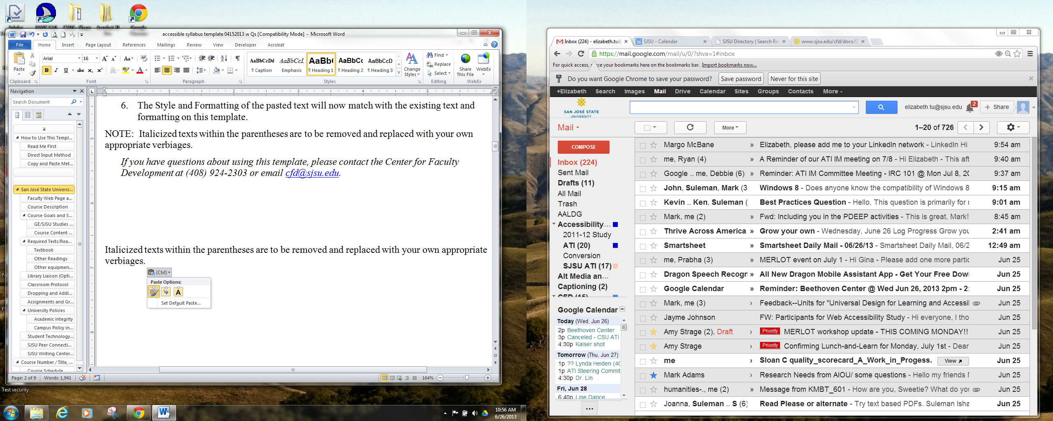 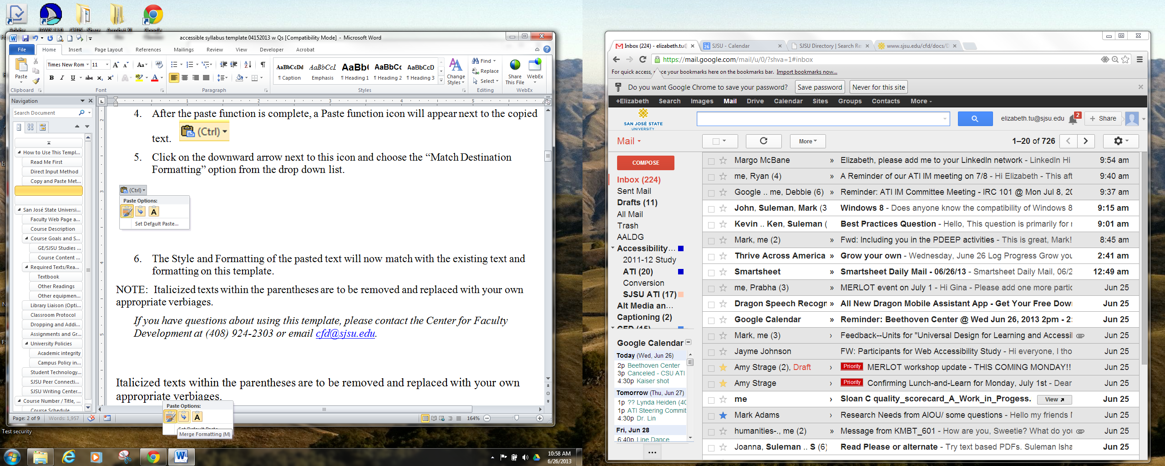

## Direct Input Method

1. Save this template on your desktop.
2. Highlight the text that you want to change and type directly over it. Text in the template will be replaced.
3. Modify or remove footer information as necessary.

NOTE: PLEASE REMOVE TEXT BELOW THAT IS ITALICIZED AND HIGHLIGHTED IN GREY AND REPLACE IT WITH YOUR OWN APPROPRIATE WORDING.

**If you have any questions about using this template, email** [**cfd@sjsu.edu**](mailto:cfd@sjsu.edu) **at Center for Faculty Development or call (408) 924-2303 at San José State University.**

**San José State University**

# School/Department Course Number, Title, Section, Semester, Year

## Course and Contact Information

|  |  |
| --- | --- |
| Instructor: | (Your name) |
| Office Location: | (Building and room number) |
| Telephone: | (area code) (telephone number) |
| Email: | (Your email address) |
| Office Hours: | (Days and time) *[See University* [*Policy S12-1*](http://www.sjsu.edu/senate/docs/S12-1.pdf) *at http://www.sjsu.edu/senate/docs/S12-1.pdf for faculty office hours guidelines]* |
| Class Days/Time: | (Days and time) |
| Classroom: | (Building and room number, or your online course web address) |
| Prerequisites: | (Delete this row if not applicable) |
| GE/SJSU Studies Category: | (Delete this row if not applicable) |

## Course Format

### Technology Intensive, Hybrid, and Online Courses(Required if applicable)

*Indicate whether this course adopts an online, hybrid, or flipped classroom delivery format. Specify any Internet connectivity or technology requirements, such as computer, special hardware devices or software apps that students must have to participate in the classroom activities and/or submit assignments. See* [*University Policy F13-2*](http://www.sjsu.edu/senate/docs/F13-2.pdf) *at http://www.sjsu.edu/senate/docs/F13-2.pdf for more details.*

### Service Learning (SL) Courses or Credit Bearing Internships (Suggested, if applicable, but not mandatory)

*If this course is a service learning course or internship, students must complete a CSU-SJSU Learning Plan & Participation Guide; participate only with an SJSU approved partner organization; and enter all required SL or Internship information in the****SJS4-Spartans 4 Service****database. More details are available at the links below.*

* *Definition of Service Learning:* Visit [*University Policy S02-3 on service learning*](http://www.sjsu.edu/senate/docs/S02-3)*:* http://www.sjsu.edu/senate/docs/S02-3.pdffor definition and more information
* [*University Policy S16-14*](http://www.sjsu.edu/senate/docs/S16-14.pdf) *on Internships, Service Learning, and Off-Campus Learning Experiences: http://www.sjsu.edu/senate/docs/S16-14.pdf*

## Faculty Web Page and MYSJSU Messaging (Optional)

*Course materials such as syllabus, handouts, notes, assignment instructions, etc. can be found on my faculty web page at http://www.sjsu.edu/people/firstname.lastname and/or on* *Canvas Learning Management System course login website* *at http://sjsu.instructure.com. You are responsible for regularly checking with the messaging system through MySJSU on* [*Spartan App Portal*](http://one.sjsu.edu) *http://one.sjsu.edu (or other communication system as indicated by the instructor) to learn of any updates.*

## Course Description (Required)

*Insert course description from the* [*University catalog*](http://info.sjsu.edu/web-dbgen/splash/catalog.html) *(http://info.sjsu.edu/web-dbgen/splash/catalog.html) augmented by section-specific description.*

## Course Goals (Optional)

*Insert program, department or course goals, as appropriate.*

### GE Learning Outcomes (GELO) (Delete if not applicable)

*If applicable, list your General Education learning outcomes here and specify which class activities/assignments/experiences are linked to those outcomes.*

Upon successful completion of this GE course, students will be able to:

1. *Insert learning outcome 1, satisfied by activity/assignment/experience XYZ*
2. *Insert learning outcome 2, etc.*

### Course Learning Outcomes (CLO) (Required)

*Insert and list your non-General Education course goals and learning outcomes here. Describe the outcome in terms of specific and measurable actions, capabilities or skills students will be able to perform through course activities/experience at the end of your course. Add any additional program or department outcomes if appropriate.*

Upon successful completion of this course, students will be able to:

1. *Insert learning outcome 1*
2. *Insert learning outcome 2, etc.*

## Required Texts/Readings (Required)

### Textbook

*Insert your complete textbook citation here. Include ISBN and information about where students can buy or access the text. Include if applicable.*

### Other Readings

*Insert the list of any additional readings here and specify where they can be found. Include if applicable.*

### Other technology requirements / equipment / material

*Include if applicable.*

## Library Liaison (Optional)

*Insert the name, email address, and other relevant information concerning your library liaison.*

## Course Requirements and Assignments (Required)

*Insert descriptions of course requirements and assignments here. Explain how course requirements, reading materials, learning activities, and assignments contribute to or are aligned with course learning outcomes. Include information about general expectations, roles and responsibilities of the students, due dates and assignment weights.* *Review the following sources and policies with your students:*

* [*University Syllabus Policy S16-9*](http://www.sjsu.edu/senate/docs/S16-9.pdf) *at http://www.sjsu.edu/senate/docs/S16-9.pdf.*
* *Office of Graduate and Undergraduate Programs’* [*Syllabus Information web page*](http://www.sjsu.edu/gup/syllabusinfo/) *at http://www.sjsu.edu/gup/syllabusinfo/*

*The* [*University Policy S16-9*](http://www.sjsu.edu/senate/docs/S16-9.pdf)*, Course Syllabi (http://www.sjsu.edu/senate/docs/S16-9.pdf) requires the following language to be included in the syllabus:*

“Success in this course is based on the expectation that students will spend, for each unit of credit, a minimum of 45 hours over the length of the course (normally three hours per unit per week) for instruction, preparation/studying, or course related activities, including but not limited to internships, labs, and clinical practica. Other course structures will have equivalent workload expectations as described in the syllabus.”

### Final Examination or Evaluation

*Insert descriptions of your final examination or evaluation information here. More details can be found in*

[University policy S17-1](http://www.sjsu.edu/senate/docs/S17-1.pdf) (http://www.sjsu.edu/senate/docs/S17-1.pdf) *which states that*

*“*Faculty members are required to have a culminating activity for their courses, which can include a final examination, a final research paper or project, a final creative work or performance, a final portfolio of work, or other appropriate assignment.”

## Grading Information (Required)

*Specify your grading policy here. Provide rubrics and explain how grades are assessed and assigned. Allow multiple opportunities to give feedback on student learning. Use rubrics or examples to explain and show students how they can assess themselves or check their own learning. More guidelines on grading information and class attendance can be found from the following two university policies:*

* [*University Syllabus Policy S16-9*](http://www.sjsu.edu/senate/docs/S16-9.pdf) *(http://www.sjsu.edu/senate/docs/S16-9.pdf)*
* *University Attendance and Participation Policy F15-12* *(http://www.sjsu.edu/senate/docs/F15-12.pdf)*

### Determination of Grades

* A statement of how grades will be determined for the course, including +/- grades if they are used.
* Extra credit options, if available.
* List of the percentage weight assigned to various class assignments.
* Penalty (if any) for late or missed work.

*Below are a few samples of accessible grading scale in table and non-table format. You can use either one or create your own grading scale as long as it is accessible with logical reading order. Different screen readers may read texts differently. The “+/-“ may not be read out loud. It is always a good practice to spell them out and spell out any abbreviations or make a reference of your abbreviation when used for the first time.*

*A plus = 1000 to 970 points*

*A = 969 to 940 points*

*A minus = 939 to 900 points*

*B plus = 899 to 870 points*

*B = 869 to 840 points*

*B minus = 839 to 800 points*

*C plus = 799 to 770 points*

*C = 769 to 740 points*

*C minus = 739 to 700 points*

*D plus = 699 to 670 points*

*D = 669 to 512 points*

*D minus = 639 to 600 points*

*F = 599 points or lower*

| *Grade* | *Points* | *Percentage* |
| --- | --- | --- |
| *A plus* | *960 to 1000* | *96 to 100%* |
| *A* | *930 to 959* | *93 to 95%* |
| *A minus* | *900 to 929* | *90 to 92%* |
| *B plus* | *860 to 899* | *86 to 89 %* |
| *B* | *830 to 829* | *83 to 85%* |
| *B minus* | *800 to 829* | *80 to 82%* |
| *C plus* | *760 to 799* | *76 to 79%* |
| *C* | *730 to 759* | *73 to 75%* |
| *C minus* | *700 to 729* | *70 to 72%* |
| *D plus* | *660 to 699* | *66 to 69%* |
| *D* | *630 to 659* | *63 to 65%* |
| *D minus* | *600 to 629* | *60 to 62%* |

### Grading Information for GE/100W (if applicable)

* **For Basic Skills** (A1, A2, A3, B4) include the following statement:

“This course must be passed with a C- or better as a CSU graduation requirement.”

* **For 100W (Area Z)** courses, include the following statement:

“This course must be passed with a C or better as an SJSU graduation requirement.”

* **For upper division GE courses (R, S, V)** include the following paragraph:

“Passage of the Writing Skills Test (WST) or ENGL/LLD 100A with a C or better (C‐ not accepted), and completion of Core General Education are prerequisite to all SJSU Studies courses. Completion of, or co‐registration in, 100W is strongly recommended. A minimum aggregate GPA of 2.0 in GE Areas R, S, & V shall be required of all students.”

## Classroom Protocol

*Insert your expectations for participation, attendance, arrival times, behavior, safety, cell phone use, etc. here.*

## University Policies (Required)

Per University Policy S16-9 *(http://www.sjsu.edu/senate/docs/S16-9.pdf)*, relevant information to all courses, such as academic integrity, accommodations, dropping and adding, consent for recording of class, etc. is available on Office of Graduate and Undergraduate Programs’ [Syllabus Information web page](http://www.sjsu.edu/gup/syllabusinfo/) at http://www.sjsu.edu/gup/syllabusinfo/” Make sure to review these university policies and resources with students.

*If applicable, include links to department and college-level rules, requirements and services.*

# Course Number / Title, Semester, Course Schedule

*List the agenda for the semester including when and where the final exam will be held. Indicate the schedule is subject to change with fair notice and how the notice will be made available.*

## Course Schedule

| **Week**  ***(Optional)*** | **Date** | **Topics, Readings, Assignments, Deadlines**  ***(If appropriate, add any extra column(s) to meet your needs.)*** |
| --- | --- | --- |
| 1 |  |  |
| 1 |  |  |
| 2 |  |  |
| 2 |  |  |
| 3 |  |  |
| 3 |  |  |
| 4 |  |  |
| 4 |  |  |
| 5 |  |  |
| 5 |  |  |
| 6 |  |  |
| 6 |  |  |
| 7 |  |  |
| 7 |  |  |
| 8 |  |  |
| 8 |  |  |
| 9 |  |  |
| 9 |  |  |
| 10 |  |  |
| 10 |  |  |
| 11 |  |  |
| 11 |  |  |
| 12 |  |  |
| 12 |  |  |
| 13 |  |  |
| 13 |  |  |
| 14 |  |  |
| 14 |  |  |
| 15 |  |  |
| 15 |  |  |
| 16 |  |  |
| Final Exam |  | Venue and Time |