|  |  |  |  |  |  |
| --- | --- | --- | --- | --- | --- |
|  | **Traditional** |  |  | **Redesign updated in collaboration with Business and math faculty. Use calculator** |  |
| **Sections** | **Topics/remarks** | **Weeks** | **Sections** | **Topics/Remarks** | **weeks** |
| 1.2 | Simple Interest (Review by Students) | 0 | Chapters0, 1, 4, 5 | Just in time Algebra Review (JITR) Via WebAssign. By students & help at co-req. math71W, embedded throughout the semester | 0 |
| 4.2-4.4 | Exp, Log, Comp. & Conti Interest | 1 | 4.2& 4.4 | Later, see below with chap 10 | 0 |
| 7.1-7.7 | Limits & Derivatives | 3 | 7.1-7.7 | Limits & Derivatives, Tangent lines.  Focus: Derivatives, algebraic methods, interpretation & business applications, power rule (real number powers), related chain rule  Omit: Complex Rational/Radicals & quotient Rules | 3 |
| 8.4-8.5 | Use of Derivative in Math | 0.75 | 8.4-8.6 | Use of Derivative in Math. Use Chart for increase/decrease & relative extrema with 1st & 2nd derivative tests. Absolute extrema.  Focus on application to business, light on f”  Optional/Omit: relation btw graphs of f, f’ & f” | 1.5 |
| 9.1-9.2 | Applications of Derivatives | 1.5 | 9.1-9.4 | Focus on relevant Applications of Derivatives.  Add more problems on optimization using modeling to create functions to optimize | 1 |
| 10.1-10.5 | Derivative of Exp & Log | 1 | 10.1-10.5 | Exp, Log, Derivative of Exp & Log  Focus on e and ln, but light on Logarithm.  JITR 4.2 as needed with sections 10.1 to10.3  JITR 4.3 as needed with section 10.4  Use 4.4 as need to solve simple equations that involve property lnAb= b lnA (less of other ln properties), and relevant applications | 2 |
| 11.1-11.4  11.5 Opt. | Integration with Applications | 2 | 11.1-11.4 | Integration with Applications  Limited to area above x-axis as needed  Focus on relevant applications to this course  Omit: Complex Rational/Radicals | 2.5 |
| 16.3-16.4 | Probability Distributions (Dep. Notes | 0.75 | 16.3-16.4  Web-Assign  e-book | Probability Distributions (continuous)  Focus: continuous case, relevant applications to this course, and for special cases focus on Uniform & Exponential Probably densities.  Omit: discrete case. | 1 |
| 5.1-5.3 | Systems of Equations | 1 | 5.1-5.3 | JITR with chap13, focus on substitution method | 0 |
| 13.1-13.4  & 13.6 | Partial Derivatives & Lagrange Multipliers.  13.2 (discuss planes only),  13.3 (discuss briefly) | 2 | 13.1-13.3  13.4  13.5  13.6 | Function of several variables & Partial Derivatives (Omit Rational/Radicals)  Very brief overview on 13.1 to 13.3  Focus on 13.4 & 13.5, relevant applications, Partial Derivatives, Extrema, Saddle, two variables for Lagrange Multipliers (JITR of systems as needed). | 2.5 |
| Newton | Newton’s Method (use your notes) | 0.5 | Newton | Omit |  |
| Exams | Exams + quizzes | 1.5 | Exams |  | 1.5 |
| Total |  | 15 | Total |  | 15 |

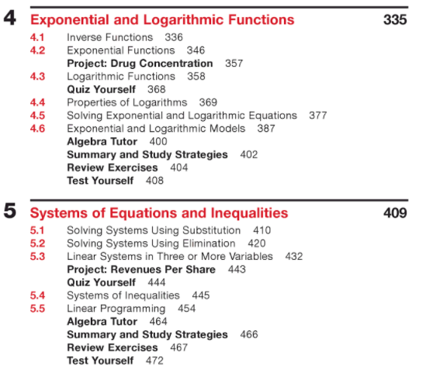Just in time Review chapters:

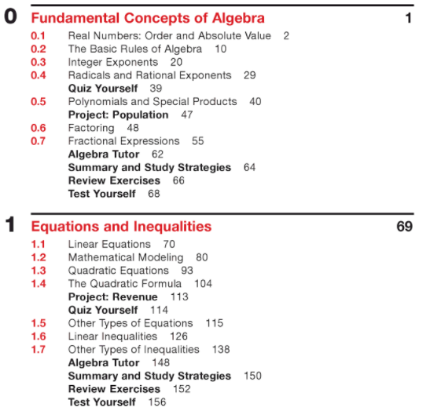

Course covers topics from sections from these chapters:

