Clearwire Corporation
4400 Lake Washington Blvd.NE
Kirkland, WA 98033
425.216.7600 (phone)
425.216.7900 (fax)
www.clearwire.com



Wimax Tester Tool (WiTT)

Document Number:
Version: 8.3

CONFIDENTIAL & PROPRIETARY
Limited Distribution to Authorized Persons Only
Copyright © 2004 Clearwire Corporation.
All Rights Reserved.

1 References 3
2 Revisions 4
3 Introduction 5
4 Statistics 7
5 Installation 9
6 Monitoring 10
7 Logging 11
8 Customization 12
Adding New Maps for WiTT 12
Managing Map Images 14
Adding New Bases to WiTT 14
Managing Bases 16
Changing the Order, Format, and Conversions of Baseband Metrics 16
Metrics Display Order 18
Metrics Format 18
Metrics Conversion 19

References
- xxx

Revisions
Date | Revision | Description | Author
January 16, 2008 | 0.1 | Initial release. | Jeff Fry
February 26, 2008 | 0.2 | Revised for WiTT 8.2a. | Jeff Fry

Introduction
The Wimax Tester Tool (WiTT) was created to help test Beceem-based Wimax devices such as USB, ExpressCard and PCMCIA on the Windows platform. It is a tool that will typically be used for drive tests. It provides GPS integration and mapping that allows the collection of metrics along a drive route.
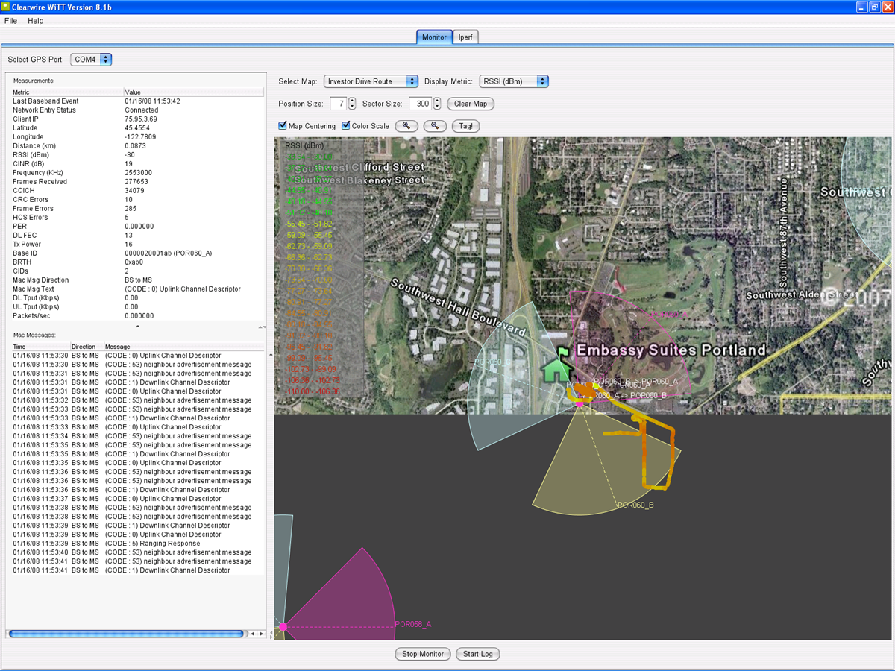
Figure 1: WiTT User Interface

The following lists the high-level features that WiTT provides:
- Real-time display of GPS, baseband, MAC messages, and OS throughput statistics.
- Logging of GPS, baseband, MAC messages, and OS throughput statistics to a CSV file for processing.
- Real-time map tracking while displaying the current position colored per current RSSI, CINR, DL-Tput, and UL-Tput (and more) color scale.
- Ability to load additional map images and select maps on the fly.
- Map zooming and centering per your current location.
- Ability to save the current map image.
- Visual display of handovers and custom text tagging at current position.
- Audible indication if network entry, network drop and handovers.
- Full-screen mode of real-time map for presentations.
- Iperf integration

Statistics
The following lists the statistics that are displayed and logged by WiTT:
Last Baseband Event
Network Entry Status
Client IP
Latitude
Longitude
Distance (km)
RSSI (dBm)
CINR (dB)
Frequency (KHz)
Frames Received
CQICH
CRC Errors
Frame Errors
HCS Errors
PER
DL FEC
Tx Power
Base ID
BRTH
CIDs
Mac Msg Direction
Mac Msg Text
DL Tput (Kbps)
UL Tput (Kbps)
Packets/sec
Packets Outbound Discarded
Packets Received Errors
Current Bandwidth
Packets Received/sec
Packets Received Non-Unicast/sec
Output Queue Length
Packets Received Discarded
Packets Sent Unicast/sec
Packets Outbound Errors
Packets Received Unknown
Packets Received Unicast/sec
Packets Sent/sec
Packets Sent Non-Unicast/sec

Installation
If a previous version of WiTT is installed, uninstall it completely by running the WiTT uninstaller from Start->Programs->Clearwire->WiTT->Uninstall WiTT.
      - WiTT is a Java-based tool that requires Java 1.5.0 or higher. Java can be downloaded from the Sun web site: http://java.sun.com/javase/downloads/
      - Go to
https://share.clearwire.com/WIMAX%20%20Operations/Forms/AllItems.aspx?RootFolder=%2fWIMAX%20%20Operations%2fSoftware%2fWiTT
and download the WiTT package.
      - Launch witt—vX.X-install.jar by double-clicking the file.
      - Follow the steps of the installer to install WiTT. Accept the default selections.
      - Launch WiTT from Start->Programs->Clearwire->WiTT.

Monitoring
The following describes how to start using WiTT to monitor statistics.
      - Ensure your GPS is connected and your Beceem-based Wimax device is connected.
      - If drive testing, ensure your other network connections such as Wifi and OpenVPN are disabled.
      - Launch WiTT.
      - Select the appropriate map.
      - Select the ‘Start Monitor’ button at the bottom.
That’s it! You should now see your current location on the map and statistics being displayed to the left. At any time, you can select ‘Stop Monitor’ to stop the monitoring.

Logging
WiTT logs all the displayed statistics to a CSV file. This CSV file is created in the installation directory of Witt (C:\Program Files\WiTT).
The following steps describe how to start logging.
      - Ensure your GPS is connected and your Beceem-based Wimax device is connected.
      - Launch WiTT.
      - Select the appropriate map.
      - Select the ‘Start Monitor’ button at the bottom. The ‘Start Log’ button will now be enabled.
      - Select the ‘Start Log’ button. This creates a CSV file with a named based on the selected map and the time. For example, the following is a file name created when logging the ‘PDX Warehouse’ map.
‘PDX Warehouse02008_January_16-12_11_56_stats.csv’
That’s it! You are now logging statistics to a CSV in the installation directory. At any time, you can select ‘Stop Log’ to stop the logging.

Customization

Adding New Maps for WiTT
Prior to performing the Field verification on the site, you may need to upload a new map to WiTT in order to view your desired coverage area. WiTT supports the adding of new maps. The following describes how to upload a new map using Google Earth. Google Earth can be download for free from: http://earth.google.com/download-earth.html
- Launch Google Earth and navigate to your site and desired coverage area.
- When you are satisfied with the view, switch to full screen mode under View->Full Screen (or F11).
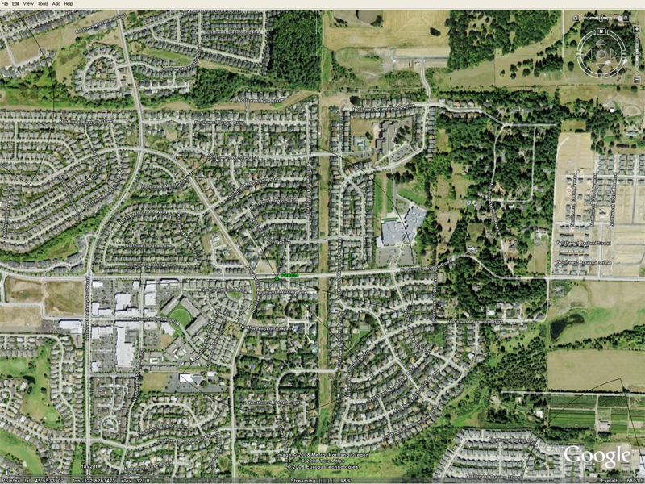
Figure 2: Google Earth Full Screen View
- When uploading a new map image to WiTT, the northwest and southeast latitude and longitude coordinates of the corners are required for image calibration. These coordinates must be in decimal format. Google Earth must be configured to do this under Tools->Options->3D View-> Show Lat/Long->Decimal Degrees. Once this is set, your cursor latitude and longitude coordinates will appear in the lower left of the Google Earth view. For your desired view, record the northwest and southeast corner coordinates. It’s very important that this be as accurate as possible.
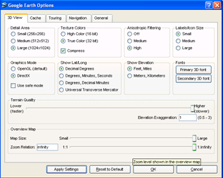
Figure 3: Google Earth Latitude and Longitude Settings
- Now save your Google Earth view as an image using File->Save Image. Remember your image file location.
- In WiTT, select Maps->Manage Maps to launch the Map Management Dialog.
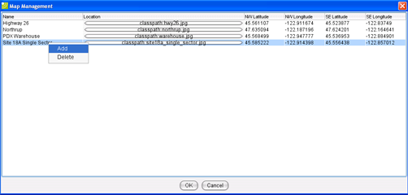
Figure 4: Map Management Dialog
- Right-click and select ‘Add’ from the popup menu.
- For the new row, specify your map name, navigate to your image location, and specify the northwest and southeast coordinates.
- Select ‘OK’ in the dialog and your map image will be available immediately in the WiTT map selection pull down.

Managing Map Images
WiTT provides the ability to manage map files. To do this, access Maps->Map Management. Google Earth is the recommended tool for saving map images for WiTT.
- Right-click on the table to add or delete maps.
- Click on the location field to update the map file location.
- Enter the northwest and southeast latitude and longitude coordinates of your map. This information is used to translate GPS coordinates to pixel location.
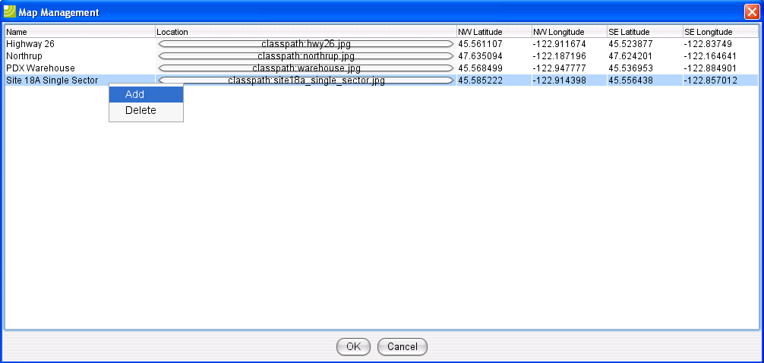
Figure 2: Map Management Dialog
- Update the map name.
- Click ‘OK’ to accept all changes. Changes are available immediately.

Adding New Bases to WiTT
WiTT allows you to add new bases to be displayed in the map view. This will probably need to be done prior to field verification. WiTT allows you to specify the site name, location, azimuth, beamwidth and color of the base to be displayed.
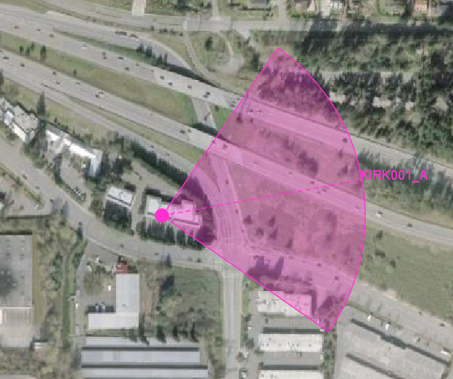
Figure 5: Base Displayed in WiTT
- In WiTT, select Maps->Manage Bases.
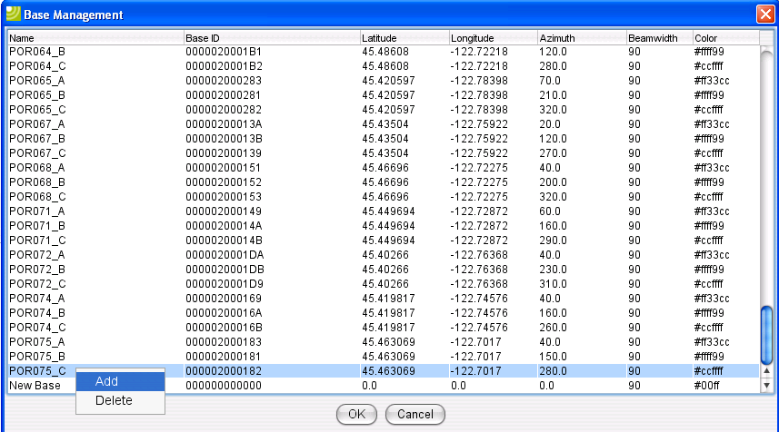
Figure 6: Base Management Dialog
- Right-click and select ‘Add’ from the popup menu.
- For the new row, specify the site name, base ID, location coordinates, azimuth, beamwidth and color.
- Select ‘OK’ in the dialog and your base will be available immediately in the WiTT map view.

Managing Bases
WiTT provides the ability to manage base files. To do this, access Maps->Base Management.
- Right-click on the table to add or delete bases. Note: In the context of WiTT a base entry in the table is a sector.
- Enter the latitude and longitude coordinates of your base. Also enter azimuth, beamwidth, and color for the base (sector). The color is a RGB hexadecimal value.
- Update the base name and base ID.
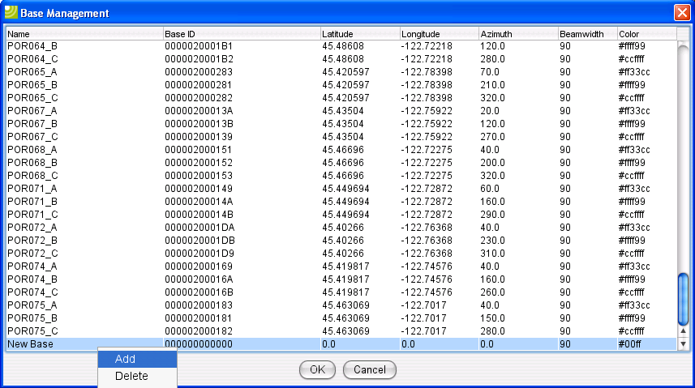
Figure 3: Base Management Dialog
- Click ‘OK’ to accept all changes. Changes are available immediately.

Changing the Order, Format, and Conversions of Baseband Metrics
The order, format, and conversion of baseband metrics displayed in the measurements table can be changed. This is done through the C:\Program Files\WiTT\config.xml file. This file is the main configuration file for WiTT. With the file the metrics are listed as follows:

<valid-metrics>
<!-- The sub process may return many metrics, but these will be the only valid ones we record. -->
<!-- The order of metrics below is important. These metrics will be displayed in the application in the following order. -->
<!-- The logger will also record in the following order. -->
<metric conversion="x" format="String" name="Last Baseband Event" property="pollTime"/>

<metric conversion="x" format="String" name="Network Entry Status" property="NETENTRY STATUS"/>
<metric conversion="x" format="String" name="Client IP" property="clientIP"/>

<!-- GPS Metrics -->
<metric conversion="x" format="###0.00000" name="Latitude" property="latitude"/>
<metric conversion="x" format="###0.00000" name="Longitude" property="longitude"/>
<metric conversion="x" format="###0.00000" name="Distance (km)" property="distance"/>

<!-- Radio Metrics -->
<metric conversion="x" format="###0" name="RSSI (dBm)" property="CUR RSSI"/>
<metric conversion="x" format="####0" name="CINR (dB)" property="CUR CINR"/>
<metric conversion="x" format="String" name="Frequency (KHz)" property="CenterFrequency in KHz"/>
<metric conversion="x" format="String" name="Frames Received" property="Num frames recvd"/>
<metric conversion="x" format="String" name="CQICH" property="Num Of CqichTxmtd"/>
<metric conversion="x" format="String" name="CRC Errors" property="Num Of CRC Errors"/>
<metric conversion="x" format="String" name="Frame Errors" property="Frames in Error"/>
<metric conversion="x" format="String" name="HCS Errors" property="Num Of Hcs Errors"/>
<metric conversion="x" format="String" name="PER" property="PER"/>
<metric conversion="x" format="String" name="DL FEC" property="Downlink burst data FEC"/>
<metric conversion="x" format="String" name="Tx Power" property="Tx Power"/>
<metric conversion="x" format="String" name="Base ID" property="BaseID"/>
<metric conversion="x" format="String" name="BRTH" property="Number of BRTH"/>
<metric conversion="x" format="String" name="CIDs" property="Number of Connections"/>
<metric conversion="x" format="String" name="Mac Msg Direction" property="Mac Msg Direction"/>
<metric conversion="x" format="String" name="Mac Msg Text" property="Mac Msg Text"/>

<!-- Typeperf Metrics -->
<metric conversion="x*8.0/1000.0" format="#####0.00" name="DL Tput (Kbps)" property="Bytes Received/sec"/>
<metric conversion="x*8.0/1000.0" format="#####0.00" name="UL Tput (Kbps)" property="Bytes Sent/sec"/>
<metric conversion="x" format="String" name="Packets/sec" property="Packets/sec"/>
<metric conversion="x" format="String" name="Packets Outbound Discarded" property="Packets Outbound Discarded"/>
<metric conversion="x" format="String" name="Packets Received Errors" property="Packets Received Errors"/>
<metric conversion="x" format="String" name="Current Bandwidth" property="Current Bandwidth"/>
<metric conversion="x" format="String" name="Packets Received/sec" property="Packets Received/sec"/>
<metric conversion="x" format="String" name="Packets Received Non-Unicast/sec" property="Packets Received Non-Unicast/sec"/>
<metric conversion="x" format="String" name="Output Queue Length" property="Output Queue Length"/>
<metric conversion="x" format="String" name="Packets Received Discarded" property="Packets Received Discarded"/>
<metric conversion="x" format="String" name="Packets Sent Unicast/sec" property="Packets Sent Unicast/sec"/>
<metric conversion="x" format="String" name="Packets Outbound Errors" property="Packets Outbound Errors"/>
<metric conversion="x" format="String" name="Packets Received Unknown" property="Packets Received Unknown"/>
<metric conversion="x" format="String" name="Packets Received Unicast/sec" property="Packets Received Unicast/sec"/>
<metric conversion="x" format="String" name="Packets Sent/sec" property="Packets Sent/sec"/>
<metric conversion="x" format="String" name="Packets Sent Non-Unicast/sec" property="Packets Sent Non-Unicast/sec"/>

</valid-metrics>

Metrics Display Order
To change the order of metrics, simply change the order of the metrics in the listing above. Move the metric tag to the location desired. This will then appear in the same order within WiTT’s measurement table.

Metrics Format
To change the format of a metric, modify the format attribute of the metric tag:
<metric conversion="x*8.0/1000.0" format="#####0.00" name="DL Tput (Kbps)" property="Bytes Received/sec"/>
This can be used to change decimal accuracy and the number decimals displayed.
The following table explains the formatting rules.

Symbol | Location | Localized? | Meaning
0 | Number | Yes | Digit
# | Number | Yes | Digit, zero shows as absent
. | Number | Yes | Decimal separator or monetary decimal separator
- | Number | Yes | Minus sign
, | Number | Yes | Grouping separator
E | Number | Yes | Separates mantissa and exponent in scientific notation. Need not be quoted in prefix or suffix.
; | Subpattern boundary | Yes | Separates positive and negative subpatterns
% | Prefix or suffix | Yes | Multiply by 100 and show as percentage
\u2030 | Prefix or suffix | Yes | Multiply by 1000 and show as per mille value
¤ (\u00A4) | Prefix or suffix | No | Currency sign, replaced by currency symbol. If doubled, replaced by international currency symbol. If present in a pattern, the monetary decimal separator is used instead of the decimal separator.
' | Prefix or suffix | No | Used to quote special characters in a prefix or suffix, for example, "'#'#" formats 123 to "#123". To create a single quote itself, use two in a row: "# o''clock".

Metrics Conversion
Metrics can be further converted from their initial values if necessary. This is accomplished through the conversion attribute:
<metric conversion="x*8.0/1000.0" format="#####0.00" name="DL Tput (Kbps)" property="Bytes Received/sec"/>

