We learn from the course that “encapsulation” is used frequently in networking. In this project, we will emulate TCP sender and receiver in application layer and call UDP protocol to transmit TCP packets. That is, TCP packets will be encapsulated and sent in UDP layer by the source and decapsulated in the receiver. In this project, both directions need to be implemented.
The TAs will tell you how to test your program. That is, TAs will write clients and/or servers to test your program. Therefore, it becomes very important to follow TAs’ formats so your program can be test. The TCP segment structure is as enclosed and you must follow the segment format and implement at least the following fields: source port, destination port, sequence number, acknowledgment number, and checksum for primitive TCP, TCP Tahoe, TCP Reno, and TCP SACK. The state diagram is as shown in the last page of the project. The server provides four video files for clients to retrieve. A client can request multiple video files within each request. The round trip delay is first set to be 150 ms for each connection. The variable threshold is initially set to 64K bytes. The MSS is 1K bytes. The TCP buffer size is assumed to have a buffer size of 32K bytes. The maximum transmission rate for each TCP connection from the server side to the client side is assumed to be 200 kbps, and the maximum transmission rate for each TCP connection from the client side to the client side is assumed to be 100 kbps. The TAs will provide you with these four video clips which basically are small video files.

Step 1: First, you would write one server and four clients, and the server and four clients can both transmit packets and ACKs. The server must be able to handle multiple file requests from multiple clients.
Step 2: Channels may have losses.
Step 3: Delay ACKs are added to senders and receivers.
Step 4: The TCP congestion control consists of the slow start and the congestion avoidance mechanisms. In step 4, you implement the slow start mechanism and the congestion avoidance mechanism.
Step 5: The fast retransmit mechanism is added (Tahoe).
For the moment, there are still only two states, slow start state, and congestion avoidance state. However, the fast retransmit mechanism is already included in TCP Tahoe. For TCP Tahoe, when a loss happens, fast retransmit is triggered and the slow start state is entered.
Step 6: The fast recovery mechanism is added (TCP Reno).
Step 7: The SACK option is incorporated into the standard.
Step 8: Now increase the number of clients to 200. The server side has to implement some prevention mechanisms to handle simultaneous requests from clients. One possible solution is suggested as follows. Since it is probably unrealistic to folk 200 child processes, the parent process has to have a method to queue input requests. Therefore, the parent process can fork some child processes responsible for queuing input requests, which in turn dispatch requests to other child processes to complete the job. In other words, the requests from the clients may need to wait for services in the server but the server will respond to clients’ requests eventually.

The program consists of nine subprojects.

- Both directions have the same transmission rate of 300 kbps.
- A server and four clients. (10)
- The link becomes unstable and there are 0.01% of loss rates. The loss rates are generated randomly. (10)
- Delay ACKs. (10)
- TCP slow start and TCP congestion avoidance. (20)
- TCP with fast retransmit (TCP Tahoe). (10)
- TCP with fast retransmit and fast recovery (TCP Reno). (10)
- The SACK option is added. The direction from client side to server side has RTT = 300 ms and the direction from server side to client side has RTT = 150 ms (15)
- Increase the number of clients to 200. (15)

Due: June 21, 2019
References:
The first five papers are suggested for understanding the mechanisms. The last three papers are for additional readings. They are listed below. The last two references are about the relationship about bandwidth x delay and TCP receiver window size.
[1] F. M. Allman, V. Paxson, and W. Stevens, “TCP congestion control,” RFC 2581, Apr. 19999, http://www.rfc-editor.org/rfc/rfc2581.txt.
[2] S. Floyd and T. Henderson, “The New Reno Modification to TCP’s Fast Recovery Algorithm,” RFC 2582, Apr 1999, http://www.rfc-editor.org/rfc/rfc2582.txt.
[3] M. Mathis, J. Mahdavi, S. Floyd, and A. Romanow, “TCP selective acknowledge options, RFC 2018,” Oct. 1996, http://www.rfc-editor.org/rfc/rfc2018.txt.
[4] V. Jacobson and R, Braden, “TCP extensions for long-delay paths,” RFC 1072, http://www.rfc-editor.org/rfc/rfc1072.txt.
[5] J. F. Kurose and K. W. Ross, Computer Networking: A Top-Down Approach Featuring the Internet, six edition, Addison Wesley, Reading, 2012
[6] K. Fall and S. Floyd, Simulation-based Comparisons of Tahoe, Reno, and SACK TCP, Computer Communication Review, vol. 26, No. 3, July 1996.
[7] S. Floyd, “A report on some recent developments in TCP congestion control,” IEEE Communications Magazine, Apr 2001, http://www.aciri.org/floyd/papers/report_Jan01.pdf.
[8] W. R. Stevens, TCP/IP Illustrated vol. 1: The Protocols, Addison-Wesley, Reading, MA, 1994. (Due: Dec 17, 2007)
[9] http://speedtest.raketforskning.com/tuning-tcp-window-size.html
[10] http://en.wikipedia.org/wiki/TCP_tuning

PS. The TA will tell you how to test your program.
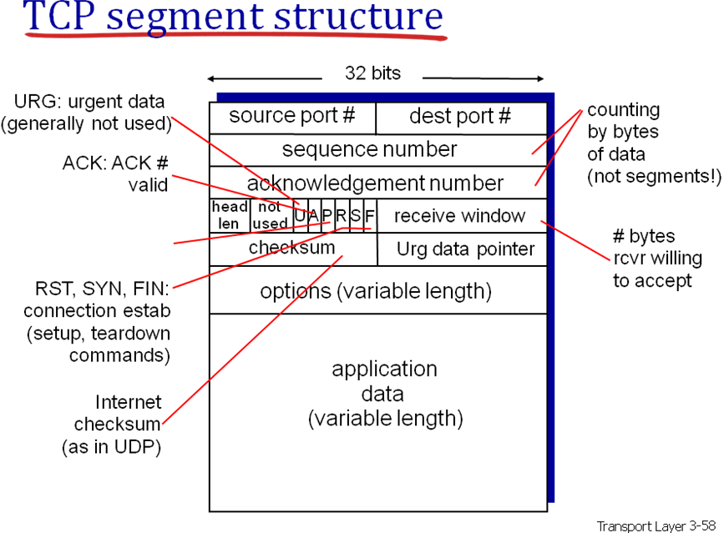

RFC 2018 TCP Selective Acknowledgement Options October 1996

The SACK option is to be included in a segment sent from a TCP that
is receiving data to the TCP that is sending that data; we will refer
to these TCP's as the data receiver and the data sender,
respectively. We will consider a particular simplex data flow; any
data flowing in the reverse direction over the same connection can be
treated independently.

2. Sack-Permitted Option

This two-byte option may be sent in a SYN by a TCP that has been
extended to receive (and presumably process) the SACK option once the
connection has opened. It MUST NOT be sent on non-SYN segments.

TCP Sack-Permitted Option:

Kind: 4

+---------+---------+
| Kind=4 | Length=2|
+---------+---------+

3. Sack Option Format

The SACK option is to be used to convey extended acknowledgment
information from the receiver to the sender over an established TCP
connection.

TCP SACK Option:

Kind: 5

Length: Variable

+--------+--------+
| Kind=5 | Length |
+--------+--------+--------+--------+
| Left Edge of 1st Block |
+--------+--------+--------+--------+
| Right Edge of 1st Block |
+--------+--------+--------+--------+
| |
/ . . . /
| |
+--------+--------+--------+--------+
| Left Edge of nth Block |
+--------+--------+--------+--------+
| Right Edge of nth Block |
+--------+--------+--------+--------+

Transport layer 3- 70, 3-104

