NAME:
CPSC 361: COMPUTER SIMULATION
Fall, 12 week, 2003
Slotterbeck

DIRECTIONS: Answer all questions on line.

(MULTIPLE-CHOICE) questions may have more than one item chosen to make the statement true. All must be selected and their identifying letters listed.

For (TRUE-FALSE) questions, type true or false.

(ESSAY) questions should be precise and specific to the question. Don't waste your time (and mine) saying the same thing in several different ways. There is no need to repeat the question as I wrote it and, consequently, know what it says! Problems marked as (ESSAY) can be of any length as long as the question is answered with reasons provided for the answer. Answer these on your own paper.

Note that questions marked (ESSAY) may just require short answers.

Definitions are marked as (DEFINE).
=============================================================

1. (ESSAY) Why is the statistical analysis of output so critical when doing simulations? What questions are asked during statistical analysis?

2. (ESSAY) Describe how Arena uses Stations and Transfers. What can they represent? What do they allow us to do? How do they relate to time delays and when would you use them instead of a time delay?

3. (ESSAY) It has been said that animation is the least important part of a simulation study and it has been said that animation is the most important part of a simulation study. Explain this statement.

4. (DEFINE)
a. terminating simulation
b. steady-state simulation

5. (ESSAY) Compare and contrast terminating simulations and steady-state simulations with respect to the statistical analysis of the output from the simulations.

6. (MULTIPLE-CHOICE) Some of the methods of making Arena run faster and fit into the Academic mode are to
a. Reduce the number of module instances
b. Eliminate statistical accumulators
c. Eliminate lines in data modules
d. Uncheck statistical-collection boxes
e. Have multiple copies of the same basic model, but have several versions- one animated, one collecting a certain set of information, another collecting another set of information, etc.
f. Rethink your solution and look for a simpler approach
g. None of the above

7. Suppose I am hired to study the deli line at a local supermarket during the dinner rush. There are three servers, and each customer takes a number to assure that the customer who has been waiting the longest gets the next available server. I plan to use ARENA with an ARRIVE to generate customers and a DEPART to record statistics as they leave. Which of the following is the best way to model the three servers? Describe the reason for your choice.

- one SERVER module, capacity 3
- three SERVER modules
- one INSPECT module, capacity 3
- three INSPECT modules
- None of the above; I must use the SETS module

8. (DEFINE)
a. A constraint (in the context of configuration comparisons)
b. A requirement (in the context of configuration comparisons)

9. Consider the following produced by the output analyzer where the mean being analyzed represents the expected difference in flowtime between the current system and a new proposed system.

Diff

95% CL Test Value
Paired-t Comparison of Means
Current-Proposed

TAVG(OUT_TA) -6
-10.1 -1.86

a. (ESSAY) Can we conclude that the expected flowtime of the proposed system is different than the expected flowtime of the current system? Why or why not?

b. Can we conclude that the expected flowtime of the proposed system is at least 6 minutes longer than the expected flowtime of the current system? Why or why not?

10. (ESSAY) Suppose a simulation model for a bookstore during book buying is built. After 50 replications of a nine-hour day, a 95% confidence interval is found for the average time a student spends standing in line. In particular, we can say we are 95% sure that the expected average time a student spends in line is somewhere between 5.42 and 9.48 minutes. Explain what is meant by this statement, particularly the "95% part".

11. (ESSAY) Suppose you are asked to simulate a network and analyze the mean system time. After we have obtained 1000 observations for each of 10 replications, the 90% confidence interval is [0.8,1.2]. If our goal is to obtain a smaller confidence interval, should we run more observations or more replications or what? Explain your answer.

12. (MULTIPLE-CHOICE) The Process Analyzer (PAN) in Arena
a. Allows you to compare many alternatives at the same time.
b. PAN operates on the compiled program files with the extension .doe.
c. In PAN, you create scenarios that use input controls and output responses.
d. PAN provides many possible graphs showing how different alternatives compare.
e. PAN automatically selects an optimal alternative.
f. None of the above.

13. (MULTIPLE-CHOICE) OptQuest
a. Searches for an optimal solution using heuristic search methods.
b. Is guaranteed to provide an optimal alternative from a specified set of alternatives.
c. Was written by the same people that provided the Arena software.
d. Can take a very long time to run if you are presenting it with many alternatives and you don't choose your bounds properly.
e. None of the above

14. (ESSAY) Exercise 06-15 models an airport security system with a checkers designated as Manual, Automated, and Security. This analysis considered the question, "If you could hire one more person, and that person could be assigned either to Manual, Automated, or Security, where would this person be best used based on the average total time in the system of all types of passengers combined." Consider the following output Describe how this analysis was performed and discuss all the information and conclusions conveyed below

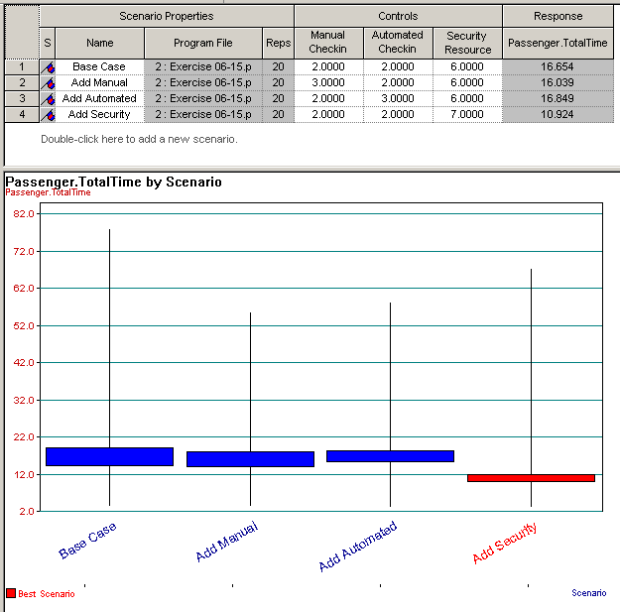

15. (ESSAY) Exercise 06-16 models an airport security system with a checkers designated as Manual, Automated, and Security. This analysis considered the question, "If you could hire a total of five more people to be allocated in any way to the existing staff at Manual, Automated, or Security, what would be the best deployment of these people, assuming you can't reduce below the original levels." Consider the following output Describe how this analysis was performed and discuss all the information and conclusions conveyed below

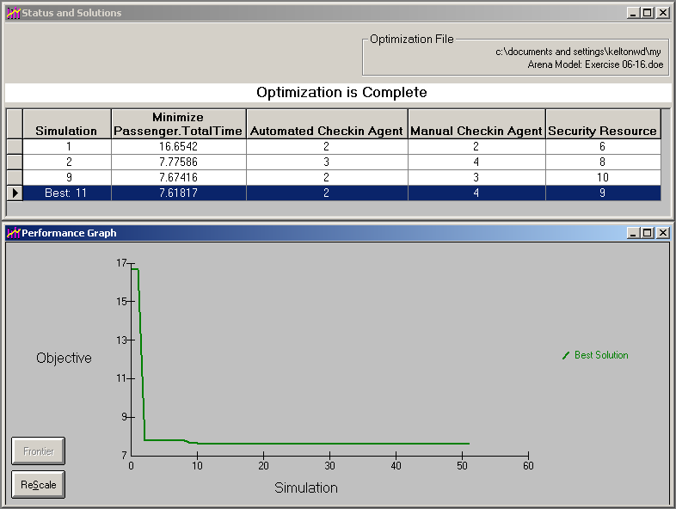

16. (ESSAY) Suppose we want to model the "walk-in" HELP desk for a computer center between 2:00 and 6:00 PM on a weekday. During this time, there is normally one person working. When that person is with a customer, (s)he can be called away to take a phone call. When this happens, (s)he always finishes with the current customer before taking the call. Discuss the difference between the use of WAIT, IGNORE, or PREEMPT for reducing capacity in this setting. Which would you choose and why?

17. (DEFINE)
a. A simulation
a. Event-driven simulation, assuming (a) is defined
b. Process-driven simulation, assuming (a) is defined
c. A system
d. The state of a system

18. (TRUE-FALSE) When building a simulation model in Arena, the modeler uses process-driven simulation techniques.

19. (TRUE-FALSE) Arena processes models using process-driven procedures.

20. (DEFINE)
a. Validation of a model
b. Verification of a model

21.(ESSAY) For each modeling task specified as a definition in question 20, provide one possible example of what you might do if you were modeling the serving line in a cafeteria.

22. (DEFINE)
a) Sample space b) Event

23. Give the sample space when three coins are tossed. Assume an H is recorded for a head and a T is recorded for a tail. Assume the coins are not biased.

24. (MULTIPLE CHOICE) If A and B are events, the symbol P(A|B) is
a) The probability that B occurs given that A has occurred.
b) P(A)P(B)/P(A ∩ B)
c) A conditional probability.
d) P(A ∩ B)/P(B), assuming P(B) ≠ 0
e) None of the above

25. (MULTIPLE CHOICE ) Saying that two events A and B are independent means
a) Knowing one of the events has occurred does not tell us anything about the probability of the other event occurring.
b) A and B are mutually exclusive.
c) P(A ∩ B) = P(A)P(B)
d) B always occurs whenever A occurs.
e) None of the above

26. (MULTIPLE CHOICE) Saying that a distribution has expected value λ assumes that
a) The value λ is expected to be seen more than any other.
b) We have sampled infinitely many times.
c) The average of all values observed is λ.
d) The average of any finite number of values seen will be exactly λ.
e) None of the above

27. Suppose we have build a model and we have found that the average service time is strictly less than the average interarrival time. Briefly discuss what you might see when the model runs. Are you guaranteed to see what you claim? Support your claims by giving reasons or examples.

28. Suppose we have a single bank machine that we want to watch for 15 minutes. We will assume that the machine is empty and idle to begin with and that the clock starts when the first customer arrives. Below we have arrival times, interarrival times, and service times for five customers. Perform the simulation by hand, filling in the chart on the next to the last page of this test. You will hand in the chart. Then compute the performance measures listed on the last page. Time units are minutes.

Customer | Time of Arrival | Interarrival Time | Service Time
1 | 0 |  | 3
2 | 1 | 1.0 | 2
3 | 3 | 2.0 | 10
4 | 6 | 3.0 | 8
5 | 10 | 4.0 | 1
6 | 16 | 6.0 | 1

a. Give the event calendar entries as [entity number, time, type]. Note it is similar to a few columns from the hand simulation we did in Chapter 1.

Entity Number | Time | Event type | Event Calendar
1 | 0.0 | Init | [1, 0.0, arr]  [-,15,end]

b. What is the Average Time in Line for an entity?:

c. What is the Average Time in the System for an entity?:

d. What is the Total Number of Customers Who Completed Transactions:?

HAVE A NICE BREAK!
LOOK FOR EMAIL WHEN YOU COME BACK FOR
PICKING UP THIS TEST AND ANY OTHER WORK I HAVE!

