Chapter 11
Classical Analysis
In this chapter, three approaches to specification are compared: formal, semiformal, and informal. I feel that students should be exposed to as many formal methods as possible. One way to introduce the FSM material to students who have had no prior exposure to formal machines is to describe a menu-based product with which most students are familiar, such as a popular word-processing package on a PC. Point out that each menu corresponds to a state, and each menu choice to an input. Once students appreciate that they have been dealing with finite state machines for years, Section 11.6 is easy to teach.

Students who have taken an operating systems course may well have been exposed to Petri nets. Also, the basic concept can be easily understood by most of the class without much effort by the instructor. I believe that Section 11.7 should be covered, if only to ensure that students are exposed to Petri nets. However, not all students will be able to do Problem 11.13.

On the other hand, I teach Sections 11.8 and 11.9 to only graduate students. Furthermore, there is only one problem involving Z at the end of the chapter.
problem solutions
11.1: Both constraints superficially appear to be precise and scientific, but neither can be measured or tested. Specifically,
(i) The term “significantly” is imprecise—significant for whom: client or developer? Also, this is a reason for developing the product, not a constraint.
(ii) The term “reasonable” is imprecise—reasonable for whom: client or developer?

11.2: Ambiguities:
Is a clove or a head of garlic to be used?
What operations are to be performed the night before? Everything?
Which juice is to be strained, orange or lemon?
What is to be frozen, the lemon or just the juice?
Is the onion to be diced, or just the shallots?
Which mixture is to be blended for 10 minutes?
Does “blend” mean “mix by hand” or “use an electric blender?”
How are the lumps to be removed, with a strainer or a blender?
The lumps in the mixture could be the mushrooms.
Two mixtures are specified, the pockwester is added to only one of them: which?
How can you kill a “fresh” pockwester?
The terms “simmer,” “bite-sized,” and “soft to the touch” are imprecise.
We can broil for any time from 1 microsecond to 3 minutes, 59 seconds.
What is to be sprinkled with Parmesan—the serving platter, or the pockwester?

Omissions:
How large is a “large onion”?
What size can of orange juice?
How large a lemon?
What kind of bread for the crumbs?
How much flour?
How much milk?
How large are medium-sized shallots?
How large are medium-sized eggplants?
What size pockwester?
What size garlic?
How much Parmesan cheese?
What size eggs?
The sugar is not listed in the ingredients.
Nor are the mushrooms.
Nor are the frobs.
What size platter is to be used?

Contradictions:
The ingredients call for frozen orange juice, the recipe calls for fresh.
After the lemon has been squeezed the night before, it is then supposed to be sliced.
We are told to “stir vigorously,” “slice,” and “in the meantime” to coat, dip, and so on—it is impossible to do all these things at once.

The following items are certainly confusing, but they are not ambiguities, omissions, or contradictions:
The lemon juice, eggplant, and garlic are never used.
Grilling in a skillet is not usually a good idea.
Shaking up mushrooms wet with milk in a paper bag is fraught with difficulties.
The instruction to whisk the eggs should precede the instruction to add them to a mixture.
If the blending is to be done with an electric blender, 10 minutes seems to be too long.
The recipe calls for first coating the mushrooms in flour, and then dipping them in milk; this may be unorthodox, but then so is much of the rest of the recipe!
Two mixtures are specified, the pockwester is added to only one of them; nothing is mentioned regarding what is to be done with the other one.

11.3: If actual sales for the current month are less than the target sales for the current month, check whether the percentage difference between the actual sales and the target sales for the current month is 5% or more. If so, check whether the percentage difference between the actual sales and target sales for the current month is greater than or equal to half of the percentage difference between the actual sales and target sales for the previous month. If this second condition also holds, print a report. Otherwise, do nothing.

11.4: For each shop, the actual sales for each month are compared with the target sales for that month.

The effectiveness of a given shop for a given month is defined by

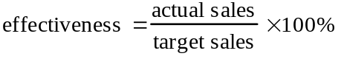

The shortfall for a given shop for a given month is defined by

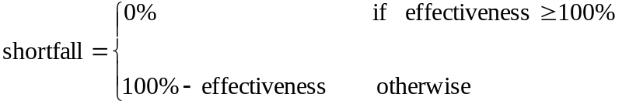

A shop is deemed to have achieved its objective for the current month if the shortfall for the current month is less than or equal to 5%, or if the shortfall for the current month is less than or equal to half the shortfall for the previous month; in the case of January, the shortfall for the previous month is deemed to be 0%.

If a shop has not achieved its objective, a report is to be printed.

11.5: The following assumptions are made: there are no service charges, no ATM withdrawals. The only transactions that are allowed are checks and deposits. All checks bear a number. The user has a pile of canceled checks, and a pile of deposit slips.

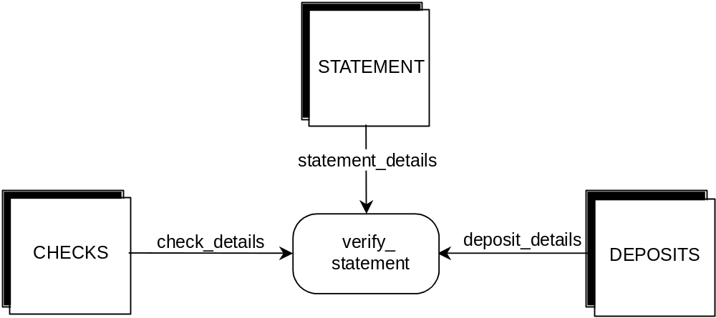
Figure 11.1. Data flow diagram for determining whether bank statement is correct.

Sort the checks in check-number order. For each check, find an entry in the bank statement that matches the check number. If no such entry is found, the statement is in error. Otherwise, mark that entry, and verify that the amount for that entry is the same as that on the check. If the amounts do not match, the statement is in error.

Sort the deposit slips according to date of deposit. For each deposit slip, find an entry in the statement that matches the date of deposit and the amount of the deposit. Mark that entry. If no such entry is found, the statement is in error.

After all checks and deposits have been processed, verify that all items on the statement have been marked. If not, the statement is in error.

Add the amount of all deposits to the beginning balance, and from that sum subtract the total of all the checks. If the result of that subtraction is not equal to the ending balance then the statement is in error, otherwise it is correct.

11.6: See Figure 11.1.

11.7: This product is concerned with books, borrowers, and librarians. The library has a collection of books which borrowers may check out and subsequently return. Each book has a unique book number. Affixed to each book is a label bearing that number in bar code format.

Each borrower has a unique borrower number. Each borrower has a card bearing that number in bar-code format that is scanned when the borrower checks out a book. Borrowers may determine all the books by a particular author in the library collection by going to a terminal and entering A = <author name>, all the books with a specific title by entering T = <book title>, or all the books in a particular subject area by entering S = <subject area>.

Librarians check out a book by entering C at a terminal, scanning the borrower bar code, and scanning the book bar code. If the book is not being held for another reader, it is issued to the borrower. When a book is returned by a borrower, the librarian enters R at a terminal, and scans the book bar code. To add a new book to the collection, the librarian enters + (plus sign), the number of the new book, and other book details. To remove a book from the collection, the librarian enters – (minus sign) and enters the book number (bar-code input is inappropriate—the book may have been stolen). A librarian can put a hold on a book for a borrower by entering H = <book number> and scanning the borrower’s bar code. [The need for the borrower’s number was intentionally omitted from the problem statement; students should not thoughtlessly rewrite the problem statement in more formal terms, but actually consider the implications of what they are writing!] A book may not be held if it is already being held for another borrower.

11.8: See Figure 11.2.

11.9: Step 1. Draw DFD. See previous problem.

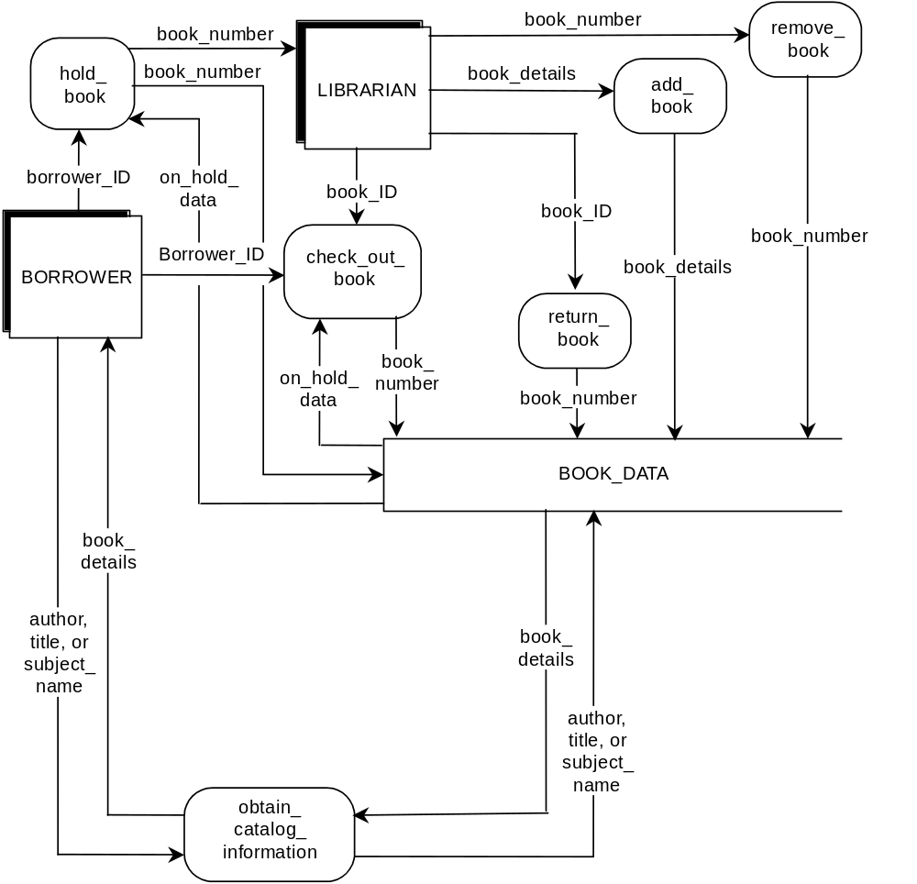
Figure 11.2. Data flow diagram for library circulation.

Step 2. Decide what sections to computerize, and how. Computerize complete product as shown in DFD, online. DFD does not show functions like issuing new borrower with an ID number and card, or maintaining borrower details. These functions were not included in the specifications, and it is therefore assumed that they will be performed manually.

Step 3. Details of data flows.

book_ID
book_number

book_details
book_number
book_bibliographic_details
author
title
subject
other_details
borrower_ID
borrower_number

on_hold_data
borrower_number if book is on hold for another borrower, else 0

Step 4. Define logic of processes.

add book
Place book_details in BOOK_DATA

check out book
Read book_ID, borrower_ID
Check that book is not being held for another borrower
Update BOOK_DATA with borrower_ID

hold book
Read book_number, borrower_ID
Check if book is already on hold
If not, update BOOK_DATA to reflect borrower_ID

obtain catalog information
Read borrower’s query
Search BOOK_DATA
Answer borrower’s query

remove book
Read book_number
Delete book_details from BOOK_DATA

return book
Read book_number
Update BOOK_DATA

Step 5. Define data stores.

BOOK_DATA (512 bytes—assumption)
book_number
author
title
subject
other details
on_hold_data
borrower_number (0 if book is not checked out)

Indexed by book_number (primary), and also by author, title, and subject (secondary)

Step 6. Define physical resources.

BOOK_DATA
Indexed sequential file
Primary index book_number
Secondary indexes author, title, and subject

Step 7. Determine input/output specifications.

book_ID, borrower_ID are input with bar code wand

book_number, book_details are input at terminal

Input screens will be designed for add book, remove book, obtain catalog information

Acknowledgment messages will be designed for add book, check out book, remove book, hold book, return book

Output screens will be designed for obtain catalog information

Step 8. Perform sizing. Assuming a maximum of 500,000 books, BOOK_DATA will need to have 256 megabytes for the catalog itself, and another 25 megabytes for indexes. A further 2 megabytes will be needed for software.

Step 9. Determine hardware requirements.

CPU
5 gigabyte disk
Tape backup system
Two terminals for borrowers
Two terminals for librarians

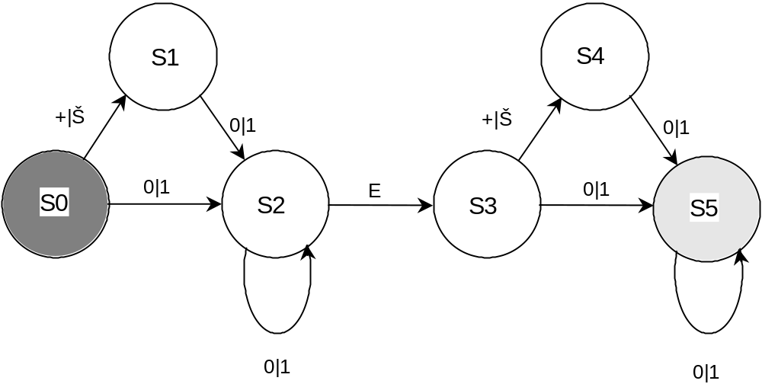
Figure 11.3. Finite state machine for accepting floating point numbers.

11.10: The FSM is shown in Figure 11.3

Set of states is {S0, S1, S2, S3, S4, S5}
Set of inputs is {+, –, 0, 1, E}
The transition function is depicted on the next page
Initial state is s0
Set of final states is {S5}
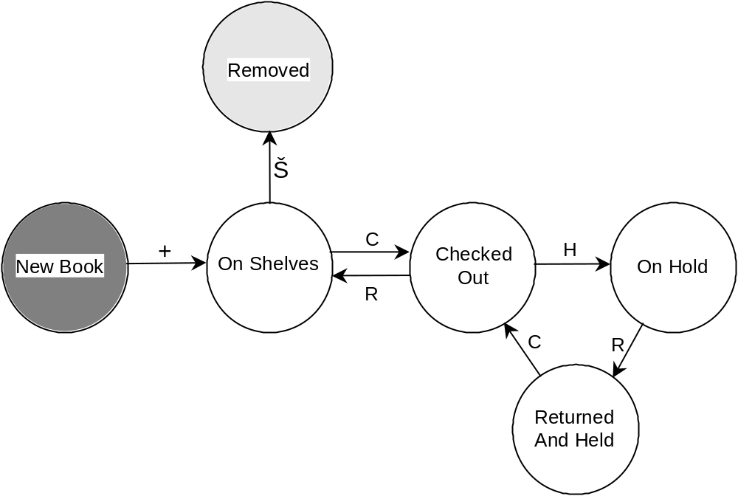
Figure 11.4. FSM for library circulation system.

11.11: The FSM for the library circulation system is shown in Figure 11.4.

Set of states is {New Book, Removed, On Shelves, Checked Out, On Hold, Returned And Held}
Set of inputs is {C, H, R, +, –}
The transition function is depicted below
Initial state is New book
Set of final states is {Removed}

11.12: The user first keys in the book number of the book in question. A menu then appears, corresponding to the current state of the book. For example, if the book is Checked out, the menu offers the user three choices, corresponding to operations R and H, and Exit. If the user enters R, say, a new menu appears corresponding to state On shelves. If the user now enters Exit, the next time the product is used with respect to the same book it will be in state On shelves, and the On shelves menu will appear.
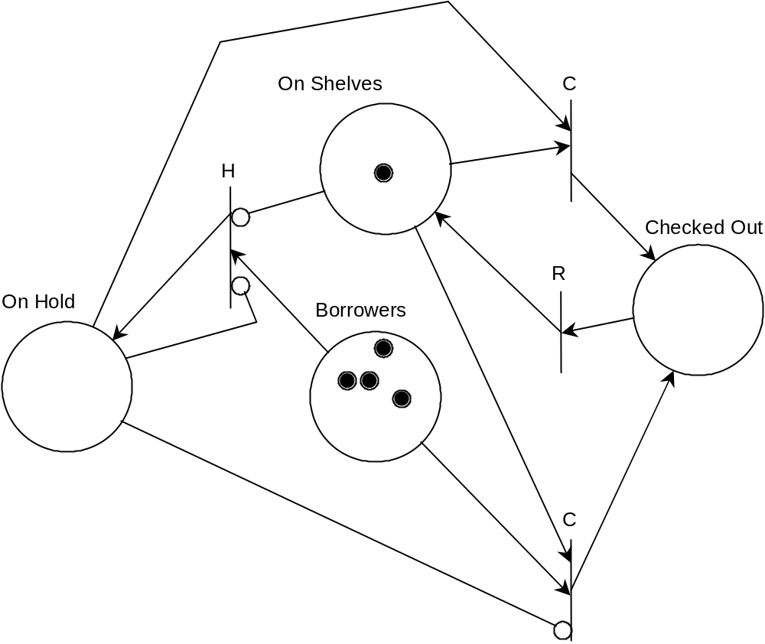
Figure 11.5. Petri net specification of library circulation system.

11.13: See Figure 11.5.

11.14: Answers will vary from enthusiasm about being given the opportunity to implement formal specifications, to dank despair even at the very thought of having to implement formal specifications!

