Chapter 11
Term project
11.15: A solution using Gane and Sarsen’s method is given.
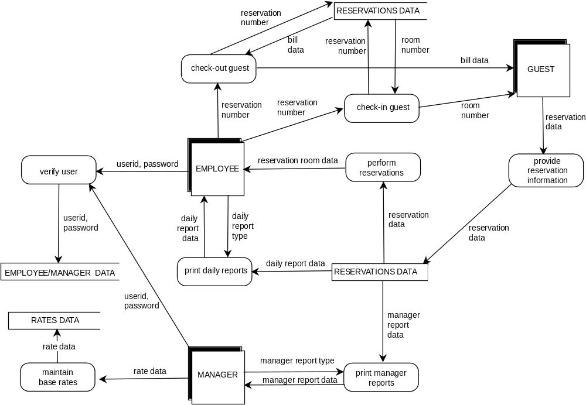

Step 1. Draw the data flow diagram.

See Figure 11.6. (To reduce the number of cross-overs, the reservations data store of data appears twice in the figure.)

Step 2. Decide what sections to computerize, and how.

All modules will be computerized as shown in the DFD in the form of a standalone product.

Step 3. Put in the Details of the Data Flows

date (10 characters)

rate (4 + 2 digits)

rate data
rate (see above)
date (see above)

userid (7 characters)

password (10 characters)

reservation data
reservation number (7 digits)
guest name (35 characters)
guest address (75 characters)
guest e-mail address (40 characters)
type (1 character)
reservation days (2 digits)
dates of reservation (14 dates—see above)
status (1 character)
comments (100 characters)
rates of reservation (14 rates—see above)
guest phone number (12 digits)
guest credit card number (16 digits)
credit card type (15 characters)
credit card expiration date (date—see above)
date reservation made (date—see above)
room number (2 digits)
date bill paid (date—see above)
amount bill paid (6 + 2 digits)

manager report type (1 character)

expected occupancy report data
date (30 × 10 characters)
number of prepaid reservations (30 × 2 digits)
number of 60-day reservations (30 × 2 digits)
number of conventional reservations (30 × 2 digits)
number of incentive reservations (30 × 2 digits)
average expected occupancy rate (2 digits)

expected room income report data
date (30 × 10 characters)
expected income for the night (30 × 8 + 2 digits)
total income for the period (8 + 2 digits)

incentive report data
date (30 × 10 characters)
incentive income for the night (30 × 8 + 2 digits)
total incentive income for the period (8 + 2 digits)
average incentive income for the period (8 + 2 digits)

manager report data
expected occupancy report data (see above)
expected room income report data (see above)
incentive report data (see above)

daily report type (1 character)

daily arrivals report data
guest name (see above)
type (see above)
room number (2 digits)
date of departure (date—see above))

daily occupancy report
room number (see above)
guest name (see above)
date of departure (date—see above)

accommodation bill
date (see above)
guest name (see above)
room number (see above)
arrival date (date–see above)
departure date (date—see above)
number of nights (2 digits)
date on which bill was prepaid (date—see above)
amount prepaid (6 + 2 digits)

daily report data
daily arrivals report data (see above)
daily occupancy report data (see above)

bill data
date (see above)
guest name (see above)
room number (see above)
arrival date (date–see above)
departure date (date—see above)
number of nights (2 digits)
date on which bill was prepaid (date—see above)
amount prepaid (6 + 2 digits)

Step 4. Define Logic of Processes

enter user ID and password
Access the main oasis system (employee or manager) menu.

enter base rate
Manager enters base rate information for one year later.

enter reservation information
Obtain information from guest.

check room availability
Determine if the requested accommodation is available.

update reservation information
Change reservation data.

cancel reservation
Cancel reservation.

update base rates
Manager updates base rates—but does not change rates for current reservations.

print daily reports
Generate daily arrivals report and occupancy report.

check-in guest
When guest arrives, enter reservation number to check-in guest and supply the room number.

run reservation admin
If guest does not check-in on appointed day, charge appropriately. If guest with 60-day reservation does not give payment information 30 days in advance, cancel reservation.

check-out guest
Using the reservation number, the guest is checked-out of the system.

print accommodation bill
Guest is provided with a bill showing the charges for the stay.

generate manager reports
Run the expected occupancy report, expected income report, and incentive report.

Step 5. Define the data stores

RESERVATIONS DATA (708 bytes)
reservation data—see above (708 characters)

EMPLOYEE/MANAGER DATA (17 bytes)
userid (7 characters)
password (10 characters)

RATES DATA (16 bytes)
rate data—see above (16 characters)

Step 6. Define physical resources

RESERVATIONS DATA (426 bytes)
Indexed sequential file
Primary index: reservation number
Secondary indexes: guest name

EMPLOYEE/MANAGER DATA (17 bytes)
Indexed sequential file
Primary index: userid

RATES DATA (16 bytes)
Indexed sequential file
Primary index: date

Step 7. Determine input/output specifications

Input screens will be designed for the following processes:

enter user ID and password
Input userid, password

enter base rate
Input date, rate

enter reservation information
Input reservation data

check room availability
Input date, type

update reservation information
Input existing reservation information, new reservation information

update base rates
Input date, rate

check-in guest
Input reservation number

run reservation admin (for no-show/no-payment)
Input date

check-out guest
Input reservation number

The following reports will be printed:

print accommodation bill
Generate a report of charges for a stay. Print date, guest name, room number, arrival date, departure date, number of nights, (if applicable) date on which bill was prepaid and amount prepaid.

expected occupancy report
Generate a report showing the expected number of rooms to be occupied for the next 30 days. Print date, number of prepaid reservations, number of 60-day reservations, number of conventional reservations, number of incentive reservations, average expected occupancy rate.

expected room income report
Generate a report showing the expected income from rooms for the next 30 days. Print date, expected income for the night, total income for the period.

daily arrivals report
Generate a report showing the expected arrivals that days and the rooms to which they assigned. Print guest name, type, room number, date of departure.

daily occupancy report
Generate a report showing the occupancy that day. Print room number, guest name, date of departure.

Step 8 . Perform Sizing

There are approximately 10 new reservations made each day. Each reservation requires about 700 bytes, so approximately 7 Kilobytes of new reservation storage are required each day, or 2.5 Gigabytes per year.

The size of a new rates data record is small (16 bytes), and there is one rates record for each day of the year. This item is therefore negligibly small

Similarly, a userid/password pair for a new employee is only 17 bytes in size, and the number of new employees is unlikely to exceed one per day, on average. Again, this item is negligibly small.

A 32 GB hard drive will provide sufficient storage space for the software and the data. Another additional 32 GB hard drive will be needed as a backup hard drive.

Step 9. Determine the Hardware Requirements

At least 2 terminals are needed at the front desk for reservations, check-in, and check-out, and at least one more is needed for the managers to running reports. Two servers will be needed, one for reservation information, and the other for backup (see Step 8). At least two printers will be needed, one at the front desk and one for management. The printers will be used to print accommodation bills, daily reports, and manager reports.

11.16. The plan is for the development of the Ophelia’s Oasis software product by an development organization consisting of three individuals: Pat, the owner of the company, and two software professionals, Quintus and Rebecca.

1. Overview.

1.1 Project Summary.

1.1.1 Purpose, Scope, and Objectives. The objective of this project is to develop a software product to perform data processing for Ophelia’s Oasis in the Amlet Desert (OOAD). In particular, the product must handle reservations and billing, and must print various informational reports regarding occupancy, arrivals, and income.

1.1.2 Assumptions and Constraints. Constraints include the following:
The deadline must be met.
The budget constraint must be met.
The product must be reliable.
The architecture must be open so that additional functionality may be added later.
The product must be user-friendly.

1.1.3 Project Deliverables. The complete product, including user manual, will be delivered 11 weeks after the project commences.

1.1.4 Schedule and Budget Summary. The duration, personnel requirements, and budget of each workflow are as follows:
Requirements workflow (1 week, two team members, $3,500)
Analysis workflow (2 weeks, two team members, $7,000)
Design workflow (2 weeks, two team members, $7,000)
Implementation workflow (3 weeks, three team members, $15,750)
Testing workflow (3 weeks, three team members, $15,750)

The total development time is 10 weeks and the total internal cost is $49,000.

1.2 Evolution of the Project Management Plan. All changes in the project management plan must be agreed to by Pat before they are implemented. All changes should be documented in order to keep the project management plan correct and up to date.

2. Reference Materials. All artifacts will conform to the company’s programming, documentation, and testing standards.

3. Definitions and Acronyms. Olivia’s Oasis in the Amlet Desert (OOAD), our client.

4. Project Organization.

4.1 External Interfaces. All the work on this project will be performed by Pat, Quintus, and Rebecca. Pat will meet weekly with the client to report progress and discuss possible changes and modifications.

4.2 Internal Structure. The development team consists of Pat (owner), Quintus, and Rebecca.

4.3 Roles and Responsibilities. Quintus and Rebecca will perform the design workflow. Pat will implement the class definitions and report artifacts, Quintus will construct the artifacts to handle reservations, and Rebecca will develop the artifacts that handle reports. Each member is responsible for the quality of the artifacts he or she produces. Pat will oversee integration and the overall quality of the software product and will liaise with the client.

5. Managerial Process Plans.

5.1 Start-up Plan.

5.1.1 Estimation Plan. As previously stated, the total development time is estimated to be 11 weeks and the total internal cost to be $49,000. These figures were obtained by expert judgment by analogy, that is, by comparison with similar projects.

5.1.2 Staffing Plan. Pat is needed for the entire 11 weeks, for the first 5 weeks in only a managerial capacity and the second 6 weeks as both manager and programmer. Quintus and Rebecca are needed for the entire 11 weeks, for the first 5 weeks as systems analysts and designers, for the second 6 weeks as programmers and testers.

5.1.3 Resource Acquisition Plan. All necessary hardware, software, and CASE tools for the project are already available. The product will be delivered to Ophelia’s Oasis management installed on a laptop that will be leased from our usual supplier.

5.1.4 Project Staff Training Plan. No additional staff training is needed for this project.

5.2 Work Plan.

5.2.1–2 Work Activities and Schedule Allocation.
Week 1. Met with client, determined requirements artifacts. Inspected requirements artifacts.
Weeks 2, 3. Produced analysis artifacts, inspected analysis artifacts. Showed artifacts to client, who approved them. Produced project management plan, inspected project management plan.
Weeks 4, 5. Produce design artifacts, inspect design artifacts.
Weeks 6–10. Implementation and inspection of each class, unit testing and documentation, integration of each class, integration testing, product testing, documentation inspection.

5.2.3 Resource Allocation. The three team members will work separately on their assigned artifacts. Pat’s assigned role will be to monitor the daily progress of the other two, oversee implementation, be responsible for overall quality, and interact with the client. Team members will meet at the end of each day and discuss problems and progress. Formal meetings with the client will be held at the end of each week to report progress and determine if any changes need to be made. Pat will ensure that schedule and budget requirements are met. Risk management will also be Pat’s responsibility.

Minimizing faults and maximizing user-friendliness will be Pat’s top priorities. Pat has overall responsibility for all documentation and has to ensure that it is up to date.

5.2.4 Budget Allocation. The budget for each workflow is as follows:
Requirements workflow $3,500
Analysis workflow 7,000
Design workflow 7,000
Implementation workflow 15,750
Testing workflow 15,750

Total $49,000

5.3 Control Plan. Any major changes that affect the milestones or the budget have to be approved by Pat and documented. No outside quality assurance personnel are involved. The benefits of having someone other than the individual who carried out the development task do the testing will be accomplished by each person testing another person’s work products.

Pat will be responsible for ensuring that the project is completed on time and within budget. This will be accomplished through daily meetings with the team members. At each meeting, Quintus and Rebecca will present the day’s progress and problems. Pat will determine whether they are progressing as expected and whether they are following the specification document and the project management plan. Any major problems faced by the team members will immediately be reported to Pat.

5.4 Risk Management Plan. The risk factors and the tracking mechanisms are as follows.

There is no existing product with which the new product can be compared. Accordingly, it will not be possible to run the product in parallel with an existing one. Therefore, the product should be subjected to extensive testing.

The client is assumed to be inexperienced with computers. Therefore, special attention should be paid to the analysis workflow and communication with the client. The product has to be made as user-friendly as possible.

Due to the ever-present possibility of a major design fault, extensive testing will be performed during the design workflow. Also, each of the team members will initially test his or her own code then test the code of another member. Pat will be responsible for integration testing and in charge of product testing.

The information must meet the specified storage requirements and response times. This should not be a major problem because of the small size of the product, but it will be monitored by Pat throughout development.

There is a slim chance of hardware failure, in which case another machine will be leased. If there is a fault in the compiler, it will be replaced. These are covered in the warranties received from the hardware and compiler suppliers.

5.5 Project Close-out Plan. Not applicable here.

6 Technical Process Plans.

6.1 Process Model. The Unified Process will be used.

6.2 Methods, Tools, and Techniques. The workflows will be performed in accordance with the Unified Process. The product will be implemented in Java.

6.3 Infrastructure Plan. The product will be developed using ArgoUML running under Linux on a personal computer.

6.4 Product Acceptance Plan. Acceptance of the product by our client will be achieved by following the steps of the Unified Process.

7 Supporting Process Plan

7.1 Configuration Management Plan. CVS will be used throughout for all artifacts.

7.2 Testing Plan. The testing workflow of the Unified Process will be performed.

7.3 Documentation Plan. Documentation will be produced as specified in the Unified Process.

7.4–5 Quality Assurance Plan and Reviews and Audits Plan. Quintus and Rebecca will test each other’s code and Pat will conduct integration testing. Extensive product testing will then be performed by all three.

7.6 Problem Resolution Plan. As stated in 5.3, any major problems faced by the team members will immediately be reported to Pat.

7.7 Subcontractor Management Plan. Not applicable here.

7.8 Process Improvement Plan. All activities will be conducted in accord with the company plan to advance from CMM level 2 to level 3 within 2 years.
8. Additional Plans. Additional components:

Security. A password will be needed to use the product.

Training. Training will be performed by Pat at time of delivery. Because the product is straightforward to use, 1 day should be sufficient for training. Pat will answer questions at no cost for the first year of use.

Maintenance. Corrective postdelivery maintenance will be performed by the team at no cost for a period of 12 months. In addition, a separate contract will be drawn up regarding enhancement.

