SUMMARY OF STUDIO-LAB 3, 1/26/07

Note: This is only a summary and will not include all details. This will not take the place of your notes or you seeing this in class. If you forget how to do something, ask! There are multiple ways to do these tasks – I tend to introduce only so as not to overwhelm beginners.

1. Always check the following which was covered earlier
Be sure to use ctrl+alt+shift (meaning push all simultaneously) to return to default settings.
Be sure your RAM (RAndom Memory) size to about 95% or around 250MB (which ever you can). There are different sizes in the labs. Use Edit > Preferences > Memory and Image Cache. Then restart Photoshop.

Introduction to Layers
For demonstration purposes, I will be using some of the files and ideas in “Classroom in a Book: The Official Training Workbook from Adobe Systems”. The text, but not the files are available on line at the library under Safari Books. Not all of the features will be explored., but detailed explanations are available there.

See the web page link to Demo3 for the files:
start-demo3.psd
door-demo3.psd

2. The following were demonstrated and discussed:
What layers provide
Viewing information in the Layers palette –
Renaming, eye icon, lock icon, paintbrush icon, link icon
Selecting and removing pixels from a layer with the Magic Eraser tool.
Rearranging layers
Changing opacity
Linking layers
Adding text and changing its appearance
Adding a layer style
Comparing layered file sizes with flattened file sizes.
Why you want to save your fully layered file.
Flattening files

Placing Objects Behind Elements Already in a Photograph Using Masks to Modify an Image

3. Use Demo2 files: Seascape and Start. (I used the flower only because it is easy to grab and I didn't want to waste studio-lab time with selecting.)

4. Create a canvas and move Seascape onto it.

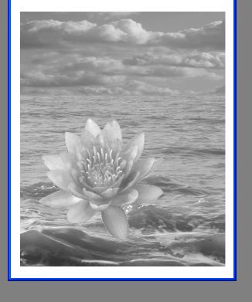
5. Select the flower in Start as we did in an earlier
studio-lab and Move it into the Seascape, but down
into the wave area where it will appear to be floating above the seas.

6. We wish to put it down in the seas so it will look like it belongs there. If we erase the flower (which we technically could do), we risk making an error at the same time that we permanently change the image.

7. Choose Layer > Add Layer Mask > Reveal All. You will see:

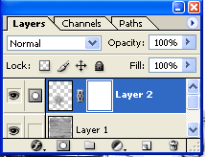

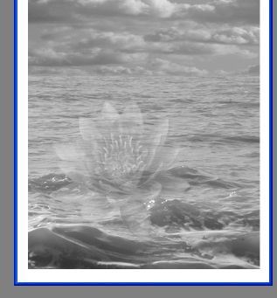
8. Be sure the white square is active by clicking on it. Reduce the Opacity so you can see the wave through the flower.

9. Look for the overlaid squares in the tool bar. Make the black square come to the top. Use a brush to paint along the contours and parts of the waves that should obscure the flower, if it was riding down in the waves and not floating above them. Play with the opacity and different brush sizes until you are satisfied with the results.

10. The modified part of the picture should look something like the following:

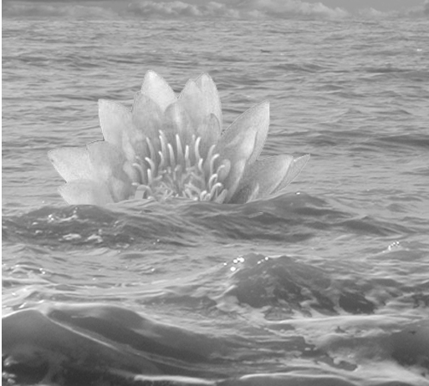

11. Note this is a nice technique for inserting an object into an image and making it belong by putting part of the other image in front of it. For example, you might in some image have a fence in the foreground and you want to put an image behind it.

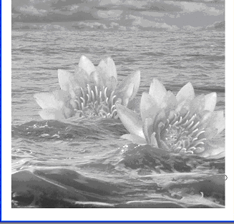
12. Add a second flower. Note it will come in front
of the first one. You can drag the layers up and down
in the palette Layers to change which is in the
foreground. Here might be a final version, after the
second flower was rotated. Be sure to change the
opacity back to 100%.

Simple Masking with QuickMask

The emphasis will be on simple masking techniques and layers.

13. Set a canvas to a size that can be printed: File > New. In the dialog box, set 11 X 8 inches (or some other choice you can print later), Grayscale, 8 bit, white, and rest as defaults.

14. . For this part, use Demo 3 files: family6 and background. (From web site- downloads.)

15. We will Select the background.jpg with the Marquee Rectangular tool and move it into onto the white canvas. Using this method you have to scale the final version (Or, you can use Copy and Paste which takes you through the clipboard. This will automatically scale, but you do use extra memory when you do it this way.)

16. We wish to move the man and woman seated on the left in family6.tif onto the background.

17. First, using the polygonal lasso tool (or any other you wish), rough capture the man and woman on the left. Do not worry about exactness. That is what we will refine with masking. You should see the lasso moving around the man and woman as shown.

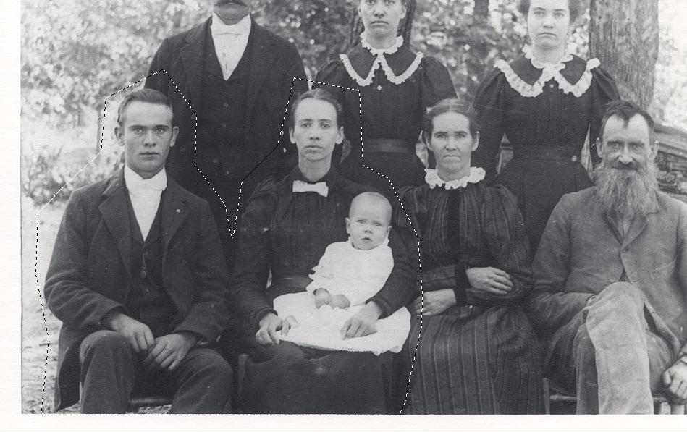

18. Enter QuickMask mode by pushing the right button in the tool bar beneath the overlaid black and white squares. You should see:
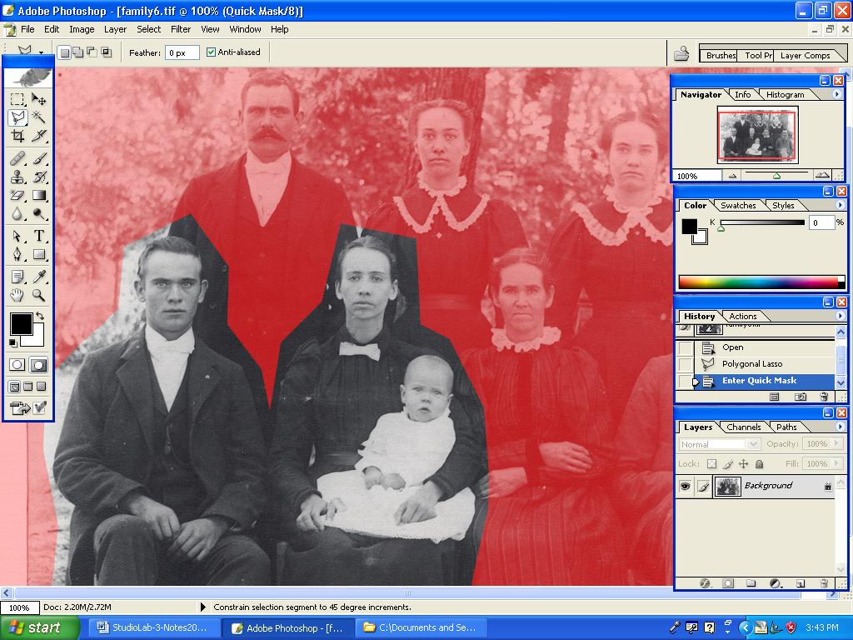

19. The red part of the picture says that part of the picture will NOT being selected if you were to move the picture now. The untouched part would be selected. However, we don’t want all those extra pixels around the objects so we must work to refine the selection.

20. Begin "painting" with a brush. You will paint in the color indicated by the square in the tool bar. It the top square is white, you can erase red paint on the picture which effectively selects more area to be selected in the future. If the top square is black, you can add to the red area by painting the unmarked parts of the picture which effectively eliminates areas. You can switch between these modes by using the arrow next to the squares on the tool bar.
Using brushes of different size and hardness and the zoom/un-zoom tools, paint at the pixel level until you exactly outline the man and woman for selection. Experiment with different possibilities and selections to learn which to use in a given situation. Use the Tab key to toggle between a full screen and a screen with palettes and the toolbox. NOTE: This step can take a long time. The quality of your final selection will depend upon how patient you are.

21. Continue refining your selection until it is of high quality.

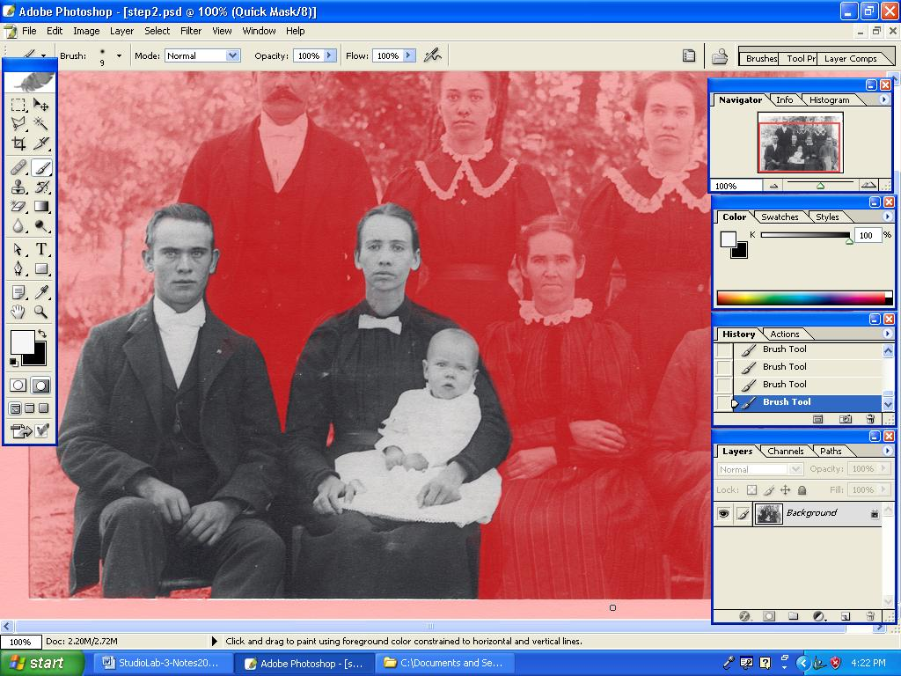

22. When you are satisfied, go back to Standard Mode by clicking on the button to the left of Quick Mode on the tool bar and you should see the waving lines around your selection.
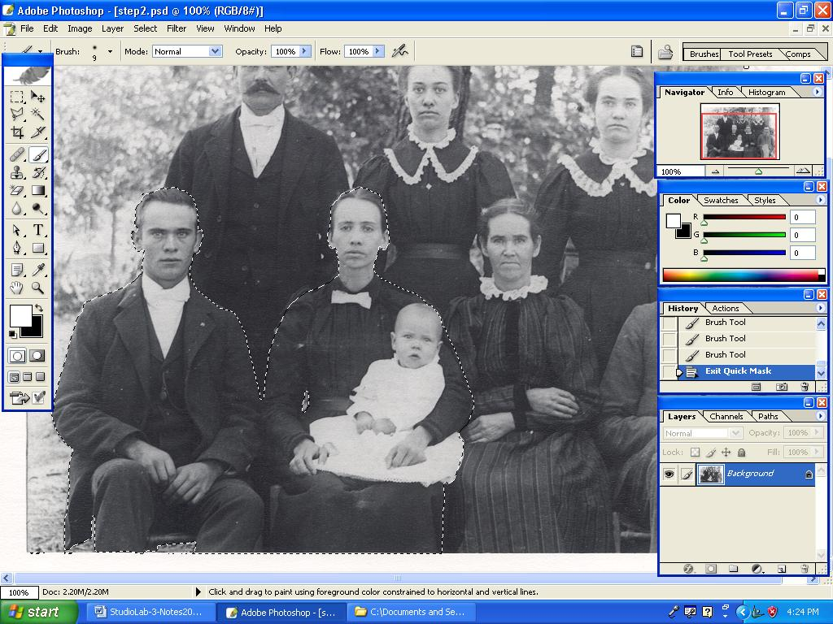

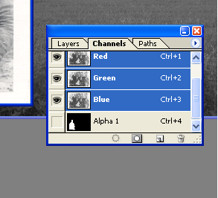
23. To save your masks for later editing and to submit with your final project, while in StandardMode, click the Channel palette tab to see it and click the Save the Selection as Channel button. You should see something like this where Alpha 1 is the mask saved in an alpha channel. (The frame buffer has a red channel, a green channel, a blue channel, and an alpha channel – each channel is a table or 2D array holding values.)

24. In Standard Mode, Move your selection onto your background and Edit > Transform it in any way you wish.

25. The final “New American Gothic” picture:
