SUMMARY OF STUDIO-LAB 3, 1/30/04

Note: This is only a summary and will not include all details. This will not take the place of your notes or you seeing this in class. If you forget how to do something, ask! There are multiple ways to do these tasks – I tend to introduce only so as not to overwhelm beginners..

1. Always check the following which was covered earlier
Be sure to use ctrl+alt+shift (meaning push all simultaneously) to return to default settings.
Be sure your RAM (RAndom Memory) size to about 95% or around 250MB (which ever you can). There are two different sizes in the labs. Use Edit > Preferences > Memory and Image Cache. Then restart Photoshop.

Simple Masking with QuickMask

2. The emphasis in this studio-lab was on simple masking techniques and layers.
Note: In the earlier lab, I had a problem because I didn't realize I was having a conflict with two different kinds of files. Ignore the next comment which will be explained when we talk about color, unless you know the difference already. (The problem specifically was I had both RGB and indexed color files which were impacting each other when both were being merged. Photoshop does so many default formats, I hadn't encountered the problem until I got in the lab.)

3. Set a canvas to a size that can be printed: File > New. In the dialog box, set 10 X 8 inches (or some other choice you can print later), Grayscale, 8 bit, white, and rest as defaults.

4. For the this part, use Demo Files: family6 and background. (From web site- downloads.)

5. We will Select the background.jpg with the Marquee Rectangular tool and move it into onto the white canvas. Using this method you have to scale the final version (Or, you can use Copy and Paste which takes you through the clipboard. This will automatically scale, but you do use extra memory when you do it this way.)

6. We wish to move the man seated on the left in family6.tif onto the background.

7. First, using the lasso tool (or any other you wish), rough capture the man. Do not worry about exactness. That is what we will refine with masking. You should see the lasso moving around the man as shown.

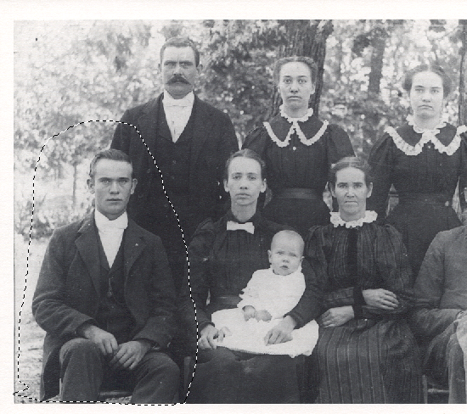
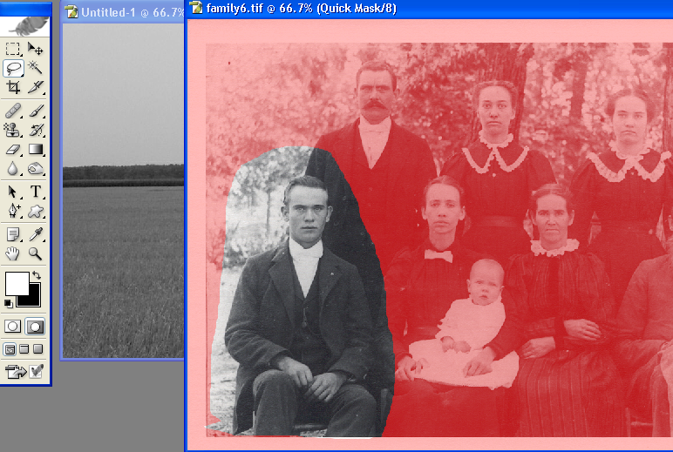
8. Enter QuickMask mode by pushing the right button in the tool bar under the overlaid black and white squares. You should see:

9. The red part of the picture is NOT being selected. The untouched part is selected.

10. Begin "painting" with a brush. You will paint in the color indicated by the square in the tool bar. It the top square is white, you can erase red paint on the picture which effectively selects more. If the top square is black, you can add to the red area by painting the unmarked parts of the picture. You can switch between these modes by using he arrow next to the squares on the tool bar.

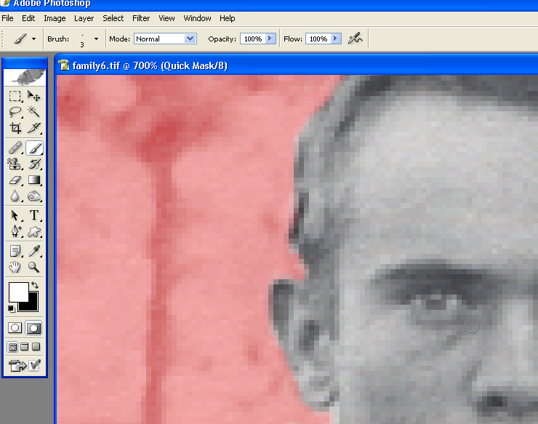
11. Using brushes of different size and hardness and the zoom tool, paint at the pixel level until you exactly outline the man for selection. Experiment with different possibilities and selections to learn which to use in a given situation.

12. When you are satisfied, go back to Standard Mode by clicking on the button to the right of Quick Mode on the tool bar and you should see the waving lines around your selection.

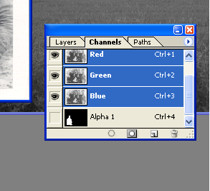
13. To save your masks for later editing and to submit with your final project, while in StandardMode, click the Channel palette tab to see it and click the Save the Selection as Channel button. You should see something like this where Alpha 1 is the mask saved in an alpha channel. (The frame buffer has a red channel, a green channel, a blue channel, and an alpha channel – each channel is a table or 2D array holding values.)

14. In Standard Mode, Move your selection onto your background and Edit > Transform it in any way you wish.

Placing Objects Behind Elements Already in a Photograph Using Masks to Modify an Image

15. Use DemoFiles: Seascape and Start. I used the flower only because it is easy to grab and I didn't want to waste studio-lab time with selecting.

16. As before, create a canvas and move Seascape on it.

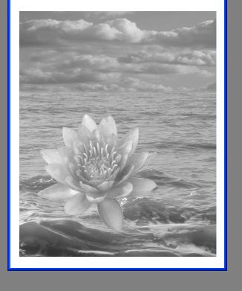
17. Select the flower in Start as we did in an earlier
studio-lab and Move it into the Seascape, but down
into the wave area where it will appear to be floating above the seas.

18. We wish to put it down in the seas so it will look like it belongs there. If we erase the flower (which we technically could do), we risk making an error at the same time that we permanently change the image.

19. Choose Layer > Add Layer Mask > Reveal All. You will see:

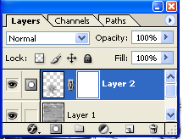

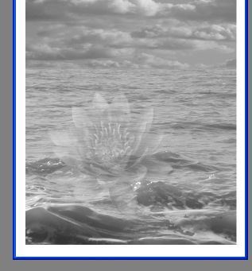
20. Be sure the white square is active by clicking on it. Reduce the Opacity so you can see the wave through the flower:

21. With the black square active, use a brush to paint along the contours and parts of the waves that should obscure the flower, if it was riding down in the waves and not floating above them. Play with the opacity and different brush sizes until you are satified with the results.

21. The modified part of the picture should look something like the following:

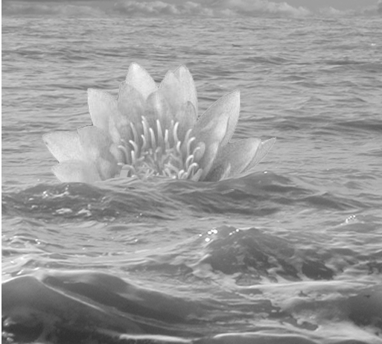

22. Note this is a nice technique for inserting an object into an image and making it belong by putting part of the other image in front of it. For example, you might in some image have a fence in the foreground and you want to put an image behind it.

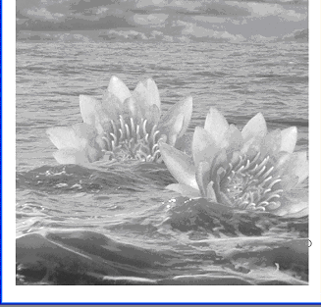
23. Add a second flower. Note it will come in front
of the first one. You can drag the layers up and down
in the palette Layers to change which is in the
foreground. Here might be a final version, after the
second flower was rotated. Be sure to change the
opacity back to 100%.

