TAKE HOME TEST: CPSC 352

Directions: You may use your notes, my slides, and the textbook. You may ask me for clarification and I will post answers in the class site's FAQ so everyone will know the answer. You are not to discuss the test with anyone else and you are not to search on the internet for answers.

The test is due in hard copy by Friday at 2:45 pm. Anytime later will lose 5 points a day.

1. Vocabulary: Select the term identifying letter (A- P) that is being defined by the given phrase or sentence (a-o)

a. Tests performed without the knowledge of the organization’s IT staff, but with the full knowledge and permission of upper management. _____
b. Tests performed with the knowledge and consent of the organization’s IT staff. _____
c. A weakness in a security system _____
d. A potential violation of security _____
e. Means and ways to block a threat which tries to exploit one or more vulnerabilities _____
f. An actual violation of security _____
g. A program that can replicate itself and send copies from computer to computer across network connections. Does not require a carrier. _____
h. A program which can take over other computers to launch hard to trace attacks. _____
i. A program that claims to perform some desirable or necessary function but also performs some function that the individual who runs the program would not expect or want. _____
j. Software that infects other programs by including a copy of the original program, which can then go on to infect other programs. Requires a carrier. _____
k. The type of virus that mutates with every infection, making detection by the “signature” of the virus impossible. _____
l. The type of virus that may change its behavior as well as its appearance. _____
m. The feature in Word and Excel that allows you to substitute a key for a sequence of commands and which can be used to activate malware. _____
n. Set of tools that are cloaked and (possibly) enable remote administration. _____
o. A program that performs an action that violates the security policy when some external event occurs. _____

A. metamorphic B. rootkit C. vulnerability D. logic bombs E. worm F.polymorphic G. attack H.control I. threat J. trojan
K. macro L.bot M.virus N. blue teaming O.red teaming
P. None of these

2. List the three basic goals of security and those that are added when people talk about “Information Assurance”. For each goal, describe a specific example of a failure of that goal and justify why your example is appropriate.

3. Some organizations that have suffered computer attacks publicize the attack, whereas others want to keep the attack confidential (not just the method or extent of the attack, but the very fact they were attacked). Labeling your answers, PUBLIC and CONFIDENTIAL, give arguments for both approaches.

4. For each item below (a-e), decide which of the following (A-D) would be appropriate for protecting the item and explain why you chose the way you did.
A. patent B. copyright c. trademark d. trade secret

a. A program for a new game that you anticipate will earn a lot of money.
b. A new 3-dimensional output device.
c. A new process for creating a VLSI chip.
d. A logo for the company that will be stamped on each lid of laptops produced.
e. The design for a web site.

5. Explain the concepts of confusion, and diffusion and their relation to cryptography.

6. Alice's public key is (77,17) and her private key is (77,53). In this crytposystem, each plaintext character is first represented as a number between 00 (for A) and 25 (for Z) with 26 being used for a blank. Each character is then encrypted individually with the RSA encryption scheme. Show the sequence of numbers that would be sent by Bob to Alice if he wants to send the word HELLO. (Note: I suggest you use a calculator for this. Windows' calculator in scientific mode has all the functions.) Put blanks between the individual letters.
Show your work: (You may use ^ for the exponential operator to avoid having to do so much work in Word as using the superscript operator repeatedly!)
Note: No one would use this exact method. Why?

7. Assume you plan to use the RSA encryption scheme and you pick, using the variable names we used in our examples, p = 7 and q = 5. So we will have unique answers (and I won't have to continually calculate for multiple values ;-)), pick the smallest e such that e meets the requirements, e > p, and e>q with e ≠ 1. Also pick the smallest possible d such that d meets the requirements. Find your public key and your private key. Show your work.

8. Obviously, the p's and q's we used above are not satisfactory. What property for p and q must we satisfy to have a good encryption scheme today? What assumption about natural number arithmetic is the RSA public key encryption algorithm based on to make it secure? Is it possible that the RSA public key encryption scheme could be broken in the future?

9. Explain what is the major problem with a symmetric key encryption scheme. Explain how the problem can be corrected by also using public key encryption.

10. Explain what kind of input values would circumvent the security of a database supposedly protected with this type of code and why those values would cause trouble. What could be done to lessen this vulnerability? (Provide as many fixes as you can think of.)

int main(int argc, char *argv[]){
int valid = 0; /* 0=false */
char str1[4];
char str2[4];

gets(str1);
gets(str2);
if (strncmp(str1,str2,4) == 0)
valid = 1; /* 1 = true */
if (valid == 0) /* zero is viewed as false */
printf("No match - deny access\n");
if (valid != 0) /*any nonzero value is viewed as true */
printf("Match - allow access\n");
}

11. Explain what causes the curve in slide 5 in Program Security Part 1 (Chapter 3).

12. Explain the phrase "smashing the stack". What can attacks of this type do? Explain some of the ways to try and prevent this type of attack. How effective are the techniques?

13) What are certificates and why are they used? Be specific.

14) What are digital signatures and why are they used? Be speci

15. Consider the following screen shot from lab 2:

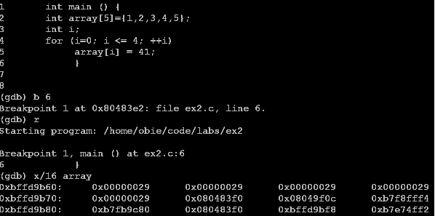
Explain what each line after the code at line 8 does or is displaying.

16. You are hired by a security firm and your first assignment is to design an algorithm that would detect any worm. What would you do?

