Directions for using cs.hiram.edu:

Your username is your campus one – i.e. lastname followed by the initials of your first name and your middle name (if it exists).

To use cs.hiram.edu from any location, you will need to use an application program named ssh. The easiest way to obtain ssh is to obtain putty from a place such as:

http://netmirror.org/mirror/putty/download.html

and download putty.exe to your desktop. There is no need to install it as this is an executable image. Click on the icon and you will see:

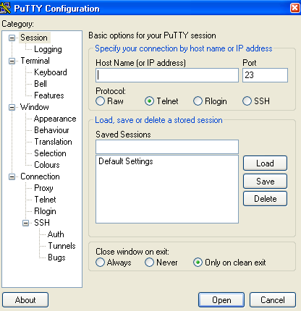

You need to fill out the window by giving the computer name and checking ssh.

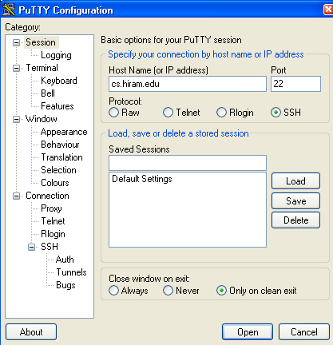

Optionally you can change other features such as the appearance (which includes the font type and size.) Click on Appearance to do that and select whatever you want to change.

Click on open and you will go to the login prompt in cs.hiram.edu (if all connections are good).


Check that you are using the bash shell and, if not, set it.

CAUTION: This machine is run by the department for instructional purposes. We keep it fairly open so you can explore. But, be cautious and DON'T MESS WITH THINGS!

Directions for using sftp (safe file transfer protocal) to move files back and forth from cs.hiram.edu:

There are many free, open source programs of this available. One for Windows is WinSCP available at

http://sourceforge.net/project/downloading.php?groupname=winscp&filename=winscp416setup.exe&use_mirror=voxel

Or, google sftp and choose one to download onto your machine. There are many options available, but I'll mention only the most basic commands.

After invoking WinSCP you will see the following window. Fill in the Host name, User name, and Password. (Port number should be 22 and file code should be SFTP). Click login.

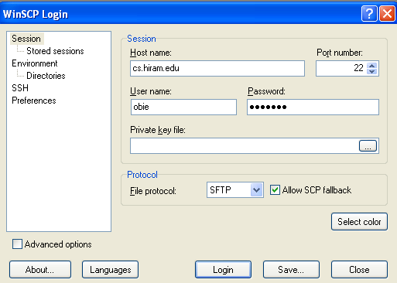

The login should be automatic. You will then see a double pane:

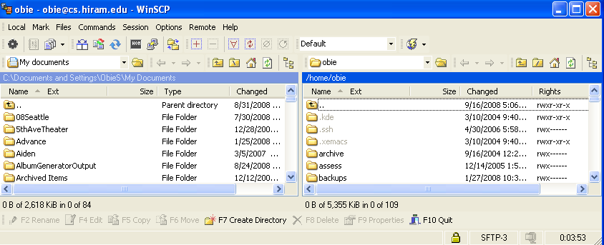

Note: I made the window small to hide some of the file names in my two directories.
The one on the left is My documents folder on my PC and the one on the right is the obie directory on cs.hiram.edu.

Use the and buttons to move around in the directories. Suppose you want to transfer a file or files from your PC to cs.hiram.edu. Then move to the folder on your PC where the file(s) reside. Move to the directory (or create it using the obvious button on the bottom of the window) where you want to place the file (or files).

Example
Suppose the following directory in cs.hiram.edu is empty:, (It doesn't have to be empty.)
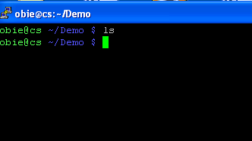

and we want to move two files to that directory from our PC. We move to the appropriate directories:

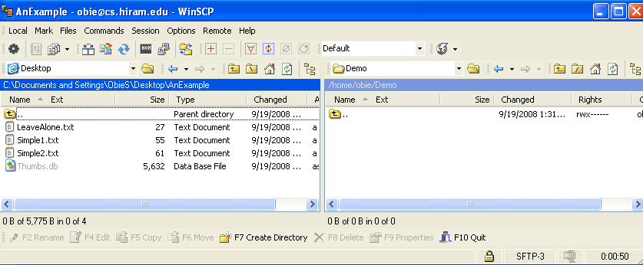

and move by highlighting:
: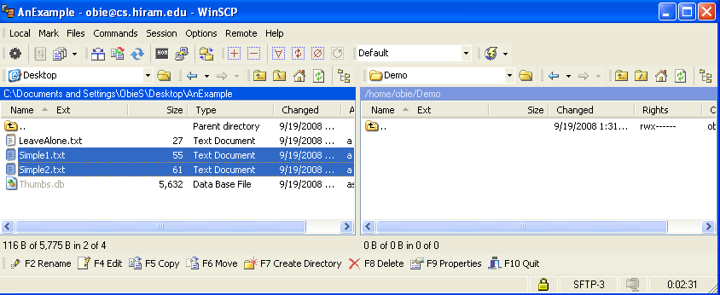

and dragging in the appropriate direction:

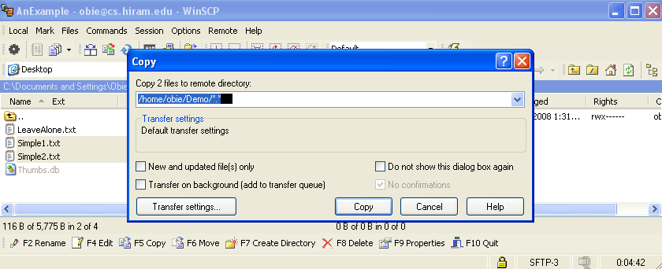

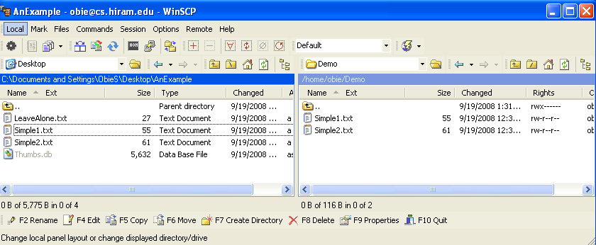

To see that these have been transferred, go to cs.hiram.edu with putty, move to the directory Demo and bring one of the files up on the screen:

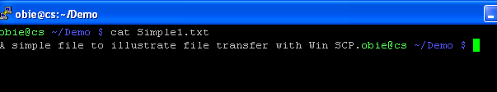

To transfer from cs.hiram.edu to your PC, just reverse the process.

Putty and SFTP use SSH instead of telnet and ftp to move data and files between computers. SSH uses public-key cryptography to authenticate the remote computer and allow the remote computer to authenticate the user, if necessary. Passwords are encrypted rather than sent as plaintext to make the transfer more secure.
SSH is typically used to log into a remote machine and execute commands, but it also supports tunneling, forwarding TCP ports and X11 connections; it can transfer files using the associated SFTP or SCP protocols. SSH uses the client-server model.
An SSH server, by default, listens on the standard TCP port 22 (We'll learn more about ports shortly.)

