TAKE HOME TEST: CPSC 352

Blue writing is my answers. Red are comments about the answer.
Directions: You may use your notes, my slides, and the textbook. You may ask me for clarification and I will email answers so everyone will know the answer. Be sure to answer in your own words. Don’t just copy from the source, The test is due in hard copy and email to obie@hiram.edu by Tuesday, Nov 1, at 9:40am. Anytime later will lose 5 points a day. You are not to discuss the test with anyone else and you are not to search on the internet for answers.

1.(15 points – 1 each) Vocabulary: Select the term identifying letter (A- P) that is being defined by the given phrase or sentence (a-o)

a. Tests performed without the knowledge of the organization’s IT staff, but with the full knowledge and permission of upper management. O
b. Tests performed with the knowledge and consent of the organization’s IT staff. N
c. A weakness in a security system C
d. A potential violation of security I
e. Means and ways to block a threat which tries to exploit one or more vulnera bilities H
f. An actual violation of security G
g. A program that can replicate itself and send copies from computer to computer across network connections. Does not require a carrier. E
h. A program which can take over other computers to launch hard to trace attacks. L
i. A program that claims to perform some desirable or necessary function but also performs some function that the individual who runs the program would not expect or want. J
j. Software that infects other programs by including a copy of the original program, which can then go on to infect other programs. Requires a carrier. M
k. The type of virus that mutates with every infection, making detection by the “signature” of the virus impossible. F
l. The type of virus that may change its behavior as well as its appearance. A
m. The feature in Word and Excel that allows you to substitute a key for a sequence of commands and which can be used to activate malware. K
n. Set of tools that are cloaked and (possibly) enable remote administration. B
o. A program that performs an action that violates the security policy when some external event occurs. D

A. metamorphic B. rootkit C. vulnerability D. logic bombs E. worm F.polymorphic G. attack H.control I. threat J. trojan
K. macro L.bot M.virus N. blue teaming O.red teaming
P. None of these

2. (6 points – 2 each) List the three basic goals of security and those that are added when people talk about “Information Assurance”. For each goal, describe a specific example of a failure of that goal and justify why your example is appropriate. Note: examples are not unique. (As noted, the Information Assurance part was #3).
BASIC GOALS:
a. Confidentiality- Example of failure - anything that makes information available to unauthorized parties such as leaving a laptop with social security numbers and names in a car and having it stolen.
b. Integrity – Example of failure - anytime information is not precise, not accurate, capable of being changed in unacceptable ways, and not consistent such as a failure to check in a database that records don't conflict.
c. Availability – Example of failure - anything that fails to provide a timely response, full allocation of resources, or high quality of service such as a denial-of-service attack.

3. Repeat question 2 with the acronym A.A.A.
(6 points – 2 each)
INFORMATION ASSURANCE GOALS:
d. authentication – Example of failure - anything that prevents the identify of someone sending a transmission from being verified such as spoofed email.
e. authorization – Example of failure – an action is allowed that shouldn't be such as allowing someone to circumvent a password login by the use of a backdoor.
f. non-repudiation – Example of failure – fail to have proof so someone can deny they took a certain action when they did such as someone calling you and telling you that you had won a million dollars and later they denied that they had said that.

4. (6 points) Some organizations that have suffered computer attacks publicize the attack, whereas others want to keep the attack confidential (not just the method or extent of the attack, but the very fact they were attacked). Labeling your answers, PUBLIC and CONFIDENTIAL, give arguments for both approaches.

I was looking for at least 3 reasons under each heading. A few others than what I listed were accepted.

PUBLIC: Arguments for this approach are
a. Discourage others from repeating the attack since the details are known.
b. Make statistics available to organization such as CERTS,
c. Encourage venders to fix the problem.
d. Allow users of the system to know if the data is compromised so they can take appropriate steps.
e. To press charges against the attacker as this requires publicly acknowledging it.
f. Publicly show how responsive the company is to attacks.

CONFIDENTIAL: Arguments for this approach are
a. Try to prevent the method from being copied.
b. Not draw attention to the fact a company's system is vulnerable.
c. Don't want people to lose confidence in the company.
d. Believe the attack is not important enough to bring it to everyone's attention.
e. Deny hackers the attention that they want.
f. Hide the fact some attackers are not detected.

5. (8 point)) Explain what is the major problem with a symmetric key encryption scheme. Explain how the problem can be corrected by also using public key encryption.
One error was that some didn't read the phrase "corrected by also using public key encryption" as opposed to "corrected by using public key encryption". Remember public key encryption is slow so using it to send a key and authenticate makes more sense than sending an entire message using something like RS.

The major problem with symmetric key encryption schemes is that a key that is needed by both the sender and receiver must be exchanged securely and with the ability to authenticate who actually sent the key. Otherwise, Trudy could send a key to Alice and Alice, thinking she was encoding for Bob, would encode her message, but Trudy could read it.

a. Sender encrypts the asymmetric key with his/her private key.
b. Sender encrypts the result with the receiver's public key and sends it.
c. Receiver decrypts the result with his/her private key which decrypts the last layer applied in b.
d. Receiver decrypts the last result with sender's public key which decrypts the rest.

If the supposed sender's public key wouldn't work to decrypt the last result, then the sender was someone else.

As noted in class, this works because the encoding and decoding are inverses of each other – i.e. one undoes the other.

6. (14 points- 4 for input; 10 for corrections.) Explain what kind of input values would circumvent the security of a database supposedly protected with this type of code and why those values would cause trouble. What could be done to lessen this vulnerability? (Provide as many fixes as you can think of.) I was looking for you to summarize all the ways this could be fixed. I accepted any 10. Again, you needed to synthesize material from different sections although the code was (almost) that in one of the labs. I did not ask you to explain how each fix worked. Although not all of the buffer overflows in the program are stack overflows, I did accept those techniques even though they could be repeated in a later question..

Giving BADINPUT BADINPUTBADINPUT as input answered the question for the lab, but not this one which checked 4 characters, not 8. If run, it says access is granted, but the program aborts which essentially closes any security hole except a denial-of-service one.

int main(int argc, char *argv[]){
int valid = 0; /* 0=false */
char str1[4];
char str2[4];

gets(str1);
gets(str2);
if (strncmp(str1,str2,4) == 0)
valid = 1; /* 1 = true */
if (valid == 0) /* zero is viewed as false */
printf("No match - deny access\n");
if (valid != 0) /*any nonzero value is viewed as true */
printf("Match - allow access\n");
}

Any input that overflows str2 into str1 or into valid or the return address causes trouble. Examples are many, but 1234 and 12341234 are similar to ones suggested in the lab as you get an exact match on 4 letters. However, 11111 and 22222 overflows into valid and makes it 49 or true.

Preventing buffer overflows:
a. Use safe languages such as Java.
b. Avoid functions known to be unsafe such as strncmp or gets.
c. Do static code analysis.
d. Use runtime checking with a product such as SafeC (or any of several mentioned).
e. Stay abreast of where vulnerabilities are in software with forums and mailing lists such as BugTraq.
f. Black list string input as allowing alphanumeric input invites trouble.
g. White list string input.
h. Use a tool such as Format Guard.
i. Specifically eliminate the variable valid and just directly handle the if statement.
j. Make the location of the variables random so return addresses can't be determined.
k. Increase the size of the buffer considerably.
l. Write your own compare function.
m. Compute the length of each input string while bringing it in and if they are at least not the same, deny access.
n. Do thorough code testing looking for buffer overflows.

7. (8 points) Explain the phrase "smashing the stack". What can attacks of this type do? Explain some of the ways to try and prevent this type of attack. How effective are the techniques? Again, I was looking for 10 techniques.
Smashing the stack is a hacking technique which overwrites entries in the stack to place executable code on the stack.

The main purpose of smashing the stack is to execute one's own malware or shell.

Ways to try and prevent this attack (some overlap with the buffer overflow reasons):
a. Change location of stack, randomly.
b. Randomize the instruction set.
c. Use stack cookies or canaries.
d. Reorder the variables in memory – ASLR (address space layout randomization)
e. Use an optimizing compiler that eliminates unneeded variables.
f. Use tools such as Stackquard.
g. Use run time checking with tools such as Libsafe.
h. Do source code analysis.
i. Make the stack non-executable.
j. Use interpreted languages such as Java.
k. Avoid unsafe functions.
l. Use exceptions.
m. Limit the number of characters read by counting them one at a time.

No technique is totally effective since for every fix devised, hackers will work hard to circumvent it. In fact, failure to carry out an attack leads to a hacker usually exerting more effort to exploit the fix.

8. (5 points) The software company Snoracle (slogan: .Unwakeable.) is selling a new defense against DDoS attacks. Their software looks at the source IP address on all incoming packets, and if it finds any IP address that accounts for more than 1% of traffic the last hour, it installs an entry in the router that blocks all packets from that address for the next 24 hours. Their marketing folks are claiming that this will stop all DDoS attacks cold in the water. Is this a good solution to the problem? Give two reasons why or why
not.
Most DDoS attacks are by bots, each with a different IP address. Thus, there would not be 1% of traffic coming from the same IP address and Snoracle would fail. Also, if traffic was slow, 1% of legit packets could come from one IP address and Snoracle would deny access. (Other reasons exist, by I was looking for the bot one particularly.)

9. (10 points – 2 each part of the curve) Explain what causes the curve below.
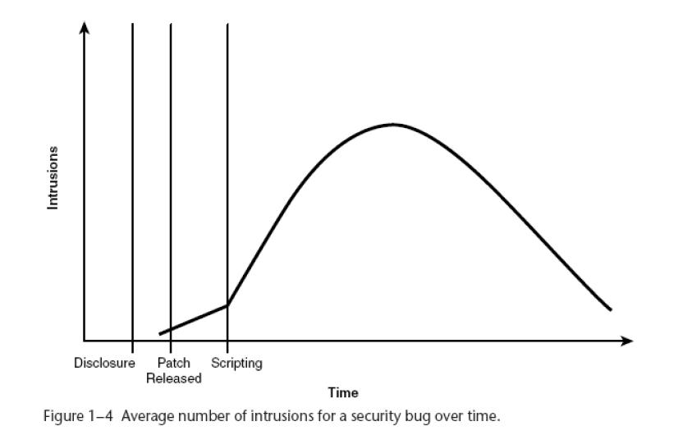
The main problem here the parts of the curve were not identified and then explained.
After the disclosure of the vulnerability and before a patch is released, there are intrusions as hackers are alerted to the problem. However, this time represents the smallest number of intrusions.
After the patch is released, more hackers are alerted to the existence of the vulnerability and the number of intrusions rises linearly.
After scripts are written to exploit the vulnerability, the number of intrusions rise almost exponentially as systems for which the flaw exists may not have applied the patch.
At some point, more and more people apply the patch and the number of intrusions rapidly declines.
However, the number of intrusions never reaches zero because there are people who never apply the patch.

10. (5 points) The Witty worm was a standard random spreading worm (i.e. it picked random IP addresses at random and attempted to infect them). However, rather than just infect a single initial host the author of the worm directly infected 100 machines that he had previously discovered were vulnerable (technically called a “hitlist”). What advantage might this “pre-seeding” offer to a worm?
By infecting 100 machines initially, there is a better chance the worm will spread. Otherwise, infecting only one other machine could cause the worm to die if the machine crashed or was taken off line. Infecting 100 machines initially would also speed up the time to infect an entire network.

11. (6 points) Consider the Berkeley CalNet Authentication Web Server, which uses a web page with a user name and user password (the password must be between 9 and 255 characters, and must contain at least three of the following: uppercase letters, lowercase letters, numbers, punctuation, and all other characters), connected to net-auth.berkeley.edu.
Give at least 3 different plausible ways to attack such a system and gain unauthorized access (1-3 sentences each).

1. Use software engineering techniques to obtain passwords.
2. Run a dictionary attack.
3. Try smashing a stack if input is not protected.
(Note: A brute force attack would not be feasible due to the length of the passwords.)

12) (6 points) What are certificates and why are they used? Be specific.
A certificate is an attachment to an electronic message used for security purposes. An individual wishing to send an encrypted message applies for a digital certificate from a Certificate Authority. The authority issues an encrypted digital certificate

The most common use of a certificate is to verify that a user sending a message is who he or she claims to be, and to provide the receiver with the means to encode a reply.

13. ( 4 points) We have seen that the usual read, write, and execute fail to fully protect the contents of a file. What other levels of protection might users want to apply to code or data in a file? Name at least 4 and explain what each choice would allow and not allow.
1) Automatically include a canaries when using a stack.
2) Duplicate – allow a file to be duplicated, but not read in the usual set up.
3) Encrypt – provide as a bit either set or not.
4) Visible – can see on screen, but can’t be copied or printed.

14. In text, Chapter 3, do C-3.8. (Yes, I know I gave this is a HW problem and we haven’t gone through it in class.)
1) The attacker gives a password longer than 8 characters and overflows buffer password. Thus, if variable continue is stored in memory after password[], the attacker an overwrite variable continue with value 1 and login without knowing the password, To defeat tis attack, variable continue should be stored before password[]. Then an overflowed buffer won’t allow illegal access.
2) This does not fix the problem since the address that points to *login can be overwritten by a buffer overflow and, hence, point to malcode. A non-malicious user could log in, but would execute the malcode.
3) The return() address can be overwritten with the same results as before.

15. (4points) A flaw in the protection system of many operating systems is argument passing. Often a common shared stack is used by all nested routines for arguments as well as the remainder of the context of each calling process.
A. Explain what vulnerabilities this flaw presents.
B. Explain how the flaw can be controlled. Assume the shared stack is still used for passing arguments and storing context.
A. Stack smashing could corrupt the stack and the attacker could use arguments for one function as arguments for another with unpredictable results.
B. Use a canary

16. (9 points). Consider the following screen shot from lab 2:

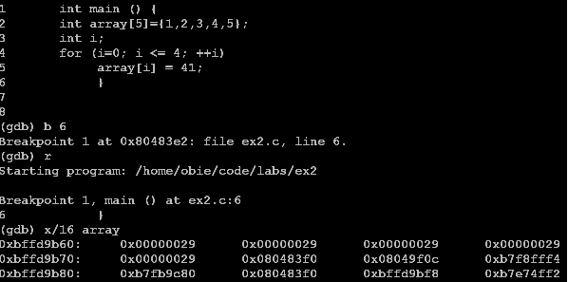
Explain what each line after the code at line 8 does or is displaying. The main difficulty here was that some did not handle all the items – in particular, mentioning the addresses at the beginning of each output line or the fact that hex output is the default. Also, only a few handled this line by line. Many lumped the answers together when the directions said “Explain what each line..”

a. (gdb) b 6
Sets the breakpoint at line 6 in the debugger gdb.
b. The next line echoes the location of the breakpoint and gives the line number for it, the name of the executable image, and the name of the source code.
c. (gdb) r
Request a run of the program.
d. The start of the program is noted in the next line.
e. The breakpoint is reached in main, line 6, and the program pauses.
f. (gdb) x/16 array
Requests an examination (x) of the variable array to display 16 words. The default is hex notation with 4 words displayed on each line.
g. The address being shown is displayed on the left side of each line with 16 memory addresses separating each number.
h. We can see the layout of array[i], i = 0, 4, as 29₁₆= 41₁₀ as the 41 was assigned to each array element followed by unknown memory contents.
i. There should be 16 words, but only 12 are showing so the screenshot probably cut off the last line.

17. (3 points) What is a social engineering attack? How can the chance of one succeeding be lessened?
If you missed this….
Social engineering attacks a user by tricking the user into revealing vital information. It works because most people are trusting and hate to deny someone information.

The best defense is to repeatedly run training sessions and send out reminders to users to watch out for the various tricks that an attacker pulls. All it takes is ONE user to compromise a network by divulging a password.

92 | A
91 | A
83 | B
83 | B
81 | B
80 | B
77 | B-
69 | C

