vim – Quick and Easy

This is an editor and produces text files just as Notepad does in Windows. It does not have a GUI interface.

IMPORTANT: The main thing to remember is that this editor has two modes-
command mode – one you enter and the one where keystrokes are interpreted as commands
insert mode – one where keystrokes are interpreted as characters to be placed in a text file. The message -- INSERT -- will be at the bottom of the file when you are in Insert mode.
Switching modes:
In command mode, typing i will switch you to insert mode.
In insert mode, pushing Esc will switch you to command mode.

Enter vim:
username@cs ~$ vim filename

You will see: 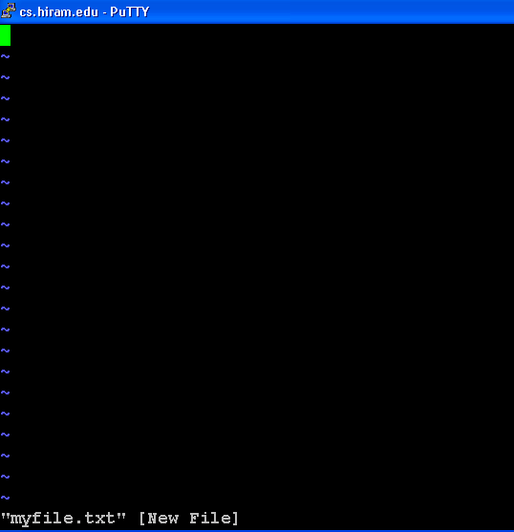

You are now in command mode.

Insert text:
To start inserting text where the cursor is, type i
To insert text after the cursor, type a

Now you may use this just like Notepad i.e. anything you type will be stored temporarily. Use your arrow keys to move around in the file. You can insert anywhere and use the Backspace or the Delete key to delete anything. (Caution: These two keys work differently. Experiment with both to see how they handle the deletion.)

Before you exit, if you wish to keep the file, you must write to it. This can be done multiple times also.

Saving the file under the name you used on entering vim:
Remember always press Esc if you are in insert mode to return to command mode and then type
:w

Saving the file under another name:
:w newname

Exiting vim and saving the file at the same time:
:wq
or
ZZ

Exiting vim and saving the file under another name:
:wq newname

Exit without saving:
:q
Note: If this doesn’t work, you haven’t saved recently. Use a forced exit with
:q!

This is all you really need to know to use vim successfully.

However, if you wish to explore other commands, see
http://www.apmaths.uwo.ca/~xli/vim/quickstart.html

although realize some of the commands given don’t work on our version. I advice you to work with the commands given here at least initially.

Note: Cutting and pasting can't be done by highlighting as in a Windows environment. Investigate yank and paste if you want to do cutting and pasting.

