Problem solutions 5.1-5.5
5.1–5.5: The action to be taken when two successive transaction records have the same key is shown in Figure 5.1 below.

In the flowchart of Figure 5.2 we assume that the last record in the old master file is a dummy record with key ZZZZZZ to ensure that the end of the old master file is never encountered before the end of the transaction file. In addition, we assume that the transaction file and the old master file are sorted as specified in Section 5.1.1 of the text. We derived this chart and put it on the board:

Next transaction | Insert | Modify | Delete
Current transaction
Insert | Error condition | Insert, then modify | Do nothing
Modify | Impossible if input file is sorted | Perform second modification | Delete record
Delete | Impossible if input file is sorted | Impossible if input file is sorted | Error condition

Figure 5.1. Action to be taken when two successive transaction records have the same key.
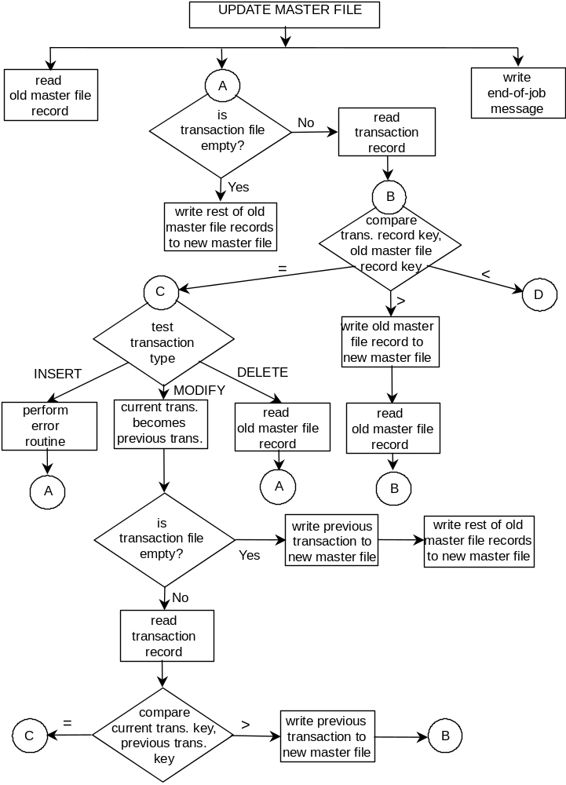
Figure 5.2. Flowchart for sequential file update using level-1 lookahead (Part 1 of 2).

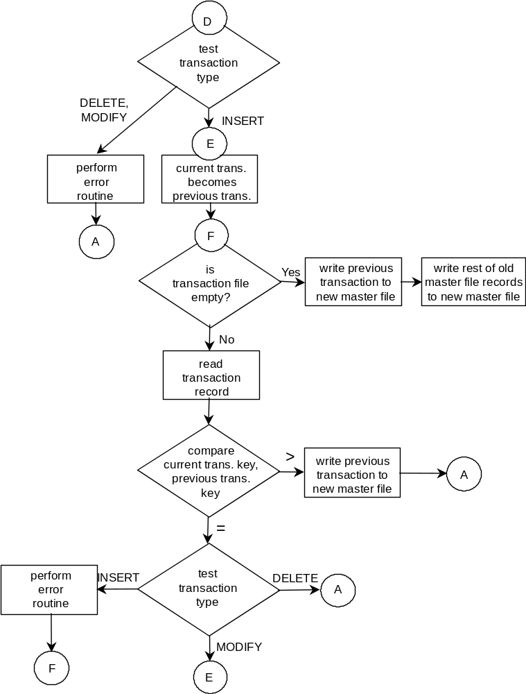
Figure 5.2. Flowchart for sequential file update using level-1 lookahead (Part 2 of 2).

The flowchart of Figure 5.2 solves all the difficulties in Problems 5.4 though 5.6.

