NAME:

MIDTERM-2002 CPSC 387: Graphics

DIRECTIONS: Answer online and email to obie@hiram.edu. You need not change color for your answers.

TRUE-FALSE questions should have precisely one of the words, TRUE or FALSE written in lower case next to the question. If False, substitute a word or words for the boldfaced word(s) in such a way that the substitution would make the sentence true. Write the word or words under the statement, please.

All other questions require short answers. A few may require the use of your own paper. Hand those papers to me at the end of the class period.

BE CAREFUL THAT YOU READ THE ENTIRE QUESTION. I can’t control the vertical spacing of the questions since when you insert answers, the questions move downward.

1. (TRUE-FALSE)
a) Changing pictures digitized from real world images in order to extract new information from them, or for artistic effect, are the concerns of a computer scientist doing graphics.

b) Computer graphics is concerned predominately with the computer construction of synthetic images of real or imaginary objects.

c) Five graphics standards and APIs, listed in increasing order of the date of their acceptance, are PHIGS, GKS, CORE, OpenGL, and X.

d) OpenGL was developed by Microsoft.

e) OpenGL includes functions for window management and user interaction. (I am using the word "window" in the sense of windows handled by an operating system, not graphics windows.)

f) OpenGL is a descriptive graphics language.

g) Architectural systems and CAD/CAM systems typically use a 1-point perspective projection.

h) In a well-designed graphics system, the user draws using screen coordinates.

i) The imaging paradigm used by OpenGL is the synthetic image model.

j) The use of the pipeline architecture for graphics systems provides device dependent graphics.

k) OpenGL provides interactive input functions and windowing control.

l) The measure of an input device is a signal from the device to the computer specifying that it has been used.

m) A pick input device provides a position in world coordinates to the user's program.

n) A mouse drag is one way to implement a stroke input device.

o) A function that is invoked when an event occurs is called an event function.

p) In OpenGL, registering a function associates the function's name with an event and the function is called whenever that event occurs.

q) In OpenGL, single buffering is used for animation typically.

r) An afford transformation maps line segments to line segments.

s) Points in well-designed graphics environments are represented internally by three-dimensional Euclidean coordinates.

t) A basis for a space consists of linearly independent vectors that span the space.

u) Saying that vectors v1, v2, and v3 are linearly independent means that when Av1 + Bv2 + Cv3 = 1, for A,B, and C scalars, then A, B, and C must be 1.

v) A frame consists of a basis and an eye point.

w) The perspective buffer in OpenGL stores the information needed to do hidden surface removal.

x) The normal of two vectors u and v, that are not collinear, is calculated by calculating the dot product of u and v.

2. In 3D space, every affine transformation can be described as a sequence of primitive transformations. Name those transformations.

3. What are homogeneous coordinates for points and vectors? Why are they used in graphics?

4. Consider the 2D rectangle with vertices (1,1), (3,1), (1,2), and (3,2). Apply each transformation below to the original rectangle. Draw the transformed figure ON YOUR OWN PAPER. Although the lines are missing, these are matrices. Be sure to label axis to show the scale of your drawing.

In addition, do one of the following for each transformation below.
i) Identify the primitive affine transformation the matrix represents
OR
ii) Write U for unknown if it is not a primitive affine transformation. In this
case, you should see the picture doesn’t transform properly.

a) 1 0 1
0 1 -2
0 0 1

b)
0 -1 0
1 0 0
0 0 1

c)
1 2 3
0 1 4
7 6 5

d)
1 1.5 0
0 1 0
0 0 1

e)
3 0 0
0 2 0
0 0 1

5. What steps would you take to form the single matrix to rotate the square in the last question 45 degrees around the point (2,-3)? Do not answer relative to the order OpenGL uses, but the steps as you would perform them.

6. On your own paper, draw an example of the object represented by the parametric equation
P(a) = av + Q where a is a scalar, v a vector, and P(a) and Q are points.
Label your choices of Q, v, P(0), P(1), P(1.5), and P(-1.5).

7. Identify the following, assuming P, Q, and R are points; a, b, and c are scalars; and u, v, w are vectors.

a. P(a) = aR + (1-a)Q

b. Q(a,b) = P + au + bv

8. a.What is a frame?

b. Why are frame changes used in graphics?

9. Identify by name the following coordinate systems used in rendering an image on the screen.

a. The coordinates used by the synthetic camera or eye.

b. The coordinates in which the programmer models objects

c. The coordinates used by the output device

d. The coordinates used after the projection is made into 2D space, but before the image is mapped to the output device. All coordinates are in the range 0.0 to 1.0.

e. The type of coordinates used internally by OpenGL and most other synthetic camera graphics packages.

10. Define the following in the context of OpenGL-GLUT programming:

a. Event-driven programming.

b. Callback functions

c. orthographic projection

d. mouse event

e. idle callback

f. double buffering

11. Explain why most objects in graphics are modeled with polygons instead of
arbitrarily defined curves?

12. Consider the following two vectors, which are drawn in a plane, defined by this paper:

Vector A Vector B

a. Draw 0.33B

b. Draw 2A

c. Draw A + B

d. Describe which direction B X A is pointing---remember the paper defines the plane where A and B are.

13. Specify the internal representation in OpenGL of each of the following:

a. The vector from (0,0,0) to (1,3,4).

b. The point (1,3,4).

14. If you are modeling the cube below, show the order in which you would traverse each of the back and bottom faces, relative to where your eye is when reading this paper in the usual position, in order to correctly identify the outside of the cube to the OpenGL software.
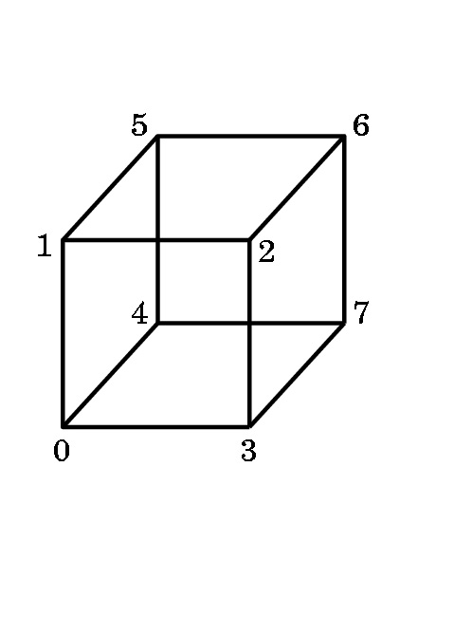

15. Suppose the following teapot is centered at the origin in 3D world space
with the spout on the positive x-axis. The entire teapot fits inside a square box with sides of length 5 units. Describe, as best you can, what would be seen on the screen with the following settings for gluLookAt, assuming the ModelView matrix is the identity matrix:.
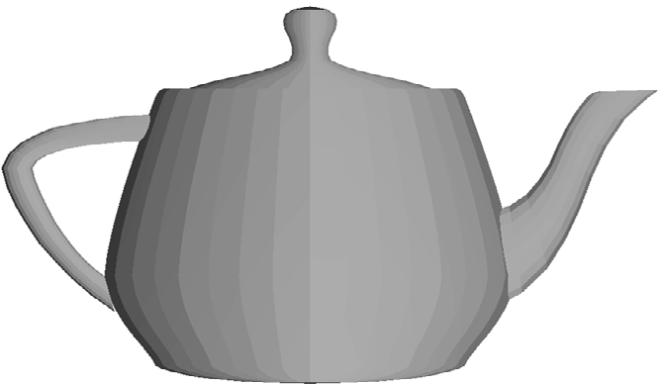
Be sure that you specify where such features as the lid, spout, and handle will be seen on the screen. If you wish, you may draw the teapot in a rectangle on your own paper.

a. eye = (0,0,20), at = (0,0,0), up = (1,0,0), fov = 60

b. eye = (0,20,0), at = (0,0,0), up = (-1,0,0), fov = 60

c. eye = (0,0,0), at = (0,0,20) , up = (0,1,0), fov = 60

16. Assume a graphics display is a 3-plane graphics device and each color gun uses 4 bits. Assume the color is given by a lookup table. Answer the following. Simplify your answers by NOT leaving them in exponential form, please.

a. How many colors can be displayed simultaneously?

b. What is the size of the device's palette?

c. How many intensities of blue can be represented? (Assume that no blue is precisely one intensity.)

d. If the resolution of the frame buffer is 1024 X 1024, how many bits are required for the frame buffer?

e. How many bits are required to store the LUT?

f. If the full palette was used instead of a LUT, how many bits are required for the frame buffer with resolution 1024 X 1024?

17. Consider the following OpenGL-GLUT code:

int A, B;
A = glutCreateMenu(D);
glutAddMenuEntry("Yes", 1);
glutAddMenuEntry("No", 2);
B= glutCreateMenu(E);
glutAddMenuEntry("Up", 1);
glutAddMenuEntry("Down", 2); glutAddMenuEntry("Stay", 3);
glutCreateMenu(C);
glutAddSubMenu("Directions",B);
glutAddSubMenu("Answers",A);
glutAddMenuEntry("Quit", 1);
glutAttachMenu(GLUT_RIGHT-BUTTON);

a. List the callback functions that the programmer must define.

b. On your own paper, sketch the hierarchy of defined menus.

18. Describe the algorithm for drawing the picture below. What is the figure that is shown?
