NAME:
QUIZ 3- CPSC 387
1. Consider the 2D rectangle with vertices (1,1), (3,1), (1,2), and (3,2). Apply each affine transformation given as a matrix below to the original rectangle. Draw the transformed figure on this paper below the matrix. Be sure to label each axis and show the scale.
Shortcut Hint: Of course, you could multiply everything out , but that will chew up a lot of time. If you recognize the matrix form as I suggested you should be able to do, many of these can be done without doing the work.

Then, do one of the following for each transformation
i) Identify the primitive affine transformation the matrix represents OR
ii) Write U for unknown if it is not a primitive affine transformation. If this case occurs, explain why you know you have this case.

a) 1 2 3 b) 1 0 -1 c) -2 0 0
0 1 4 0 1 2 0 -1 0
7 6 5 0 0 1 0 0 1

d) 0 -1 0 e) 1 2 0
1 0 0 2 1 0
0 0 1 0 0 1

2. What steps would you take to form the single matrix to rotate the square in the last question 45 degrees around the point (2,-3)? Do not answer relative to OpenGL---i.e. list commands in the order you would perform them, independent of OpenGL, assuming you had only the three primitive operations available in 2D. Be specific saying such things as scale 3 in the x direction and 2 in the y direction (if you need to do that operation).

3. Draw the object represented by the parametric equation where you can pick P, Q, and v.
P(a) = av + Q where a is a scalar, v a vector, and P(a) and Q are points.Label your choices of Q, v, P(0), P(1), P(2), and P(-1).

4. If you are modeling the cube below, show the order in which you would traverse each of the left and back faces, relative to where your eye is when reading this paper in the usual position, in order to correctly identify the outside of the cube to the OpenGL software.
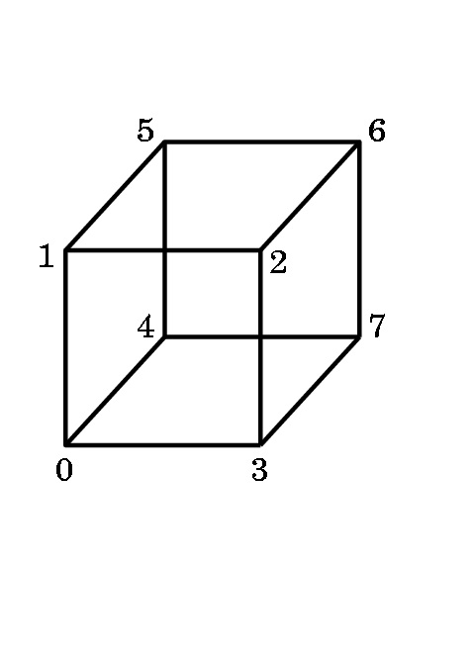
5.. Suppose the teapot shown on the screen in the front of the room is centered at the origin in 3D world space. You are sitting in front of that screen, just as if it was a computer monitor. Thus, for your eye coordinates, the spout is on the positive x-axis.
The entire teapot fits inside a square box with sides of length 5 units. Describe, as best you can, what would be seen on the screen with the following settings for gluLookAt and a gluPerspective setting for fov given as below. Assume the near and far planes will allow the entire teapot to lie in the viewing frustrum. Be specific about where the spout is, the top, etc. in the rendered picture.

a. eye = (0,0,20), at = (0,0,0), up = (-1,0,0), fov = 60

b. eye = (0,20,0), at = (0,0,0), up = (0,0,1), fov = 60

c. eye = (0,0,20), at = (0,5,0) , up = (0,1,0), fov = 60

