Chapter 6:

R1:
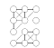

If G has 12 vertices and 3 connected components, then the maximum number
of edges it can have is 45. This would be a fully connected component with 10
vertices (thus having 45 edges) and two connected components each with a single
vertex.

R2: We know that m <= n*n−1)/2 is O(n2). It follows, therefore, that O(log(n2)) =
O(2logn) = O(logn)

R3:
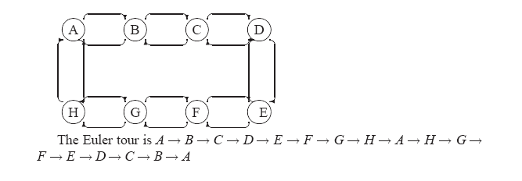
R4: The topological sorting algorithm can help us solve this problem.
_ Build a digraph to represent the course prerequisite requirements. The nine
courses are vertices in the digraph. If a course A is a prerequisite for another
course B, the digraph has a directed edge from A to B.
_ Apply the topological sorting algorithm on this digraph. The result is one
possible sequence of courses for Bob.
For the give set of prerequisites, the solution is not unique. For example, one
possible solution is LA15, LA16, LA22, LA31, LA32, LA126, LA127, LA141,
LA169. Another solution is LA15, LA16, LA127, LA31, LA32, LA169, LA22,
LA126, LA141.

R5 Inserting a vertex runs in O(1) time since it is simply inserting an element into
a doubly linked list. To remove a vertex, on the other hand, we must inspect all
edges. Clearly this will take O(m) time.

R6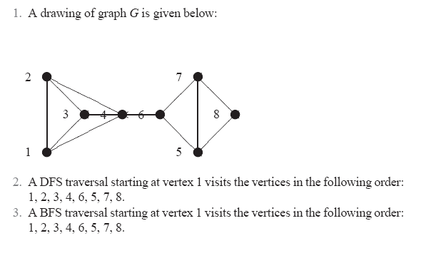
R7 1. The adjacency list structure is preferable. Indeed, the adjacency matrix
structure wastes a lot of space. It allocates entries for 100,000,000 edges
while the graph has only 20,000 edges.
2. In general, both structures work well in this case. Regarding the space requirement,
there is no clear winner. Note that the exact space usage of the
two structures depends on the implementation details. The adjacency matrix
structure is much better for operation areAdjacent, while the adjacency
list structure is much better for operations insertVertex and removeVertex.
3. The adjacency matrix structure is preferable. Indeed, it supports operation
areAdjacent in O(1) time, irrespectively of the number of vertices or edges.

R8- discussion
R9 below
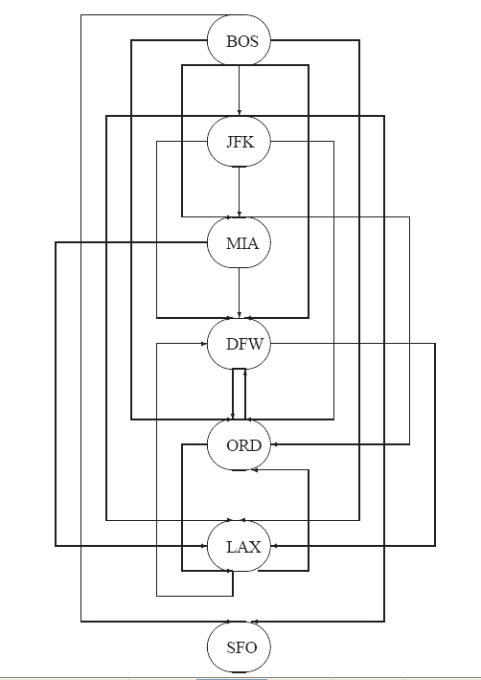
R10: (BOS, JFK, MIA, ORD, DFW, SFO, LAX).

