C-1.27

Start at the upper left of the matrix. Walk across the matrix until a 0 is found.
Then walk down the matrix until a 1 is found. This is repeated until the last row or column is encountered. The row with the most 1’s is the last row which was walked across. Clearly this is an O(n)-time algorithm since at most 2 _ n comparisons are made.

R2.2

The tree expresses the formula 6/(1−5/7) = 6/((7-5)/7) = 6/(2/7) = (6)(7)/2 = 21

/
6 -
1 /
5 7

R2.3

It is not possible for the postorder and preorder traversal of a tree with more than one node to visit the nodes in the same order. A preorder traversal will always visit the root node first, while a postorder traversal node will always visit an external node first.
It is possible for a preorder and a postorder traversal to visit the nodes in the reverse order. Consider the case of a tree with only two nodes.

R2.10

A worst-case sequence for insertion sort would be one that is in descending order of keys,
e.g., 44 36 29 25 22 15 13 10 9 3.

With this sequence, each element will first be moved to the front and then moved back in the sequence incrementally, as every remaining is processed. Thus, each element will be moved n times. For n elements, this means at a total of n2 times, which implies Ω(n2) time overall.

R2.14

With a preorder traversal, a heap that produces its elements in sorted order is that which is represented by the vector (1;2;5;3;4;6;7). There does not exist a heap for which an inorder traversal produces the keys in sorted order. This is because in a heap the parent is always less than all of its children or greater than all of its children. The heap represented by (7;3;6;1;2;4;5) is an example of one which produces its keys in sorted order during a postorder traversal

C2.2

Name the two stacks as E and D, for we will enqueue into E and dequeue from
D. To implement enqueue(e), simply call E.push(e). To implement dequeue(), simply call D.pop(), provided that D is not empty. If D is empty, iteratively pop every element from E and push it onto D, until E is empty, and then call D.pop().

For the amortized analysis, charge $2 to each enqueue, using $1 to do the push into E. Imagine that we store the extra cyber-dollar with the element just pushed. We use the cyber-dollar associated with an element when we move it from E to D. This is sufficient, since we never move elements back from D to E. Finally, we charge $1 for each dequeue to pay for the push from D (to remove the element returned). The total charges for n operations is O(n); hence, each operation runs in O(1) amortized time.

C2.10

The idea is to perform a preorder (or postorder) traversal of the tree, where the “visit” action is to report the depth of the node that is currently visited. This can be easily done by using a counter that keeps track of the current depth. Method PrintDepth(v,d) prints the depth d of the current node v and recursively traverses the subtree defined by v. If T is the tree, then, initially,we call PrintDepth(T.root(),0).

Observe that we use only methods of the abstract tree ADT.
Algorithm PrintDepth(v,d):
print(d)
for each w ε T.children(v) do
PrintDepth(w,d +1)

C2.29

The path to the last node in the heap is given by the path represented by the binary expansion of n with the highest-order bit removed.
Ex 1: n=5=101 so 01 represents go left, go right.

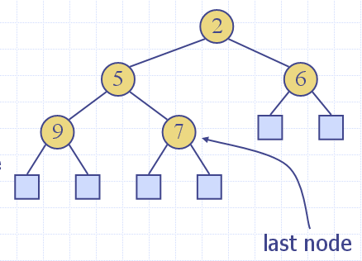

Ex 2: n=8 = 1000 so 0000 says go left 4 times
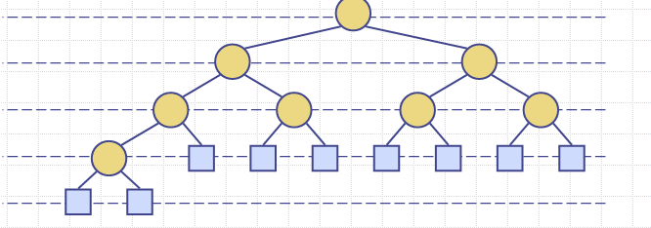

R5.1 S={(12,4), (10,6), (8,5), (11,7), (14,3), (7,1), (9,6)} of benefit-weight pairs with
W = 18.
Choose: (14,3), (12,4), (11,7), (6.666,4) taking 2/3 from (10,6)

R5.3 T={(1,2), (1,3), (1,4), (2,5), (3,7), (4,9), (5,6), (6,8), (7,9)} of start-finish times.

1: (1,2) (2,5) (5,6) (6,8)
2: (1,3) (3,7) (7,9)
3: (1,4) (4,9)

R5.5 Compute 10110011*10111010

