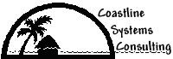

Coastline Systems Consulting

Customer Response System

INTRODUCTION

In this section you will learn background information that will prepare you to understand and complete each of the milestones of this case study. This information includes a history of the business, a description of the business’s current facilities, and the descriptions of the problems that triggered the project.

Case Background
Coastline Systems Consulting is a small solutions provider company located in Destin, Florida. The staff of seven IT technicians, designers, systems analysts, and programmers provides a range of networking, computer hardware, and software solutions to area businesses. Coastline works with clients to analyze their business needs. They then provide a packaged solution that often combines custom-built hardware, purchased software, and custom programming. In addition to the seven technicians, Coastline has one receptionist/bookkeeper.

As a small organization, Coastline is an informal, "shirt-sleeve" environment. Everyone is on a first-name basis, even with Peter Charles, the president.

Organization Structure

Coastline Systems Consulting

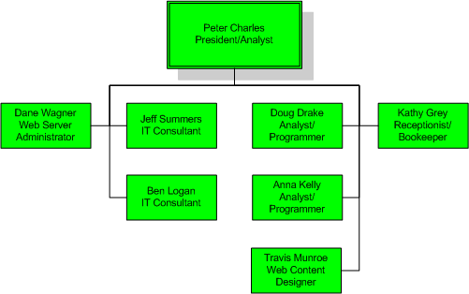

Information Systems Facilities

PCs
- Each technician works uses a Dell notebook:
- Pentium III class machines with 128 MB RAM, 10-20 GB hard drives
- Pentium 4 class machines with 512 MB RAM, 30-50 GB hard drives
- The bookkeeper/receptionist has a Dell Optiplex desktop running a Pentium 4, 256MB RAM, and an 80 GB hard drive:
- Operating systems - MS Windows NT 4.0, Windows 2000 Professional, or Windows XP Professional
- Tools - MS Office XP suite plus other software depending on use
- Internet Browser – Internet Explorer (version 6 or higher)
- Various inkjet and laser printers

Servers
- Dell PowerEdge Server
- 512 megabytes of RAM, 40 GB RAID-5 hard drive storage
- Operating system - MS Windows 2000 Server
- Providing DHCP, Security, and Internet Access, and Database Management (SQL Server 2000)
- Dell PowerApp Appliance Servers
- Providing Web hosting
- Operating system – Windows 2000 Server with IIS

Networking
- The company headquarters is equipped with wireless networking so notebooks can roam throughout the building. Notebooks also have integrated Ethernet NICs and modems so they can connect to the Internet at home and at clients' places of business.

The Problem
The IT technicians are drowning in a sea or work and work for clients is not being done in an optimum manner. Clients call and e-mail both to the general office and to individual consultants whenever they have any kind of hardware or software problem. Consultants manage the requests that come directly to them. Kathy Grey, the receptionist/bookkeeper, passes on requests that come through the general office. If the problem is complex it may require multiple trips, and the technician has to keep track of what he or she has done to try to fix the problem. Sometimes a second technician has to be dispatched, necessitating communication concerning the previous work.

The president, Peter Charles, wants to develop a system that is both more responsive to clients and helpful to technicians. He would like to see a system that allows clients to directly enter their service requests. The system would track the status of each request along with the hours spent for billing purposes. Mr. Charles also wants the system to be able to generate statistics and reports so he can pursue continuous improvement in this area.

