

MILESTONE 4 – DATA MODELING

Synopsis
The requirements analysis phase answers the question, ‘What does the user need and want from a new system?’ The requirements analysis phase is critical to the success of any new information system! In this milestone we need to identify what information systems requirements need to be defined from the system users’ perspectives and draw graphical, logical, models to document the data requirements for a new and improved system.
Data modeling is a technique for organizing and documenting a system’s data. Data modeling is sometimes called database modeling because a data model is usually implemented as a database. Data is viewed as a resource to be shared by as many processes as possible. As a result, data must be organized in a way that is flexible and adaptable to unanticipated business requirements – and that is the purpose of data modeling.
In this milestone you will first discover those entities in the system that are or might be described by data. With each entity we identify, we will define it in respect to the business. Then, we will construct a Context Data Model that graphically depicts each of the entities and the relationships they have with each other. Next, we will refine the context data model to include primary and foreign keys. The resulting model is called a Key-Based Data Model. Finally, we refine the key-based data model to include any hierarchies and attributes, and this model is referred to as the Fully Attributed Data Model.

Objectives
After completing this milestone, you should be able to:

- Understand and perform the techniques for entity discovery.
- Define each entity with respect to the business and complete an entity/definition matrix.
- Perform the necessary data modeling techniques to organize and document the data requirements for the proposed system.
- Construct the Context, Key-Based, and Fully Attributed data models.

Prerequisites
Before starting this milestone the following topics should be covered:
- Data modeling – Chapter 7
- Milestone 2 Solution

Assignment
In this assignment we will use our results of the previous Milestone and transcripts of an interview with IT consultant Jeff Summers and receptionist/bookkeeper Kathy Grey, both of Coastline Systems Consulting. The results of this activity will identify the business data requirements for the proposed system.
Exhibit 4.1 is a copy of the transcript of the interview. Refer to the transcript, sample forms, and results from Milestones 1 and 2 for the information necessary to complete the activities.

Activities
- Complete an Entity/Definition Matrix. Analyze each of the forms referenced by the user interview plus any comments made by Jeff Summers. Make assumptions where necessary.
- Prepare a Context Data Model.
- Prepare a Key-Based Data Model.
- Prepare a Fully Attributed Data Model including any generalization hierarchies. Add the data attributes for each entity.
Deliverable format and software to be used are according to your instructor’s specifications. Deliverables should be neatly packaged in a binder, separated with a tab divider labeled “Milestone 4”.

References:

Milestone 3 Solution
Provided by your instructor Your work from Milestone 3.

Transcripts of Interview with Jeff Summers and Kathy Grey and Accompanying Sample Forms and Report
Exhibits 4.1-4.5

Templates
See on-line learning center website for the textbook.

Deliverables: All due weekend 5

Entity Definition Matrix: Due: __/__/__
Time:_______

Context Data Model: Due: __/__/__
Time:_______

Key-Based Data Model: Due: __/__/__
Time:_______

Fully Attributed Data Model: Due: __/__/__
Time:_______

ADVANCED OPTIONNO

For the advanced option, assume that the proposed system must also handle the tracking accounts receivable and payments on customer statements. Your instructor will specify additional system requirements for this part of the system. Modify your initial Entity Definition Matrix and Fully Attributed Data Model to be able to handle this system requirement.

Entity Definition Matrix: Due: __/__/__
Time:_______

Fully Attributed Data Model: Due: __/__/__
Time:_______

Milestone’s Point Value: _______

The following is a copy of the transcript of an interview conducted by Anna Kelly with IT consultant Jeff Summers and receptionist/bookkeeper Kathy Gray of Coastline Systems Consulting. The goal of this interview was to obtain sample forms and to ask questions about them to discover data entities of the system.

Exhibit 4.1

Scene: The meeting room at Coastline Systems Consulting. Anna Kelly scheduled the interview to obtain instructions and sample forms for designing the data structure for the customer response system.
Jeff: Good morning, Anna!
Anna: Good morning, Jeff. Good morning, Kathy. Thanks for taking the meeting.
Jeff: Kathy was just telling me about this request tracking system you are working on. Sounds good. How can I help?
Anna: Thanks. I thought I should start with designing the data.
Jeff: You requested some samples of the forms we use now out on site. Here are copies of the main forms I think will be relevant.
Anna: Great! That will be a big help.
Jeff: The first form is the PC Configuration Sheet [Exhibit 4.2]. This is just a spreadsheet that we currently use to keep track of equipment in each PC. We build one of these sheets for each client where we service hardware.
Anna: OK. Are these columns all the pieces of information that need to be tracked for each PC?
Jeff: I don’t think this whole format works very well. I can remember several years ago when we had to add a column for CD ROM drive when those started getting popular.
Anna: Today, we may need a column for mouse as we are getting all kinds of specialty mice and other pointing devices on the market.
Jeff: We may also need a column for web cam, also. But the point is that we don’t want to be restructuring the data every time there’s a technology shift.
Anna: I see. So we ought to move away from having specific components as fields.
Jeff: Right. Also, we have a problem with this format in that it doesn’t allow for multiple hard drives or multiple CD ROMs. That happens pretty often.
Anna: Any other problems with it?
Jeff: Well, let’s say I replace the modem. I know what the PC now has. But I don’t know what it had before, how long that component was in service.
Anna: So you want a history of each PC.
Jeff: From a component standpoint, I just need to see a list of all components that have ever been in the PC, when those components were added, and when they were removed.
Anna: It’s not that I’m questioning your processes, but why do you need to know about components that are no longer in a PC?
Jeff: For one thing, clients like us to tell them about PCs that are causing problems over and over. Another reason is so on continuing problems we can see what was tried before.
Anna: That makes sense. So those dates need to be tracked for each installed component. What else needs to be tracked components?
Jeff: For things such as RAM, I need to track a quantity, too. For other items, I should track the Serial Number of the component.
Anna: OK. Given the changes you want, I think we ought to define the word “component.”
Jeff: Good question. You have to think about how we buy and upgrade. Sometimes we buy a complete system with CPU, monitor, mouse, keyboard – the works in one package.
Anna: If you buy it as one unit, do you get all the detailed component information and enter it to the columns?
Jeff: No, because if we bought it as a unit we let the vendor service it as a unit under warranty. In those cases a complete system would be a single component. But then later we upgrade a hard drive, add RAM, replace something, etc. A replacement NIC can be a separate component.
Anna: I know we custom build some PCs. What about them?
Jeff: A PC we build from individual parts is all components.
Anna: So, if everything is a component, is there any information that pertains to the PC in general?
Jeff: Yes. First of all, this PC Configuration Sheet doesn’t show it, but we need to track whether we are talking about a PC, a printer, a router, a hub or some other kind of technology equipment.
Anna: We service all those?
Jeff: If by service, you mean repair, then no. But if you mean make sure it is operational, then yes.
Anna: So I should call it equipment instead of PC. What else do we track about each piece of equipment?
Jeff: Each piece of equipment is given a name. We let the users name their own machines. Sometimes they change them. Also, everything has an “In Service Date.” And, of course, we track which client owns the equipment.
Anna: I notice this sheet tracks the user.
Jeff: Yeah. But tracking the user just doesn’t work. We don’t get informed of personnel turnover. So we go into an office months later and can’t find the people we have on file. That’s why we have started using a numeric ID for each piece of equipment. We just have it printed on a sticker that we attach to the machine.
Anna: I think that covers the equipment and component questions. Let’s get Kathy involved and talk about service requests. That’s the centerpiece of this system. Unfortunately we don’t have any forms for that, do we?
Kathy: Not unless you count sticky notes and e-mails.
Anna: So let’s approach it this way: What information do you need to communicate to a tech when a service request comes in?
Kathy: Well, which client it is, of course. Also a description of the problem and the person reporting the problem.
Jeff: If it deals with a particular machine, we need that, too. But not all do. Some deal with web hosting or software.
Anna: I have in my notes that Peter wants to track resolution time. So we’ll need dates. Now for the work techs do on those problems, we can use the good old time and billing spreadsheets. I see you’ve brought one, Jeff. [Exhibit 4.3]. I use one, also, but my work is a little different from yours. For instance, I notice that you have some fixed dollar amounts in there. What are those?
Jeff: Those are things that I have to buy for the client and have Kathy charge back to them.
Anna: That makes sense. But that really means we are using this spreadsheet for two different things – work and other charges. Something else that strikes me is that most of these work entries don’t seem to be fixing a service request, but some do.
Jeff: Right. All service requests should have work done on them. But not all work is done in response to a service request. Some is done for new projects for the client.
Anna: Let’s see what else. Of course, we have date, begin and end time in 24-hour time, and total time, which is calculated from end time minus begin time. Now, I’ve always entered that work type and description, but I’ve never really understood what those were used for.
Kathy: The description is what is printed on the client’s statement. Here, I brought one along [Exhibit 4.4]. The work type is how we get the billing rate. Each type of work carries a set rate.
Anna: Oh, we charge the clients the time we work times the set rate.
Kathy: Yes, but there is one more piece of the puzzle. Some clients get a small discount off our set rates. For instance, not-for-profits get a 20% discount. So they are charged for time spent times the rate less the discount.
Anna: So rates go by the type of work, and discounts go by the client.
Kathy: Exactly.
Anna: Since this system will be used to generate the billing statements, we’ll need to track client addresses so we can send them.
Kathy: Right. But Peter said the other day that down the road he would like to see if this system could send the statements via e-mail.
Anna: Oh. That’s something else we’ll need to track.
Jeff: While you’re at it, I don’t know how many times I’ve needed a client phone number. Put that in there, too. Then we have phone, e-mail, and address all in one handy place that we can get at from anywhere on the Internet.
Anna: Right. That’s a good point, Jeff. Wow. I’m glad I talked with you two. This is giving me lots of good information. In fact, I think I have everything I need now to design the data.
Jeff: We’re just glad you’re working on this system. It sounds like a lifesaver.
Anna: Well, thanks for your time. You have both been a big help.

Exhibit 4.2

PC Configuration Sheet

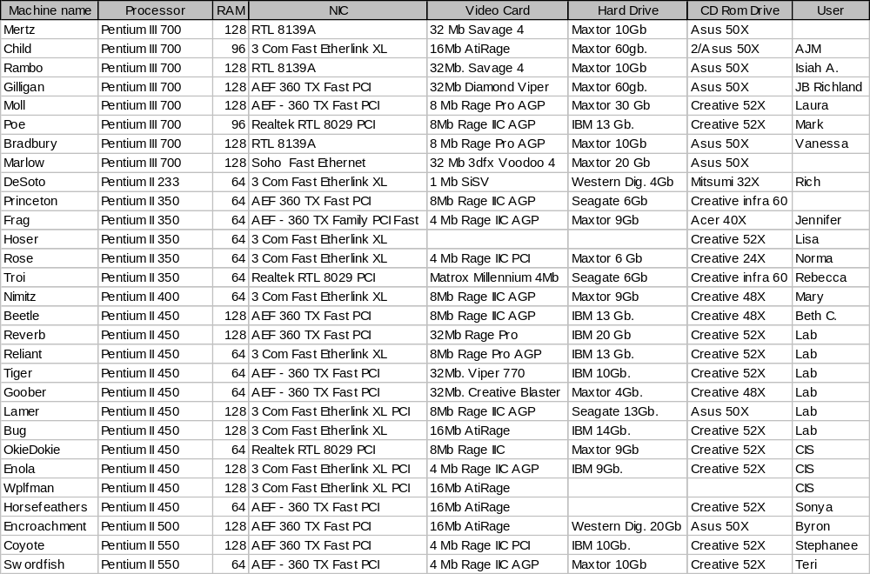

Exhibit 4.3
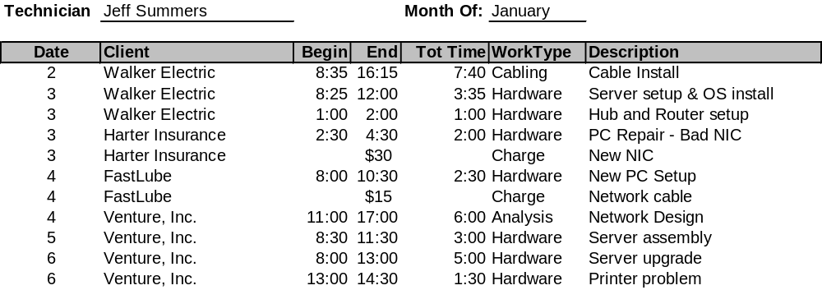Time and Billing Spreadsheet

Exhibit 4.4

Client Billing Statement

