Class Exercise 3- DFD
Chapter 9- Minicases 1 (pg 392) and 3 (pg 393)

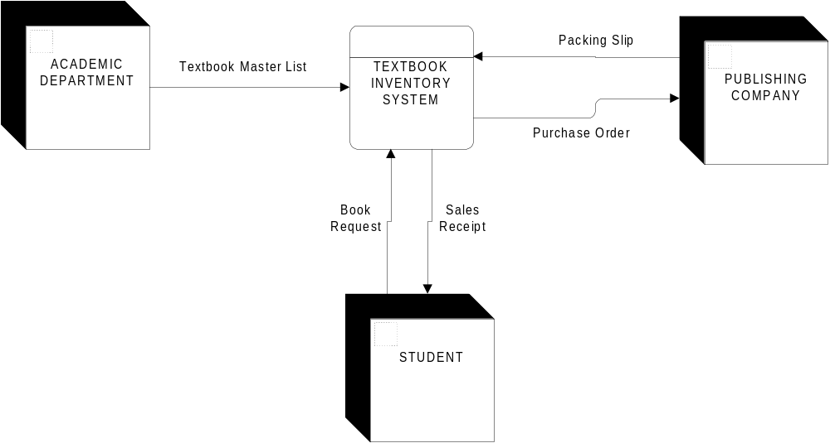1. The purpose of the TEXTBOOK INVENTORY SYSTEM at a campus bookstore is to supply textbooks to students for classes at a local university. The university’s academic departments submit initial data about courses, instructors, textbooks, and projected enrollments to the bookstore on a TEXTBOOK MASTER LIST. The bookstore generates a PURCHASE ORDER, which is sent to publishing companies supplying textbooks. Book orders arrive at the bookstore accompanied by a PACKING SLIP, which is checked and verified by the receiving department. Students fill out a BOOK REQUEST that includes course information. When they pay for their books, the students are given a SALES RECEIPT.

- 3. The purpose of the production scheduling system is to respond to a PRODUCTION ORDER (submitted by the SALES DEPARTMENT) by generating a daily PRODUCTION SCHEDULE, generating RAW MATERIAL REQUISITIONS (sent to the MATERIALS MANAGEMENT DEPARTMENT) for all production orders scheduled for the next day, and generating JOB TICKETS for the work to be completed at each workstation during the next day (sent to the SHOP FLOOR SHIFT SUPERVISOR). The work is described in the following statements. The production scheduling problem can be conveniently broken down into three functions: routing, loading, and releasing. For each product on a PRODUCTION ORDER, we must determine which workstations are needed, in what sequence the work must be done, and how much time should be necessary at each workstation to complete the work. This data is available from the PRODUCTION ROUTE SHEETS. This process, which is referred to as ROUTING THE ORDER, results in a ROUTE TICKET. Given a ROUTE TICKET (for a single product on the original PRODUCTION ORDER), we then LOAD THE REQUEST. Loading is nothing more than reserving dates and times at specific workstations. The reservations that have already been made are recorded in the WORKSTATION LOAD SHEETS. Loading requires us to look for the earliest available time slot for each task, being careful to preserve the required sequence of tasks (determined from the ROUTE TICKET). At the end of each day, the WORKSTATION LOAD SHEETS for each workstation are used to produce a PRODUCTION SCHEDULE. JOB TICKETS are prepared for each task at each workstation. The materials needed are determined from the BILL OF MATERIALS data store, and MATERIAL REQUESTS are generated for appropriate quantities.

