Chapter 11
Specification Phase
11.1: Both constraints superficially appear to be precise and scientific, but neither can be measured or tested. Specifically,
(i) The term “significantly” is imprecise—significant for whom: client or developer? Also, this is a reason for developing the product, not a constraint.
(ii) The term “reasonable” is imprecise—reasonable for whom: client or developer?

11.2: Ambiguities:
Is a clove or a head of garlic to be used?
What operations are to be performed the night before? Everything?
Which juice is to be strained, orange or lemon?
What is to be frozen, the lemon or just the juice?
Is the onion to be diced, or just the shallots?
Which mixture is to be blended for 10 minutes?
Does “blend” mean “mix by hand” or “use an electric blender?”
How are the lumps to be removed, with a strainer or a blender?
The lumps in the mixture could be the mushrooms.
Two mixtures are specified, the pockwester is added to only one of them: which?
How can you kill a “fresh” pockwester?
The terms “simmer,” “bite-sized,” and “soft to the touch” are imprecise.
We can broil for any time from 1 microsecond to 3 minutes, 59 seconds.
What is to be sprinkled with Parmesan—the serving platter, or the pockwester?

Omissions:
How large is a “large onion”?
What size can of orange juice?
How large a lemon?
What kind of bread for the crumbs?
How much flour?
How much milk?
How large are medium-sized shallots?
How large are medium-sized eggplants?
What size pockwester?
What size garlic?
How much Parmesan cheese?
What size eggs?
The sugar is not listed in the ingredients.
Nor are the mushrooms.
Nor are the frobs.
What size platter is to be used?

Contradictions:
The ingredients call for frozen orange juice, the recipe calls for fresh.
After the lemon has been squeezed the night before, it is then supposed to be sliced.
We are told to “stir vigorously,” “slice,” and “in the meantime” to coat, dip, and so on—it is impossible to do all these things at once.

The following items are certainly confusing, but they are not ambiguities, omissions, or contradictions:
The lemon juice, eggplant, and garlic are never used.
Grilling in a skillet is not usually a good idea.
Shaking up mushrooms wet with milk in a paper bag is fraught with difficulties.
The instruction to whisk the eggs should precede the instruction to add them to a mixture.
If the blending is to be done with an electric blender, then 10 minutes seems to be too long.
The recipe calls for first coating the mushrooms in flour, and then dipping them in milk; this may be unorthodox, but then so is much of the rest of the recipe!
Two mixtures are specified, the pockwester is added to only one of them; nothing is mentioned regarding what is to be done with the other one.

11.3: If actual sales for the current month are less than the target sales for the current month, then check whether the percentage difference between the actual sales and the target sales for the current month is 5% or more. If so, then check whether the percentage difference between the actual sales and target sales for the current month is greater than or equal to half of the percentage difference between the actual sales and target sales for the previous month. If this second condition also holds, then print a report. Otherwise, do nothing.

11.4: For each shop, the actual sales for each month are compared with the target sales for that month.

The effectiveness of a given shop for a given month is defined by

The shortfall for a given shop for a given month is defined by

A shop is deemed to have achieved its objective for the current month if the shortfall for the current month is less than or equal to 5%, or if the shortfall for the current month is less than or equal to half the shortfall for the previous month; in the case of January, the shortfall for the previous month is deemed to be 0%.

If a shop has not achieved its objective, then a report is to be printed.

11.5: The following assumptions are made: there are no service charges, no ATM withdrawals. The only transactions that are allowed are checks and deposits. All checks bear a number. The user has a pile of canceled checks, and a pile of deposit slips.
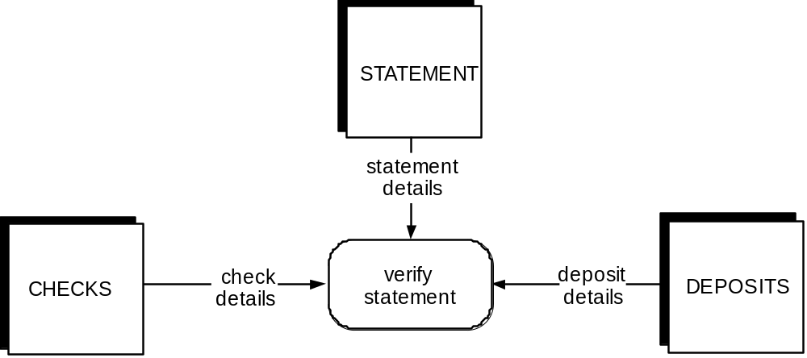

Figure 11.1. Data flow diagram for determining whether bank statement is correct.

Sort the checks in check-number order. For each check, find an entry in the bank statement that matches the check number. If no such entry is found, the statement is in error. Otherwise, mark that entry, and verify that the amount for that entry is the same as that on the check. If the amounts do not match, then the statement is in error.

Sort the deposit slips according to date of deposit. For each deposit slip, find an entry in the statement that matches the date of deposit and the amount of the deposit. Mark that entry. If no such entry is found, the statement is in error.

After all checks and deposits have been processed, verify that all items on the statement have been marked. If not, the statement is in error.

Add the amount of all deposits to the beginning balance, and from that sum subtract the total of all the checks. If the result of that subtraction is not equal to the ending balance then the statement is in error, otherwise it is correct.

11.6: See Figure 11.1.

11.7: This product is concerned with books, borrowers, and librarians. The library has a collection of books which borrowers may check out and subsequently return. Each book has a unique book number. Affixed to each book is a label bearing that number in bar code format.

Each borrower has a unique borrower number. Each borrower has a card bearing that number in bar-code format that is scanned when the borrower checks out a book. Borrowers may determine all the books by a particular author in the library collection by going to a terminal and entering A = <author name>, all the books with a specific title by entering T = <book title>, or all the books in a particular subject area by entering S = <subject area>.

Librarians check out a book by entering C at a terminal, scanning the borrower bar code, and scanning the book bar code. If the book is not being held for another reader, it is issued to the borrower. When a book is returned by a borrower, the librarian enters R at a terminal, and scans the book bar code. To add a new book to the collection, the librarian enters + (plus sign), the number of the new book, and other book details. To remove a book from the collection, the librarian enters – (minus sign) and enters the book number (bar-code input is inappropriate—the book may have been stolen). A librarian can put a hold on a book for a borrower by entering H = <book number> and scanning the borrower’s bar code. [The need for the borrower’s number was intentionally omitted from the problem statement; students should not thoughtlessly rewrite the problem statement in more formal terms, but actually consider the implications of what they are writing!] A book may not be held if it is already being held for another borrower.

11.8: See Figure 11.2.

11.9: Step 1. Draw DFD. See previous problem.

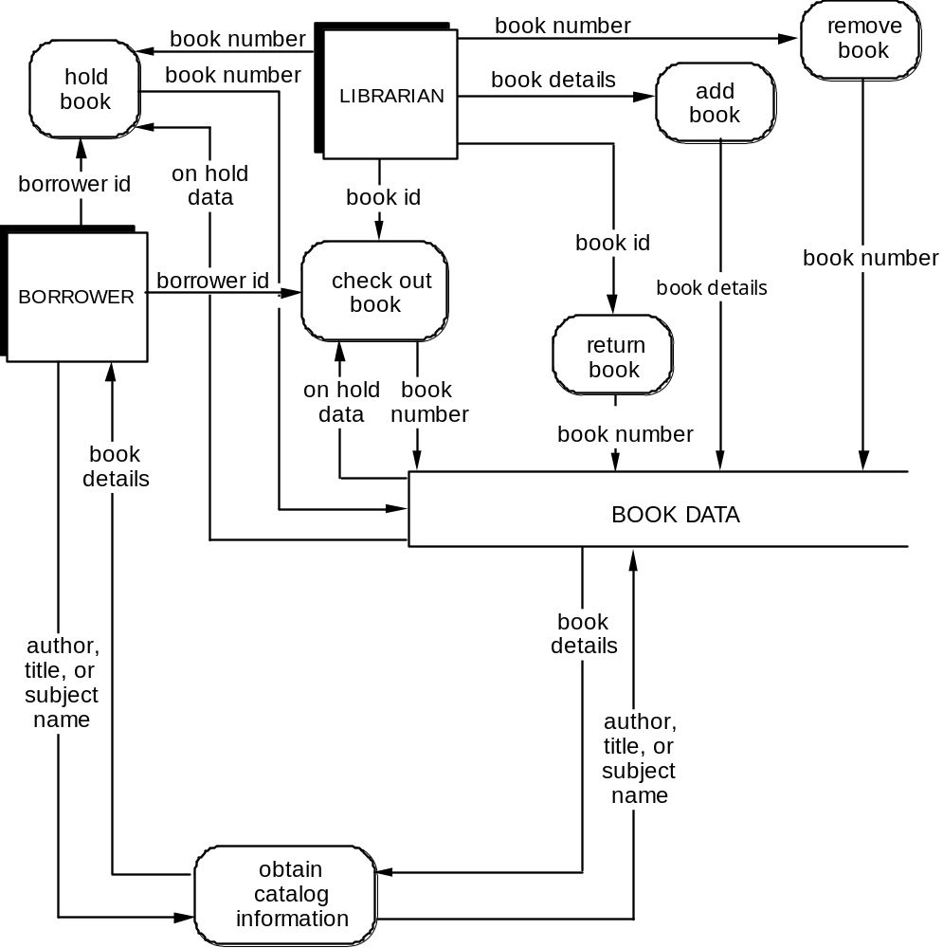

Figure 11.2. Data flow diagram for library circulation.

Step 2. Decide what sections to computerize, and how. Computerize complete product as shown in DFD, online. DFD does not show functions like issuing new borrower with an ID number and card, or maintaining borrower details. These functions were not included in the specifications, and it is therefore assumed that they will be performed manually.

Step 3. Details of data flows.

book id
book number

book details
book number
book bibliographic details
author
title
subject
other details
borrower id
borrower number

on hold data
borrower number if book is on hold for another borrower, else 0

Step 4. Define logic of processes.

add book
Place book details in book DATA

check out book
Read book id, borrower id
Check that book is not being held for another borrower
Update BOOK DATA with borrower id

hold book
Read book number, borrower id
Check if book is already on hold
If not, update BOOK DATA to reflect borrower id

obtain catalog information
Read borrower’s query
Search BOOK DATA
Answer borrower’s query

remove book
Read book number
Delete book details from BOOK DATA

return book
Read book number
Update BOOK DATA

Step 5. Define data stores.

book DATA (512 bytes—assumption)
book number
author
title
subject
other details
on hold data
borrower number (0 if book is not checked out)

Indexed by book number (primary), and also by author, title, and subject (secondary)

Step 6. Define physical resources.

book DATA
Indexed sequential file
Primary index book number
Secondary indexes author, title, and subject

Step 7. Determine input/output specifications.

book id, borrower id are input with bar code wand

book number, book details are input at terminal

Input screens will be designed for add book, remove book, obtain catalog information

Acknowledgment messages will be designed for add book, check out book, remove book, hold book, return book

Output screens will be designed for obtain catalog information

Step 8. Perform sizing. Assuming a maximum of 500,000 books, BOOK DATA will need to have 256 megabytes for the catalog itself, and another 25 megabytes for indexes. A further 2 megabytes will be needed for software.

Step 9. Determine hardware requirements.

CPU
400 megabyte disk
Tape backup system
Two terminals for borrowers
Two terminals for librarians

.


Figure 11.3. Finite state machine for accepting floating point numbers.

11.10: The FSM is shown in Figure 11.3

Set of states is {S0, S1, S2, S3, S4, S5}
Set of inputs is {+, –, 0, 1, E}
The transition function is depicted on the next page
Initial state is s0
Set of final states is {S5}

Figure 11.4. FSM for library circulation system.

11.11: The FSM for the library circulation system is shown in Figure 11.4.

Set of states is {New Book, Removed, On Shelves, Checked Out, On Hold, Returned And Held}
Set of inputs is {C, H, R, +, –}
The transition function is depicted below
Initial state is New book
Set of final states is {Removed}

11.12: The user first keys in the book number of the book in question. A menu then appears, corresponding to the current state of the book. For example, if the book is Checked out, then the menu offers the user three choices, corresponding to operations R and H, and Exit. If the user enters R, say, then a new menu appears corresponding to state On shelves. If the user now enters Exit, then the next time the product is used with respect to the same book it will be in state On shelves, and the On shelves menu will appear.

Figure 11.5. Petri net specification of library circulation system.

11.13: See Figure 11.5.

11.14: Answers will vary from enthusiasm about being given the opportunity to implement formal specifications, to dank despair even at the very thought of having to implement formal specifications!
Term project
11.15: A solution using Gane and Sarsen’s method is given.

Step 1. Draw data flow diagram. See Figure 11.6

Step 2. Decide what sections to computerize, and how. Computerize complete product as shown in DFD, online, in the form of a keyboard-driven, standalone product.

Figure 11.6. Data flow diagram for CPE project.

Step 3. Put in the Details of the Data Flows

name details
first name (15 characters)
middle initial (1 character)
last name (15 characters)
suffix (5 characters)

address details
first line of address (25 characters)
second line of address (25 characters)
city (14 characters)
state (14 characters)
postal code (10 characters)
country (20 characters)

telephone details
country code (5 digits)
area code (3 digits)
city code (4 digits)
number (4 digits)
extension (6 digits)

medical personnel details
medical personnel name—see name details above (36 characters)
medical personnel beeper (4 digits)

parent details
parent name—see name details above (36 characters)
parent home address—see address details above (108 characters)
parent local address—see address details above (108 characters)
parent home telephone—see telephone details above (22 digits)
parent local telephone—see telephone details above (22 digits)

patient registration
patient name—see name details above (36 characters)
patient number (11 characters)
patient location (6 characters)
first parent—see parent details above (274 characters)its)
second parent—see parent details above (274 characters)
primary physician—see medical personnel details above (40 characters)
primary nurse—see medical personnel details above (40 characters)
date admitted (10 characters)

patient needs, checkout date
date discharged (10 characters)
lives within 500 miles (1 character)
needs WF assistance (1 character)
needs JCF assistance (1 character)
needs JC assistance (1 character)

WF visit details
visitor number (11 characters)
patient number (11 characters)
visit date (10 characters)
start time (5 characters)
end time (5 characters)
comments (100 characters)
visit again (1 character)

need WF details
patient name—see name details above (36 characters)
patient number (11 characters)
patient location (6 characters)

visitor assignment details
visitor name—see name details above (36 characters)
patient name—see name details above (36 characters)
patient number (11 characters)
patient location (6 characters)

record JC details
patient name—see name details above (36 characters)
patient number (11 characters)
gift date (10 characters)
gift cost (3 digits)
description (50 characters)
comments (100 characters)

need JC details
patient name—see name details above (36 characters)
patient number (11 characters)
patient location (6 characters)

JCF visit details
patient name—see name details above (36 characters)
visitor name—see name details above (36 characters)
patient number (11 characters)
relationship (10 characters)
start date (10 characters)
budget cost (3 digits)

need JCF details
patient name—see name details above (36 characters)
patient number (11 characters)
patient location (6 characters)

forthcoming visits details
patient name—see name details above (36 characters)
patient number (11 characters)
start date (10 characters)
comments (100 characters)

visitor registration
visitor name—see name details above (36 characters)
visitor address—see address details above (108 characters)
visitor home telephone—see telephone details above (22 digits)
visitor office telephone—see telephone details above (22 digits)
visitor fax number—see telephone details above (22 digits)
visitor number (11 characters)
visitor beeper (4 digits)
number of daily visits (14 digits)

visitor details
visitor name—see name details above (36 characters)
visitor phone—see telephone details above (22 digits)
number of daily visits (14 digits)

Step 4. Define Logic of Processes

check-in patient
Obtain patient registration details.

update patient record
Update a patient’s record with information about patient needs, checkout date.

schedule WF visit
Obtain information about a Wee Friends visit.

need WF report
Generate a report of those who need WF assistance. Print patient name, number, and location.

visitor assignments report
Generate a report of patient/visitor assignments for Wee Friends visits. Print patient name, number, and location as well as visitor name.

record JC assignment
Obtain information about a JC gift assignment.

need JC report
Generate a report of those who need JC assistance. Print patient name, number, and location.

schedule visit
Obtain information about a JCF visit.

need JCF report
Generate a report of those who need JCF assistance. Print patient name, number, and location.

forthcoming visits report
Generate a report a report of all patients who have forthcoming visits. Print patient name, number, location, visit start date, and comments.

register visitor
Obtain information about a visitor.

generate next-day visitor report
Generate a report of all visitors who are scheduled to visit for a particular day. Print visitor name and home phone number, and the times of each visit.

Step 5. Define the data store

PATIENT DATA (705 bytes)
patient details—see patient registration above (691 characters)
patient requirements—see patient needs, checkout date above (14 characters)

WF VISIT DATA (143 bytes)
visitor number (11 characters)
patient number (11 characters)
visit date (10 characters)
start time (5 characters)
end time (5 characters)
comments (100 characters)
visit again (1 character)

JC GIFT DATA (210 bytes)
patient name—see name details above (36 characters)
patient number (11 characters)
gift date (10 characters)
gift cost (3 digits)
description (50 characters)
comments (100 characters)

JCF VISIT DATA (106 bytes)
patient name—see name details above (36 characters)
visitor name—see name details above (36 characters)
patient number (11 characters)
relation (10 characters)
start date (10 characters)
budget cost (3 digits)

VISITOR DATA (254 bytes)
visitor name—see name details above (36 characters)
visitor address—see address details above (108 characters)
visitor home telephone—see telephone details above (22 digits)
visitor office telephone—see telephone details above (22 digits)
visitor fax number—see telephone details above (22 digits)
visitor number (11 characters)
visitor beeper (4 digits)
number of daily visits (14 digits)

Step 6. Define physical resources

PATIENT DATA
Indexed sequential file
Primary index: patient number
Secondary indexes: last name, first name

WF VISIT DATA
Indexed sequential file
Primary index: visit date
Secondary indexes: patient number, visitor number

JC GIFT DATA
Indexed sequential file
Primary index: gift date
Secondary index: patient number

JCF VISIT DATA
Indexed sequential file
Primary index: start date
Secondary index: patient number

VISITOR DATA
Indexed sequential file
Primary index: visitor number
Secondary indexes: last name, first name

Step 7. Determine input/output specifications

Input screens will be designed for the following processes:

check-in patient
Input patient registration details.

update patient record
Input patient needs, checkout date.

schedule WF visit
Input WF visit details.

record JC assignment
Input record JC gift details.

schedule visit
Input JCF visit details.

register visitor
Input visitor registration details.

The following reports will be printed:

need WF report
Generate a report of those who need WF assistance. Print patient name, number, and location.

visitor assignments report
Generate a report of patient/visitor assignments for Wee Friends visits. Print patient name, number, and location, as well as visitor name.

need JC report
Generate a report of those who need JC assistance. Print patient name, number, and location.

need JCF report
Generate a report of those who need JCF assistance. Print patient name, number, and location.

forthcoming visits report
Generate a report of all patients who have forthcoming visits. Print patient name, number, visit start date, and comments.

generate next-day visitor report
Generate a report of all visitors who are scheduled to visit for a particular day. Print visitor name and home phone number, and the times of each visit.

Step 8. Perform Sizing

There are approximately 10 new patients checked in each day. Because each patient record requires just fewer than 700 bytes, there is approximately 8 Kb worth of new patient storage required each day.

Each week, there are about 5 new WF visitors that sign up to volunteer. Because each visitor record requires fewer than 256 bytes of storage, there is a need for under 2 Kb of additional storage each week for visitor data.

There are approximately 100 WF visits each week. The storage requirements to store the details of each visit are about 145 bytes. Therefore, about 15 Kb are needed each week to store all of the information about WF visits.

There are approximately 50 JC Gifts assigned each week. The storage requirements to store the details of each assignment are about 210 bytes. Therefore, about 11 Kb are needed each week to store all of the information about JC gift assignments.

There are approximately 25 JCF visits each week. The storage requirements to store the details of each visit are about 110 bytes. Therefore, about 3 Kb are needed each week to store all of the information about JCF visits.

Step 9. Determine the Hardware Requirements

The hardware requirements for the CPE application are not very demanding. A PC must be purchased to host the application. This computer will reside at the nurse’s stations. This machine must be dedicated to CPE and should have about 5 Gb of disk storage. This is needed to store all of the records to support the CPE application. Tape backup is recommended.

A laser printer is also needed at the nurse’s station in order to print out the various reports.

11.16 The plan presented here is an SPMP for development of the product for the Child-Parent Extension (CPE) committee of Broadlands Area Children’s Hospital by a small software organization consisting of three individuals, namely Pat, the owner of the company, and two software engineers, Quintus and Rebecca.

1. Introduction.

1.1. Project Overview. The objective of this project is to develop a software product that will assist the Child-Parent Extension (CPE) committee in meeting the needs of children who are unaccompanied by their parents and/or whose parents are in financial difficulties. The product will print reports that will be used to organize a daily visit for each child, transportation for a parent to visit his or her child, and gifts for each child.

The time, budget, and personnel requirements are as follows:
Requirements phase (1 week, two team members, $1800)
Object-oriented analysis phase (2 weeks, two team members, $3600)
Design phase (2 weeks, two team members, $3600)
Implementation phase (2 weeks, three team members, $5400)
Integration phase (3 weeks, three team members, $8100)
[The implementation and integration phases will be combined, as described in Chapter 15]
The total development time is 10 weeks and the total internal cost is $22,500.

1.2. Project Deliverables. The complete source code with user and operations manuals will be delivered 10 weeks after the project commences. The client will be responsible for acquiring the recommended hardware and system software by the time the product is delivered.

1.3. Evolution of the SPMP. All changes in the SPMP must be agreed to by Pat before they are implemented. All changes should be documented in order to keep the SPMP correct and up to date.

1.4. Reference materials. Our company’s coding, documentation, and testing standards.

1.5 Definitions and Acronyms.

BACH—Broadlands Area Children’s Hospital
CPE—Child-Parent Extension
JCF—Joining Children with their Families
JC—Juvenile Comforts
SPMP—software project management plan
WF—Wee Friends

2. Project Organization.

2.1. Process Model. The software life-cycle model to be used is the waterfall model with rapid prototyping. The specifications were written by Quintus and Rebecca, and verified by the client at meetings between Pat and the client. The design task will be shared between Quintus and Rebecca, and Pat will check the overall design. Coding will also be performed by Quintus and Rebecca. Quintus and Rebecca will test each other’s code and Pat will conduct integration testing. Extensive testing will then be performed by all three. The time required for all these activities is outlined in the Introduction.

2.2. Organizational Structure. The development team consists of Pat (owner), Quintus, and Rebecca (software engineers).

2.3. Organizational Boundaries and Interfaces. All the work on this project will be performed by Pat, Quintus, and Rebecca. Pat will meet weekly with the client to report progress and discuss possible changes and modifications. Any major changes that will affect the milestones or the budget will have to be approved by Pat, and documented. No outside SQA personnel will be involved. The benefits of having someone other than the individual who carried out the development task to do the testing will be accomplished by each person testing another person’s work products.

2.4. Project Responsibilities. Each member is responsible for the quality of the module he or she codes. Pat will handle the class definitions, Quintus will write the WF modules, and Rebecca will code the JC and JCF modules. Pat will oversee module integration and overall quality of the product and will liaise with the client.

3. Managerial Process.

3.1. Managerial Objectives and Priorities. The overall objective is to deliver a fault-free product on time and within budget. If this cannot be achieved, priority is given to completing the routines needed to organize the JCF visits.

The three team members will work separately on their assigned modules. Pat’s role will be to monitor the daily progress of the other two, oversee integration, be responsible for overall quality, and interact with the client. Team members will meet at the end of each day and discuss problems and progress. Formal meetings with the client will be held at the end of each week to report progress and determine if any changes need to be made. Pat will ensure that schedule and budget requirements are met. Risk management will also be Pat’s responsibility.

Minimizing faults and maximizing user-friendliness will be Pat’s priorities. Pat is also responsible for all documentation and has to ensure that it is up to date.

3.2. Assumptions, Dependencies and Constraints. Acceptance criteria are listed in the specification document. In addition:
The deadline must be met.
The budget constraints must be met.
The product must be reliable.
The architecture must be open so that additional modules may be added later.
The product must conform to the client’s hardware.
The product must be user-friendly.

3.3. Risk Management. The risk factors and the tracking mechanisms are as follows:

There is no existing software with which the new product can be compared. Accordingly, it will not be possible to run the product in parallel with an existing one. Therefore, the product should be subjected to extensive testing.

The users are assumed to be inexperienced with computers. Therefore, special attention should be paid to the specification phase and communication with the users. The product has to be made as user-friendly as possible.

There is always the possibility of a major design fault, so extensive testing will be performed during the design phase. Also, each of the team members will initially test his or her own code and then test the code of another member. Pat will be responsible for integration testing.

The product must meet the specified storage requirements and response times. This should not be a major problem because of the small size of the product, but it will be monitored by Pat throughout development.

There is a slim chance of hardware failure, in which case another machine will be leased. If there is a fault in the compiler, it will be replaced. These are covered in the warranties received from the hardware and compiler suppliers.

3.4. Monitoring and Controlling Mechanisms. Pat will be responsible for all review and auditing. This will be accomplished through daily meetings with the team members. At each meeting, Quintus and Rebecca will present the day’s progress and problems. Pat will determine whether they are progressing as expected, and whether they are following the specifications and the SPMP. Any major problems faced by the team members will immediately be reported to Pat.

3.5. Staffing Plan. Pat is needed for the entire 10 weeks, for the first 5 weeks only in a managerial capacity and the second 5 weeks as both manager and programmer. Quintus and Rebecca are needed for the entire 10 weeks.

4. Technical Process.

4.1. Methods, Tools, and Techniques. The waterfall model with rapid prototyping will be used. The rapid prototype was written in C. The specifications were drawn up using object-oriented analysis. Object-oriented design will be used. Source code will be written in C++ or Java and run under LINUX on a PC. Documentation and coding will be performed in accordance with company standards.

4.2. Software Documentation. Software documentation will follow company standards. Reviews of documentation will be conducted by Pat at the completion of each phase of the process model. This will ensure that all the documentation for a particular phase has been completed by the time the next phase is started.

4.3. Project Support Functions. Quality assurance will be performed as described in Section 2.1.

5. Work Packages, Schedule, and Budget.

5.1. Work Packages. The “items” involved are patients, parents, CPE volunteers, and BACH staff. Routines are needed to store information about patients and their parents, and produce reports regarding daily visits, gifts, and parental visits. The methods for each of the items will be created independently. The team members will be in constant communication; this should ensure that the classes are compatible.

5.2. Dependencies. As specified in the process model. Specifically, no phase will be started until the work products of the previous phase have been approved by Pat.

5.3. Resource Requirements. Three PCs running under LINUX, together with standard LINUX tools.

5.4. Budget and Resource Allocation. The budget for each phase is as follows:
Requirements phase: $1800
Object-oriented analysis phase: $3600
Object-oriented design phase: $3600
Implementation phase: $5400
Integration phase: $8100
Total : $22,500

5.5. Schedule.

Week 1: Met with client, determined requirements. Produced rapid prototype. Client and users approved rapid prototype.
Weeks 2–3: Performed OOA, wrote specification document. Inspected specification document, approved by client. Produced SPMP, inspected SPMP.
Weeks 4, 5: Object-oriented design document, object-oriented design inspection, detailed design document, detailed design inspection.
Weeks 6–7: Implementation and inspection of each module, module testing and documentation.
Weeks 8–10: Integration of each module, inspection of individual modules, product testing, documentation check.

Additional Components.

Security: A password will be needed to use the product.

Training: Training will be performed by Pat at time of delivery. Because the product is straightforward to use, 3 days are sufficient for training. Pat will answer questions at no cost for the first year of use.

Product Maintenance: Corrective maintenance will be performed by the team at no cost for a period of 12 months. A separate contract will be drawn up regarding future enhancement.

