Chapter 12
Object-Oriented Analysis Phase
The exercises in this chapter give students their first practical exposure to the object-oriented paradigm. It is important to stress that repeated iteration is an intrinsic quality of this paradigm, and of object-oriented analysis (OOA) in particular. For example, problems 12.2 and 12.4 seem extremely straightforward. However, the students will have to iterate a number of times between use-case modeling, class modeling, and dynamic modeling before they arrive at an acceptable solution. (In general, there may be more than one acceptable solution to a given problem.)
problem solutions
12.1: The state diagrams for classes Button, Elevator, and Elevator Doors are shown in Figures 12.1, 12.2, 12.3, and 12.4, respectively.

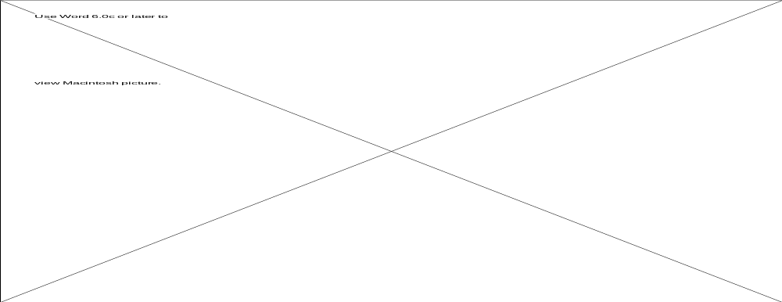

Figure 12.1. State diagram for class Button.



Figure 12.2. State diagram for class Elevator.

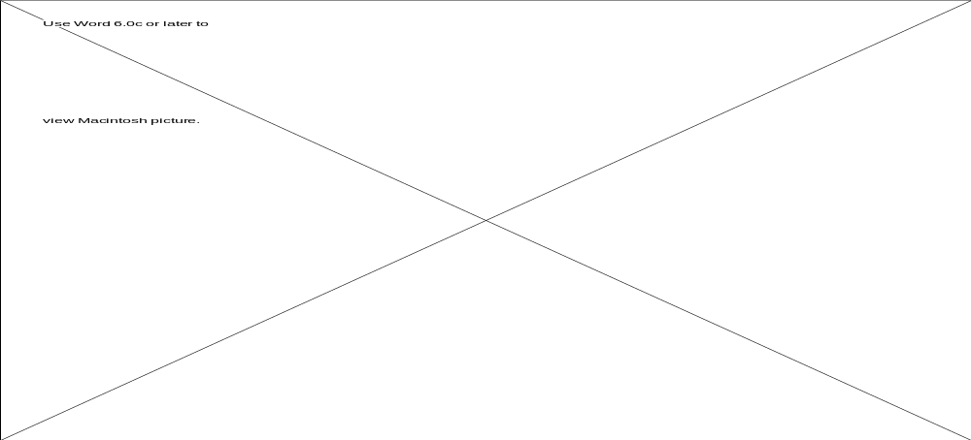

Figure 12.3. State diagram for class Elevator Doors.

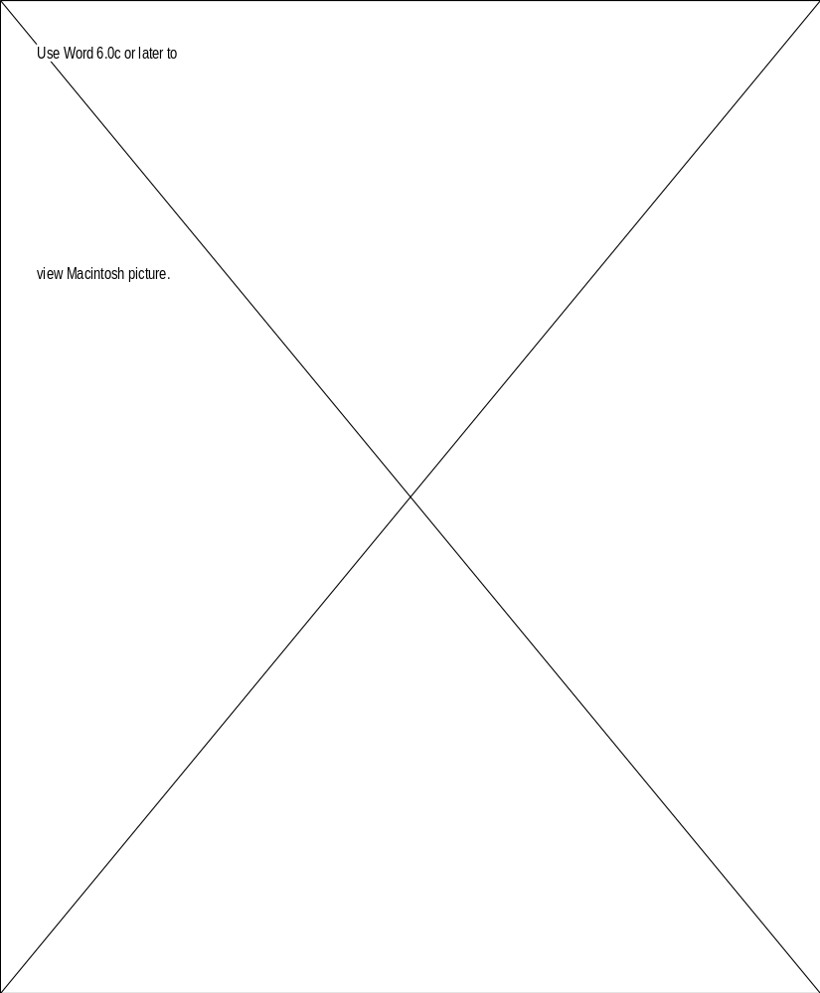

Figure 12.4. Use-case diagram for library circulation system.

12.2: Use-Case Modeling

See Figure 12.4. Figure 12.5 shows the expanded scenario for checking out a book; the expanded scenarios for returning a book, removing a book, adding a book, requesting a book to be held, or making a query are similar.

Borrower hands book to be checked out to librarian. Borrower previously had hold placed on book.
1. Librarian enters C at computer terminal, then scans book and borrower’s card with bar code reader.
2. Book’s borrower number is updated.
3. Hold information is cleared
Possible Alternatives
A. Book had not previously been on hold.

Figure 12.5. Expanded scenario for checking out a book.

Class Modeling

Candidate classes are determined using noun extraction.

Stage 1. Concise Problem Definition: An automated library circulation system is to be constructed.

Stage 2. Informal Strategy: An automated library circulation system is to be constructed. Each book in the library, as well as each borrower, can be identified by a bar-code. A book can be checked out provided it is not being held for another borrower; at most one borrower can place a hold on a book checked out by another borrower. When a book is returned, it is checked in by a librarian. Borrowers and librarians are permitted to query a catalog of library holdings. Librarians may also modify the catalog.

Stage 3. Formalize the Strategy: An automated library circulation system is to be constructed. Each book in the library, as well as each borrower, can be identified by a bar-code. A book can be checked out provided it is not being held for another borrower; at most one borrower can place a hold on a book checked out by another borrower. When a book is returned, it is checked in by a librarian. Borrowers and librarians are permitted to query a catalog of library holdings. Librarians may also modify the catalog.

With regard to the nouns in the previous paragraph, borrower, librarian, and bar-code do not change while the library is operating; in object-oriented terminology, they do not have an internal state. Accordingly, these nouns cannot correspond to classes. In addition, library, hold, holding, and system are abstract nouns. Finally, catalog is information that relates to books. This leaves Book as the sole candidate class.

The class diagram is shown in Figure 12.6.
Book
book number : integer
author : char[41]
title : char[41]
subject : char[41]
borrower number : integer
hold number : integer

Figure 12.6. Class diagram for library circulation system.

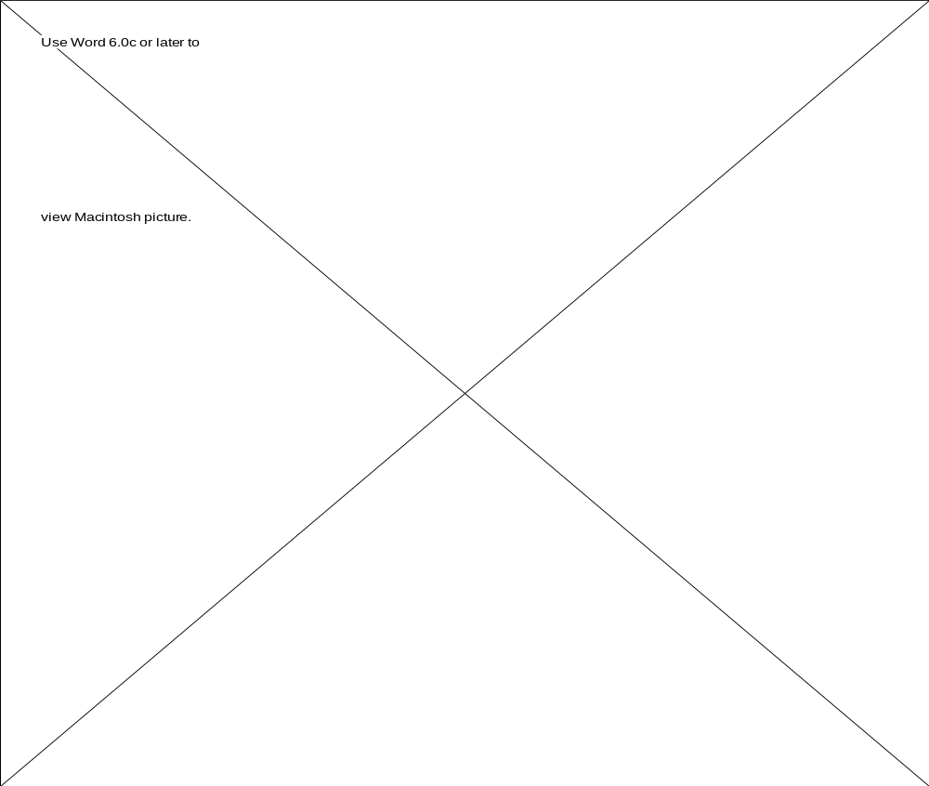

Figure 12.7. State diagram for library circulation system.

Dynamic Modeling

Figure 12.7 shows the state diagram for class Book. It reflects the various states through which a book may move, and the transitions between those states.



Figure 12.8. Use-case diagram for ATM product.

12.3: As explained in Section 11.6 of Object-Oriented and Classical Software Engineering, Fifth Edition, an FSM is a quintuple. In nonmathematical terms, an FSM consists of states and the inputs that result in a transition from state to state. For object-oriented modeling, however, we also want to incorporate the action that is to be taken on entering a state.

Furthermore, this should appear as part of the state diagram. This simplifies later development, particularly the object-oriented design phase. However, the resulting formalism will not be formal, a price we are willing to pay because OOA as a whole is a semiformal technique.

12.4: Use-Case Modeling

The use-case is shown in Figure 12.8. Figure 12.9 is an expanded scenario for withdrawing funds; the expanded scenarios for deposit, transfer, and balance request are similar.

1. User inserts card into ATM and then enters PIN.
2. ATM verifies that PIN is correct.
3. Menu appears on screen.
4. User chooses to withdraw funds.
5. User enters $60 as amount to be withdrawn.
6. Adequate funds are available, so machine updates user’s account balance.
ATM dispenses money.
7. ATM prints receipt showing new balance.
Possible Alternatives
A. User enters incorrect PIN.
B. User requests $50.
C. User has less than $60 in account.

Figure 12.9. Expanded scenario for withdrawing funds.

Class Modeling

The candidate classes are chosen using noun extraction.

Stage 1. Concise Problem Definition: A system to control an automatic teller machine (ATM) is to be constructed.

Stage 2. Informal Strategy: A system to control an ATM is to be constructed. After a customer’s card has been successfully verified, the customer may deposit and withdraw money from an account, inquire about the balance of an account, and transfer funds between two separate accounts.

Stage 3. Formalize the Strategy: A system to control an ATM is to be constructed. After a customer’s card has been successfully verified, the customer may deposit and withdraw money from an account, inquire about the balance of an account, and transfer funds between two separate accounts.

With regard to the nouns in the previous paragraph, ATM, card, and customer do not change while the system is operating; in object-oriented terminology, they do not have an internal state. Also, funds and money are abstract nouns. Finally, balance is a property of account. Thus, the sole candidate class is Account.

The class diagram is shown in Figure 12.10.

Account
account number: integer
balance : float
PIN number : integer

Figure 12.10. Class diagram for ATM product.

Dynamic Modeling

Figure 12.11 shows a state diagram for the ATM as a whole because class Account does not move from state to state.

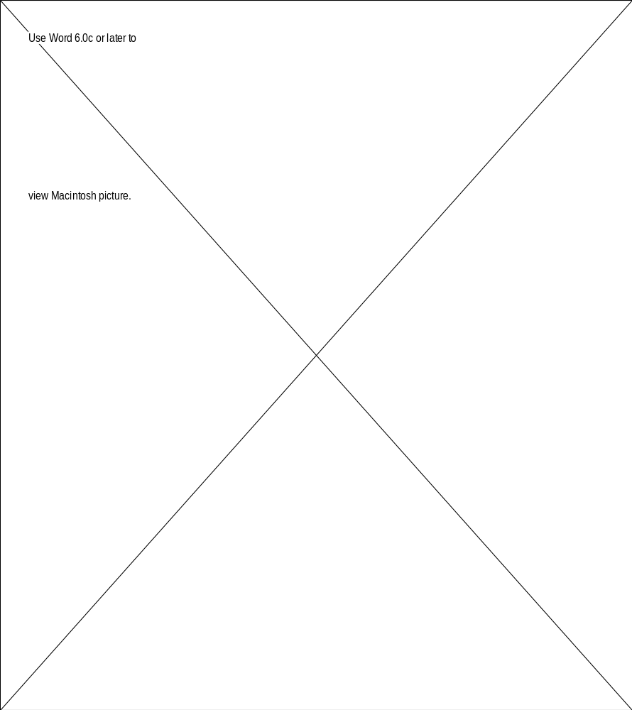

Figure 12.11. State diagram for ATM product.

12.5: Object-oriented analysis consists of three steps: use-case modeling, class modeling, and dynamic modeling. It is possible, in theory, to do the dynamic modeling step before the class modeling step. However, this is not advisable, because when the classes are eventually extracted, major changes in the state diagram are almost certain to be required. The reason is that the state diagram (essentially a finite state machine) cannot represent or identify inheritance. Thus, the latest point at which classes can be introduced is the start of the class modeling

12.6: It is possible (though not advisable) to use the rapid prototype as a way of determining what the classes should be. Thus, classes would be introduced early in the requirements phase.

Alternatively, class modeling could precede use-case modeling in the object-oriented analysis phase, and classes would be introduced at the very beginning of the object-oriented analysis phase. However, this approach would preclude experienced developers from extracting the classes from the scenarios or using CRC cards.

12.7: A wide variety of formalisms could be used, both graphical and textual. All that is required is that the formalism should reflect the various states, transitions, and actions that are involved.

However, such formalisms are less convenient to use. For example, the mathematical formalism of Section 11.6 of Object-Oriented and Classical Software Engineering is less suitable than the one used here. Textual formalisms are equally unsuitable.

12.8: The principle of stepwise refinement requires as many decisions as possible to be postponed. All the operations that have to be included in the product (“methods”) must eventually appear in the state diagram. However, assigning the methods to specific classes can wait until the design phase. On the other hand, modeling becomes extremely complex unless the attributes are assigned to their specific classes.

In fact, there is another good reason to wait until the design phase before allocating methods to classes, namely that the choice of architecture (for example, client-server) will affect where the classes are physically located, and hence may affect how the operations are organized into methods, and which methods should be allocated to which classes.
term project
12.9: Use-Case Modeling

The use-case for updating a patient is shown in Figure 12.12; a corresponding expanded scenario is shown in Figure 12.13.

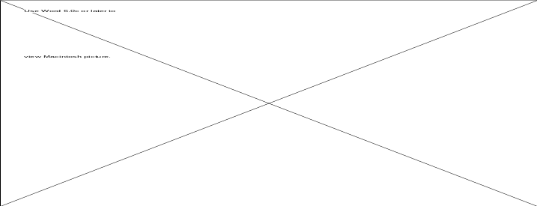

Figure 12.12. Use-case diagram for updating a patient record.

1. The nurse queries the patient number from the CPE database
2. The nurse views the patient record.
3. If the nurse notices that the patient needs JCF assistance the nurse updates the patient record to reflect the JCF need.
4. If the nurse notices that the patient needs WF assistance the nurse updates the patient record to reflect the WF need.
5. If the nurse notices that the patient needs JC assistance the nurse updates the patient record to reflect the JC need.
6. When the patient is discharged, the nurse enters the discharge date.
7. The nurse inserts the updated record into the CPE database
Possible Alternatives
A. The patient number does not represent a currently registered patient.
B. The nurse notices that the patient does not live within 500 miles of BACH; such a patient is not eligible for JCF assistance.
C. If the discharge date of the patient is not yet known, the nurse enters “???” for the recorded discharge date.

Figure 12.13. Extended scenario corresponding to Figure 12.12.

The use case for recording a WF visit is shown in Figure 12.14; a corresponding expanded scenario is shown in Figure 12.15. The other use-cases are: check-in patient; record visitor information; print next-day volunteer list; print the report of those needing WF assistance; print the master and visitor assignment list; record a JCF visit; print the report of those needing JCF assistance; print report of forthcoming JCF visits; record JC gift assignment; print report of those needing JC assistance. These use cases are similar to the two we have presented, and so are their respective expanded scenarios.

.



Figure 12.14. Use-case diagram for recording a WF visit.

1. The nurse records the visitor number for the visit.
2. The nurse records the patient number for the visit.
3. The nurse records the date of the visit.
4. The nurse records the start time of the visit.
5. The nurse records the end time of the visit.
6. The nurse asks the visitor if he or she would like to visit this patient again.
7. The visitor replies to the nurse’s question.
8. The nurse records the response.
9. The nurse asks the visitor for comments concerning the visit.
10. The visitor provides comments.
11. The nurse records the response.
Possible Alternatives
A. The visitor number does not represent a registered visitor.
B. The patient number does not represent a currently registered patient.
C. The time of the start or the end of the visit is not known.
D. The visitor was not available to offer a response to the request for future visits or any comments.

Figure 12.15. Extended scenario corresponding to Figure 12.14.

Class Modeling

As explained in the text, we choose to extract candidate classes via noun extraction, rather than from the scenarios or CRC cards.

Concise Problem Definition: A computerized system is needed to keep track of several departments devoted to the special care of child patients who have parents who are unable to visit or are in financial difficulties.

Informal Strategy: Patient records are updated to reflect each child’s needs. Various reports are generated that list the patients who are in need of assistance.

Formalize the Strategy: The CPE system must keep track of the names, addresses, and telephone numbers of patients, parents, and visitors. Details of the staff members (primary physician and primary nurse) assigned to each patient must also be recorded. The JCF, JC, and WF offices require numerous types of reports.

After removing the abstract nouns from the formalized strategy paragraph, the candidate classes are: Name, Address, Telephone, Patient, Parent, Visitor, Staff, JC, JCF, and WF. The resulting class diagram is shown in Figure 12.16.

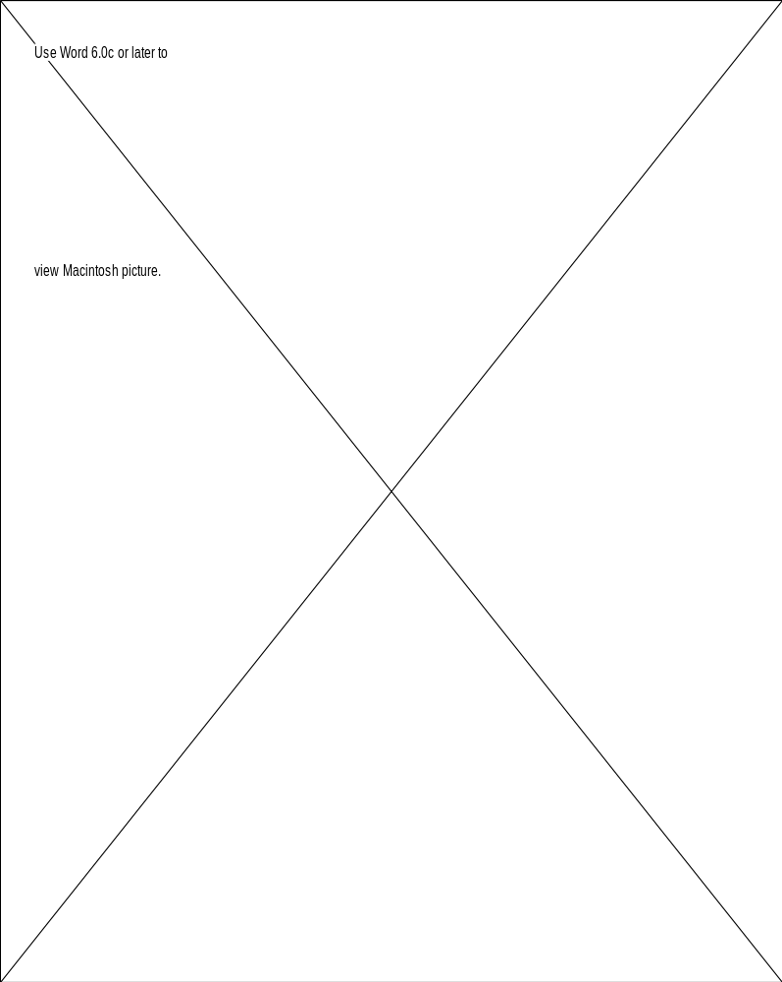

Figure 12.16. Class Diagram for CPE product.

Dynamic Modeling

A state diagram for the CPE product is shown in Figure 12.17. As explained in the text, a state diagram appertains to a class. However, the classes of the CPE problem do not move from state to state, so we give a diagram for the product as a whole. The diagram represents the history of a patient’s stay at Broadlands Area Children’s Hospital. To simplify the diagram, states that deal with the recording of a specific visit or gift assignment have been omitted. Also, the complete list of reports that could be requested has been collapsed into a single state—this state could be expanded considerably.

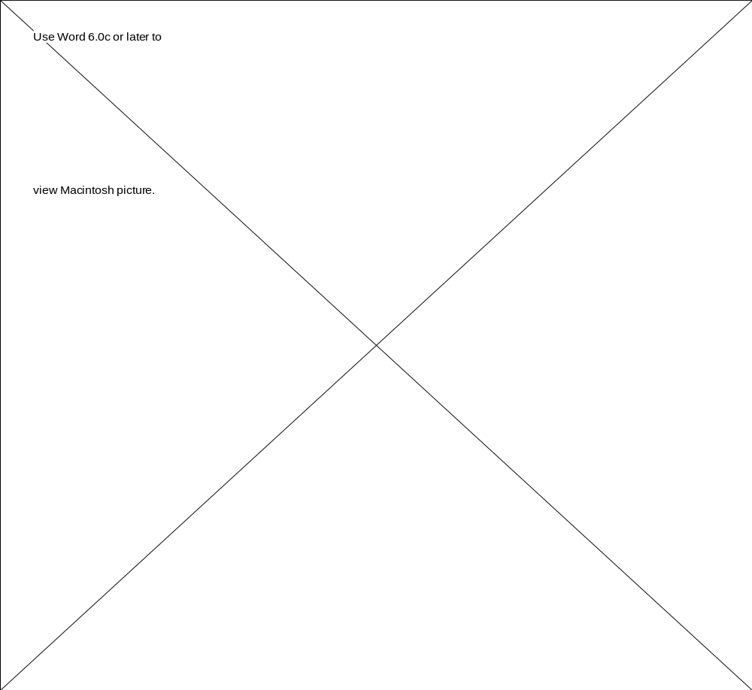

Figure 12.17. State diagram for CPE product.

