Chapter 13
Design Phase
I strongly suggest that at least two different techniques for architectural design be taught. It is important that students be exposed to more than one design method, otherwise they will think that there is only one way to design a product. Data flow analysis is the most popular design method today, whereas object-oriented design will surely be the design method of the future, so I recommend that those two methods be taught. Finally, transaction analysis is quick and easy to teach, and is superior to data flow analysis for the design of transaction-processing systems.
Problem solutions
13.1: An architectural design is presented in Figure 13.1; the detailed design of one module appears in Figure 13.2.

It is advisable to inform the students whether or not a complete detailed design is required, and if not, the number of modules that should be designed.

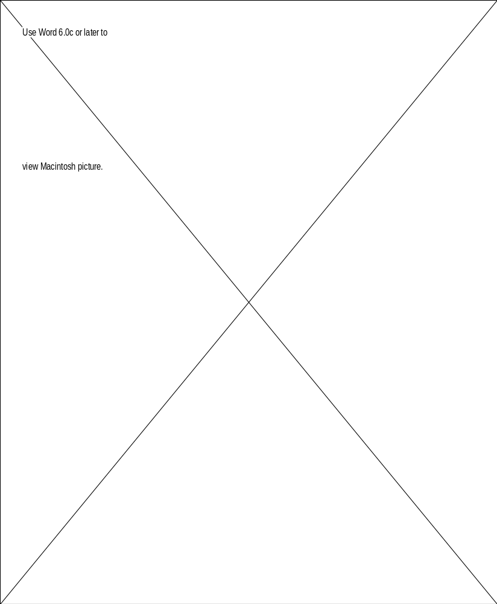

Figure 13.1. Structure chart of product to determine whether bank statement is correct.

 | Module name | total checks
 | Module type | function, does not return value
 | Return type | void
 | Input arguments | statement : statement type
 | Output arguments | statement : statement type  check total : money type  ok : Boolean
 | Error messages | none
 | Files accessed | none
 | Files changed | none
 | Modules called | match checks  arguments: statement : statement type  sorted checks : check list  ok : Boolean
 | Narrative | This module calls match checks which returns ok, a boolean, and a sorted list of checks. If the value of ok that is returned is true, then this module takes the sorted list of checks and returns the sum of the dollar values of the checks. Otherwise, this module does nothing, and returns the value of ok, unchanged, to its caller.

Figure 13.2. Detailed design of one module of product to determine whether bank statement is correct.

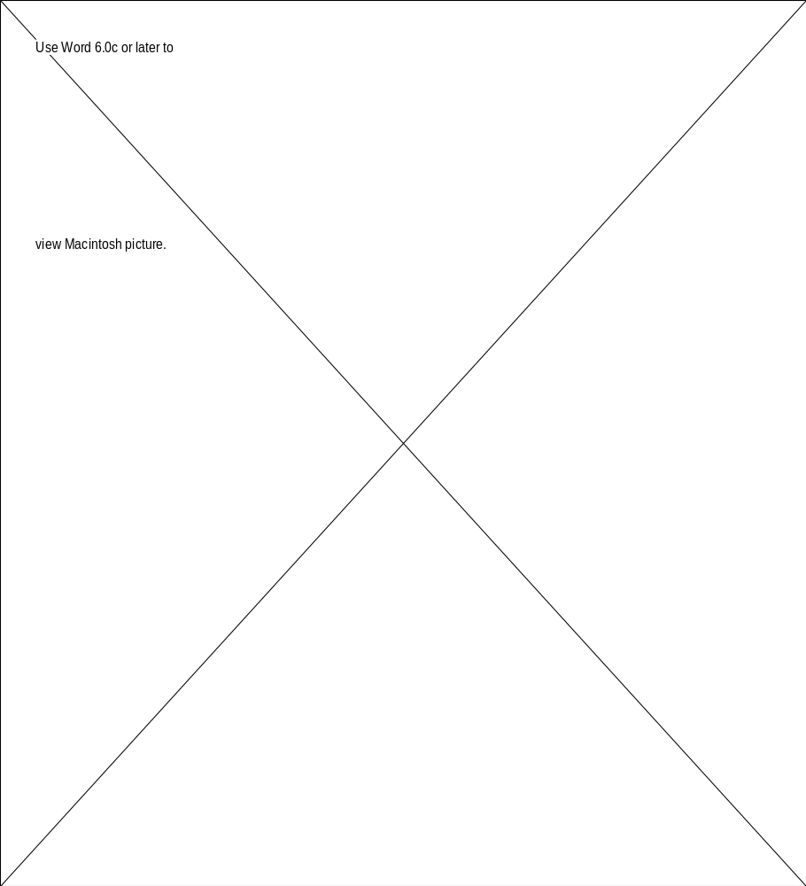

Figure 13.3. Architectural design of automated teller machine using transaction analysis.

13.2: See Figure 13.3.

In practice, when a deposit is made the account file is updated only after the deposit has been verified.

Figure 13.4. Architectural design of automated teller machine using transaction analysis. Error-handling modules have been added.

13.3: In the architectural design of Figure 13.4 all modules have functional cohesion, there is data coupling between each pair of communicating modules and no coupling between all other pairs.



Figure 13.5. Structure chart of library circulation system.

13.4: Pseudocode (PDL) is a more concise way of representing a detailed design than the tabular method. Also, coding from pseudocode is more straightforward. The disadvantage is that a carelessly designed pseudocode can be all but a programming language. As a result, the design will be all but code.

13.5: The architectural design is shown in Figure 13.5.

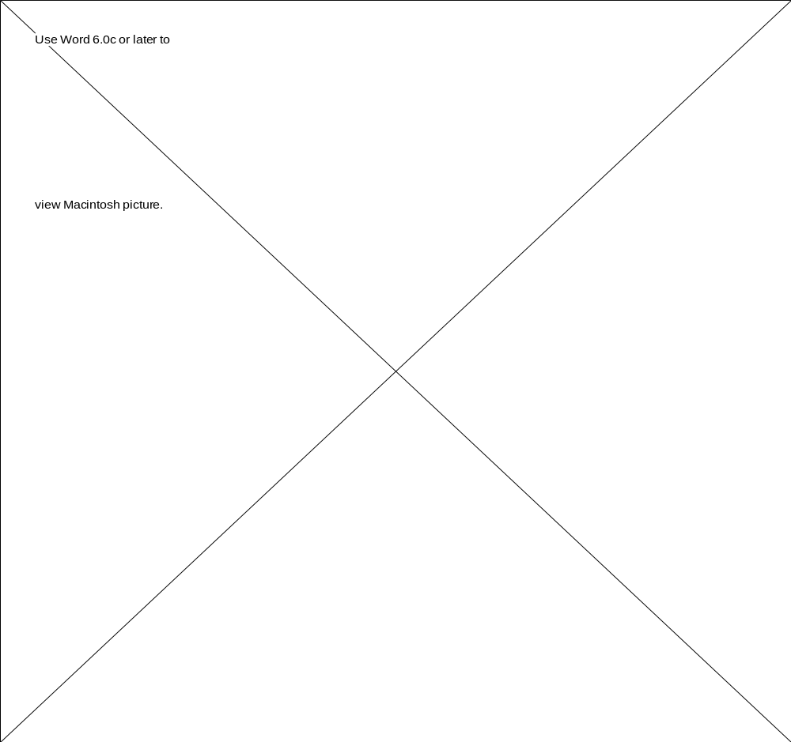

Figure 13.6. Architectural design of library circulation system using transaction analysis.

13.6: The architectural design is shown in Figure 13.6. Many students will find transaction analysis to be more appropriate than data flow analysis because the automated library system is transaction-driven.

13.7: Step 1. Construct interaction diagrams for each scenario.

The collaboration diagram corresponding to the scenario of Figure 12.5 is shown in Figure 13.7. The other three collaboration diagrams are similar.

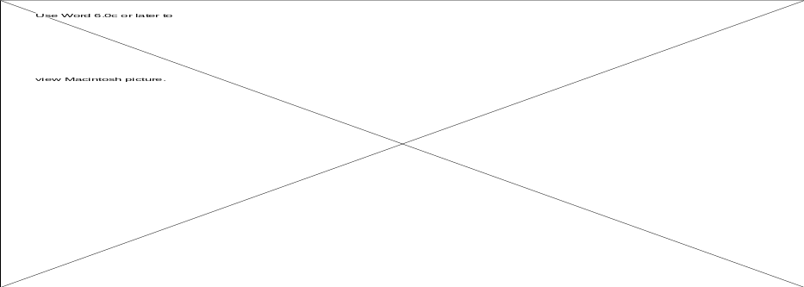

Figure 13.7. Collaboration diagram corresponding to scenario of Figure 12.5.

Book
book number : integer
author : char[41]
title : char[41]
subject : char[41]
borrower number : integer
hold number : integer
add book
check out book
hold book
obtain information
remove book
return book

Figure 13.8. Detailed class diagram for library problem.

Step 2. Determine the methods of the classes and draw the detailed class diagram.

From the collaboration diagrams, it is clear that methods of class Book are add book, check out book, hold book, obtain information, remove book, and return book. The detailed class diagram is shown in Figure 13.8.

Step 3. Design the product in terms of objects and their clients.

The object-client relations are shown in Figure 13.9.
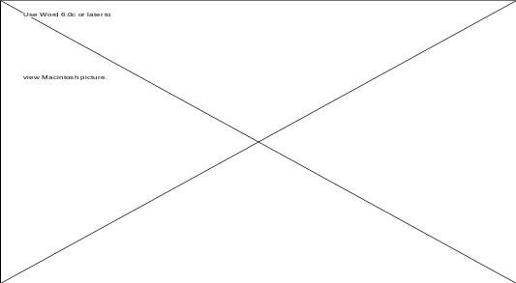

Figure 13.9. Client-object relations for library problem: C++ version (left)) Java version (right).

Step 4. Produce the detailed design

A PDL (pseudocode) representation of the six methods of class Book is now given.

void addBook ()
{
Book book;

create new book
scan bar code to input book.bookNumber;
input bibliographic information (book.author, book.subject, book.title);
add book to collection;
}

void check outBook (int borrowerNumber)
{
int currentBookNumber;
Book book;

scan bar code to input borrowerNumber;
scan bar code to input currentBookNumber;
book = fetch (currentBookNumber);

if book is on hold
{
if book.holdNumber is not equal to borrowerNumber
display ("Book is on hold for another borrower.");
}
else
checkOut (book, borrowerNumber);
}

void holdBook (int borrowerNumber)
{
int wantedBookNumber;
Book book;

input wantedBookNumber from borrower;
book = fetch (wantedBookNumber);

if book is on hold
display ("Book is on hold for another borrower.");
else
{
scan bar code to input borrowerNumber;
book.holdNumber = borrowerNumber;
}
}

void obtainInformation (String requestString)
{

extract request type from requestString;
extract author, subject, or title from requestString;
search for desired book;
display results of search;
}

void removeBook ()
{
int removalNumber;
Book book;

scan bar code to input removalNumber;
book = fetch (removalNumber);
remove book from collection;
}

void returnBook (void)
{
int returnedBookNumber ;

scan bar code to input returnedBookNumber;
book = fetch (returnedBookNumber);
replace book;
}

The next refinement of the detailed design depends critically on how the library is implemented; it is therefore omitted here.

13.8: Step 1. Construct interaction diagrams for each scenario.

The collaboration diagram corresponding to the scenario of Figure 12.9 is shown in Figure 13.10. The other five collaboration diagrams are similar.
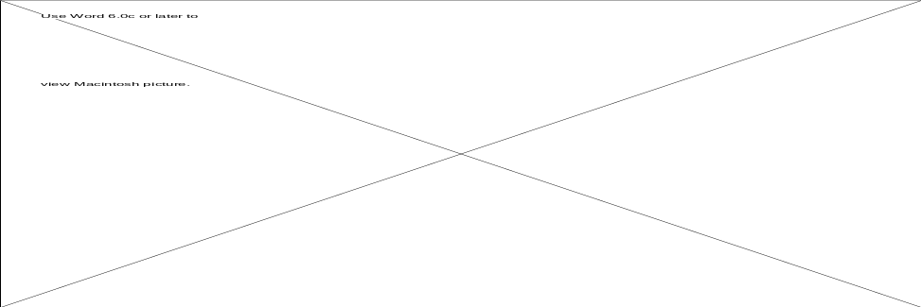

Figure 13.10. Collaboration diagram corresponding to scenario of Figure 12.9.

Account
account number: integer
balance : float
PIN number : integer
deposit
determine balance display menu
transfer
verify PIN number
withdraw

Figure 13.11. Detailed class diagram for ATM problem.

Step 2. Determine the methods of the classes and draw the detailed class diagram.

From the collaboration diagrams, it is clear that methods of class Account are deposit, determine balance, display menu, transfer, verify PIN, withdraw. (At first sight, print receipt might appear to be a method of class Account. However, the format of the receipt varies depending on the transaction type. Thus, method print receipt would have control coupling and logical cohesion. Instead, each transaction type needs to print it own receipt.) The detailed class diagram is shown in Figure 13.11.

Step 3. Design the product in terms of objects and their clients.

The object-client relations are shown in Figure 13.12.

Step 4. Produce the detailed design

A PDL (pseudocode) representation of the seven methods for class Account is now given.

void deposit (Account account, float amount, Date date)
{
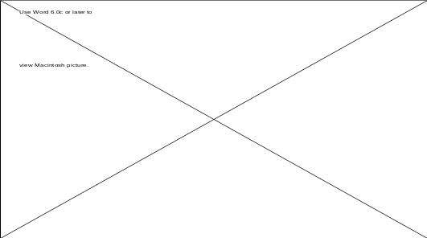

Figure 13.12. Client-object relations for ATM problem: C++ version (left), Java version (right).

obtain amount from customer;
account.balance := account.balance + amount;
performDepositActions (accountNumber, amount);
printDepositReceipt (account, amount, date);
}

void determineBalance (Account account)
{
display (account.balance);
}

void displayMenu (void)
{
display menu of choices;
}

void transfer (Account sourceAccount, Account destinationAccount, float amount, Date date)
{
obtain sourceAccount, destinationAccount, amount from customer;

if (amount > sourceAccount.balance)
error routine ("Amount is greater than current balance.");
else
{
performWithdrawActions (sourceAccount, amount, date);
performDepositActions (destinationAccount, amount, date);
printTransferReceipt (amount, sourceAccount, destinationAccount, date);
}
}

boolean verifyPINnumber (Account account, int digitSequence)
{
if (digitSequence = account.PINnumber )
return ("okay");
else
errorRoutine ("Invalid PIN number.");
}

void withdraw (Account account, float amount, Date date)
{
if (amount mod 20 is not equal to 0)
errorRoutine ("Amount not in units of $20.");
else if (amount > account.balance)
errorRoutine ("Amount is greater than current balance.");
else if (amount > 200)
errorRoutine ("Amount exceeds $200 limit.");
else
{
account.balance := account.balance – amount;
performWithdrawActions (accountNumber, amount);

printWithdrawReceipt (account, amount, date);
}
}

The detailed design of object Account depends critically on hardware details; it is therefore omitted here.
term project
13.14: Step 1. Construct interaction diagrams for each scenario

The sequence diagram for the scenario for updating a patient record (Figure 12.13) is shown in Figure 13.13. The collaboration diagram for the scenario for recording a WF visit (Figure 12.15) is shown in Figure 13.14. The remaining interaction diagrams are similar.
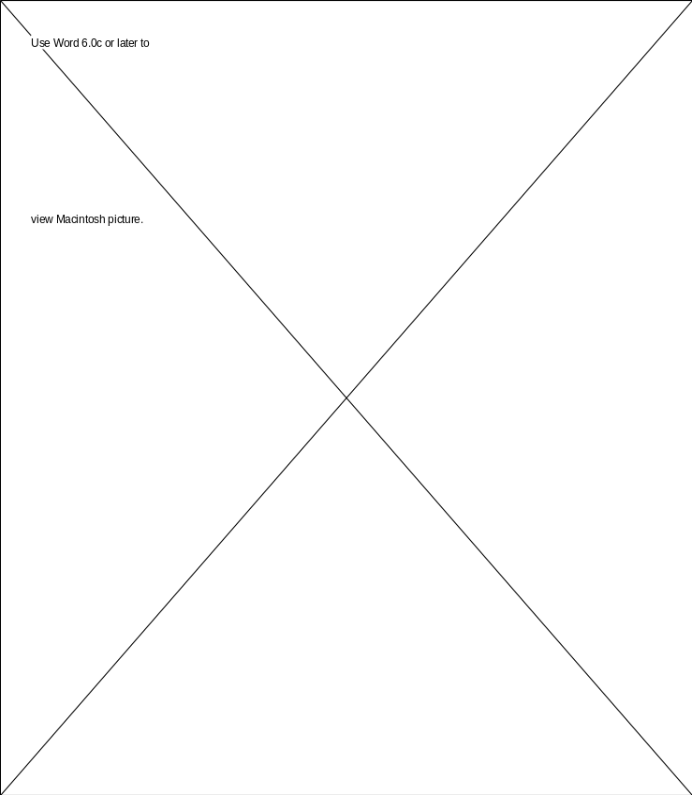

Figure 13.13. Sequence diagram for scenario for updating a patient record (Figure 12.13).



Figure 13.14. Collaboration diagram for scenario for recording a WF visit (Figure 12.23).

Step 2. Construct the detailed class diagram:

The detailed class diagram is showed in Figure 13.15. Because the detailed class diagram is large it is shown in four parts.

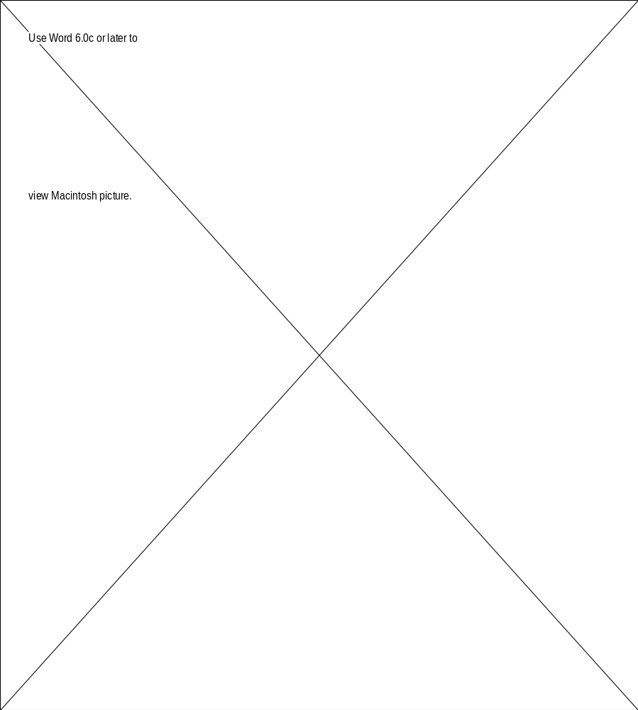

Figure 13.15. Detailed class diagram for the CPE product (Part 1 of 4).

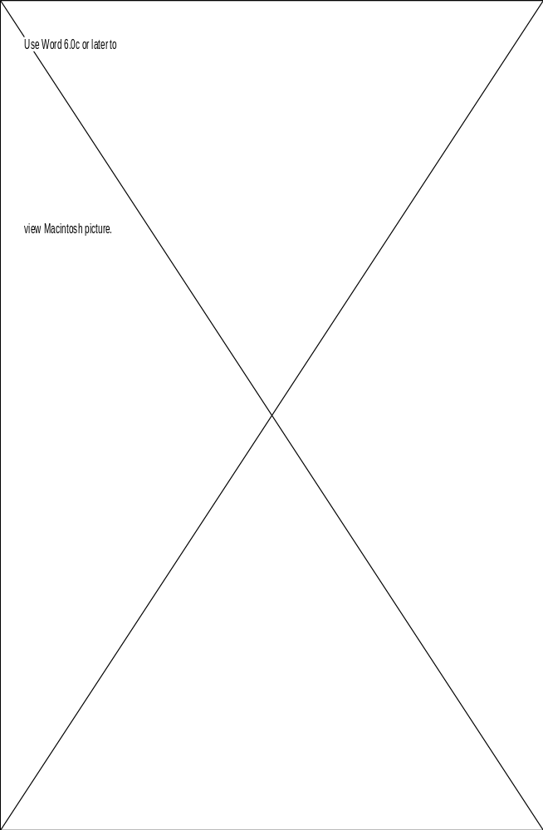

Figure 13.15. Detailed class diagram for the CPE product (Part 2 of 4).

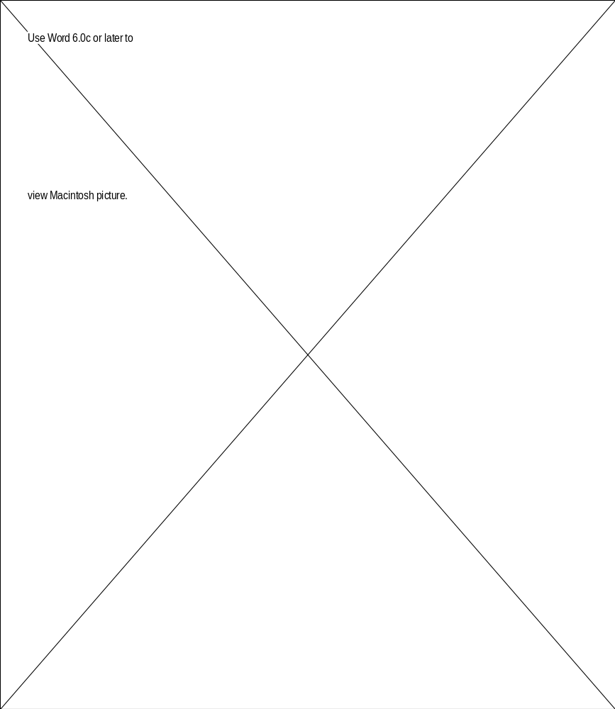

Figure 13.15. Detailed class diagram for the CPE product (Part 3 of 4).

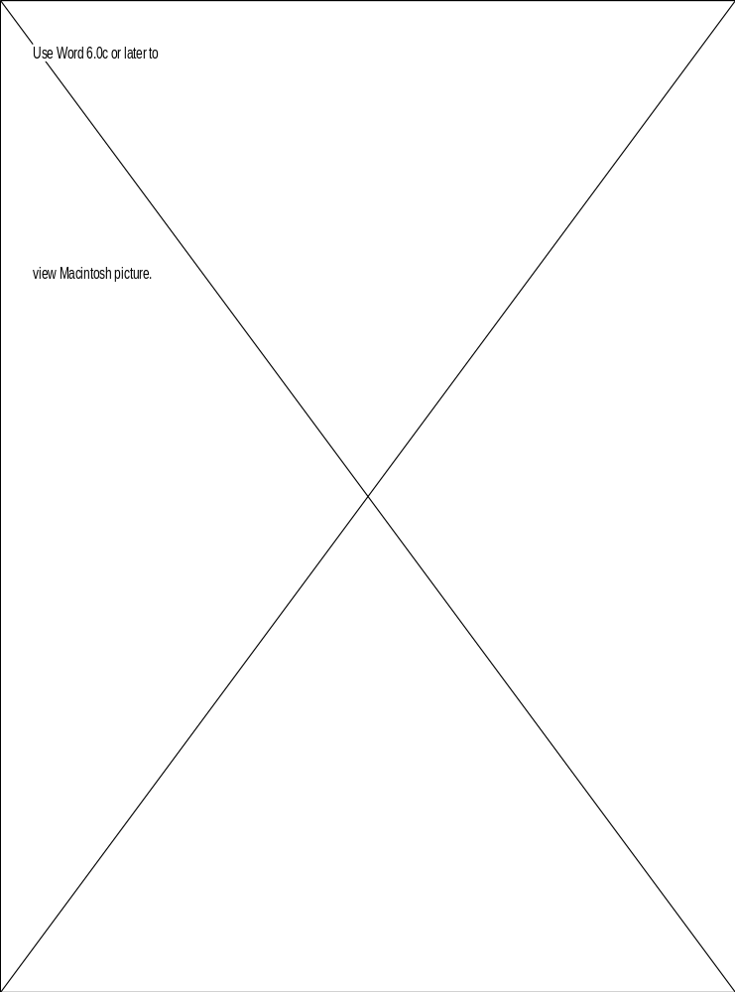

Figure 13.15. Detailed class diagram for the CPE product (Part 4 of 4).

Step 3. Design the product in terms of objects and their clients.

The object-client relations for the C++ version are shown in Figure 13.16 and for the Java version in Figure 13.17.

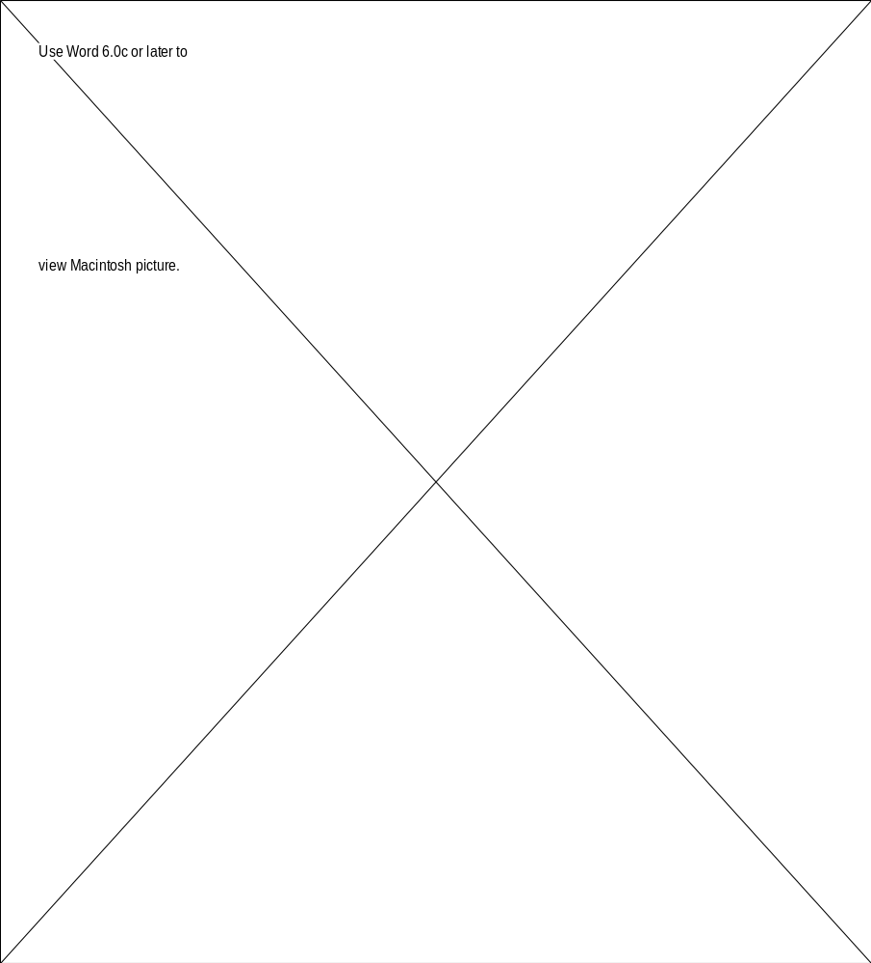

Figure 13.16. Client-object relations for C++ version of CPE product.

Figure 13.17. Client-object relations for Java version of CPE product.

Step 4. Produce the detailed design:

The detailed design for implementation in C++ appears below; the Java version starts on page 41.

Detailed design for C++ version.

The following 56 modules are presented in alphabetical order by class name, and by method name within a class.

Class name | CAddress
Method name | get
Return type | void
Input parameters | None
Output arguments | None
Error Messages | None
Files accessed | None
Files changed | None
Modules called | Utils::get_string
Narrative | Obtains information about an address

Class name | CAddress
Method name | print
Return type | void
Input parameters | None
Output arguments | None
Error Messages | None
Files accessed | None
Files changed | None
Modules called | None
Narrative | Prints an address

Class name | CJCFVisit
Method name | adjustOrder
Return type | void
Input parameters | String, Vector
Output arguments | Vector
Error Messages | None
Files accessed | None
Files changed | None
Modules called | None
Narrative | Moves a particular number to the front of a vector

Class name | CJCFVisit
Method name | completeVisit
Return type | void
Input parameters | None
Output arguments | None
Error Messages | Patient with this patient number does not exist
Files accessed | None
Files changed | None
Modules called | CJCFVisit::findVisit, Utils::get_string, Utils::press_enter, Utils::get_int
Narrative | Records information after a visit is completed

Class name | CJCFVisit
Method name | findVisit
Return type | void
Input parameters | String
Output arguments | CJCFVisit
Error Messages | None
Files accessed | None
Files changed | None
Modules called | None
Narrative | Finds a particular JCF visit

Class name | CJCFVisit
Method name | forthcomingVisitsReport
Return type | void
Input parameters | None
Output arguments | None
Error Messages | None
Files accessed | None
Files changed | None
Modules called | Utils::press_enter
Narrative | Produces a report of all patients who have forthcoming visits

Class name | CJCFVisit
Method name | get
Return type | void
Input parameters | CPatient
Output arguments | None
Error Messages | None
Files accessed | None
Files changed | None
Modules called | Utils::get_string, Utils::get_int, CJCFVisit::adjustOrder
Narrative | Obtains information regarding a JCF visit

Class name | CJCFVisit
Method name | needJCFReport
Return type | void
Input parameters | None
Output arguments | None
Error Messages | None
Files accessed | None
Files changed | None
Modules called | CPatient::findPatient, Utils::press_enter
Narrative | Displays a report of patients who need JCF support

Class name | CJCFVisit
Method name | registerNeed
Return type | void
Input parameters | String
Output arguments | None
Error Messages | None
Files accessed | None
Files changed | None
Modules called | Utils::find_number
Narrative | Records the JCF need for a particular patient number

Class name | CJCFVisit
Method name | removeNeed
Return type | void
Input parameters | String
Output arguments | None
Error Messages | None
Files accessed | None
Files changed | None
Modules called | Utils::remove_number
Narrative | Removes a particular patient from JCF needs

Class name | CJCFVisit
Method name | scheduleJCFVisit
Return type | void
Input parameters | None
Output arguments | None
Error Messages | None
Files accessed | None
Files changed | None
Modules called | CJCFVisit::get, CPatient::findPatient, Utils::press_enter, Utils::get_char
Narrative | Assigns a family visit to the patient at the top of the JCF visit queue

Class name | CJCGift
Method name | get
Return type | void
Input parameters | CPatient
Output arguments | None
Error Messages | None
Files accessed | None
Files changed | None
Modules called | Utils::get_string, Utils::get_int
Narrative | Obtains information regarding a gift

Class name | CJCGift
Method name | needJCReport
Return type | void
Input parameters | None
Output arguments | None
Error Messages | None
Files accessed | None
Files changed | None
Modules called | CPatient::findPatient, Utils::press_enter
Narrative | Displays a report of patients who need JC support

Class name | CJCGift
Method name | recordJCAssignment
Return type | void
Input parameters | CPatient
Output arguments | None
Error Messages | None
Files accessed | None
Files changed | None
Modules called | CPatient::findPatient, CJCGift::get, Utils::get_char, Utils::press_enter
Narrative | Assigns a gift to the patient at the top of the JC queue

Class name | CJCGift
Method name | registerNeed
Return type | void
Input parameters | String
Output arguments | None
Error Messages | None
Files accessed | None
Files changed | None
Modules called | Utils::find_number
Narrative | Records the JC need for a particular patient number

Class name | CJCGift
Method name | removeNeed
Return type | void
Input parameters | String
Output arguments | None
Error Messages | None
Files accessed | None
Files changed | None
Modules called | Utils::remove_number
Narrative | Removes a particular patient from JC needs

Class name | CName
Method name | get
Return type | void
Input parameters | None
Output arguments | None
Error Messages | None
Files accessed | None
Files changed | None
Modules called | Utils::get_string, Utils::get_char
Narrative | Obtains information about a name

Class name | CName
Method name | print
Return type | void
Input parameters | None
Output arguments | None
Error Messages | None
Files accessed | None
Files changed | None
Modules called | None
Narrative | Prints a name

Class name | CParent
Method name | get
Return type | void
Input parameters | None
Output arguments | None
Error Messages | None
Files accessed | None
Files changed | None
Modules called | Utils::get_string, CAddress::get, CTelephone::get
Narrative | Obtains information about a parent

Class name | CPatient
Method name | findPatient
Return type | CPatient
Input parameters | String
Output arguments | None
Error Messages | None
Files accessed | None
Files changed | None
Modules called | None
Narrative | Finds a particular patient

Class name | CPatient
Method name | get
Return type | void
Input parameters | None
Output arguments | None
Error Messages | None
Files accessed | None
Files changed | None
Modules called | Utils::press_enter, Utils::get_char, Utils::get_string, CPatient::patientExists, CName::get, CStaff::get, CParent::get
Narrative | Obtains information about a patient

Class name | CPatient
Method name | patientExists
Return type | BOOLEAN
Input parameters | None
Output arguments | None
Error Messages | None
Files accessed | None
Files changed | None
Modules called | None
Narrative | Determines if the current patient already exists

Class name | CPatient
Method name | updateRecord
Return type | void
Input parameters | None
Output arguments | None
Error Messages | Patient with this patient number does not exist
Files accessed | None
Files changed | None
Modules called | Utils::press_enter, Utils::get_char, Utils::get_string, CPatient::findPatient, CJCFVisit::registerNeed, CJCFVisit::removeNeed, CWFVisit::registerNeed, CWFVisit::removeNeed, CJCGift::registerNeed, CJCGift::removeNeed
Narrative | Records the various needs of each patient

Class name | CPerson
Method name | get
Return type | void
Input parameters | None
Output arguments | None
Error Messages | None
Files accessed | None
Files changed | None
Modules called | CAddress::get, CTelephone::get
Narrative | Obtains information about a person

Class name | CStaff
Method name | get
Return type | void
Input parameters | None
Output arguments | None
Error Messages | None
Files accessed | None
Files changed | None
Modules called | Utils::get_string, CName::get
Narrative | Obtains information about a staff member

Class name | CStaff
Method name | print
Return type | void
Input parameters | None
Output arguments | None
Error Messages | None
Files accessed | None
Files changed | None
Modules called | CName::print
Narrative | Prints information about a staff member

Class name | CTelephone
Method name | get
Return type | void
Input parameters | None
Output arguments | None
Error Messages | None
Files accessed | None
Files changed | None
Modules called | Utils::get_string
Narrative | Obtains information about a phone number

Class name | CTelephone
Method name | print
Return type | void
Input parameters | None
Output arguments | None
Error Messages | None
Files accessed | None
Files changed | None
Modules called | None
Narrative | Prints information about a phone number

Class name | CVisitor
Method name | get
Return type | void
Input parameters | None
Output arguments | None
Error Messages | None
Files accessed | None
Files changed | None
Modules called | Utils::get_string, Utils::get_int, CPerson::get, CTelephone::get
Narrative | Obtains information about a visitor

Class name | CVisitor
Method name | nextDayVisitorReport
Return type | void
Input parameters | None
Output arguments | None
Error Messages | None
Files accessed | None
Files changed | None
Modules called | Utils::press_enter, Utils::get_int
Narrative | Displays all visitors who are scheduled to visit on a particular day

Class name | CWFVisit
Method name | buildVisitorAssignments
Return type | void
Input parameters | None
Output arguments | Vector
Error Messages | None
Files accessed | None
Files changed | None
Modules called | Utils::get_int, CPatient::findPatient, CWFVisit::findVisitorAssignment, CWFVisit::selectFirstAvailable
Narrative | Builds a list of visitors available for assignment

Class name | CWFVisit
Method name | findVisitAgain
Return type | String
Input parameters | String, Vector
Output arguments | None
Error Messages | None
Files accessed | None
Files changed | None
Modules called | CWFVisit::findVisitorAssignment
Narrative | Looks into previous visits and returns the visitor number for a visitor who requested another visit with this patient

Class name | CWFVisit
Method name | findVisitorAssignment
Return type | VisitorAssignment
Input parameters | String, Vector
Output arguments | None
Error Messages | None
Files accessed | None
Files changed | None
Modules called | None
Narrative | Returns the VisitorAssignment corresponding to a particular visitor number

Class name | CWFVisit
Method name | get
Return type | void
Input parameters | None
Output arguments | None
Error Messages | None
Files accessed | None
Files changed | None
Modules called | Utils::get_string, Utils::get_char
Narrative | Obtains information regarding a Wee Friends visit

Class name | CWFVisit
Method name | needWFReport
Return type | void
Input parameters | None
Output arguments | None
Error Messages | None
Files accessed | None
Files changed | None
Modules called | Utils::press_enter, CPatient::findPatient
Narrative | Displays a report of patients who need WF support

Class name | CWFVisit
Method name | registerNeed
Return type | void
Input parameters | String
Output arguments | None
Error Messages | None
Files accessed | None
Files changed | None
Modules called | Utils::find_number
Narrative | Records the WF need for a particular patient number

Class name | CWFVisit
Method name | removeNeed
Return type | void
Input parameters | String
Output arguments | None
Error Messages | None
Files accessed | None
Files changed | None
Modules called | Utils::remove_number
Narrative | Removes a particular patient from WF needs

Class name | CWFVisit
Method name | selectFirstAvailable
Return type | VisitorAssignment
Input parameters | Vector
Output arguments | None
Error Messages | None
Files accessed | None
Files changed | None
Modules called | None
Narrative | Selects the first available visitor

Class name | CWFVisit
Method name | visitorAssignmentsReport
Return type | void
Input parameters | None
Output arguments | None
Error Messages | None
Files accessed | None
Files changed | None
Modules called | Utils::press_enter, Utils::get_char, CWFVisit::buildVisitorAssignments
Narrative | Prints list of visitors available for assignment

Class name | Utils
Method name | clear_screen
Return type | void
Input parameters | None
Output arguments | None
Error Messages | None
Files accessed | None
Files changed | None
Modules called | None
Narrative | Clears the contents of the screen

Class name | Utils
Method name | display_main_menu
Return type | void
Input parameters | None
Output arguments | None
Error Messages | None
Files accessed | None
Files changed | None
Modules called | Utils::get_char, Utils::clear_screen, Utils::press_enter, Utils::WF_menu, Utils::JCF_menu, Utils::JC_menu, CPatient::get, CPatient::updateRecord
Narrative | Displays the main menu and dispatches user requests

Class name | Utils
Method name | find_number
Return type | BOOLEAN
Input parameters | String, Vector
Output arguments | None
Error Messages | None
Files accessed | None
Files changed | None
Modules called | None
Narrative | Determines if a particular number exists in a vector

Class name | Utils
Method name | get_char
Return type | char
Input parameters | None
Output arguments | None
Error Messages | Error while reading file
Files accessed | None
Files changed | None
Modules called | None
Narrative | Returns a single character entered from the keyboard

Class name | Utils
Method name | get_int
Return type | int
Input parameters | None
Output arguments | None
Error Messages | None
Files accessed | None
Files changed | None
Modules called | Utils::get_string
Narrative | Returns an integer entered from the keyboard

Class name | Utils
Method name | get_string
Return type | String
Input parameters | None
Output arguments | None
Error Messages | Error while reading file
Files accessed | None
Files changed | None
Modules called | None
Narrative | Returns a string entered from the keyboard

Class name | Utils
Method name | JC_menu
Return type | void
Input parameters | None
Output arguments | None
Error Messages | None
Files accessed | None
Files changed | None
Modules called | Utils::get_char, Utils::clear_screen, Utils::press_enter, CJCGift::needJCReport, CJCGift::recordJCAssignment
Narrative | Displays the Juvenile Comforts menu and dispatches user requests

Class name | Utils
Method name | JCF_menu
Return type | void
Input parameters | None
Output arguments | None
Error Messages | None
Files accessed | None
Files changed | None
Modules called | Utils::get_char, Utils::clear_screen, Utils::press_enter, CJCFVisit::needJCFReport, CJCFVisit::completeVisit, CJCFVisit::scheduleJCFVisit, CJCFVisit::forthcomingVisitsReport
Narrative | Displays the Joining Children with Families menu and dispatches user requests

Class name | Utils
Method name | load
Return type | void
Input parameters | String
Output arguments | Vector
Error Messages | Error while reading file
Files accessed | None
Files changed | File indicated by input parameter
Modules called | None
Narrative | Loads the contents of a vector from a file

Class name | Utils
Method name | load_database
Return type | void
Input parameters | None
Output arguments | None
Error Messages | None
Files accessed | None
Files changed | None
Modules called | Utils::load, Utils::load_history
Narrative | Makes the appropriate calls to load the CPE data into memory

Class name | Utils
Method name | load_history
Return type | void
Input parameters | String
Output arguments | Vector
Error Messages | Error while reading file
Files accessed | None
Files changed | File indicated by input parameter
Modules called | None
Narrative | Loads the contents of a history vector from a file

Class name | Utils
Method name | press_enter
Return type | void
Input parameters | None
Output arguments | None
Error Messages | I/O exception
Files accessed | None
Files changed | None
Modules called | None
Narrative | Waits until the user presses the <enter> key

Class name | Utils
Method name | save
Return type | void
Input parameters | String
Output arguments | Vector
Error Messages | Error while writing file
Files accessed | File indicated by input parameter
Files changed | None
Modules called | None
Narrative | Save the contents of a vector to a file

Class name | Utils
Method name | save_database
Return type | void
Input parameters | None
Output arguments | None
Error Messages | None
Files accessed | None
Files changed | None
Modules called | Utils::save, Utils::save_history
Narrative | Makes the appropriate calls to save the CPE data to persistent storage

Class name | Utils
Method name | save_history
Return type | void
Input parameters | String
Output arguments | Vector
Error Messages | Error while writing file
Files accessed | File indicated by input parameter
Files changed | None
Modules called | None
Narrative | Saves the contents of a history vector to a file

Class name | Utils
Method name | WF_menu
Return type | void
Input parameters | None
Output arguments | None
Error Messages | None
Files accessed | None
Files changed | None
Modules called | Utils::get_char, Utils::clear_screen, Utils::press_enter, CVisitor::get, CVisitor::nextDayVisitorReport, CWFVisit::get, CWFVisit::needWFReport, CWFVisit:: visitorAssignmentsReport
Narrative | Displays the Wee Friends menu and dispatches user requests

Detailed design for Java version.

The following 56 modules are presented in alphabetical order by class name, and by method name within a class.

Class name | CAddress
Method name | get
Return type | void
Input parameters | None
Output arguments | None
Error Messages | None
Files accessed | None
Files changed | None
Modules called | Utils.get_string
Narrative | Obtains information about an address

Class name | CAddress
Method name | print
Return type | void
Input parameters | None
Output arguments | None
Error Messages | None
Files accessed | None
Files changed | None
Modules called | None
Narrative | Prints an address

Class name | CJCFVisit
Method name | adjustOrder
Return type | void
Input parameters | String, Vector
Output arguments | Vector
Error Messages | None
Files accessed | None
Files changed | None
Modules called | None
Narrative | Moves a particular number to the front of a vector

Class name | CJCFVisit
Method name | completeVisit
Return type | void
Input parameters | None
Output arguments | None
Error Messages | Patient with this patient number does not exist...
Files accessed | None
Files changed | None
Modules called | CJCFVisit.findVisit, Utils.get_string, Utils.press_enter, Utils.get_int
Narrative | Records information after a visit is completed

Class name | CJCFVisit
Method name | findVisit
Return type | void
Input parameters | String
Output arguments | CJCFVisit
Error Messages | None
Files accessed | None
Files changed | None
Modules called | None
Narrative | Finds a particular JCF visit

Class name | CJCFVisit
Method name | forthcomingVisitsReport
Return type | void
Input parameters | None
Output arguments | None
Error Messages | None
Files accessed | None
Files changed | None
Modules called | Utils.press_enter
Narrative | Produces a report of all patients who have forthcoming visits

Class name | CJCFVisit
Method name | get
Return type | void
Input parameters | CPatient
Output arguments | None
Error Messages | None
Files accessed | None
Files changed | None
Modules called | Utils.get_string, Utils.get_int, CJCFVisit.adjustOrder
Narrative | Obtains information regarding a JCF visit

Class name | CJCFVisit
Method name | needJCFReport
Return type | void
Input parameters | None
Output arguments | None
Error Messages | None
Files accessed | None
Files changed | None
Modules called | CPatient.findPatient, Utils.press_enter
Narrative | Displays a report of patients who need JCF support

Class name | CJCFVisit
Method name | registerNeed
Return type | void
Input parameters | String
Output arguments | None
Error Messages | None
Files accessed | None
Files changed | None
Modules called | Utils.find_number
Narrative | Records the JCF need for a particular patient number

Class name | CJCFVisit
Method name | removeNeed
Return type | void
Input parameters | String
Output arguments | None
Error Messages | None
Files accessed | None
Files changed | None
Modules called | Utils.remove_number
Narrative | Removes a particular patient from JCF needs

Class name | CJCFVisit
Method name | scheduleJCFVisit
Return type | void
Input parameters | None
Output arguments | None
Error Messages | None
Files accessed | None
Files changed | None
Modules called | CJCFVisit.get, CPatient.findPatient, Utils.press_enter, Utils.get_char
Narrative | Assigns a family visit to the patient at the top of the JCF visit queue

Class name | CJCGift
Method name | get
Return type | void
Input parameters | CPatient
Output arguments | None
Error Messages | None
Files accessed | None
Files changed | None
Modules called | Utils.get_string, Utils.get_int
Narrative | Obtains information regarding a gift

Class name | CJCGift
Method name | needJCReport
Return type | void
Input parameters | None
Output arguments | None
Error Messages | None
Files accessed | None
Files changed | None
Modules called | CPatient.findPatient, Utils.press_enter
Narrative | Displays a report of patients who need JC support

Class name | CJCGift
Method name | recordJCAssignment
Return type | void
Input parameters | CPatient
Output arguments | None
Error Messages | None
Files accessed | None
Files changed | None
Modules called | CPatient.findPatient, CJCGift.get, Utils.get_char, Utils.press_enter
Narrative | Assigns a gift to the patient at the top of the JC queue

Class name | CJCGift
Method name | registerNeed
Return type | void
Input parameters | String
Output arguments | None
Error Messages | None
Files accessed | None
Files changed | None
Modules called | Utils.find_number
Narrative | Records the JC need for a particular patient number

Class name | CJCGift
Method name | removeNeed
Return type | void
Input parameters | String
Output arguments | None
Error Messages | None
Files accessed | None
Files changed | None
Modules called | Utils.remove_number
Narrative | Removes a particular patient from JC needs

Class name | CName
Method name | get
Return type | void
Input parameters | None
Output arguments | None
Error Messages | None
Files accessed | None
Files changed | None
Modules called | Utils.get_string, Utils.get_char
Narrative | Obtains information about a name

Class name | CName
Method name | print
Return type | void
Input parameters | None
Output arguments | None
Error Messages | None
Files accessed | None
Files changed | None
Modules called | None
Narrative | Prints a name

Class name | CParent
Method name | get
Return type | void
Input parameters | None
Output arguments | None
Error Messages | None
Files accessed | None
Files changed | None
Modules called | Utils.get_string, CAddress.get, CTelephone.get
Narrative | Obtains information about a parent

Class name | CPatient
Method name | findPatient
Return type | CPatient
Input parameters | String
Output arguments | None
Error Messages | None
Files accessed | None
Files changed | None
Modules called | None
Narrative | Finds a particular patient

Class name | CPatient
Method name | get
Return type | void
Input parameters | None
Output arguments | None
Error Messages | None
Files accessed | None
Files changed | None
Modules called | Utils.press_enter, Utils.get_char, Utils.get_string, CPatient.patientExists, CName.get, CStaff.get, CParent.get
Narrative | Obtains information about a patient

Class name | CPatient
Method name | patientExists
Return type | boolean
Input parameters | None
Output arguments | None
Error Messages | None
Files accessed | None
Files changed | None
Modules called | None
Narrative | Determines if the current patient already exists

Class name | CPatient
Method name | updateRecord
Return type | void
Input parameters | None
Output arguments | None
Error Messages | Patient with this patient number does not exist...
Files accessed | None
Files changed | None
Modules called | Utils.press_enter, Utils.get_char, Utils.get_string, CPatient.findPatient, CJCFVisit.registerNeed, CJCFVisit.removeNeed, CWFVisit.registerNeed, CWFVisit.removeNeed, CJCGift.registerNeed, CJCGift.removeNeed
Narrative | Records the various needs of each patient

Class name | CPerson
Method name | get
Return type | void
Input parameters | None
Output arguments | None
Error Messages | None
Files accessed | None
Files changed | None
Modules called | CAddress.get, CTelephone.get
Narrative | Obtains information about a person

Class name | CStaff
Method name | get
Return type | void
Input parameters | None
Output arguments | None
Error Messages | None
Files accessed | None
Files changed | None
Modules called | Utils.get_string, CName.get
Narrative | Obtains information about a staff member

Class name | CStaff
Method name | print
Return type | void
Input parameters | None
Output arguments | None
Error Messages | None
Files accessed | None
Files changed | None
Modules called | CName.print
Narrative | Prints information about a staff member

Class name | CTelephone
Method name | get
Return type | void
Input parameters | None
Output arguments | None
Error Messages | None
Files accessed | None
Files changed | None
Modules called | Utils.get_string
Narrative | Obtains information about a phone number

Class name | CTelephone
Method name | print
Return type | void
Input parameters | None
Output arguments | None
Error Messages | None
Files accessed | None
Files changed | None
Modules called | None
Narrative | Prints information about a phone number

Class name | CVisitor
Method name | get
Return type | void
Input parameters | None
Output arguments | None
Error Messages | None
Files accessed | None
Files changed | None
Modules called | Utils.get_string, Utils.get_int, CPerson.get, CTelephone.get
Narrative | Obtains information about a visitor

Class name | CVisitor
Method name | nextDayVisitorReport
Return type | void
Input parameters | None
Output arguments | None
Error Messages | None
Files accessed | None
Files changed | None
Modules called | Utils.press_enter, Utils.get_int
Narrative | Displays all visitors who are scheduled to visit on a particular day

Class name | CWFVisit
Method name | buildVisitorAssignments
Return type | void
Input parameters | None
Output arguments | Vector
Error Messages | None
Files accessed | None
Files changed | None
Modules called | Utils.get_int, CPatient.findPatient, CWFVisit.findVisitorAssignment, CWFVisit.selectFirstAvailable
Narrative | Builds a list of visitors available for assignment

Class name | CWFVisit
Method name | findVisitAgain
Return type | String
Input parameters | String, Vector
Output arguments | None
Error Messages | None
Files accessed | None
Files changed | None
Modules called | CWFVisit.findVisitorAssignment
Narrative | Looks into previous visits and returns the visitor number for a visitor who requested another visit with this patient

Class name | CWFVisit
Method name | findVisitorAssignment
Return type | VisitorAssignment
Input parameters | String, Vector
Output arguments | None
Error Messages | None
Files accessed | None
Files changed | None
Modules called | None
Narrative | Returns the VisitorAssignment corresponding to a particular visitor number

Class name | CWFVisit
Method name | get
Return type | void
Input parameters | None
Output arguments | None
Error Messages | None
Files accessed | None
Files changed | None
Modules called | Utils.get_string, Utils.get_char
Narrative | Obtains information regarding a Wee Friends visit

Class name | CWFVisit
Method name | needWFReport
Return type | void
Input parameters | None
Output arguments | None
Error Messages | None
Files accessed | None
Files changed | None
Modules called | Utils.press_enter, CPatient.findPatient
Narrative | Displays a report of patients who need WF support

Class name | CWFVisit
Method name | registerNeed
Return type | void
Input parameters | String
Output arguments | None
Error Messages | None
Files accessed | None
Files changed | None
Modules called | Utils.find_number
Narrative | Records the WF need for a particular patient number

Class name | CWFVisit
Method name | removeNeed
Return type | void
Input parameters | String
Output arguments | None
Error Messages | None
Files accessed | None
Files changed | None
Modules called | Utils.remove_number
Narrative | Removes a particular patient from WF needs

Class name | CWFVisit
Method name | selectFirstAvailable
Return type | VisitorAssignment
Input parameters | Vector
Output arguments | None
Error Messages | None
Files accessed | None
Files changed | None
Modules called | None
Narrative | Selects the first available visitor

Class name | CWFVisit
Method name | visitorAssignmentsReport
Return type | void
Input parameters | None
Output arguments | None
Error Messages | None
Files accessed | None
Files changed | None
Modules called | Utils.press_enter, Utils.get_char, CWFVisit.buildVisitorAssignments
Narrative | Builds a list of visitors available for assignment

Class name | Utils
Method name | clear_screen
Return type | void
Input parameters | None
Output arguments | None
Error Messages | None
Files accessed | None
Files changed | None
Modules called | None
Narrative | Clears the contents of the screen

Class name | Utils
Method name | display_main_menu
Return type | void
Input parameters | None
Output arguments | None
Error Messages | None
Files accessed | None
Files changed | None
Modules called | Utils.get_char, Utils.clear_screen, Utils.press_enter, Utils.WF_menu, Utils.JCF_menu, Utils.JC_menu, CPatient.get, CPatient.updateRecord
Narrative | Displays the main menu and dispatches user requests

Class name | Utils
Method name | find_number
Return type | boolean
Input parameters | String, Vector
Output arguments | None
Error Messages | None
Files accessed | None
Files changed | None
Modules called | None
Narrative | Determines if a particular number exists in a vector

Class name | Utils
Method name | JC_menu
Return type | void
Input parameters | None
Output arguments | None
Error Messages | None
Files accessed | None
Files changed | None
Modules called | Utils.get_char, Utils.clear_screen, Utils.press_enter, CJCGift.needJCReport, CJCGift.recordJCAssignment
Narrative | Displays the Juvenile Comforts menu and dispatches user requests

Class name | Utils
Method name | JCF_menu
Return type | void
Input parameters | None
Output arguments | None
Error Messages | None
Files accessed | None
Files changed | None
Modules called | Utils.get_char, Utils.clear_screen, Utils.press_enter, CJCFVisit.needJCFReport, CJCFVisit.completeVisit, CJCFVisit.scheduleJCFVisit, CJCFVisit.forthcomingVisitsReport
Narrative | Displays the Joining Children with Families menu and dispatches user requests

Class name | Utils
Method name | get_char
Return type | char
Input parameters | None
Output arguments | None
Error Messages | Error while reading file
Files accessed | None
Files changed | None
Modules called | None
Narrative | Returns a single character entered from the keyboard

Class name | Utils
Method name | get_int
Return type | int
Input parameters | None
Output arguments | None
Error Messages | None
Files accessed | None
Files changed | None
Modules called | Utils.get_string
Narrative | Returns an integer entered from the keyboard

Class name | Utils
Method name | get_string
Return type | String
Input parameters | None
Output arguments | None
Error Messages | Error while reading file
Files accessed | None
Files changed | None
Modules called | None
Narrative | Returns a string entered from the keyboard

Class name | Utils
Method name | load
Return type | void
Input parameters | String
Output arguments | Vector
Error Messages | Error while reading file
Files accessed | None
Files changed | File indicated by input parameter
Modules called | None
Narrative | Loads the contents of a vector from a file

Class name | Utils
Method name | load_database
Return type | void
Input parameters | None
Output arguments | None
Error Messages | None
Files accessed | None
Files changed | None
Modules called | Utils.load, Utils.load_history
Narrative | Makes the appropriate calls to load the CPE data into memory

Class name | Utils
Method name | load_history
Return type | void
Input parameters | String
Output arguments | Vector
Error Messages | Error while reading file
Files accessed | None
Files changed | File indicated by input parameter
Modules called | None
Narrative | Loads the contents of a history vector from a file

Class name | Utils
Method name | press_enter
Return type | void
Input parameters | None
Output arguments | None
Error Messages | I/O exception
Files accessed | None
Files changed | None
Modules called | None
Narrative | Waits until the user presses the <enter> key

Class name | Utils
Method name | remove_number
Return type | boolean
Input parameters | String, Vector
Output arguments | Vector
Error Messages | None
Files accessed | None
Files changed | None
Modules called | None
Narrative | Removes a particular number from a vector

Class name | Utils
Method name | save
Return type | void
Input parameters | String
Output arguments | Vector
Error Messages | Error while writing file
Files accessed | File indicated by input parameter
Files changed | None
Modules called | None
Narrative | Saves the contents of a vector to a file

Class name | Utils
Method name | save_database
Return type | void
Input parameters | None
Output arguments | None
Error Messages | None
Files accessed | None
Files changed | None
Modules called | Utils.save, Utils.save_history
Narrative | Makes the appropriate calls to save the CPE data to persistent storage

Class name | Utils
Method name | save_history
Return type | void
Input parameters | String
Output arguments | Vector
Error Messages | Error while writing file
Files accessed | File indicated by input parameter
Files changed | None
Modules called | None
Narrative | Saves the contents of a history vector to a file

Class name | Utils
Method name | WF_menu
Return type | void
Input parameters | None
Output arguments | None
Error Messages | None
Files accessed | None
Files changed | None
Modules called | Utils.get_char, Utils.clear_screen, Utils.press_enter, CVisitor.get, CVisitor.nextDayVisitorReport, CWFVisit.get, CWFVisit.needWFReport, CWFVisit. visitorAssignmentsReport
Narrative | Displays the Wee Friends menu and dispatches user requests

