NAME:___________________________________

FINAL: CPSC 387: Graphics, Fall 2002

DIRECTIONS: Answer electronically except for those questions where I ask you to provide an answer on paper. Email your answers to obie@hiram.edu

MCC are multiple-multiple choice questions and ALL correct choices should be made. For these, place Xs on the left of the letters.
TRUE-FALSE questions should have precisely one of the words, TRUE or FALSE marked.
MATCHING questions can use more than one matching item or none.
All other questions require short answers.

1. In 3D space, every affine transformation can be described as a sequence of primitive transformations. Name those transformations.

2. What are homogeneous coordinates for points and vectors? Why are they used in graphics?

3. Consider the 2D rectangle with vertices (1,1), (3,1), (1,2), and (3,2). Apply each transformation below to the original rectangle. Draw the transformed figure on your paper. Be sure to label axis and show the scale.

Then, do one of the following for each transformation
i) Identify the primitive affine transformation the matrix represents OR
ii) Write U for unknown if it is not a primitive affine transformation. If this case occurs, explain why you know you have this case.
Answer this second part electronically.

a) 1 2 3
0 1 4
7 6 5

b) 0 -1 0
1 0 0
0 0 1

c) 1 0 -1
0 1 2
0 0 1

d) 1 2 0
2 1 0
0 0 1

e) -2 0 0
0 -1 0
0 0 1

4. What steps would you take to form the single matrix to rotate the square in the last question 45 degrees around the point (2,-3)? Do not answer relative to OpenGL---i.e. list commands in the order you would perform them, independent of OpenGL. Be specific saying such things as scale 3 in the x direction and 2 in the y direction (if you need to do that operation).

5. Draw on your own paper an example of the object represented by the parametric equation
P(a) = av + Q where a is a scalar, v a vector, and P(a) and Q are points.
Label your choices of Q, v, P(0), P(1), P(2), and P(-1).

6. Identify the following, assuming P, Q, and R are points; a, b, and c are scalars; and u, v, w are vectors.

a. P(a) = aR + (1-a)Q

b. Q(a,b) = P + au + bv

7. Why are 4 X 4 matrices used to represent transformations in 3D space?

8. a. What is a frame?

b. Why are frame changes used in graphics?

9. Name the following coordinates:

a. The coordinates used by the synthetic camera

b. The coordinates in which the programmer models objects

c. The coordinates used by the output device

d. The form of coordinates used internally by OpenGL and most other synthetic camera graphics packages.

10. Explain in detail why most objects in graphics are modeled with polygons instead of arbitrarily defined curves?

11. Explain why Bezier curves and B-spline curves are useful for drawing curves in graphics.

12. If you are modeling the cube below, show the order in which you would traverse each of the left and back faces, relative to where your eye is when reading this paper in the usual position, in order to correctly identify the outside of the cube to the OpenGL software.
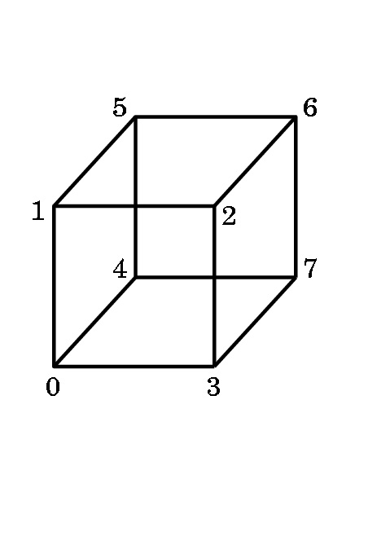
13. Suppose the following teapot is centered at the origin in 3D world space

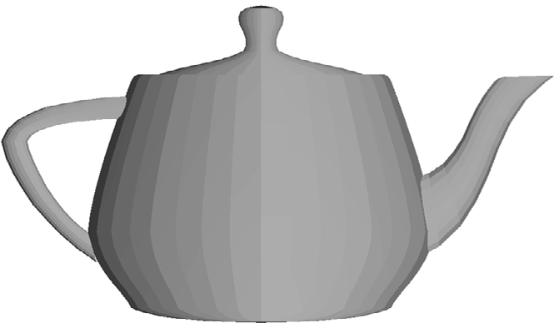
with the spout on the positive x-axis. The entire teapot fits inside a square box with sides of length 5 units. Describe, as best you can, what would be seen on the screen with the following settings for gluLookAt, assuming the ModelView matrix is the identity matrix: Be specific about where the spout is, the top, etc. in the rendered picture.

a. eye = (0,0,20), at = (0,0,0), up = (-1,0,0), fov = 60

b. eye = (0,20,0), at = (0,0,0), up = (0,0,1), fov = 60

c. eye = (0,0,20), at = (0,5,0) , up = (0,1,0), fov = 60

14. (MCC) OpenGL uses the following rendering algorithm:
a. Painter's
b. Ray-tracing
c. Phong
d. Gouraud
e. Z-buffer
f. None of the above

15. (MCC) The following rendering algorithms produce shadows, reflections, and refractions as they render a scene:
a. Painter's
b. Ray-tracing
c. Phong
d. Gouraud
e. Z-buffer
f. None of the above

16.(MCC) Although the algorithm was modified, which of the following was the basic rendering algorithm used in the production of Disney's "Toy Story"?
a. Painter's
b. Ray-tracing
c. Phong
d. Gouraud
e. Z-buffer
f. None of the above

17. DEFINE:
a. depth buffer

b. shadow buffer

18. Identify the shading model used for each of the following:
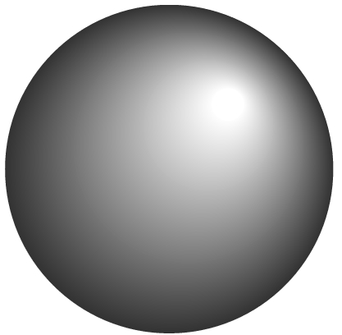
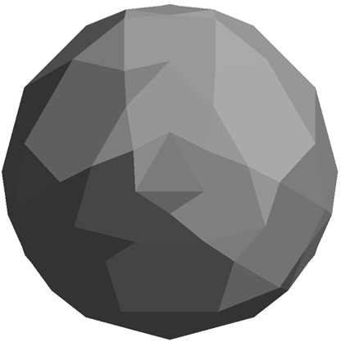
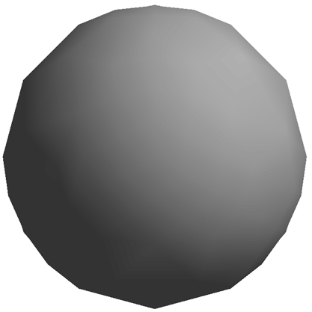
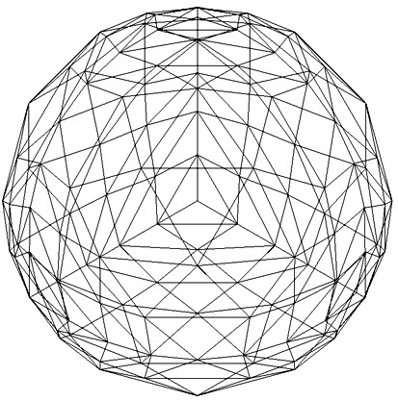

ANSWER: ANSWER: ANSWER: ANSWER:

19. Identify the shading algorithm being described for an object modeled with polygons:

a. Gives the same color to every polygon ______________________________

b. Does a color calculation for every pixel. _____________________________

c. Does one color computation per polygon _____________________________

d. Blends color along the edges of polygons by interpolation.________________

e. The GL_FLAT shading provided by OpenGL. __________________________

f. The GL_SMOOTH shading provided by OpenGL. _______________________

20. (MATCHING) Match the lighting types to each phrase that describes them by listing the capital letters identifying the phrase.
a. ambient light ________________________________________

b. diffuse light ___________________________________________

c. specular light __________________________________________

A. Directionless
B. Directional
C. Light intensity is the same at every point of a surface.
D. Typically from a large light source.
E. Often shines through a diffuser that scatters light in all directions.
F. Contributes to the highlight on an object, if it exists
G. Reflects light sharply at an angle

21. (MCC) Match the material properties to each phrase that describes them by listing the capital letters identifying the phrase.
a. ambient settings___________________________________________

b. diffuse settings ___________________________________________

c. specular settings__________________________________________

d. shininess settings _________________________________________

A. Determines the color of highlights, if they exist.
B. Determines the dominant color when no direct light is on the material.
C. Determines the dominant color when the surface is illuminated.
D. Determines the size of the highlights, if they exist..

22. DEFINE:
a. normal

b. normalized normal

c. vertex normal

23. Normalize the vector from (0,0,0) to (-1, 2, 3).

24. (TRUE-FALSE) In OpenGL, normals are provided for evaluators and primitives, but for other objects you must calculate the normals for lighting to work properly.

25. (TRUE-FALSE) In OpenGL, if you have defined a light and then changed the ModelView matrix, the light's position will automatically be recalculated.

26 Define the following and why they are used.

a. Environment mapping

b. Bump mapping

27. (MCC) Antialiasing techniques are used to correct aliasing errors that are seen as
a. Jaggies
b. Staircasing
c. Missing or malformed polygons
d. Disintegrated textures
e. None of the above.

28. DEFINE: articulated figure

29. Why are hierarchical structures used to model articulated figures?

30 Consider the following which models a robot with each M_{k} being the matrix required to position the extremity relative to its parent.

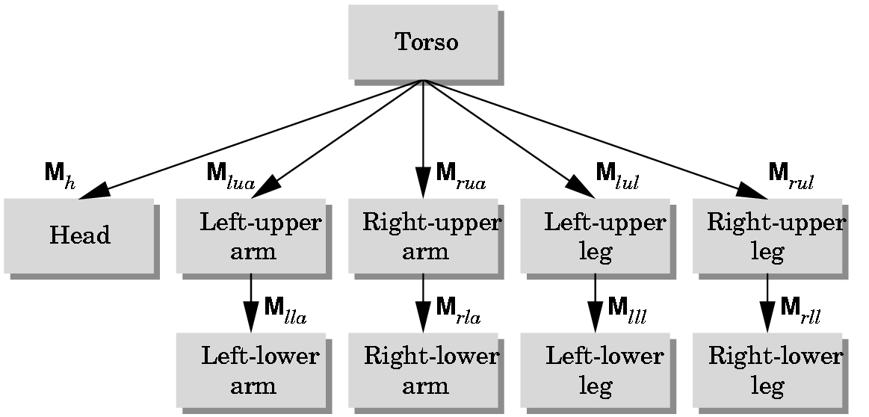

Let M be the current modelview matrix when the rendering code for torso is drawn.

a. What is the modelview matrix used when the left-upper leg is drawn?
ANSWER:

b. What is the modelview matrix used when the left-lower leg is drawn?
ANSWER:

c. When is M pushed?
ANSWER:

d. Why is M pushed?
ANSWER:

31. Assume that an OpenGL program is in ModelView mode and the following code is being executed where
draw -- is code for rendering an object using its vertices
and each primitive transformation is given with its parameter not specified below:

glPushMatrix();
glTranslate ....;
glRotate ...;
draw();
glPopMatrix();

Let M = the modelview matrix at the start of the code, T= the translate matrix formed, R = the rotate matrix formed, and P = the projection matrix in effect at the start of the code.

When the draw command is issued, show the matrix (as a product of matrices, naturally) used to render the points in draw:

ANSWER:

32. (MCC) Texturing as a graphics technique
a. Adds a great deal of realism rather quickly.
b. Can, in OpenGL, affect performance.
c. Can, in OpenGL, affect lighting parameters.
d. Is similar to pasting stamps on an object.
e. Is subject to aliasing problems.
f. None of the above.

33. In the class work on texturing, we used a file format of _________ for the image because it was a cross-platform format.

34. (TRUE-FALSE) The file format we used in the class work on texturing is the only file format that OpenGL supports.

35. First derivative continuity at joins of curves and surfaces is important in graphics because it guarantees that parts of a figure do not exhibit non-smooth ____________.

36. What would you probably see if the 1st derivative at the joins of surfaces forming an animated figure was not continuous?
ANSWER:

37 Second derivative continuity at joins of curves and surfaces is important in graphics because it guarantees that parts of a figure do no exhibit non-smooth ______________.

38. What would you probably see if the 2nd derivative at the joins of surfaces forming an animated figure was not continuous?
ANSWER:

39. When we say a Bezier curve is affine invariant in a graphics setting, what does that mean?
ANSWER:

40. (MMC) The following are properties of Bezier curves:
a. They are defined as parametric equations.
b. They are polynomials.
c. They are continuous except at the endpoints.
d. They can be pieced together easily with 1st derivative continuity.
e. They can be pieced together easily with 2nd derivative continuity.
f. None of the above.

41. Given the following control points in the plane for a Bezier curve,
p₁
•

p₀
• •
• p₃
p₂

which of the following could be the curve defined by the points?

a. p₁
•

p₀
• •
• p₃
p₂

b. p₁
•

p₀
• •
• p₃
p₂

c. p₁
•

p₀
• •
• p₃
p₂

d. p₁
•

p₀
• •
• p₃
p₂

42. For each curve above which in not a Bezier curve defined by the specified control points, next to the curve state what property of a Bezier curve is violated.

43. If we wish to splice a Bezier curve with control points p₀, p₁, p₂, ... p_{n} to another Bezier curve with control points q₀, q₁, p₂, ... q_{m} and have 1st derivative continuity at one of the endpoints, how must we choose some of the points for the second curve?
ANSWER:

44.(MMC) Reasons that B-splines are used instead of Bezier curves or surfaces include a. Local control is better.
b. B-splines are simpler to understand and formulate.
c. 2nd derivative continuity at joins is easier to obtain.
d. The degree of the polynomial can be kept low even when more control points are desired.
e. They are easier to calculate.
f. Unlike Bezier curves or surfaces, they are specified by explicit equations.
g. None of the above.

45. Recall the definition of a Bezier cuve in 3D space:

Let p_{k} = (x_{k}, y_{k}, z_{k)} be a control point for k = 0, 1, ...,n
n
P(u) = Σ C(n,k) u^{k} (1-u)^{n-k}p_{k} where C(n,k) = n!/ (k! (n-k)!)
k=0

C(n,k) are the binomial coefficients. (Recall how to calculate those using Pascal’s triangle—the n=2 case is easy for finding the coefficients.)

Calculate the following points using
n=2, p₀ = (-1,1,1), p₁ = (1,0,0), and p₂ = (0,0,2).
Showing your work or stating how you determined the answer will allow you to receive partial credit in case you make a calculating error. Show your work on your own paper and mark here that you have done that.

a. P(0)

b. P(1)

c. P(1/2)

46. (MMC) Fractals are good for modeling structures such as
a. Fire
b. Water
c. Shorelines
d. Mountains
e. Trees
f. None of the above

47. (MMC) Properties of fractals are
a. On zooming in, the shape becomes more irregular.
b. On zooming out, the shape becomes more irregular.
c. The Hausdorff-Bisciovitch dimension is strictly smaller than the topological dimension.
d. Self-similarity
e. If the fractal is enlarged, it is identical to the original fractal.
f. None of the above

48. Natural landscapes are modeled with a ruggedness factor of approximately ____ and mountains such as the Alps are modeled typically with a ruggedness factor of approximately _____.

49. Consider the following window and its extensions:

Assume the ordering for the clipping with the Cohen Sutherland Algorithm is in the order Top, Left, Bottom, Right.

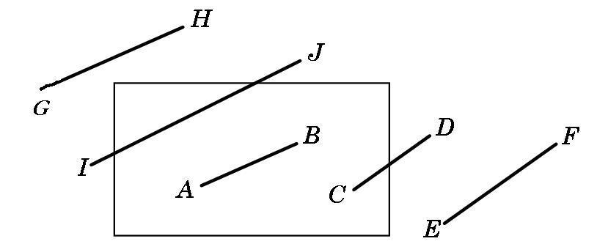

For each line segment above, state whether it is TA (trivially accepted), TR (trivially rejected), or, if it is clipped, how many clips take place.

AB
CD

EF

GH

IJ

50. On your own paper, show how the line segment CD above is handled by the Cohen Sutherland Algorithm and label the points that must be calculated as 1 for first, 2 for second, etc.

51. Why is the Liang-Barksy Clipping Algorithm ultimately more efficient than the Cohen-Sutherland Clipping Algorithm.

52. What is the test used by the Back-Removal Algorithm to cull back polygons? In what kind of an axis system must it be performed? Are there any types of polygons that can’t be handled properly by the algorithm? Explain your answers.

53. Why is the Utah Teapot so popular as a testing object?

54. Explain why parametric equations are used more than explicit or implicit equations in graphics. Be specific and give examples, if possible, as to the types of problems that can be avoided by using parametric equations.

BE SURE TO FILL OUT THIS PAGE!!!

Indicate below by a check which of the following you have submitted for CPSC 387:

1) _______The paper describing the changes you made to gasket3d.c and screen shots of runs.

2) _______Your code for the Star program.

3) _______Your screen shots for the Star program.

4) _______ Your code for creation of your Creature and directions for running it.

5) _______ Your code for flying around your Creature and directions for running it.

