NAME:___________________________________Put your initials on each page please.

CPSC 387: Graphics

DIRECTIONS: Answer on these sheets when possible. Use additional paper if necessary.

1. Mark each of the following as True or False in the blank provided. If False, substitute a word or words for the boldfaced word(s) in such a way that the substitution would make the sentence true. Write the word or words under the statement, please.

a) _____ Changing pictures digitized from real world images in order to extract new information from them, or for artistic effect, are the concerns of a computer scientist doing graphics.

b) _____ Computer graphics is concerned predominately with the computer construction of synthetic images of real or imaginary objects.

c) _____ To avoid screen flicker, a refresh display must refresh at the rate of at least 200 times per second.

d) _____ Raster output devices use frame buffers to hold the generated image in memory.

e) _____ Five graphics standards and APIs, listed in increasing order of the date of their acceptance, are PHIGS, GKS, CORE, OpenGL, and X.

f) _____ OpenGL was developed by Microsoft.

g) _____ OpenGL is controlled and managed today by Microsoft.

h) _____ OpenGL includes functions for window management and user interaction. (I am using the word "window" in the sense of windows handled by an operating system, not graphics windows.)

i) _____ OpenGL is a descriptive graphics language.

j) _____ Architectural systems and CAD/CAM systems typically use a 1-point perspective projection.

k) _____ To avoid distortion when rendering a scene, the viewport and the display window should use the same aspect ratio.

l) _____ In a well-designed graphics system, the user draws using screen coordinates.

m) _____ The imaging paradigm used by OpenGL is the synthetic image model.

n) _____ The use of the pipeline architecture for graphics systems provides device independent graphics.

o) _____ OpenGL provides interactive input functions and windowing control.

p) _____ The measure of an input device is a signal from the device to the computer specifying that it has been used.

q) _____ A pick input device provides a position in world coordinates to the user's program.

r) _____ A mouse drag is one way to implement a stroke input device.

s) _____ Request mode is a standard input mode in which a program halts and waits for input.

t) _____ A function that is invoked when an event occurs is called an event function.

u) _____ In OpenGL, registering a function associates the function's name with an event and the function is called whenever that event occurs.

v) _____ In OpenGL, single buffering is used for animation typically.

w) _____ An afford transformation maps line segments to line segments.

x) _____ Points in well-designed graphics environments are represented internally by three-dimensional Euclidean coordinates.

y) _____ A basis for a space consists of linearly independent vectors that span the space.

z) _____ Saying that vectors v1, v2, and v3 are linearly independent means that when Av1 + Bv2 + Cv3 = 1, for A,B, and C scalars, then A, B, and C must be 1.

aa) _____ A frame consists of a basis and a eye point.

bb) _____ The perspective buffer in OpenGL stores the information needed to do hidden surface removal.

cc) _____ A face normal is a vector that is parallel to a face.

dd) _____ A vertex normal is the sum of the normals of edges meeting at that vertex.

2. In 3D space, every affine transformation can be described as a sequence of primitive transformations. Name those transformations.

3. What are homogeneous coordinates for points and vectors? Why are they used in graphics?

4. Consider the 2D rectangle with vertices (1,1), (3,1), (1,2), and (3,2). Apply each transformation below to the original rectangle. Draw the transformed figure.

Then, do one of the following for each transformation
i) Identify the primitive affine transformation the matrix represents OR
ii) Write U for unknown if it is not a primitive affine transformation.
Be sure to label axis to show the scale.

a)
1 0 2
0 1 -1
0 0 1

b)
0 -1 0
1 0 0
0 0 1

c)
1 0.5 0
0 1 0
0 0 1

d)
1 2 3
0 1 4
7 6 5

e)
2 0 0
0 3 0
0 0 1

5. What steps would you take to form the single matrix to rotate the square in the last question 45 degrees around the point (2,-3)? Do not answer relative to OpenGL.

6. Draw an example of the object represented by the parametric equation
P(a) = av + Q where a is a scalar, v a vector, and P(a) and Q are points.
Label your choices of Q, v, P(0), P(1), P(2), and P(-2).

7. Identify the following, assuming P, Q, and R are points; a, b, and c are scalars; and u, v, w are vectors.

a. P(a) = aR + (1-a)Q

b. Q(a,b) = P + au + bv

c. (u, v, w, P) where u, v, and w span 3D space and are linearly independent.

d. (u,v,w) where u, v, and w span 3D space and are linearly independent.

8. Compute the following. If the computation is impossible, state "I" and explain why.

a. 1 3 2 1 b. 1 2
1 4 1 2 = 3 5 =
3 1 2 3 4 2

c. 1 3 2 1 d. 1 2 0 3 =
1 4 1 2 = 3 5 1 2
3 1 2 3

9. a.What is a frame?

b. Why are frame changes used in graphics?

10. Assume a graphics display is a 3-plane graphics device using RGB color and each color gun uses 4 bits. Assume the color is given by a lookup table. Answer the following. Simplify your answers by NOT leaving them in exponential form, please.

a. How many colors can be displayed simultaneously?

b. What is the size of the device's palette?

c. How many intensities of blue can be represented? (Assume that no blue is precisely one intensity.)

d. If the resolution of the frame buffer is 1024 X 1024, how many bits are required for the frame buffer?

e. How many bits are required to store the LUT?

f. If the full palette was used instead of a LUT, how many bits are required for the frame buffer with resolution 1024 X 1024?

11. Identify the following coordinates:

a. The coordinates used by the synthetic camera

b. The coordinates in which the programmer models objects

c. The coordinates used by the output device

d. The form of coordinates used internally by OpenGL and most other synthetic camera graphics packages.

12. Consider the following OpenGL-GLUT code:

int A, B;
A = glutCreateMenu(D);
glutAddMenuEntry("Yes", 1);
glutAddMenuEntry("No", 2);
B= glutCreateMenu(E);
glutAddMenuEntry("Up", 1);
glutAddMenuEntry("Down", 2); glutAddMenuEntry("Stay", 3);
glutCreateMenu(C);
glutAddSubMenu("Directions",B);
glutAddSubMenu("Answers",A);
glutAddMenuEntry("Quit", 1);
glutAttachMenu(GLUT_RIGHT-BUTTON);

a. List the callback functions that the programmer must define.

b. Sketch the hierarchy of defined menus.

13. Describe the algorithm for drawing the picture below. What is the name of the picture?
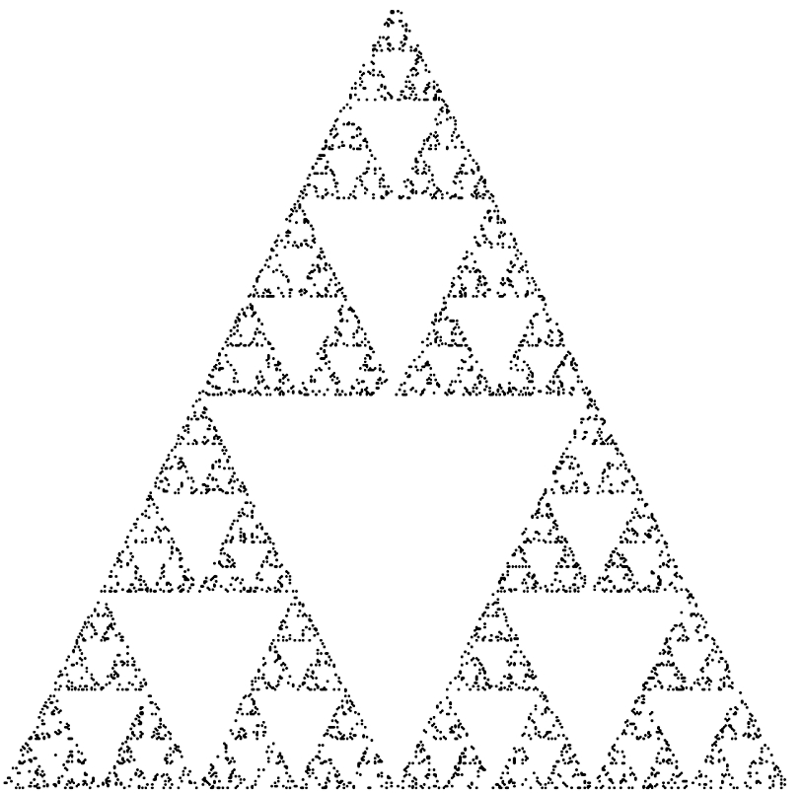

14. Define the following in the context of OpenGL-GLUT programming:

a. Event-driven programming.

b. Callback functions

c. main event loop

d. mouse event

e. idle callback

f. double buffering

15. Explain why most objects in graphics are modeled with polygons instead of curves?

16. Consider the following two vectors which are drawn in a plane defined by this paper:

Vector A Vector B

a. Draw 0.5A

b. Draw 2B

c. Draw A + B

d. Draw 4B + A

e. Describe which direction B X A is pointing---remember the paper defines the plane where A and B are.

f Show two different frames that use A and B as basis vectors in 2D space.

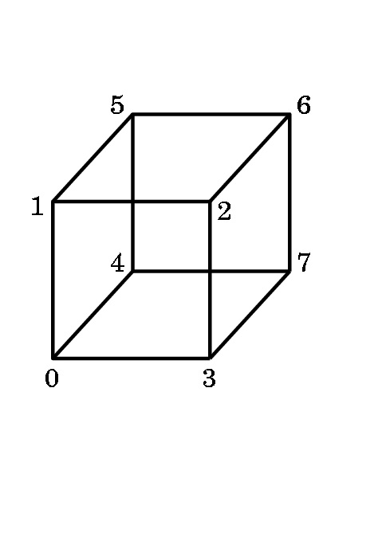
17. If you are modeling the above cube, show the order in which you would traverse each of the six faces in order to correctly identify the outside of the cube to the OpenGL software.

18. The program for the color cube interpolated the color over each face's surface. What does this mean and how was it done?

