Chapter 4: The Building Blocks: Binary Numbers, Boolean Logic, and Gates – Exercises Not Done in Class

12. Run-length encoding of xxxyyyyyyzzzzAAxxxx would be (x,3) (y,6) (z,4) (A,2) (x,4). Assuming one byte per character, the original takes 19 bytes, and the encoding takes 10 bytes, for a compression ration of 19:10, almost 2:1.
13. (a) The word KAI would be 11101 00 10 in the variable length code given. It takes 9 bits, compared to 12 bits in the 4-bit encoding. The savings is 4:3, or about 1.33.
(b) MAUI would be 11100 00 11110 10 in the variable length code. It takes 14 bits, compared to 16 bits in the 4-bit encoding. The savings is 8:7, or about 1.14.
(c) MOLOKAI would be 11100 0111 1111111 0111 11101 00 10 in the variable length code. It takes 29 bits, compared to 28 bits in the 4-bit encoding. In this case, the variable length code is actually longer, because it contains many less-frequent letters. The “savings” is 28:29, or 0.97.
22. A multiplexor with 2^{N} input lines has N selector lines, so a four-input multiplexor will need 2 input lines and an eight-input multiplexor will need 3 input lines.

23. Suppose the input lines are labeled as i_{0,} i₁, i₂, and i₃ and the selector lines are labeled (left to right) as s₁ and s₂. i₀ will be the output if both s₁ and s₂ are zero, i₁ will be the output if s₁ = 0 and s₂ = 1. The Boolean expression for a 4-input multiplexor is therefore
The circuit is
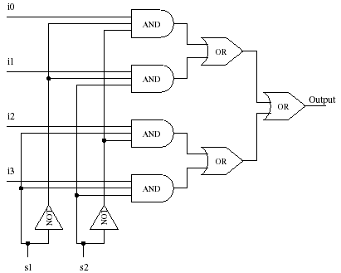

24. Suppose the input lines are labeled as i₁, i₂, and i₃, and the outputs are labeled Out₀ through Out₇. Out₀ is turned on when i₁, i₂, and i₃ are all zero, Out₃ is on when i₁ = 0, i₂ = 1, and i₃ = 1, and so forth. The circuit must have 8 subparts, one for each possible combination of input values. Each part ANDs together a particular Boolean expression like
and the result is the corresponding output line (Out₃, in this case).
