Chapter 3: The Efficiency of Algorithms
Solutions to End-of-Chapter Exercises not Done in Class – ask in class Wed if you don’t understand any of the answers.
9. Initially, the entire list is unsorted (the marker U for the unsorted section is at the end of the list, position n). Within the loop at step 3, the marker is decreased (at step 8) once for each pass until the unsorted section of the list is reduced to one element, which means U = 1. The inner loop at step 5 is always done as many times as it takes to move C
Value of U | Number of passes through loop at step 5
n | n - 1 | (C goes from 2 through n)
n – 1 | n – 2 | (C goes from 2 through n - 1)
. . . | . . . | . . .
2 | 1 | (C goes from 2 through 2)
The loop at step 5 is therefore done (n – 1) + (n – 2) + . . . + 2 + 1 times, which is Ө(n²). Each pass through this loop requires one comparison, at step 6.
19. Step 1: Get values for the target to be searched for, n, and the n list items
Step 2: Set the value of i to 1, set the value of Found to NO, set the value of Greater to NO
Step 3: While (Found = NO) and (i ≤ n) and (Greater = NO) do steps 4 through 8
Step 4: If target is equal to the ith element then do steps 5 and 6
Step 5: Set the value of Found to YES
Step 6: Print the message "Item found at location" i
Step 7: If element i is greater than target, set the value of Greater to YES
Step 8: Add 1 to the value of i
Step 9: If Found = NO, then print the message
Step 10: Stop
20. (a) n (for example, if target is equal to last element in list, must check all n elements)
(b) n/2 – element will be found just as in regular sequential search
(c) Yes – for elements that are not in the list but are less than some of the list elements, algorithm will terminate sooner than regular sequential search. (But remember that the list must already be sorted.)
29. Since the textbook example uses 3 bins, to be optimal we would have to use 1 or 2 bins. Two bins can be used as follows. Obviously, 1 bin isn’t possible. Therefore, 2 is optimal.
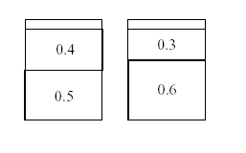
30 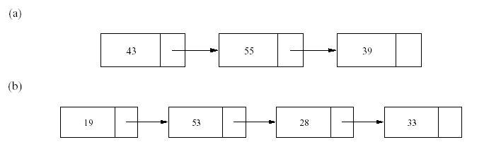
(c) Locate the first item. Follow the pointers through the list; if the next item ever has the value 0, then change its pointer to point to the next item in the list (removing the zero item). Stop at the end of the list.
There are at most n – 1 pointer operations and at most n – 2 change pointer operations, hence this is an Ө(n) algorithm.
31. (a) 2, 1, 2, 1, 2, 1, 2, 1
(b) 4, 2, 1, 4, 2, 1, 4, 2, 1, 4, 2, 1, 4, 2, 1, 4, 2, 1, 4, 2, 1, 4, 2, 1
(c) Θ(n lg n)
(d) 16 * 4 = 64
32. (a) n - 1 (largest so far must be compared with all elements in the list after item 1)
(b) Θ(n²) to sort + 0 comparisons required to get the second largest value = Θ(n²)
(c) (n - 1) + (n - 2) = Θ(n)

