CPSC 375, SPRING, 12-WEEK, 2009, Test 2
Software Engineering - Slotterbeck

DIRECTIONS: All answers should be put in this booklet online. Please be careful to read the directions below and the ones before each problem carefully. If you have any questions about interpretation, please ask me for help.

BE SURE TO ANSWER THE QUESTIONS AT THE END OF THE TEST.

IMPORTANT!!!!!!!! In the header, put your name so it will appear on each page when printed.

For (MATCHING) Note that any entry can be used more than once or not at all. HOWEVER, all matching questions on this test have single answers -i.e. choose only one of of A, B, C, etc. for each question a,b,c,etc.

For MULTIPLE CHOICE (MC) questions, write the identifying letter (a,b,c,...) for all correct entries. This means that more than one selection may be required.

For TRUE-FALSE questions, underline the TRUE or FALSE.
If a boldface word or words is in a false statement, substitute a word or words for the boldface ones that will make the statement true in a non-trivial way. For example, given a statement such as
"CPSC 375 normally meets in C-108"
correcting this with "a room other than C-108" would be a trivial way of correcting it. Instead, you should suggest the correction "C-106".

For the other problems, lists, words, phrases, or short essays that answer the questions may be used. This is the default type of question and is unmarked on the test booklet. All other types will be marked.

Note: This page appears on many of my tests. Not all of these types of questions will necessarily be on this particular test.

1. (TRUE-FALSE) The earliest possible time that detailed, significant planning can take place is after the requirements are complete.

2. (MC) ANS:
The difficulties associated with using the number of lines of code as a metric are due to many things, but include the following
a. Code writing is only a small part of the software development cycle and it seems short-sighted to ignore the time needed for requirements, specifications, testing, and managing.
b. Implementing a project in two different languages could produce radically different numbers.
c. Some languages, such as LISP, really don't have a concept of "a line of code".
d. It is unclear what should be counted as a line? Should comments be counted? Should declarations be counted?
e. Often tool code is delivered to the client. The question arises as to whether or not the size of this code should be included in the count.
f. Professionals often misjudge the size of the code, especially when the application area is unfamiliar to them.
g. None of the above

3. (MC) ANS:
Which of the following are used in computing the number of function points for a product?
a. Number of databases used
b. Number of input items
c. Number of output items
d. Number of inquiries
e. Number of master files
f. Number of interfaces
g. None of the above

4. (MC) ANS:
COCOMO has the following properties:
a. It is one of the most widely used algorithmic cost estimation models.
b. It accurately predicts cost and duration of a project.
c. It is not just one model, but several.
d. It uses the KDSI metric, an estimate of the product's development mode, and a measure of the intrinsic level of difficulty in developing the product to compute the number of person-months for the project and a number called the nominal effort.
e. The person-month figure can be used by an organization that keeps records to estimate future project details such as dollar costs, development schedules, phase and activity distributions, computer costs, and annual maintenance costs.
f. None of the above.

5. (TRUE-FALSE) Experiments to measure software productivity rates have shown a better fit using the metric KDSI than function points.
6. (TRUE-FALSE) Although size estimates can be imprecise, if an organization keeps careful records over time showing size estimates at the beginning of a project and the final product sizes, the results can be useful in making future predictions.

7. A person-year is calculated as how many hours of work over a year by one person? ANS:

8. (TRUE-FALSE) There is no need to worry about training until the product is finished. Then the user can be trained.

9. (TRUE-FALSE) The Software Project Management Plan is first able to be constructed during the specification phase.

10. (MC) ANS:
The Unified Process
a. Was the procedures we followed when doing object-oriented specifications (analysis),
b. Is due to Jacobson, Booch, and Rumbaugh.
c. Was developed and became popular in the last decade.
d. Is very easy to learn.
e. Is the methodology of choice for object-oriented software.
f. None of the above

11. (MC) ANS:
The personal interview
a. Is generally recognized as the most important and most often used fact-finding technique for eliciting requirements.
b. Result are affected by body language and skill of the interviewer.
c. Usually requires more than one interviewer:
a scribe – who records the answers
an interviewer – who asks the questions
d. Is most productive when it is not planned in advance.
e. None of the above.

12. (MC) ANS:
Which of the following are true about the requirement phase?
a. Functional requirements are handled as part of the requirements and analysis workflows
b. The detailed information for some nonfunctional requirements is not available until the requirements and analysis workflows have been completed
c. The initial requirements are based on the initial business model
e. Requirements provide an answer to the question, "How is the product built?".
f. None of the above

13. (MC) ANS
A use case
a. Models an interaction between the software product itself and the users of that software product.
b. Actor can represent only one entity - for example, all bank customers can't be an actor.
c. Actor is a member of the world outside the software product.
d. Actor must be a human being.
e. Shows the client that the requirements team understands the business domain and who interacts with whom in different cases.
f. Is used to provide the client with an easy to understand diagram that can be used to decide whether something is missing, misrepresented, or out of place.
g. None of the above

14. (MC) ANS:
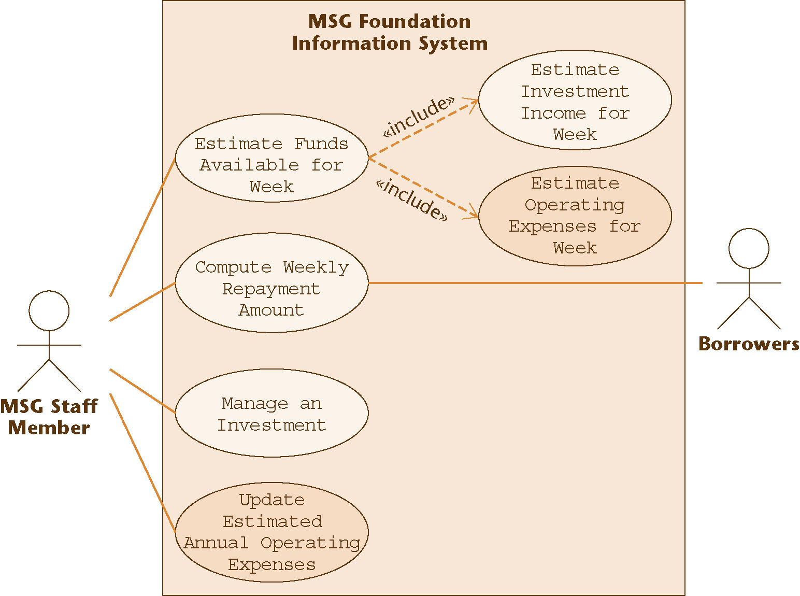
Consider the diagram

Which of the following are true:
a. The above diagram is designed using LMU.
b. You would be more likely to see a use case in a classical project than an object-oriented one.
c. MSG Staff Member and Borrowers are actors in the use case above.
d. MSG Staff Member and Borrowers both participate in a process called "estimate operating expenses for week".
e. "Estimate operating expenses for week" is a superclass of "Estimate funds available for week".
f. None of the above.

15. (MC) ANS:
For each use case identified by a process name, the team eliciting requirements provides:
a. A use case diagram
b. Code for the use case
c. A brief description of the use case.
d. A step-by-step description of the use case.
e. None of the above

16. Consider the following:
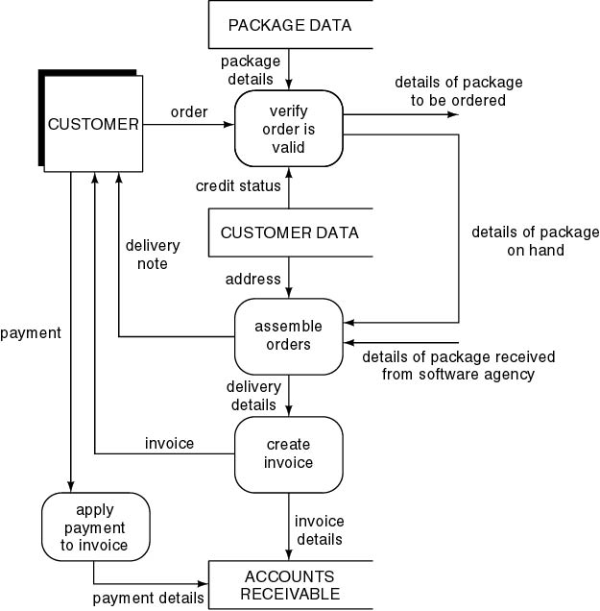

a. Give the name, but not the acronym, for the above type of diagram. ANS:
b. If you are unable to find one the following, place an N next to the request. Using the diagram above, give the name of one of the
Dataflows ANS:
Processes ANS:
External entities ANS:
Internal entities ANS:
Stores ANS:
c. The techniques we used for creating DFDs were due to whom? ANS:

17. (MC) ANS:
Which of the following are true of DFDs?
a. A DFD is one modeling tool in the object-oriented paradigm for system analysis.
b. In a DFD, data stores are parts of the system that will not be dealt with in the system being modeled.
c. DFDs stress that the modeling is keeping data and processes separated.
d. The top level of a DFD is called it a primitive level.
e. When decomposing a DFD, the dataflows are expanded to provide more detail.
f. Dataflows are typically labeled as verbs.
g. Process names are typically nouns.
h. None of the above
18. (MC) ANS:
DFDs allow you to
a. Demonstrate the sequencing of activities.
b. Show the timing of data flows.
c. Model how data flows through an information system.
d. Chooses classes to use in C++
e. None of the above

19. (MATCHING) Choose the most likely modeling entity from A-E
A. External entity
B. Data flow.
C. Process
D. Data store
E. None of the above
when building a DFD for each of the items described below

a. The computer that will run the system being designed. ANS:
b. Data in motion, moving from one place in a system to another ANS:
c. Data at rest, which may take the form of many different physical representations. ANS:
d. A computer-based file containing employee information ANS:
e. A function for calculating an employee's salary ANS:
f. A supplier of auto parts to the company ANS:

20. (MC) ANS:
Which of the following is a true statement regarding a data store?
a. A data store has a noun phrase label.
b. Data can move from an outside entity directly to a data store.
c. Data can move directly from a suitable process to a data store.
d. Data can move directly from one data store to another data store.
e. Data can move from an outside entity directly to another outside entity.
e. None of the above

21. (MC) ANS:
Which of the following are guidelines for drawing DFDs?
a. All data flows should be labeled.
b. External entities (or agents) are outside the system.
c. Individuals performing functions within the system are not entities -- their functions are captured as processes.
d Dataflow names are typically verbs
e. Process names are typically nouns.
f. Two processes can be directly connected by a dataflow.
g. Two stores can be directly connected by a dataflow.
h. Two external entities can be directly connected by a dataflow.
i. None of the above

22. Consider the following diagram. Identify all errors in the diagram below and briefly say what the error is. Be sure you identify all the entities involved in each error.
ANS:

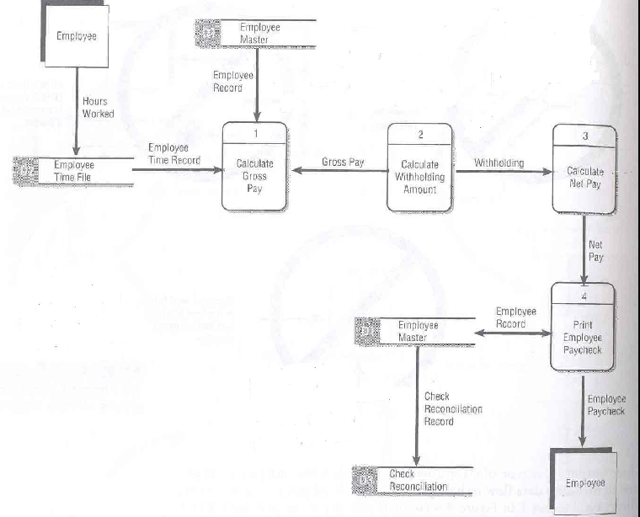

23. (MC) ANS:
The characteristics of a rapid prototype are:
a. It is hastily built.
b. Imperfections can be ignored
c. It exhibits only key functionality
d. The emphasis is only on what the client sees
e. Complex details such as error checking and file updating can be ignored
f. It is designed to provide the client with an understanding of the product
g. It should be coded carefully so the code can be reused when the final product is produced.
h. None of the above

24. (MC) ANS:
Prototyping works best when
a. The application area is well understood by everyone
b. Requirements are unclear or not well understood
c. Building new systems without existing systems
d. Building decision support systems
e. The software complexity requires modeling
f. Tools are available to support modeling
g. None of the above

25. (MC) ANS:
Some of the drawbacks of prototyping are:
a. There is a tendency to avoid documentation
b. There may be pressure to put the prototype model into production
c. The team may be tempted to shortcut well-designed procedures for producing good software
d. Because the customer sees working software, they assume the project is more complete than it is.
e. It can degrade into a build and fix model easily.
f. None of the above

26.(MC) ANS:
The specification document
a. Is a contract between the client and the developers.
b. Should never provide acceptance tests to be used.
c. Must be informal enough for the client to understand.
d. Must be formal enough for the developers to use.
e. None of the above

27. (MC) ANS:
Which of the following are tasks that must be performed when the Gane and Sarsen method is used to write a specification:
a. Construct a DFD of the existing system.
b. Construct a DFD of the proposed system.
c. Decide what parts of the existing system are to be computerized.
d. Determine the details of the dataflows which are some of the data.
e. Define the logic of the processes.
f. Specify response times needed for network work
g. Define the data stores
h. Define the physical resources.
i. Define the I/O Specifications
j. Determine the sizing
k.Determine the hardware requirements
l. None of the above

28. (TRUE-FALSE) The methods of Gane and Sarsen, De Marco/, and Yourdon have resulted in major improvements in the software industry.

29. (TRUE-FALSE) From the same data, various teams would produce the same DFD.

30. ERD is an acronym for what" ANS:.

31. (MC) ANS:
ERDs can be used to:
a. Model data and the relationships between the data.
b. Provide information that will be needed to build data stores, particularly databases.
c. Determine dataflows.
d. Help analysts identify business vocabulary.
e. Provide sketches for process code.
f. None of the above.

32. (MC) ANS:

Consider the following ERD:

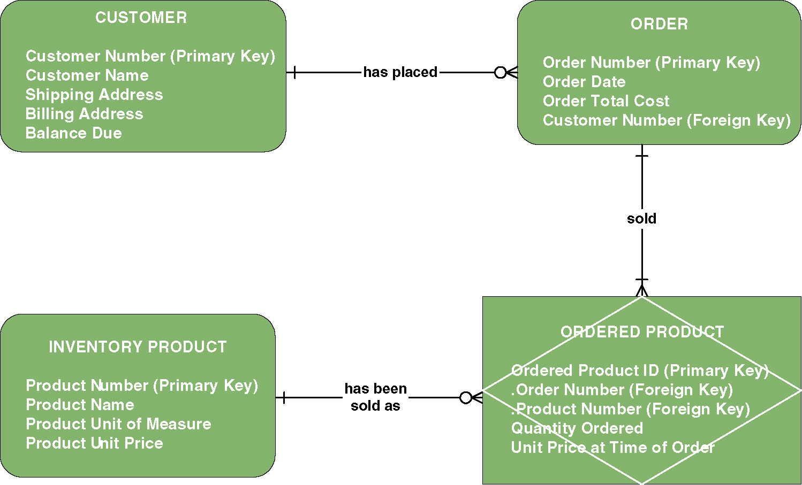

Which of the following assertions are made by the diagram?

a. A CUSTOMER has placed zero or more ORDERS.
b. An ORDERED PRODUCT can be sold as more than one INVENTORY PRODUCT.
c. A CUSTOMER, ORDER, and an INVENTORY PRODUCT are associative entities.
d. An ORDER sells at least one ORDERED PRODUCT.
e. A CUSTOMER can exist without placing any ORDERS.
f. None of the above.

33. (TRUE-FALSE) The type of relationship that needs to be avoided is a many-to-many relationship.

34. (TRUE-FALSE) All relationships are bidrectional although only one verb might be used to identify the relationship on the ERD.

35. (MC) ANS:
Specification and design techniques can be classified as formal, semi-formal and informal. Which of the following techniques are not classified as semi-formal?
a. English descriptions
b. Finite state machines
c. Gane and Sarsen's systems
d. Petri Nets
e. The language Z
f. None of the above

36. (MC) ANS:
Consider the decision table:
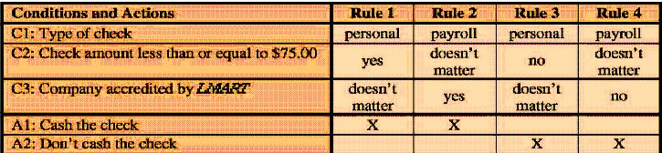
Which of the following policies are supported by this table?
a. For a personal check of $100 from a company accredited by LMART, cash the check.
b. For a payroll check of $100.00 from a company accredited by LMART, cash the check.
c. For a payroll check of less than $75 from a company not accredited by LMART, cash the check.
d. None of the above.

37. (MC) ANS:
When contrasting structured analysis and object analysis, which of the following are true?
a. A pure structured analysis approach separates data and processes, models them separately, and only checks that they are coordinated.
b. A pure object analysis approach deals with the data and processes as a cohesive whole.
c. Older structured analysis methodologies developed many different DFDs that are now not deemed to be necessary.
d. It is not unusual to see an analyst mix the methodologies and, for example, produce use-cases when doing structured analysis.
e. Object analysis has gained in popularity as object-oriented languages have become popular.
f. No one uses structured analysis techniques anymore and they were only introduced in this class for historical reasons.
g. Case tools exist for structured analysis as well as object analysis.
h. None of the above

38. (MC) ANS:
Consider the diagram below the next question. You need not repeat the word Class in your answers. Write N if there are none of that type.
a. List the boundary classes. ANS:
b. List the entity classes. ANS:
c. List the functional classes. ANS:
d. List the control classes. ANS:

39. (MC) ANS:
Consider the diagram below.
a. The diagram is called a state diagram.
b. It realizes the scenario of a use case.
c. The numbering shows the ordering of activities.
d. None of the above

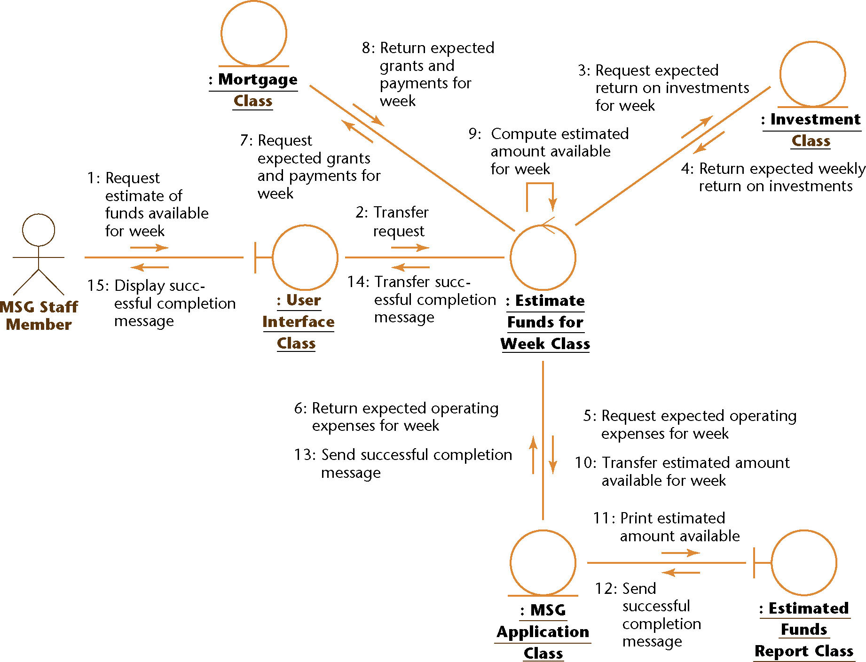

40. (MATCHING ) Match the following to the sentence describing the item.
A. Milestone B. Critical path C. Gantt chart
D. Task E. PERT chart G. None of these

a. The date on which the work product is deemed to be completed. ANS:
b. The smallest unit of work subject to management accountability ANS:
c. A bar graph showing each task in a project, its estimated duration, and, for completed tasks, the actual time used to complete the task. ANS:
d. The sequence of tasks that must be completed in the time estimated or the length of the project will change. ANS:
e. Where your resources should be placed if the project starts to slip in time. ANS:

41. Use the following diagram to answer the questions below:

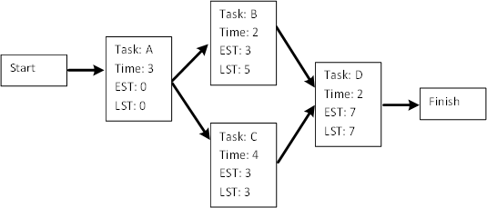

a. What does EST mean?
b. What does LST mean?
c. What tasks are in the critical path? How do you know?
d. Why is the critical path important?
e. Name the kind of chart shown above.

42. Use the following diagram to answer the questions below:
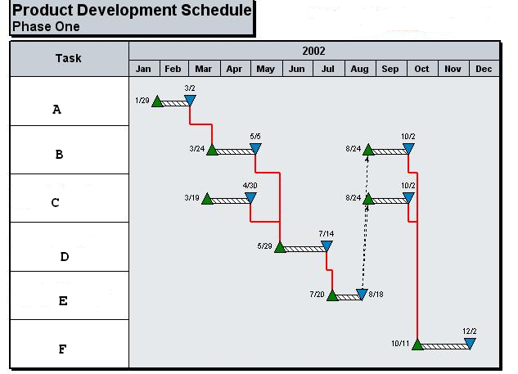
a. Name the kind of chart shown above.
b. What do the red lines (the single line segments connecting triangles) show?
c. Name all the tasks that could take more time than shown and still have the project end at 12/2.
d. How much additional time can each take without impacting the delivery date.

43. (TRUE-FALSE) The degree of interaction within a module is called coupling.

44. (MC) ANS:
Informational cohesion
a. Is the preferred type of cohesion to be used in design work.
b. Depends on passing a parameter which specifies which part of the code to execute.
c. Essentially implements an abstract data type.
d. Dictates that all functions that appear in time to be close to each other should be put in the same module.
e. None of the above.

45. (MC) ANS:
Content coupling
a. Is the preferred type of coupling to be used in design work.
b. Allows modules to invoke functions in various modules.
c. Allows a modules to be inter linked.
d. Allows access to common data.
e. None of the above.

46. (MC) ANS:
Examples of fourth generation languages are:
a. C++
b. Java
d. Report generators
e. Forms generators
f. None of the above

47. (MC) ANS:
A stub has the following properties
a. It is code written during testing that is to be provided to the customer.
b. It is an example of throw-away code that allows various tests to be run.
c. It can usually be expanded into working code.
d. It is used when bottom-up testing is performed.
e. None of the above

48. Give just the identifying letter(s) for each answer.
Which of the following are names for testing to specifications? ANS;
Which of the following are names for testing to code? ANS:
a. structured
b. black-box
c. data-driven
d. logic-driven
e. glass-box
f. functional
g.input/output driven
h. (s)path-oriented

49. The specifications for a DBMS state that the product must handle any number of records between 1 and 64,000.
List representative test cases you would use when testing to specifications by giving the number of records you would use for testing. ANS:

50. (MC) ANS:
Which of the following are examples of testing to code? Choosing cases that
a. Execute each statement.
b. Execute each equivalence class representative for all the input.
c. Execute each branch.
d. Execute each path in the code.
e. None of the above

51. (TRUE-FALSE) When testing a product, it suffices to show the product is correct.
If FALSE, briefly explain why.

52. (TRUE-FALSE) A product can be correct and still not perform satisfactorily.
If FALSE, briefly explain why.

53. (TRUE-FALSE) A product can fail to be correct and still perform satisfactorily.
If FALSE, briefly explain why.

Be sure to answer this question. It is difficult to evaluate others, but you will find that you will be doing this in almost any job you take. Please answer exactly and provide examples where possible. You may include yourself as an answer if you feel you can justify your choice.

I. Who were your teammates on the project?
II. What teammate did the most to help on the project? Why did you choose this person (or persons)?
III. Is there anyone who did not pull their own weight on the project? Why did you choose this person (or persons)?
IV, Did you have trouble meeting as a group outside of class? If yes, why?
V. Did you learn anything from working in a group? Explain your answer.
VI. What would have made your group be even more successful?

HAVE A NICE BREAK!

