# 

# Lab 1

CPSC35200, Fall, 12 week

Computer Security

# 1) Get Virtual Machines for your lab machine

These are already installed--- you just have to make them available. Next time, I’ll make alternate materials available for other machines.

Login into lab machine

Go to application =>accessories=>terminal

On left menu, choose System Tool and then VMWare Player.

You should see the following:

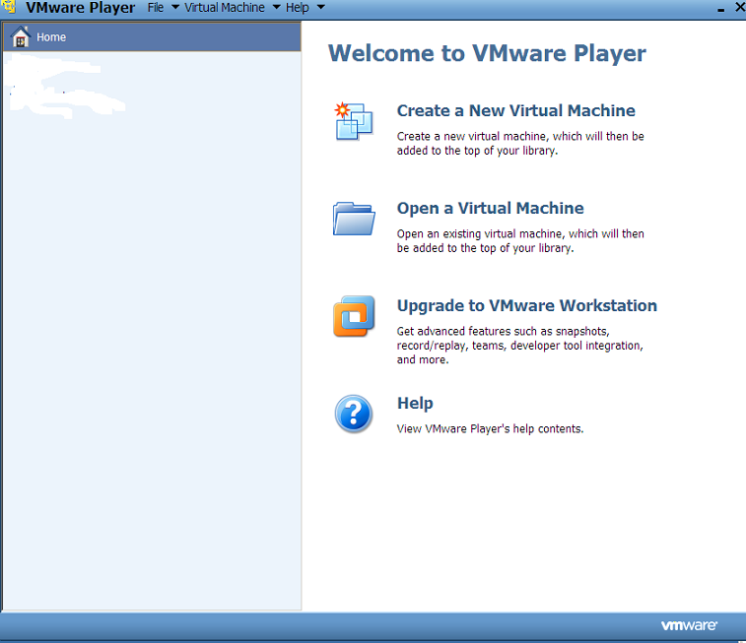

Choose “Open a Virtual Machine”

**2, Load VMs**

Locate the VMs ubuntu 10.vmx and ubuntu10tm.vmx and click on the first one,

Decline an update for tools on both by clicking “remind me later” and click “I copied it” when that message comes up.

Repeat with the other VM.

Note: In the future, calling VNPlayer should bring up the following:

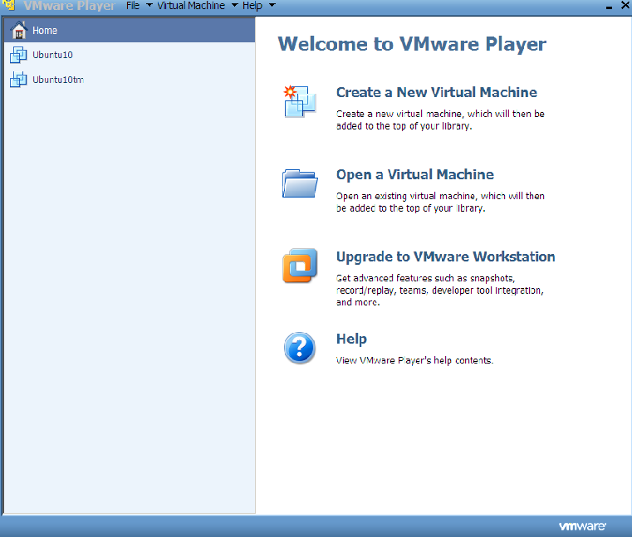

Click on ubuntu 10 on the left and choose “play virtual machine”. The other VM has some preloaded software that will be used in other labs.

**3) Login**

Login Linux using username “ubuntu10tm”or “user” and password “123456”. DO NOT CHANGE THIS PASSWORD EVER!

After logging in, you should see the Ubuntu 10 GNOME interface. The virtual machine runs Linux as if it is an independent computer. Actually, the Linux is running in the memory of the computer and simulates another physical machine that the virtual machine (VM) was created.

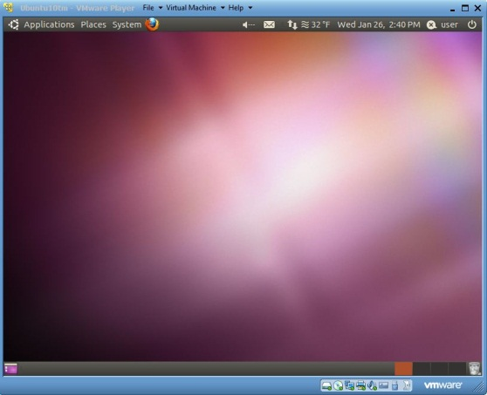

**4. Basic Skills - demo**

Below are some basic skills to use with a virtual machine

* To start directing mouse and keyboard input to a running virtual machine, type Ctr+g or click anywhere in the virtual machine window.
* To start directing mouse and keyboard input to the host PC, type Ctr+Alt.
* To get the logon window for Windows, use Ctr+Alt+Insert, instead of Ctr+Alt+Delete.
* Scroll the bar on the right and at the bottom of the virtual machine window to see a wider screen.
* To transfer files between the host and a running Windows virtual machine, just drag-and-drop the files.
* A USB disk is also a convenient way for transferring files between the host PC and a virtual machine. Inserting a USB disk to your PC when the virtual machine is active will attach the USB disk to the virtual machine.

Check out the menu bar for Linux GUI on the top panel of the window. The menu bar includes Applications (similar to Windows Start Panel), Places (all devices and storages), and System (Linux system functions).

# 5) Basic Linux Commands

* + 1. Click on Applications, Accessories and Terminal (You may need to scroll the window down to see Terminal if your screen is not big enough).
    2. It opens up a Linux command prompt like the screen below.

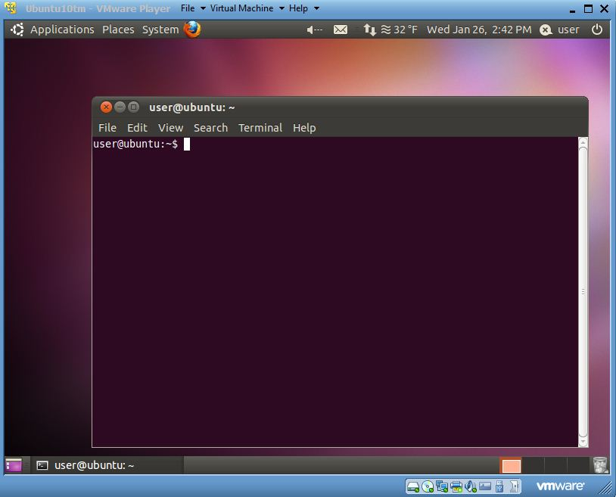

Try Linux commands under the command prompt “user@ubuntu~$” (we will use $ referring the command prompt for all the instructions below). Practice several basic Linux commands to get a feel for the software,

Browse around to see what is there,

# 

**6. Cracking Passwords- Watch demo**

Basically, we’ll do the following:

Download John the Ripper from <http://www.openwall.com/john/f/john-1.7.8.tar.gz>

Untar and compile:

tar –xvzf john-1.7.8.tar.gz

cd john=1.7.8/scr

make

make clean generic

Locate passwd and shadow files. Can you read them?

You need the shadow file to crack with John and you need superuser status for that. Luckily, user is in the wheel group so use

sudo su

First, add a couple of users to the system with easy passwords:

adduser <name>

Copy the shadow file to your run directory

Run john on that file and several others I will provide:

./john myshadow1

Does this work?