6 Attendance Module
The attendance module in Eyebox HRMS (Human Resource Management System) is a component or feature that enables organizations to effectively track and manage employee attendance and work hours. It provides a centralized system for recording, monitoring, and analyzing employee attendance data, allowing HR departments to streamline attendance management processes and ensure accurate payroll calculations.
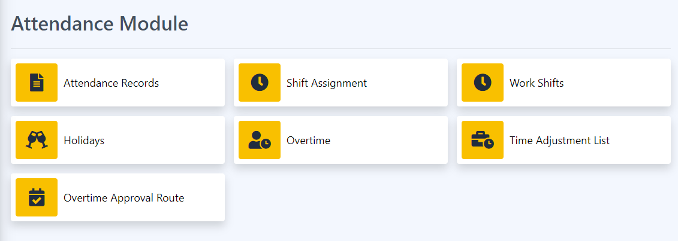

6.1 Attendance Records
Attendance records in Eyebox HRMS (Human Resource Management System) refer to the digital or electronic records that capture and store information about employee attendance, including clock-in and clock-out times, breaks, leaves, and other attendance-related data. The attendance records within an HRMS serve as a centralized and reliable source of information for tracking and managing employee attendance.

1. Time and Attendance Tracking: The HRMS captures employee attendance data through various methods such as manual entry, biometric devices, time clocks, or mobile applications. The system records precise timestamps for clock-in, clock-out, and breaks, ensuring accurate tracking of employee working hours.

2. Real-Time Updates: The HRMS provides real-time updates of attendance records, allowing supervisors, managers, and HR personnel to access the latest attendance data. This enables timely decision-making, such as identifying absences, addressing attendance issues, or managing staffing requirements.

3. Leave and Absence Management: The attendance records within the HRMS include information about employee leaves, such as vacation days, sick leaves, personal leaves, or any other approved time off. This helps in maintaining comprehensive attendance records and ensures accurate tracking of leave balances.

4. Compliance and Policy Enforcement: The attendance records within the HRMS facilitate compliance with labor laws and company attendance policies. They help in monitoring and enforcing attendance rules, such as tracking late arrivals, early departures, or managing overtime hours based on predefined policies and regulations.

5. Historical Data: The HRMS maintains historical attendance records, allowing organizations to track attendance patterns over time. This historical data can be used for analyzing trends, identifying absenteeism issues, and making data-driven decisions to improve attendance management and productivity.

6. Reporting and Analytics: The attendance records stored in the HRMS can be utilized to generate reports and analytics related to employee attendance. These reports provide insights into attendance patterns, absenteeism rates, punctuality, and other attendance-related metrics. They help HR personnel and management to identify areas for improvement and make informed decisions.

7. Integration with Payroll: The attendance records within the HRMS are often integrated with the payroll system. This integration ensures accurate calculation of employee wages based on attendance data, such as working hours, overtime, or leave deductions. It streamlines the payroll process and reduces manual errors.

8. Data Security and Privacy: Attendance records within the HRMS are securely stored, ensuring data privacy and compliance with data protection regulations. Access to attendance records is typically limited to authorized personnel, ensuring confidentiality and data integrity.

Overall, attendance records in Eyebox HRMS provide a comprehensive and reliable system for tracking and managing employee attendance, enabling organizations to maintain accurate records, ensure compliance, and optimize workforce management processes. Import and export of data and endorsing it for payroll processing.
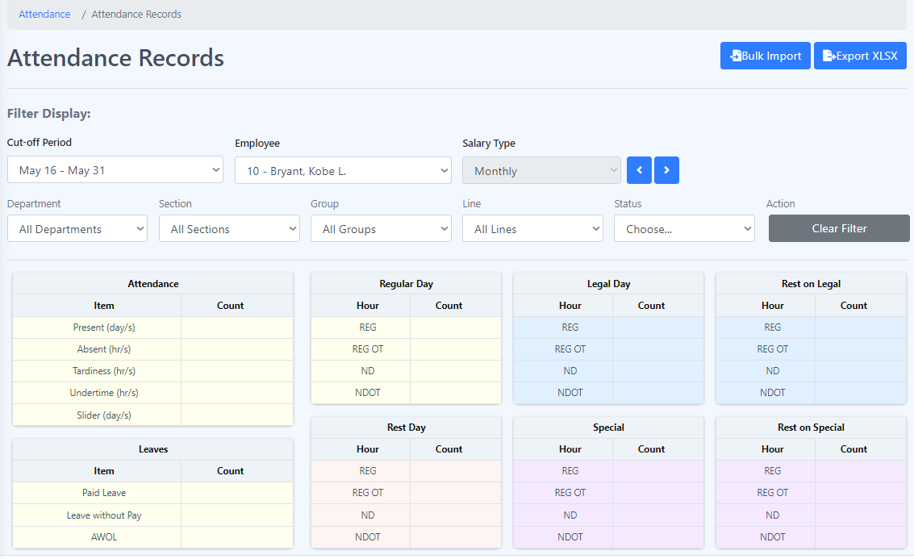
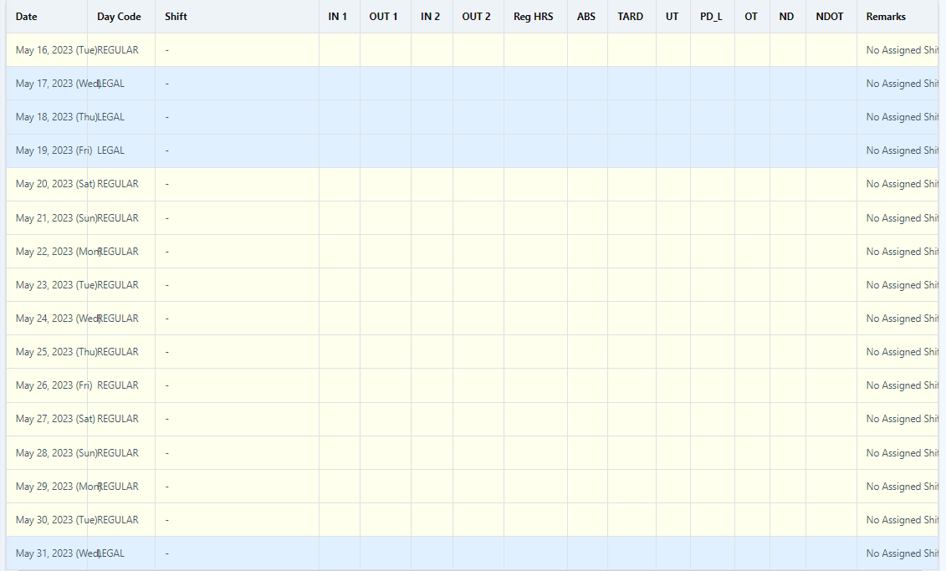

Attendance -> Attendance records -> Bulk import
How to import in bulk?
Step 1: In “Attendance records” click “Bulk Import” button at the upper right corner of the page.
Step 2: Follow the step given before uploading the CSV.

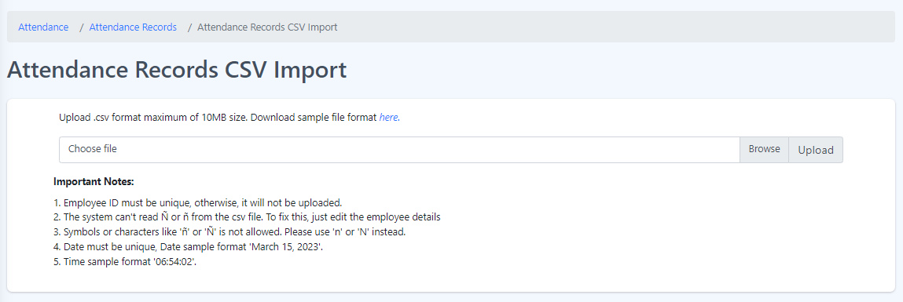

6.2 Shift Assignment
Shift assignment in Eyebox HRMS (Human Resource Management System) refers to the process of assigning employees to specific shifts or work schedules within an organization. It involves the allocation of employees to designated time slots or periods, ensuring adequate coverage and effective workforce management.
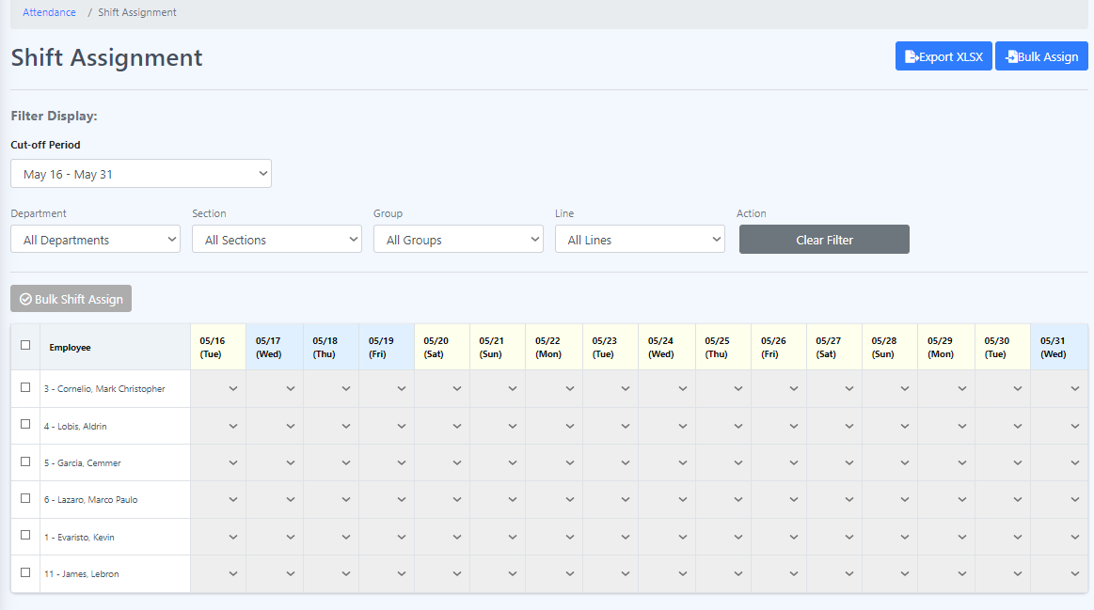

How to assign shifts?
Step 1: Choose an employee to whom you want to assign a shift and select the day on which you will assign the chosen employee.
Step 2: Select the shift that you want to assign to the employee.

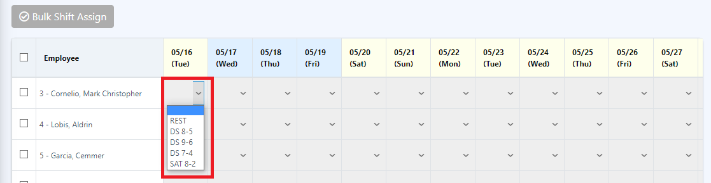

How to bulk shift assign?
Step 1: Navigate to the shift assignment section.

Step 2: Click on an employee or select all employees that you want to bulk shift assign.

Step 3: Look for the option or button labeled "Bulk Shift Assign" that enables bulk shift assignment.

Step 4: Click on the bulk shift assign to initiate the process.
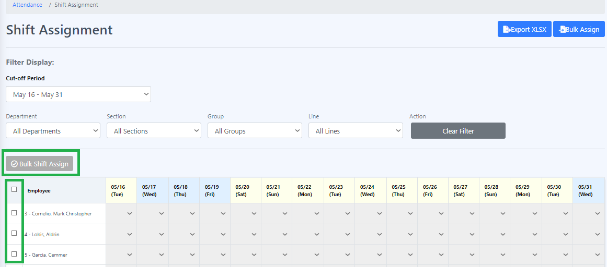

Step 5: You will likely be presented with a form or template to input the necessary information for assigning shifts.

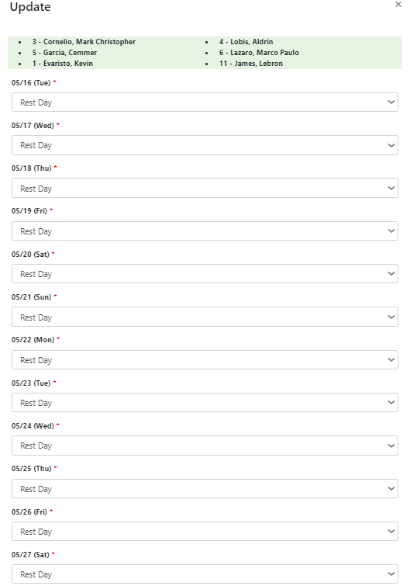
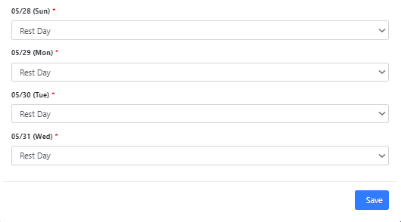

Step 6: Select the shift that you want to assign to the employee in the form or template.

Step 7: Once you have finished assigning shifts, click the "Save" button to initiate the process.

How to Bulk Import of Shift Assignment?
1. Click the "Bulk Import" button.
2. Follow the provided set of rules.

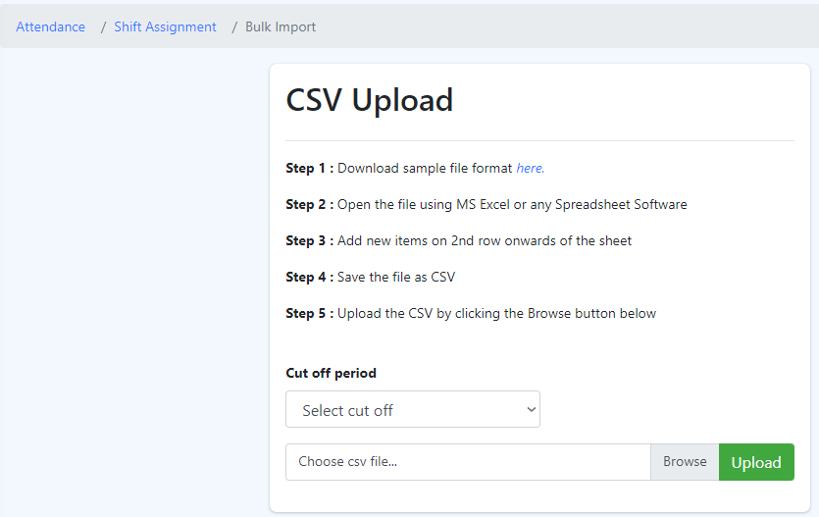

6.3 Work Shifts
Work shifts in Eyebox HRMS (Human Resource Management System) refer to predefined periods of time during which employees are scheduled to work. These shifts help organizations efficiently manage their workforce and ensure adequate coverage across various operational hours. Work shifts within an HRMS typically include specific start and end times, as well as any associated rules or requirements.
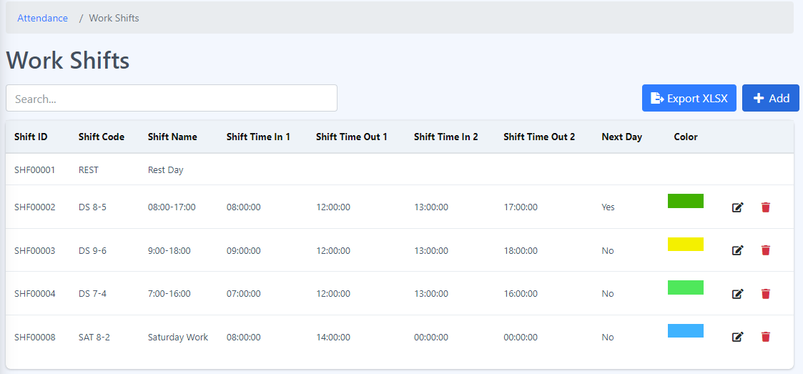

- Shift ID - A shift ID, or Shift Identifier, is a unique alphanumeric code or numerical value assigned to a specific work shift within an organization. It serves as an identifier or reference for a particular shift and helps in tracking and managing schedules effectively.

- Shift Code - A shift code, also known as a shift identifier or shift number, is a unique alphanumeric code or numerical value assigned to a specific work shift within an organization. It serves as a code or identifier to distinguish and reference a particular shift.

- Shift Name - A shift name is a descriptive label or title assigned to a specific work shift within an organization. It serves as a recognizable name that represents a particular shift and helps in easily identifying and referring to it.

- Shift Time in and Time Out - Shift time in and time out refer to the designated start and end times of a specific work shift within an organization. These time points indicate when employees are expected to begin and finish their work for a particular shift.

- Next Day - When referring to shift time in and time out for the "next day," it typically means that the shift extends beyond midnight and carries over into the following calendar day. In such cases, the time out would occur after midnight, indicating the end of the shift on the subsequent day.

- Color - Color is a visual perception resulting from the stimulation of photoreceptor cells in the human eye by different wavelengths of light. It is the characteristic that allows us to differentiate objects based on the wavelengths of light they reflect or emit.

How to add work shifts?
Step 1: Click the “Add” button.

Step 2: Fill in all the required field(s) and click “Save”.
All new work shifts are added to the table under the "Work Shifts" section.

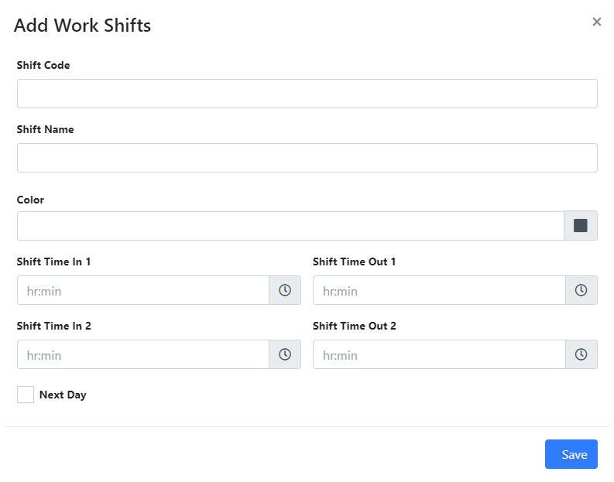

How to Edit Work Shifts?
Step 1: Click the edit icon located near the color column.

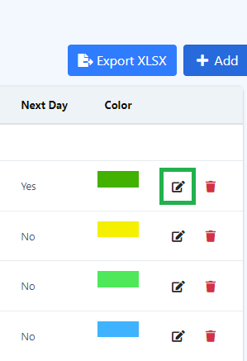

Step 2: Edit the required field(s) and click "Save".
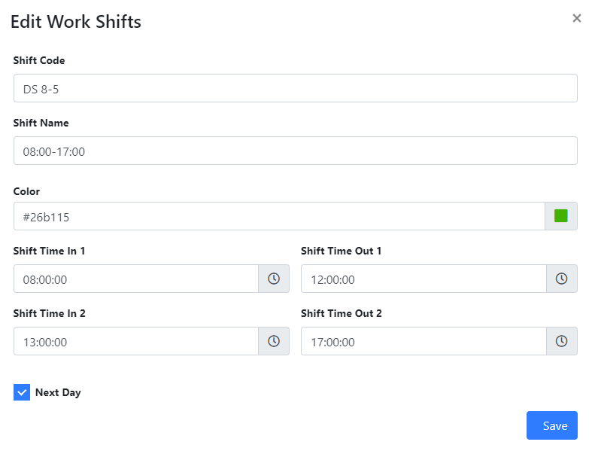

6.4 Holidays
Holidays in an HRMS (Human Resource Management System) refer to specific days that are recognized and designated as non-working days for employees. These are typically days of significance or importance, such as national holidays, religious observances, or other special occasions.
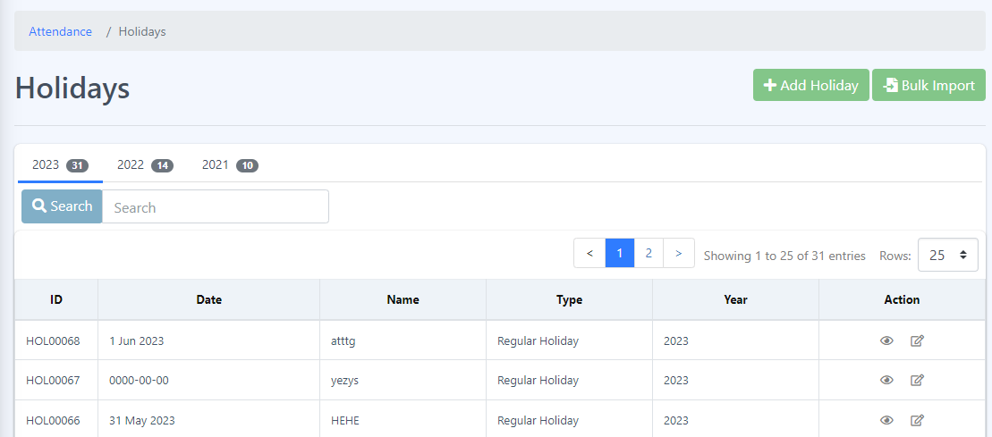

1. Holiday ID: Each holiday is assigned a unique identification number or code, known as the holiday ID. It serves as a reference point for the holiday and ensures its uniqueness within the system.

2. Date: The date attribute represents the specific day on which the holiday occurs. It includes the day, month, and year information to accurately identify the holiday.

3. Name: The name attribute refers to the official or commonly recognized name of the holiday. For example, "New Year's Day," "Christmas," or "Labor Day."

4. Type: The type attribute categorizes the holiday based on its nature or origin. This can include various types such as national holidays, public holidays, religious holidays, cultural holidays, or company-specific holidays. It helps in organizing and grouping holidays for reporting and management purposes.

5. Year: The year attribute specifies the calendar year to which the holiday belongs. This is particularly relevant when generating holiday calendars or scheduling employee time off, as holidays may vary from year to year.

How to Add a new Holiday?
- Click on the "Add Holiday" button.
- Fill in all the required fields, such as the date, name, type and year, and then click the "Submit" button.
- The newly added data will be displayed in the table on the Holidays page.

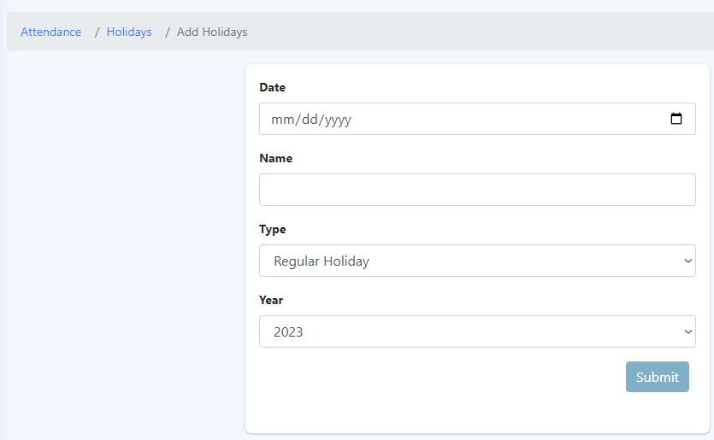

How to see more details about the holiday?
  - Click on the eye icon located under the Actions column.
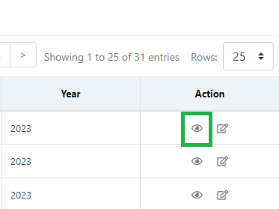
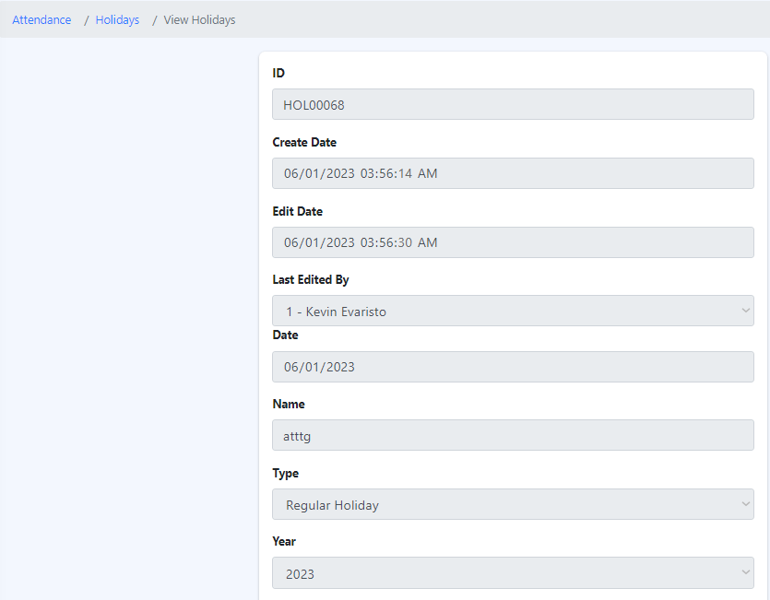

How to edit a Holiday?
- Click the edit icon under the Actions column. which is the icon next to the eye icon.

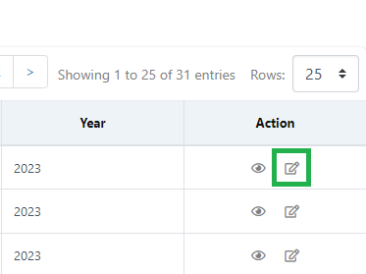

- Edit the required field(s) and click "Submit”.

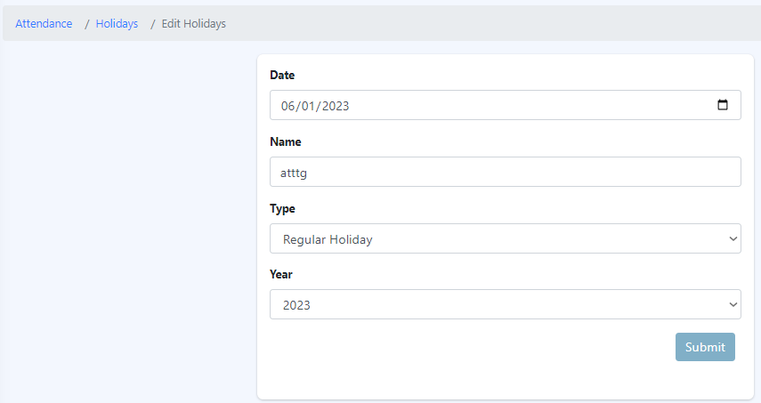

6.5 Overtime Requests
The “Overtime Requests" feature within Eyebox HRMS allows employees to view and manage their recorded overtime hours. It provides a centralized platform for employees to track their overtime work and access relevant information related to their overtime hours. The functionalities of this section are the following:
- Overtime Summary: The "Overtime Requests " section displays a summary of the employee's recorded overtime hours. It provides an overview of the total accumulated overtime hours, typically categorized by pay period or specific timeframes.
- Overtime Details: Employees can access detailed information about their recorded overtime hours within the HRMS. This includes the date, time, and duration of each overtime session, as well as any associated remarks or comments.
- Overtime Documentation: If required, employees can access any relevant documentation or supporting materials related to their recorded overtime hours. This may include timesheets, supervisor approvals, or any other evidence that justifies the overtime work performed.
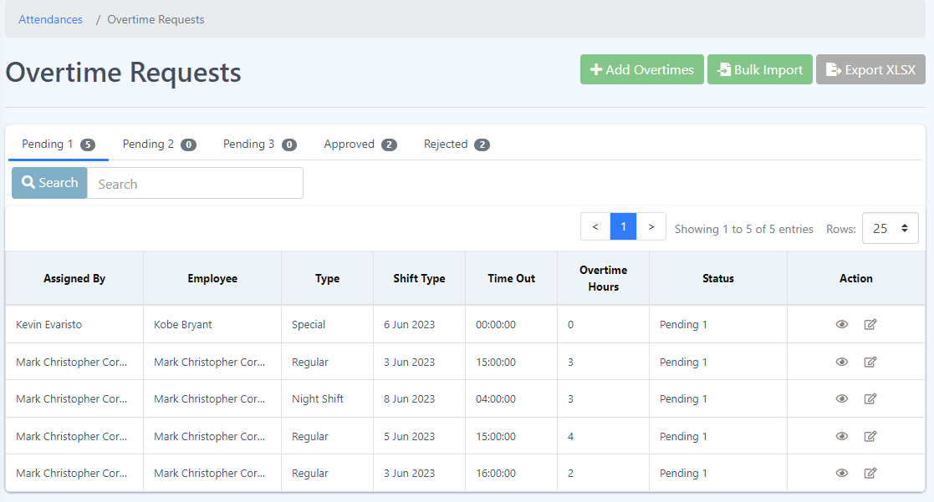

Attendance -> Overtime Requests -> Add Overtimes
The "Add Overtimes" module in Eyebox HRMS streamlines the process of recording and managing overtime hours for employees. By providing a structured interface for entering overtime details, attaching supporting documentation, and facilitating the approval workflow, it ensures accurate tracking and proper management of additional work hours. This feature promotes transparency, compliance with labor regulations, and facilitates effective overtime management within the organization.

How to add Overtime Requests?
Step 1: Fill-up the form and send your attachment if needed.
Step 2: Click the “Submit” button.
Step 3: A message will pop up that you have successfully submitted your form. Click the “Ok” button and this should redirect you to “Overtime Requests” page and able to see your created request.

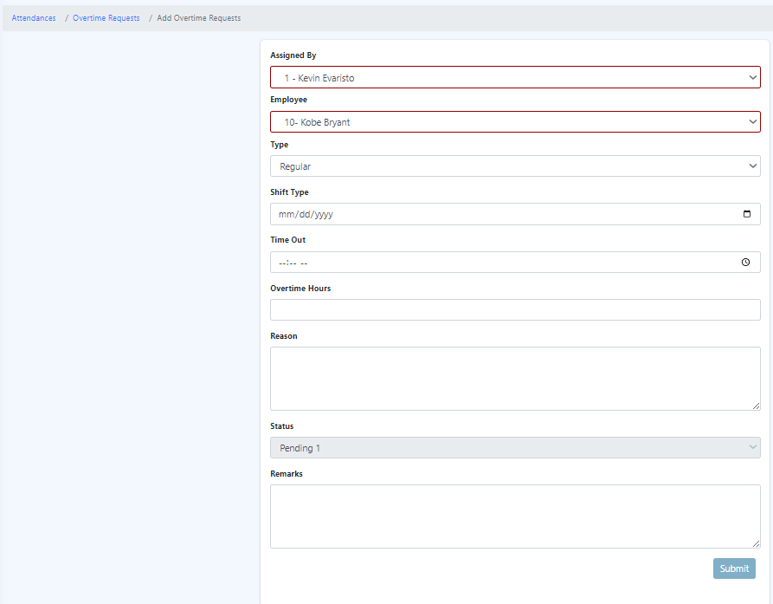

How to see more details about the Overtime Requests?
1. Click the eye icon located under the “Actions” column.
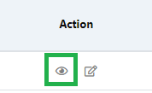

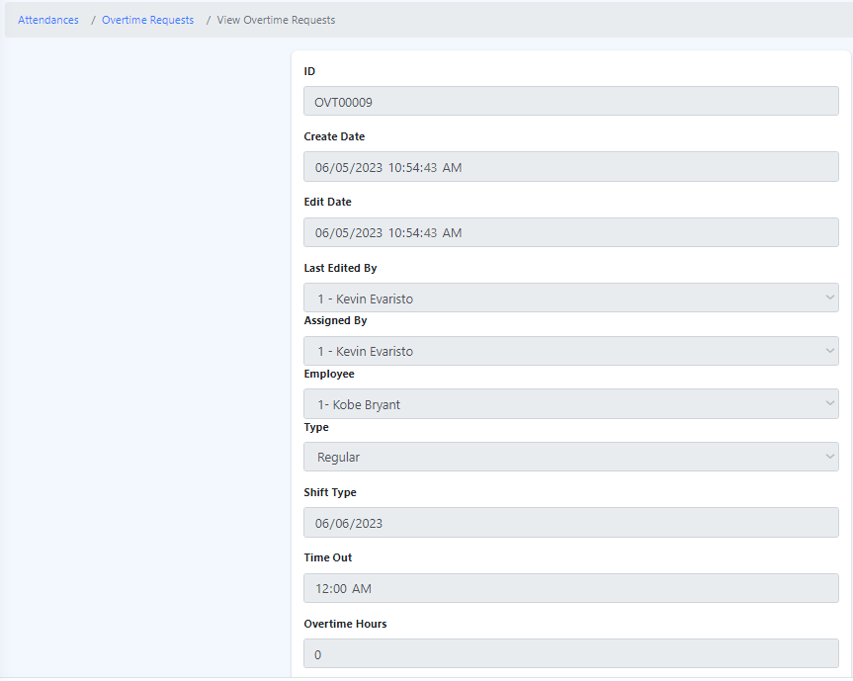
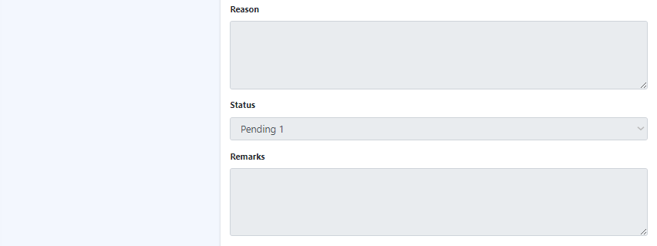

How to Edit Overtime Requests?
- Click the edit icon located under the Action column, which is the icon next to the eye icon.

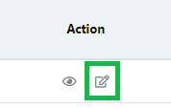

- Edit the required field(s) and click "Submit".
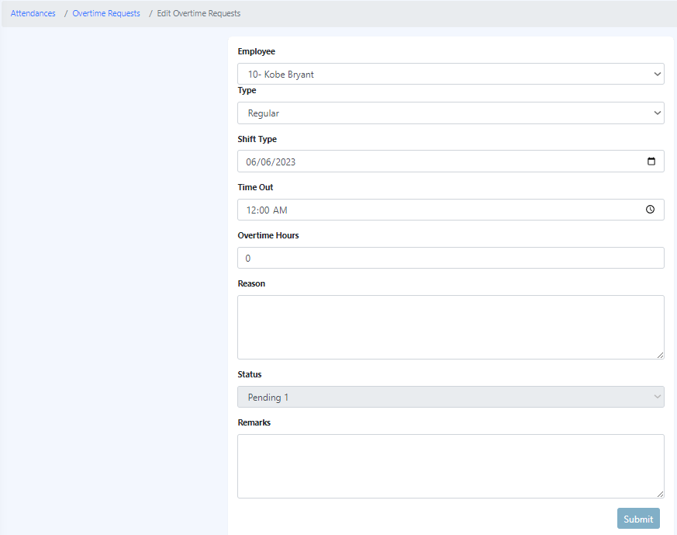

How to Bulk Import of Overtime Requests?
  - Click the "Bulk Import" button.
  - Follow the provided set of steps.

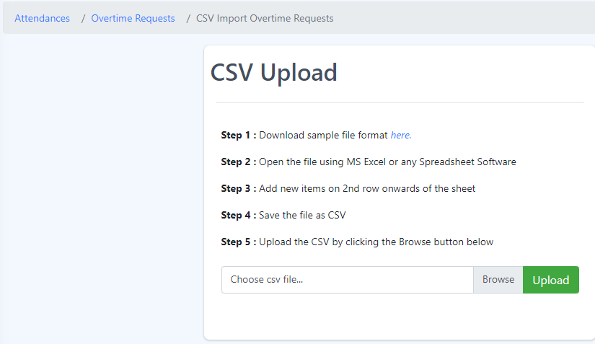

6.6 Time Adjustment List
The employee time adjustments feature within the HRMS allows authorized personnel to make changes or corrections to recorded employee time entries. These are the functionalities in the time adjustment:

1. Authorized Access: Only designated personnel, such as HR administrators or managers, with the appropriate permissions can access and make time adjustments within the HRMS. This ensures that adjustments are made by authorized individuals.

2. Types of Time Adjustments: The HRMS provides options for different types of time adjustments, such as:

- Clock-In/Clock-Out Corrections: Authorized personnel can adjust clock-in and clock-out times if there are errors or discrepancies in the original records. This helps to reflect the actual time worked by the employee accurately.

3. Documentation and Audit Trail: The HRMS maintains a record of all time adjustments made, including details such as the date, time, reason for adjustment, and the individual who made the adjustment. This documentation serves as an audit trail for transparency and accountability purposes.

4. Approval Workflow: Depending on the organization's policies, time adjustments may require approval before they are finalized. The HRMS can incorporate an approval workflow where adjustments are reviewed and authorized by designated personnel, ensuring proper oversight.

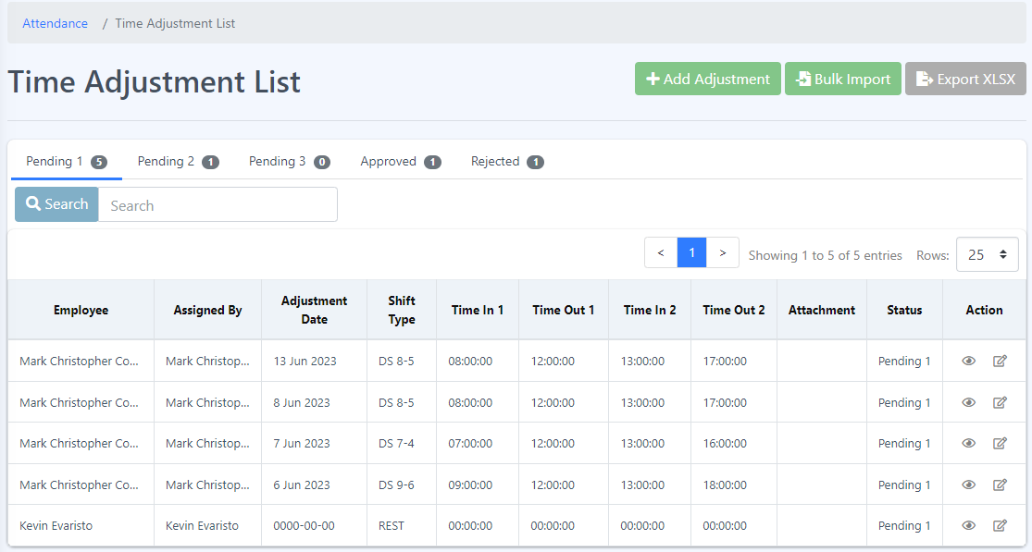

How to Add Time Adjustment List?
Step 1: Fill-up all the blanks and attach your file.
Step 2: Click the “Submit” button.
Step 3: A message will pop up that you have successfully submitted your form. Click the “Ok” button and this should redirect you to “Time Adjustment List” page.

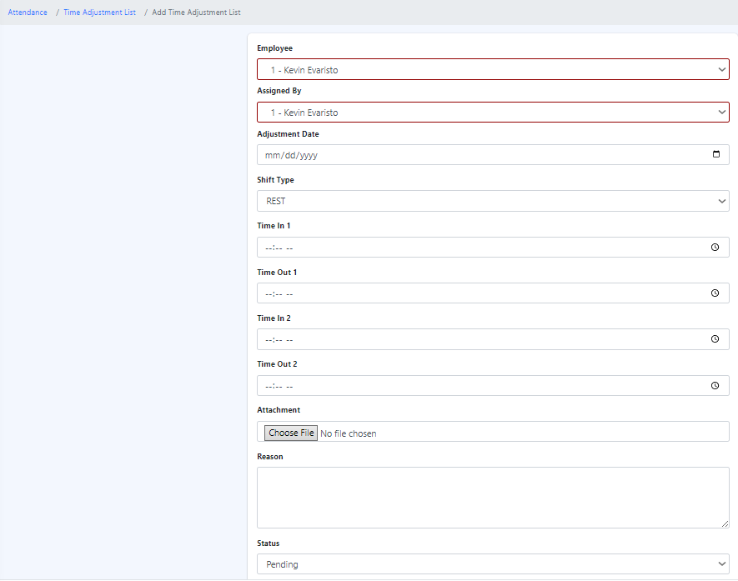
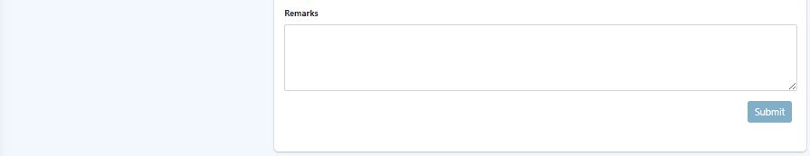

How to see more details about the Time Adjustment List?
  - Click on the eye icon located under the Actions column.


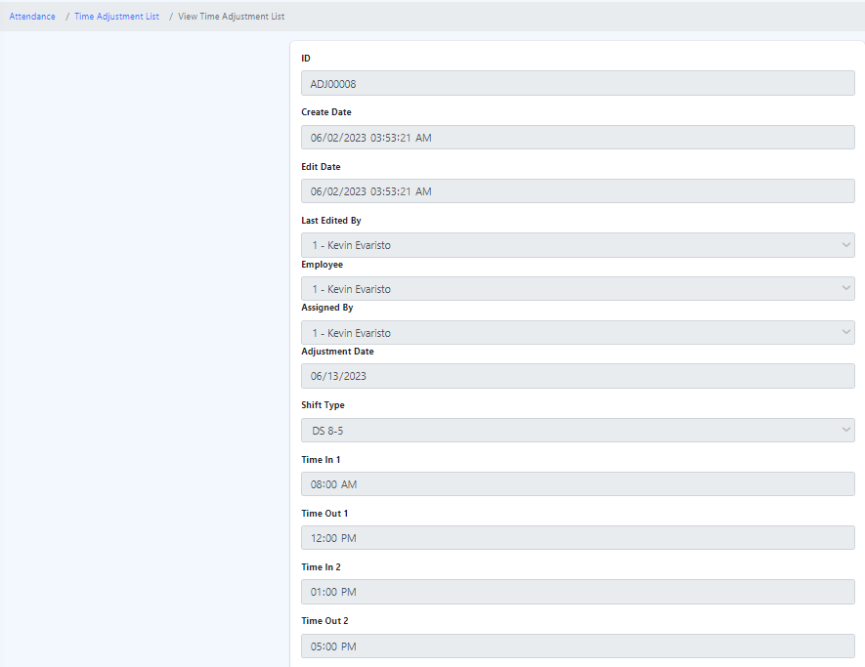
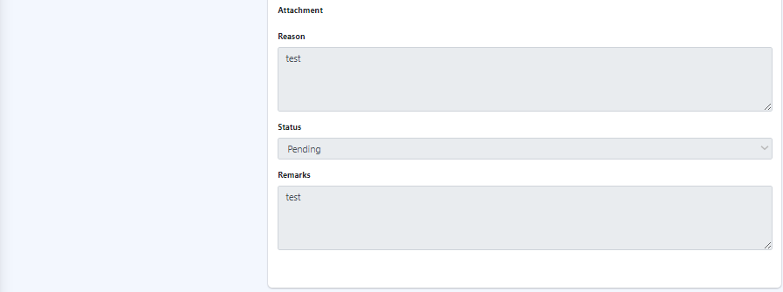

How to edit Time Adjustment List?
- Click the edit icon under the Actions column. which is the icon next to the eye icon.



- Edit the required field(s) and click "Submit.
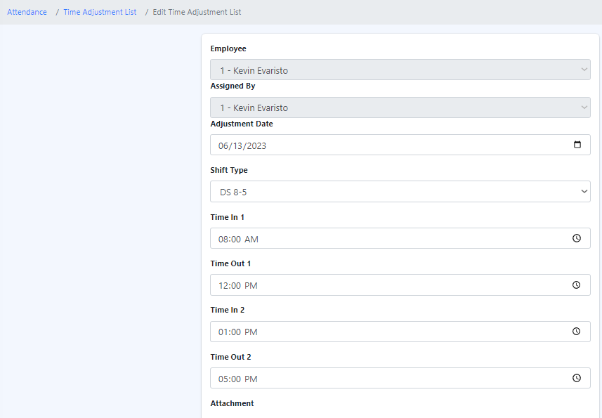
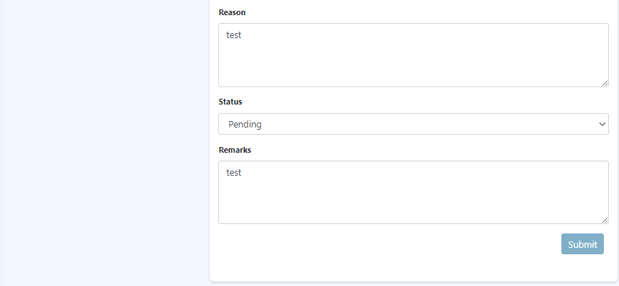

How to Bulk Import of Overtime Requests?
1. Click the "Bulk Import" button.
2. Follow the provided set of steps.

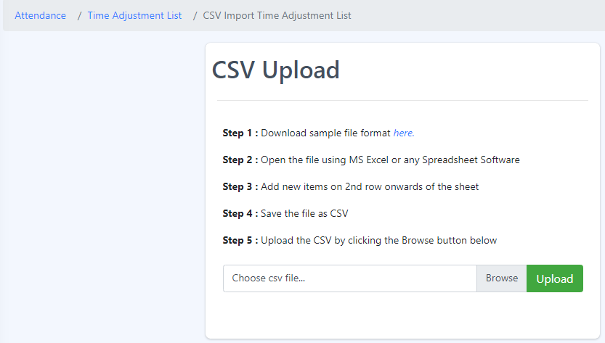

6.7 Overtime Approval Route
The overtime approval route in an HRMS (Human Resource Management System) refers to the defined workflow or process through which overtime requests are submitted, reviewed, and approved within the system. It outlines the steps and individuals involved in the approval process for overtime work.
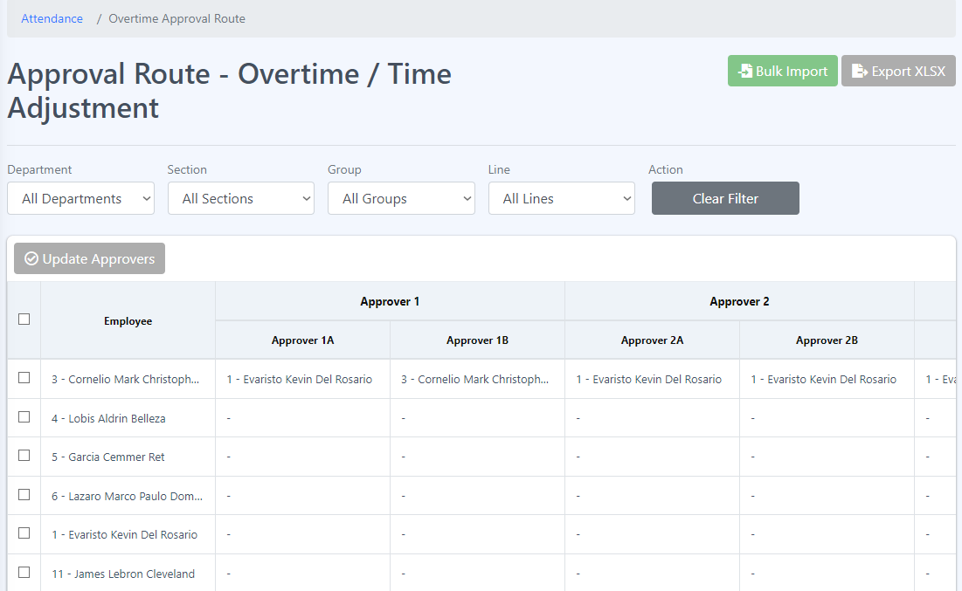
How to update approvers?

- Navigate to the approval route – overtime/time adjustment section.
- Click on an employee or select all employees that you want to assign or update as approvers.
- Look for the option or button labeled "Update Approvers" that allows you to assign or update approvers.

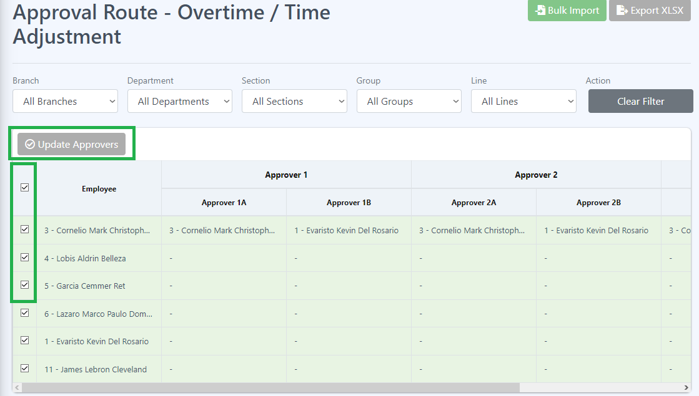

- Click on the update approvers button to initiate the process.
- You will likely be presented with a form or template to input the necessary information for assigning or updating approvers.
- Select an employee whom you want to assign or update as an approver in the form or template.
- Once you have finished assigning or updating approvers, click the "Save" button to initiate the process.

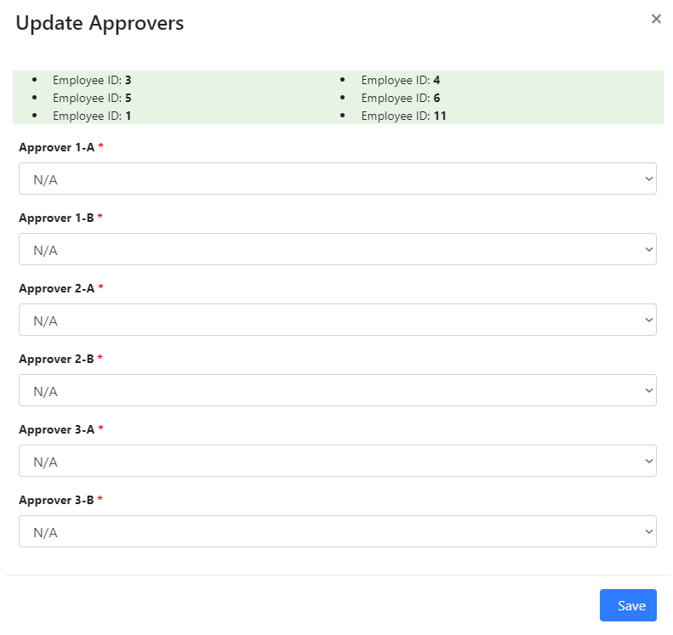

How to Bulk Import of Overtime Approval Route?
1. Click the "Bulk Import" button.
2. Browse and upload the data you wish to import.
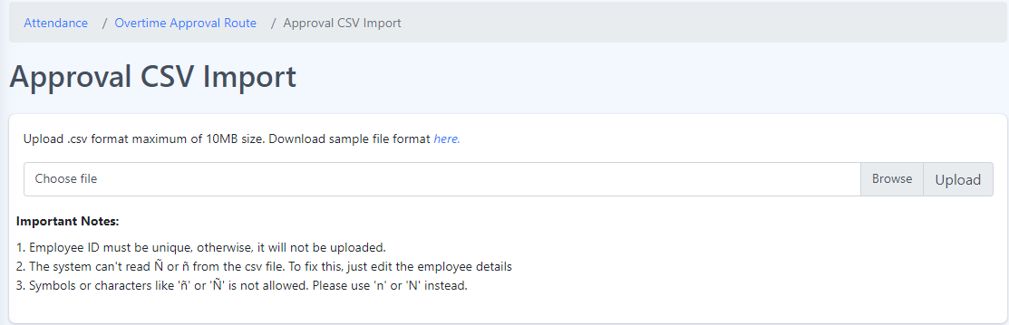

6.8 Zkteco Attendance
ZKTeco Attendance refers to the attendance management system provided by ZKTeco, a leading global provider of biometric and RFID-based security and time management solutions. ZKTeco Attendance offers advanced features and technologies to accurately record and manage employee attendance data.

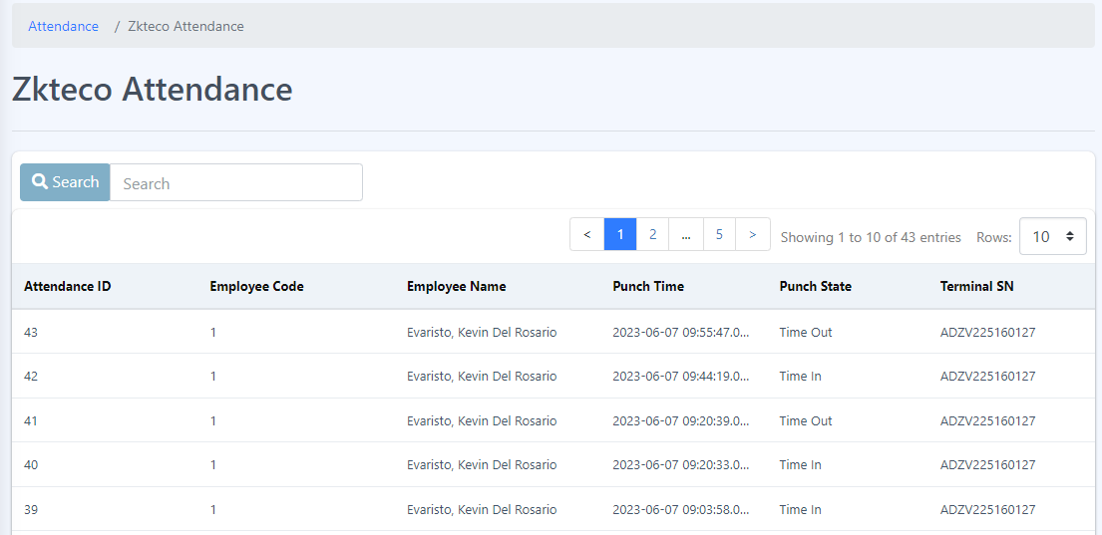

In ZKTeco Attendance, various attributes are used to identify and manage attendance records. These attributes include:

1. Attendance ID: The attendance ID is a unique identifier assigned to each attendance record. It serves as a reference number to distinguish one attendance entry from another.

2. Employee Code: The employee code is a specific code or number assigned to each employee within the organization. It serves as a unique identifier for each individual employee.

3. Employee Name: The employee’s name attribute represents the name of the employee associated with the attendance record. It helps identify the employee whose attendance is being recorded.

4. Punch Time: The punch time attribute denotes the specific time at which an employee performs a punch, indicating their check-in or check-out time. It captures the exact timestamp when the attendance event occurs.

5. Punch State: The punch state attribute indicates the state or status of the attendance punch. It signifies whether it is a check-in, check-out, break-in, break-out, or any other defined state. This attribute helps categorize and differentiate various attendance events.

6. Terminal SN: The terminal SN (Serial Number) attribute refers to the unique serial number assigned to the attendance terminal or device used for capturing attendance punches. It helps identify the specific device or terminal from which the attendance data originates.

These attributes collectively contribute to the accurate recording and management of attendance data in the ZKTeco Attendance system. By capturing and associating these attributes with each attendance record, the system can generate comprehensive reports, track employee attendance patterns, and facilitate efficient attendance management within the organization.

