Chemo Tracking App Specification

Contents

This document contains:

* Summary
* User Stories
* Scope of Project
* Wire Frames
* Files List
* Location of Process Information
* Stretch Goals
* Proposed Schedule

Summary

The Chemo Tracking App allows a user to do a fake sign up to view and track certain key issues in their chemotherapy experience. For this exercise the key issues are: water intake, protein intake, and exercise. This is an into level app with no access to database functionality, and doctors are not helping us determine common patient needs. Therefore, as needed, we will fake much of the personal information and all of the medical needs by creating at least some of the objects in JavaScript with dummy information.

User stories

A cancer patient who wants to track their progress on the following goals:

* Track the following goals: fluid, protein, and exercise
* Receive reminders when he/she is too low on a goal
* View daily progress and update prgress
* View weekly/monthly progress
* Receive daily motivation

Developer:

* Create a page with fake sign up info, but track user name to customize other screens
* Provide a daily page with the ability to add, view progress, and receive alerts for all three goals
* Provide a page with charts of weekly and monthly progress on all goals.

Scope of the Project

The project will have two major components and one optional set of components:

* Four screens
* Reminders on one screen
* Animation/super cool looks (optional)

The project will have four screens (not final names):

* Welcome/Sign Up
  + First name (keeping it super friendly, and, yes, simple)
  + Past typical water intake per day
  + Past typical protein intake per day
  + Daily motivational quote
  + Once signed up this screen switches to a toggle for the Daily and Charting pages
  + All information except quote needs to persist
* Daily Page
  + Allow user to click a button to add a glass of water to goal
  + Entry box to add a number of protein grams which is added to daily toal via a submit button
  + Check off exercise needs based on sign up requirement (may be beyond us, as in we may need to fake the “based on” part) and submit information using a button
  + Above information needs to persist for that day (feature may be beyond us, as in do we clear every 24 hours?)
  + Basic reminders when customer is low, high, or on track for any daily need
  + Daily motivational quote
  + All information except daily motivation quote needs to persist (I think)
* Charting
  + Weekly, and monthly bar chart for water, protein, and exercise (not sure we really need a daily chart – or it can be a stretch goal)
  + Motivational quote
  + All information except the quote needs to persist
* About us – list of contributers

Reminders are another huge part of this app and warrant the time of a new page, if not more time. Present plans are to provide **basic** reminders for the Daily page. Reminders include telling the user in text if they are too low, high, or on track for a daily goal.

As for pictures, we need at least a logo. Optionally it would be nice to have picture icons for water, protein, and exercise

Wire Frames

Welcome/Sign Up page

On the first visit the following age will display.

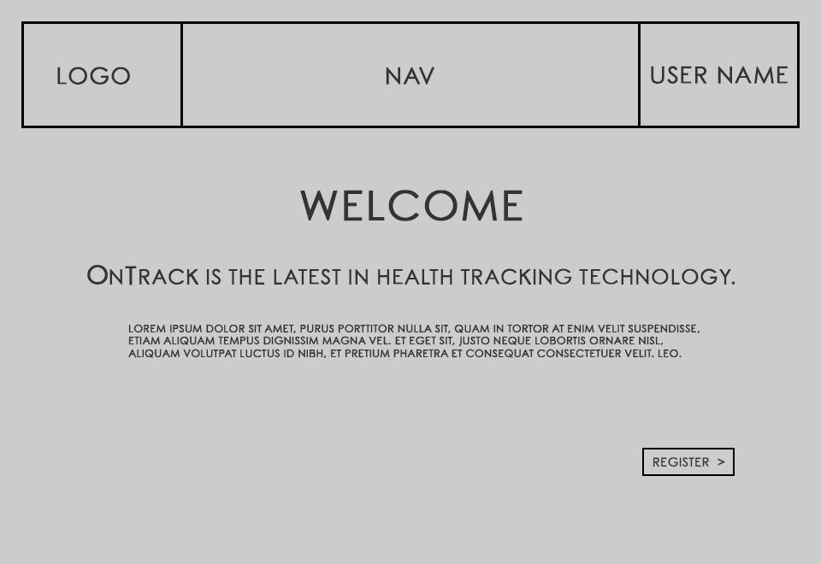

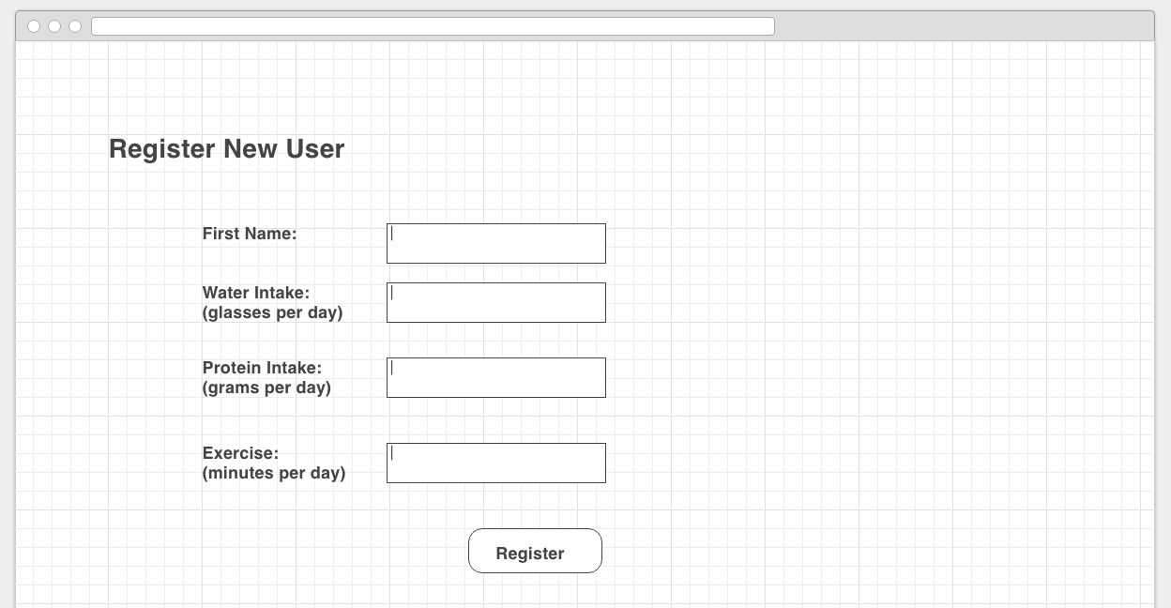

After sign up is complete this page will display, and allow access to the Daily or Chart page.

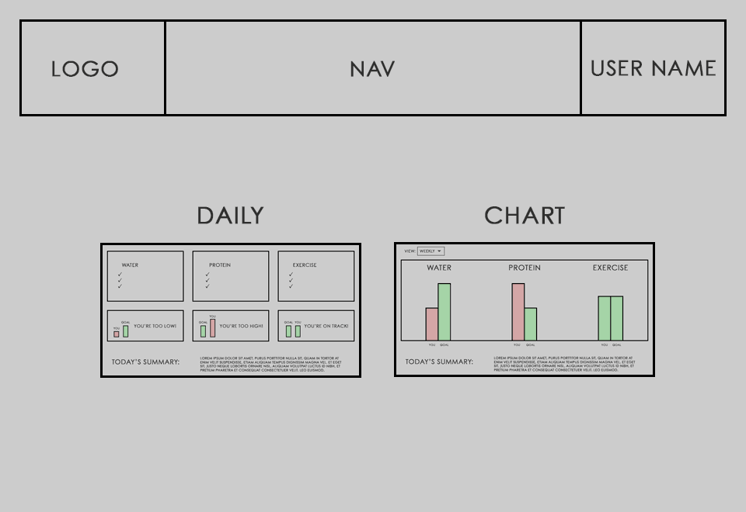

Daily Goals

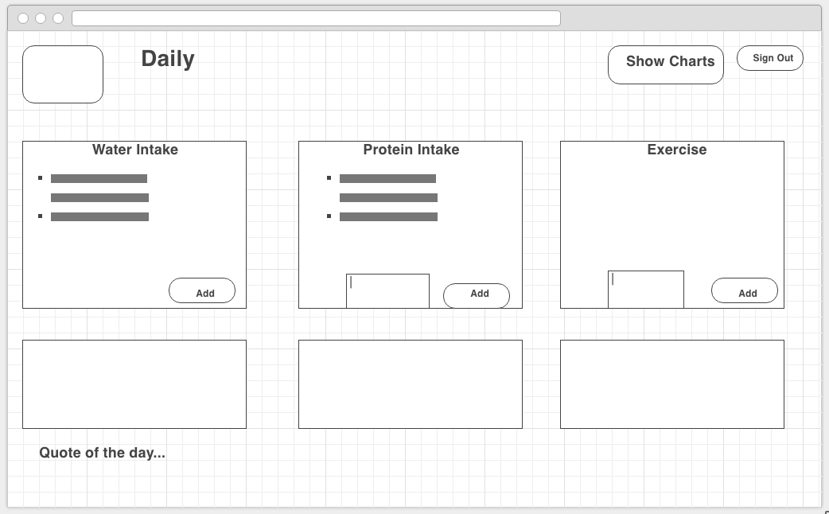

Charts

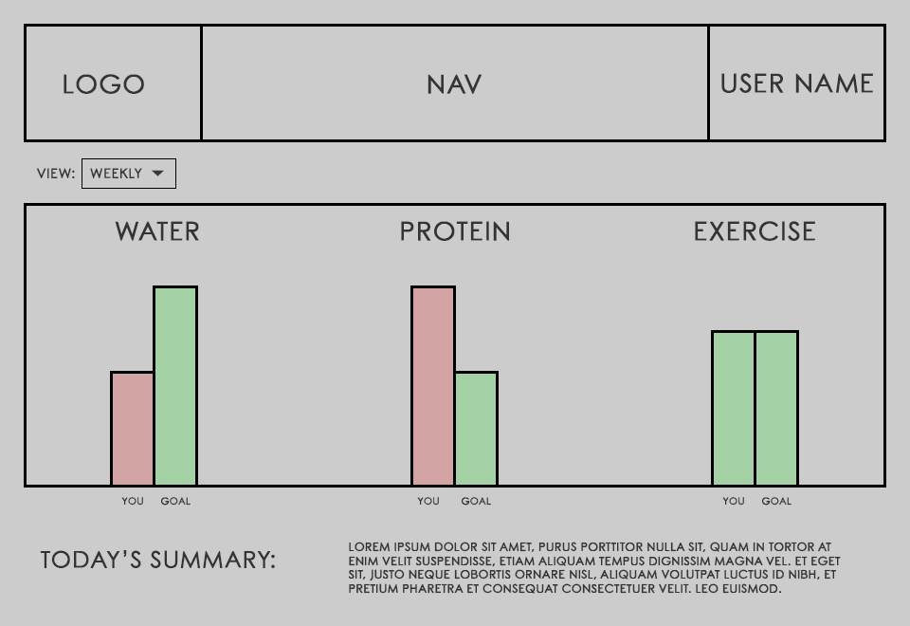

About Us

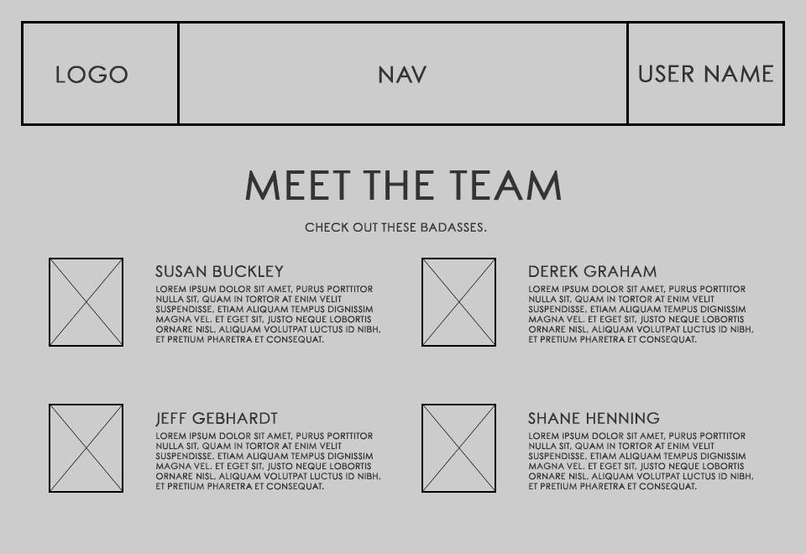

Files List

We will include the following files:

* HTML file for each page
* CSS for each page
* Each page will also include the Skelleton and Skelleton Normaization CSS files
* JavaScript file for each page

Location of Process Information

Information about GitHub workflow and other work process information is located in our README.

Stretch Goals

If the whole team is ready, we'll add:

* Hipper charts
* Animation to charts (e.g., remember Derek's idea of water filling a glass? Cool chart idea.)
* Hover on buttons
* Track clicks on ads

Proposed Schedule

**Monday**

* Hopefully talk before proposal
* Get through proposal
* More white boarding and discussion for:
  + Final design (the adults may tell us to do things very differently)
  + Decide on as many names for things or conventions as we can imagine
  + Go over our merge party process
* Maybe code – especially really nailing down names for coding and pages will keep us from killing each other

**Tuesday**

* In ugly mode, get the three pages running in basic mode with HTML and JS
* TEST - make a list of our HTML/JS bugs
* Discuss color scheme, or perhaps someone has an idea (let's not pick pink due to that other website)
* White board out final CSS goals and/or begin to implement them

**Wednesday**

* Fix HTML/JSS bugs – do it Wednesday after discussing other stuff on Tuesday and with fresh minds
* Get CSS nailed down and implemented
* Get logo in

**Thursday**

* Add animation for charts
* Implement animation for high priority reminders (ex, way low on water)
* Fit and finish
  + Hover overs
  + Better colors
  + Etc.
* Work on presentation for Friday