Library License (LL)
Jeff Goldenson, David Weinberger
Harvard Library Innovation Lab

Dalia Topelson, David O’Brien, Christopher Bavitz
The Berkman Center for Internet & Society, Harvard University

January, 2013

What is Library License?
The Library License is an effort to create a space in the digital world where works, still under copyright, may be securely made available to the public.

The Library License is a model agreement between an author and her/his publisher that after a work has passed a specified threshold – sales have dropped below a certain level, a substantially new edition has come out, or a certain number of years have passed, etc. – every public and school library will be allowed to distribute one electronic copy of that work through the library’s usual digital distribution system.

Why?
The Library License is envisioned as a means of ensuring that libraries have access to old and new digital content in a way that complements publishers’ and authors’ rights in the content they create.

Inserting Library License into the existing Copyright Timeline
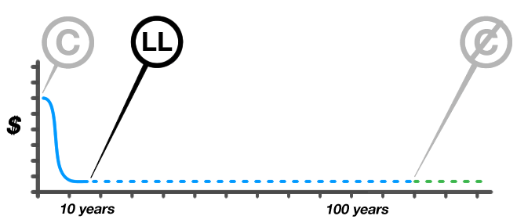

Works languish in copyright long after significant market interest subsides. Why not make one digital edition, with appropriate DRM practices, available from each library?

Passing the threshold means that there is a significantly diminished commercial market for the work, so making one copy available at a time for the users of a library does no harm, but can bring important benefits:

- 1 The work is archived in public, keeping it accessible to the occasional user who wants it.
- 2 The work might help build demand for other works by the author.
- 3 Because the digital copy is released with restrictions on the number of simultaneous copies, the length of the lending period, and (potentially) the inability to print selections, it might drive incremental demand for copies printed on-demand by the publisher.

