**How Minneapolis policing changed during a historic summer of turmoil**

<http://static.startribune.com/news/projects/all/20200627-police_calls/>

By Jeff Hargarten and Kim Hyatt  Star Tribune

Minneapolis police say there is no slowdown responses to 911 calls since civil unrest around George Floyd's death ended, yet concerns from residents, advocates and lawmakers linger about such perceived changes as summer draws to a close.

A Star Tribune analysis of Minneapolis Police Department daily call volume suggests the challenges of elevated violence, staffing issues, budgetary holes, widespread criticism and a global pandemic took a toll on the department’s resources and shifted its attentions.

Typically, police activity rises with summertime crime waves, but this year saw less energy poured into everyday policing as riots, shootings and homicides strained law enforcement – resulting in cops simultaneously tackling more violence, while responding to significantly fewer calls overall.

As Minneapolis transitions into autumn, here's a look at some key ways policing changed in the last few months.

**Staffing shortages, decreased activity**

Service calls for police response either through 911 or other dispatches noticeably declined since the [unrest that rocked Minneapolis](https://www.startribune.com/following-historic-unrest-data-show-a-quieter-minneapolis/568966851/) ended, in part [underscoring the department's staffing and budgetary problems](https://www.startribune.com/minneapolis-police-face-staffing-challenges-as-violence-rises/571982152/). The force lost 10 percent of its officers through resignation, termination, retirement or medical leave – and could shed more employees by year’s end.

Recorded police activity fell around 30 percent in each June, July and August compared to summer months in 2019. Activity was also down compared to April of this year, bucking the typical escalation in summer crime response Minneapolis usually sees.

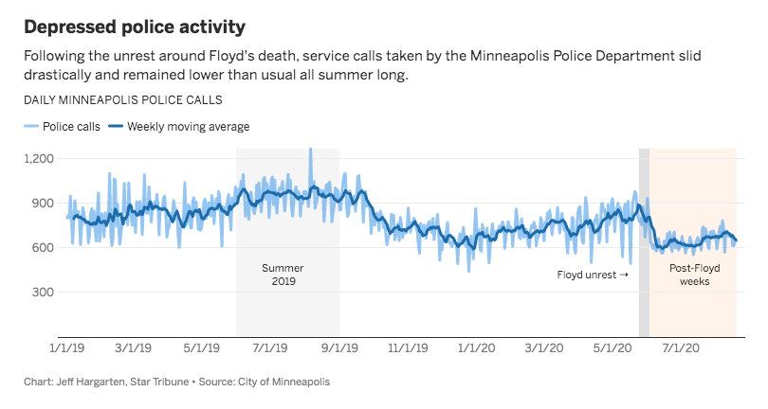

A separate analysis of various police and crime measurements from the city show similar trends continued after [Downtown Minneapolis riots in late August](https://www.startribune.com/mpls-under-a-curfew-until-6-a-m-mayor-requests-guard-for-unrest/572231992/) and into September (TK and through Labor Day???).

Even considering citywide and nationwide [declines in crime rates](https://www.startribune.com/fbi-violent-crime-in-minnesota-dropped-last-year-continuing-decade-long-trend/562007692/) and police calls over the years, these dropoffs are more stark. And activity [similarly slowed](https://www.startribune.com/minneapolis-officers-face-accusations-of-slowdown/378529735/) after Jamar Clark was killed by Minneapolis police in 2015, despite violent crime persisting in that incident's aftermath.

Ronal Serpas, a criminal justice professor at Loyola University New Orleans with 34 years in law enforcement, described a “hangover effect” following a high-profile police killing, like in Ferguson in 2014. Overtime hours worked, officers being reshuffled behind the scenes and squad cars staging in central locations could affect what the department handles.

For months after the [Third Precinct was burned in South Minneapolis](https://www.startribune.com/minneapolis-third-precinct-george-floyd-emails-public-records-reveal-what-happened-before-abandoned-mayor-frey/566290701/), for instance, units staged at the Minneapolis Convention Center.

“For the many days following the death of Mr. Floyd, a significant percentage of the police department was likely taken away from its normal proactive duties,” Serpas said.

**More reactive, less proactive**

Those staffing issues, the ongoing pandemic and surges in post-unrest violence appear to have reshuffled the focus for Minneapolis police, making the department more reactive than proactive.

This summer, [gunfire reports increased by magnitudes](https://www.startribune.com/surge-in-gun-violence-tests-minneapolis-leaders/571524202/), violent crimes jumped overall, the city [reached 56 murders on the year](https://www.startribune.com/fatal-shooting-in-n-minneapolis-jordan-neighborhood-marks-city-s-56th-homicide-of-2020/572279292/) along with renewed rioting after a homicide suspect killed himself on Nicollet Mall, drawing the National Guard into Minneapolis once again.

Meanwhile, nearly every other metric of police activity fell sharply compared to last year, and across every precinct.

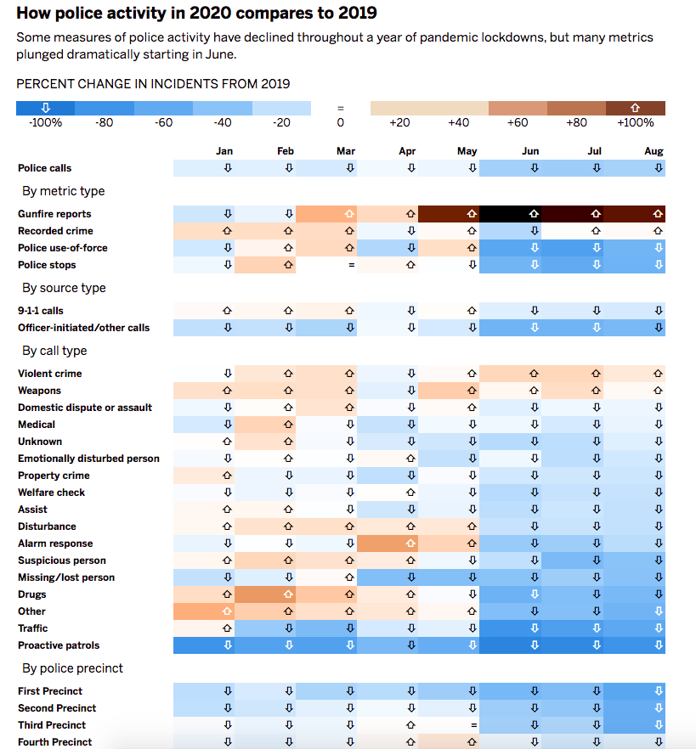

Police stops and officer-initiated calls dropped more than half, incidents where cops employed force reduced by about two-thirds, and patrols (which have been down all year) nearly vanished compared to usual levels.

The COVID-19 pandemic plays has also played a large role. For instance, the Downtown West neighborhood in the First Precinct historically clocks the most police incidents as a commuter and entertainment destination, but quarantine lockdowns triggered steep crime dropoffs starting in April.

Officer safety has been another concern, both in terms of coronavirus and community hostility. Derek Iverson, a supervisor with Minneapolis 911, said instances of “fake 911 calls” may also have officers avoiding calls where “people try to bait them into confrontation or attack them.”

“We’re not doing anything different in terms of how we take calls or enter calls," he said. "The only real difference is sometimes the way in which officers are having to be careful.”

**Strained responses and relations**

Though 911 calls increased for the summer, Minneapolis police appear to handle fewer of them, with some of the load being pushed by emergency dispatchers to other agencies.

And residents noticed, as online commentary filled with complaints about slow or non-existent emergency response. Lawsuits against the city alleged inadequate policing, callers were reportedly told to contact 311 instead and Minneapolis City Council members expressed concerns about delayed or missing service, particularly around the Third Precinct where Floyd died.

A Star Tribune analysis of service requests to the Minneapolis Emergency Communications Center (MECC) shows a widened gap between received 911 calls and how many are dispatched to the Minneapolis Police Department for response.

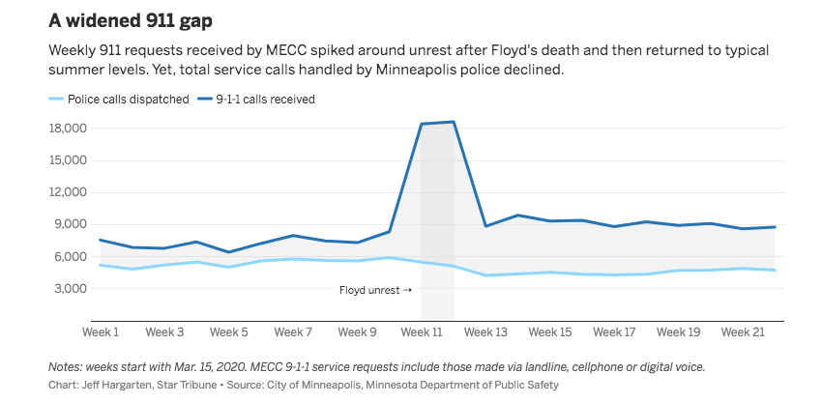

Even during a particularly violent year, emergency requests received by MECC have remained fairly steady aside from notable periods of unrest, and have actually been down slightly most weeks from last year, partially due to COVID-19 and fewer residents calling 911 overall. By contrast, 311 calls spiked this year.

Some are reluctant to call police at all amid ongoing city council and advocate efforts to disband or defund the department, further altering the relationship between police and communities they serve.

Tabitha Montgomery, executive director of Powderhorn Neighborhood Association, said there is a spectrum of people hesitating before calling 911 for different reasons, such as trying to weigh the importance of the call against what could happen if a situation escalates, or “communal shame or blame” for placing that call.

But Montgomery doesn’t believe that hesitation will continue if alternatives to 911 aren’t communicated.

“Residents and the police department and elected leaders are all beginning to rethink, reconsider how policing is approached in Minneapolis,” she said.