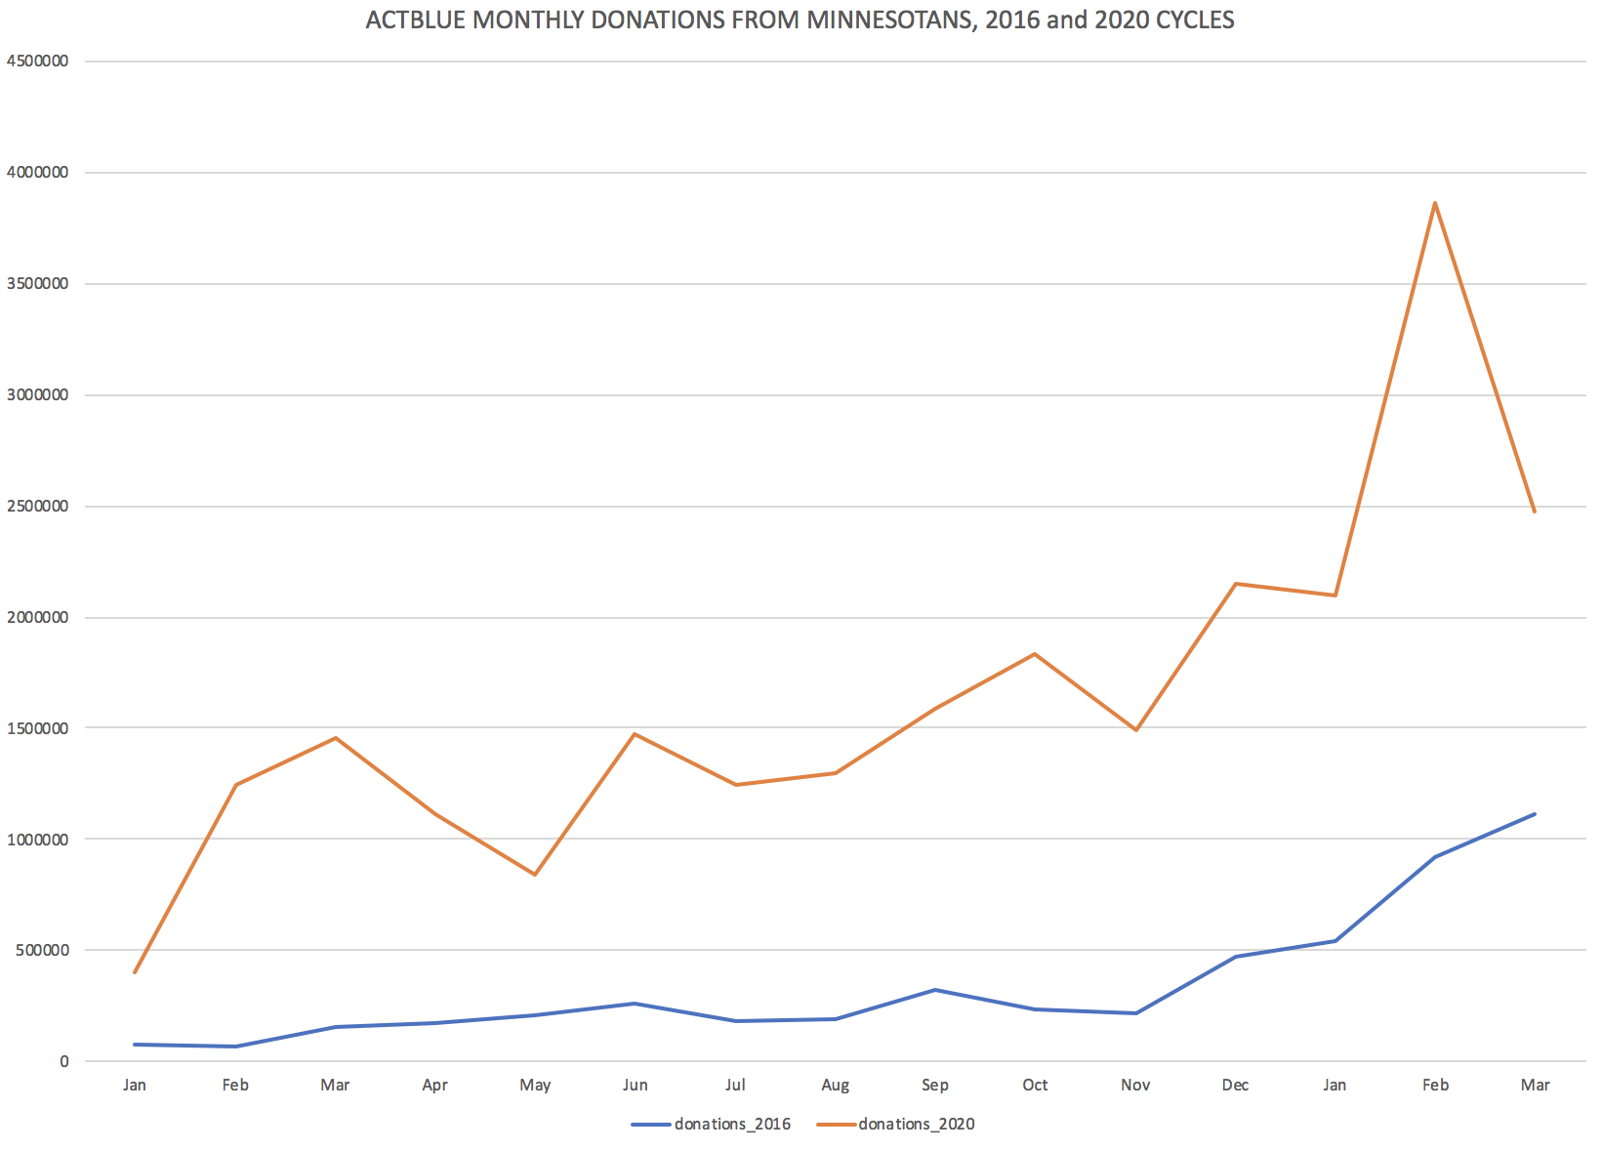

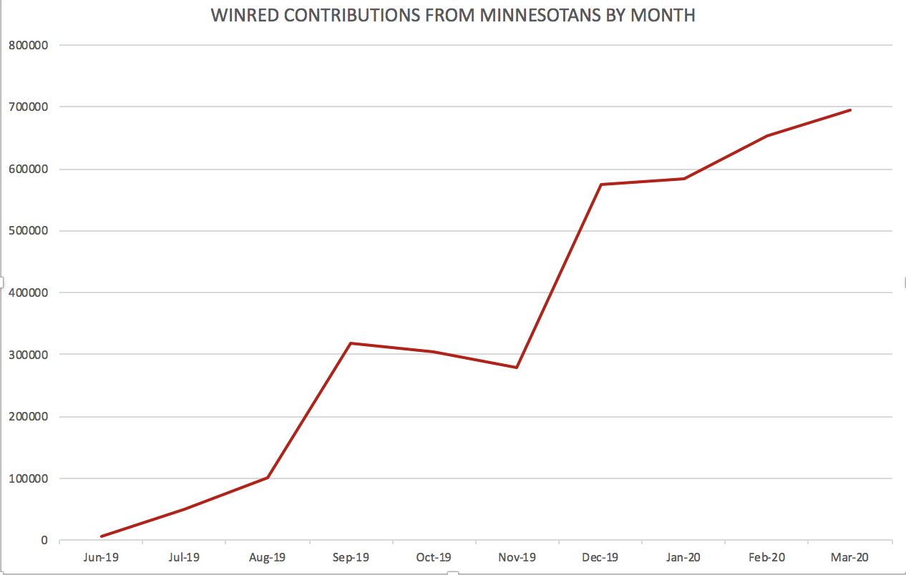

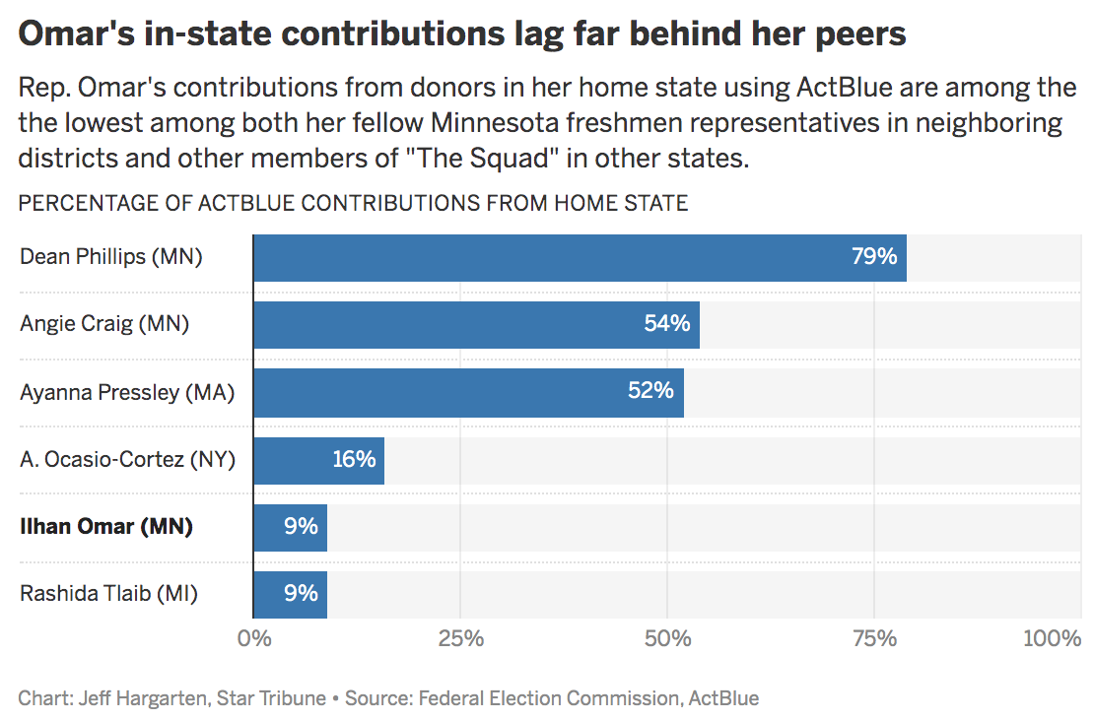

This chart in DataWrapper: <https://datawrapper.dwcdn.net/0OJEj/1/>

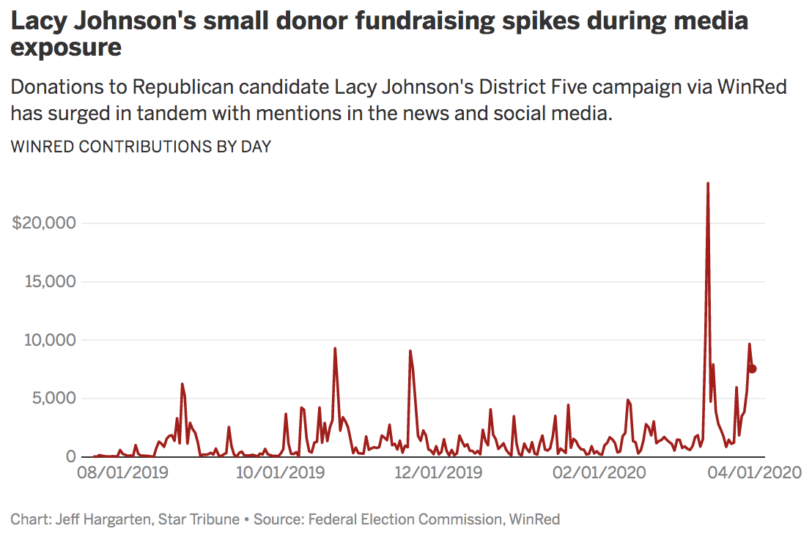This chart in DataWrapper: <https://datawrapper.dwcdn.net/E4LIY/> **LACY JOHNSON’S WINRED CONTRIBUTIONS BY STATE**

|  |  |
| --- | --- |
| **TX** | **13.8%** |
| **FL** | **13.0%** |
| **CA** | **12.1%** |
| **MN** | **8.2%** |
| **NY** | **3.9%** |
| **WA** | **3.0%** |
| **AZ** | **3.0%** |
| **OH** | **2.7%** |
| **Other** | **40.2%** |

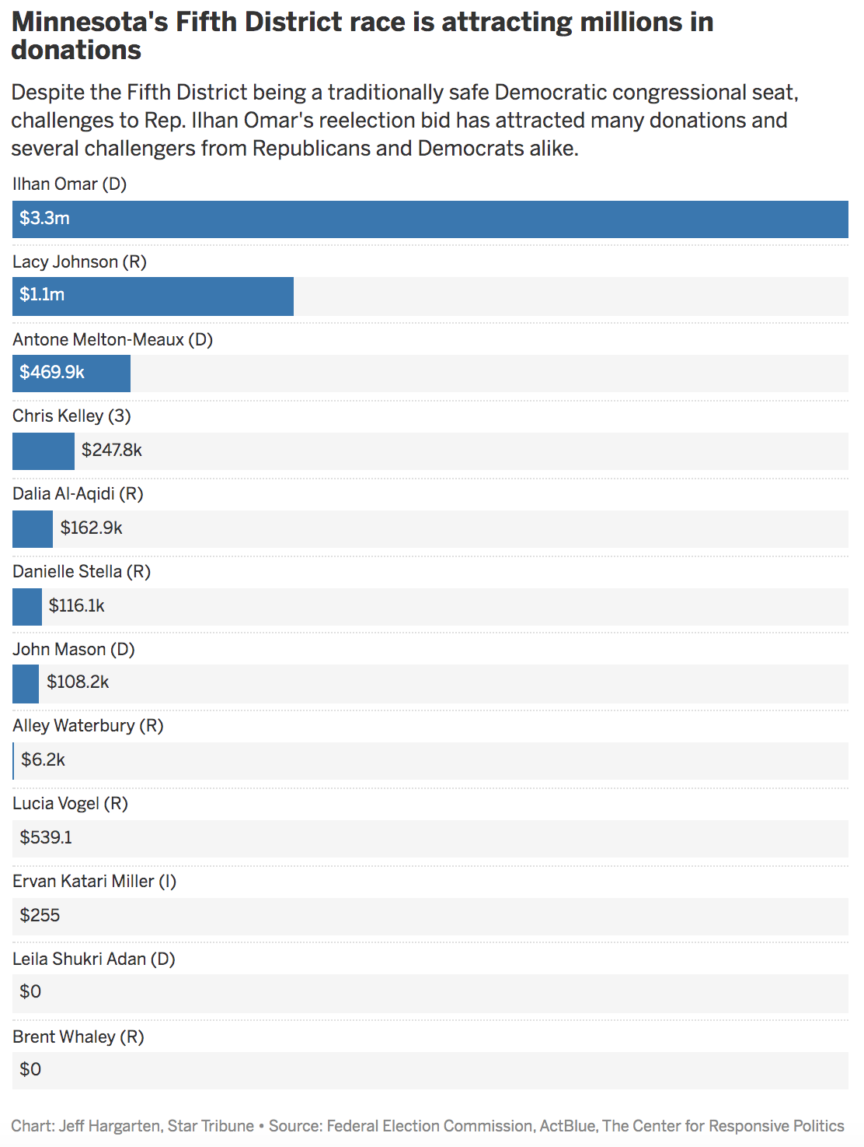

This chart in DataWrapper: <https://datawrapper.dwcdn.net/VKjDL/1/>

**REP. ILHAN OMAR (D, MN)**

**TOPLINE NUMBERS**

|  |  |
| --- | --- |
| Raised: | $3,345,136 |
| Spent: | $2,081,660 |
| Cash on hand: | $1,318,304 |
| Debts: | $0 |

**SOURCE BREAKDOWN**

|  |  |  |
| --- | --- | --- |
| Small Individual Contributions (< $200) | $1,898,354 | 56.67% |
| Large Individual Contributions | $1,410,194 | 42.10% |
| PAC Contributions | $41,232 | 1.23% |
| Candidate self-financing | $0 | 0.00% |
| Other | ($4,643) | -0.13% |

**IN-STATE VERSUS OUTSTATE**

|  |  |  |
| --- | --- | --- |
| In State | $263,978 | 8.39% |
| Out of State | $2,881,942 | 91.61% |
| No State | $880 | 0.03% |

**IN-DISTRICT VERSUS OUT-DISTRICT**

|  |  |  |
| --- | --- | --- |
| In District | $147,401 | 4.68% |
| Out of District | $2,649,234 | 84.19% |
| No District | $350,165 | 11.13% |

ESTIMATED **$2,846,162** RAISED FROM ACTBLUE DONORS (REFUNDS NOT FACTORED)

ESTIMATED **83,000** UNIQUE ACTBLUE DONORS, 2019-2020

**TOP STATES FOR ACTBLUE DONATIONS, 2019-2020**

|  |  |
| --- | --- |
| CA | 23.2% |
| NY | 11.3% |
| MN | 8.5% |
| TX | 5.5% |
| WA | 5.0% |
| IL | 4.5% |
| MA | 4.4% |
| FL | 3.7% |
| Other states | 33.9% |

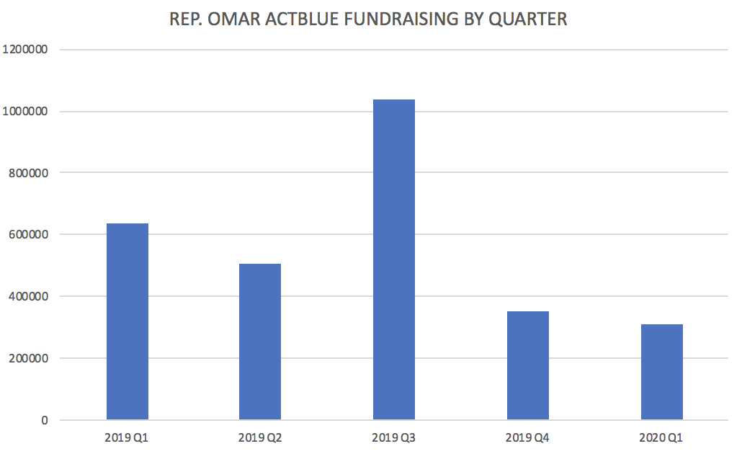

**REP. ANGIE CRAIG (D, MN)**

**TOPLINE NUMBERS**

|  |  |
| --- | --- |
| Raised: | $2,703,629 |
| Spent: | $769,310 |
| Cash on hand: | $2,021,710 |
| Debts: | $200,000 |

**SOURCE BREAKDOWN**

|  |  |  |
| --- | --- | --- |
| Large Individual Contributions | $1,394,602 | 51.58% |
| PAC Contributions | $947,116 | 35.03% |
| Small Individual Contributions (< $200) | $309,278 | 11.43% |
| Other | $47,034 | 1.74% |
| Candidate self-financing | $5,600 | 0.20% |

**IN-STATE VERSUS OUTSTATE**

|  |  |  |
| --- | --- | --- |
| In State | $605,483 | 55.56% |
| Out of State | $484,297 | 44.44% |
| No State | $0 | 0.00% |

**IN-DISTRICT VERSUS OUT-DISTRICT**

|  |  |  |
| --- | --- | --- |
| In District | $163,879 | 15.04% |
| Out of District | $673,564 | 61.81% |
| No District | $252,337 | 23.15% |

ESTIMATED **$1,078,689** RAISED FROM ACTBLUE DONORS (REFUNDS NOT FACTORED)

ESTIMATED **7,200** UNIQUE ACTBLUE DONORS, 2019-2020

**TOP STATES FOR ACTBLUE DONATIONS, 2019-2020**

|  |  |
| --- | --- |
| MN | 54.7% |
| CA | 11.0% |
| NY | 8.5% |
| IL | 3.9% |
| MA | 3.8% |
| DC | 2.8% |
| CT | 2.5% |
| TX | 1.7% |
| FL | 1.6% |
| Other | 9.5% |

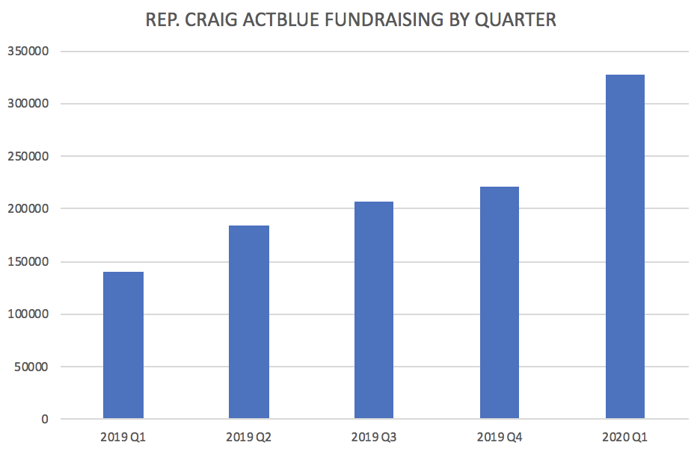

**REP. DEAN PHILLIPS (D, MN)**

**TOPLINE NUMBERS**

|  |  |
| --- | --- |
| Raised: | $1,067,136 |
| Spent: | $762,331 |
| Cash on hand: | $346,286 |
| Debts: | $250,000 |

**SOURCE BREAKDOWN**

|  |  |  |
| --- | --- | --- |
| Large Individual Contributions | $861,542 | 80.74% |
| Small Individual Contributions (< $200) | $156,373 | 14.65% |
| Other | $49,222 | 4.61% |
| PAC Contributions | $0 | 0.00% |
| Candidate self-financing | $0 | 0.00% |

**IN-STATE VERSUS OUTSTATE**

|  |  |  |
| --- | --- | --- |
| In State | $681,972 | 73.75% |
| Out of State | $242,774 | 26.25% |
| No State | $0 | 0.00% |

**IN-DISTRICT VERSUS OUT-DISTRICT**

|  |  |  |
| --- | --- | --- |
| In District | $289,608 | 31.32% |
| Out of District | $421,054 | 45.53% |
| No District | $214,084 | 23.15% |

ESTIMATED **$697,361** RAISED FROM ACTBLUE DONORS (REFUNDS NOT FACTORED)

ESTIMATED **4,000** UNIQUE ACTBLUE DONORS, 2019-2020

**TOP STATES FOR ACTBLUE DONATIONS, 2019-2020**

|  |  |
| --- | --- |
| MN | 78.8% |
| CA | 9.7% |
| FL | 3.0% |
| MA | 1.5% |
| NY | 1.0% |
| TX | 0.9% |
| AZ | 0.8% |
| WY | 0.8% |
| Other | 3.4% |

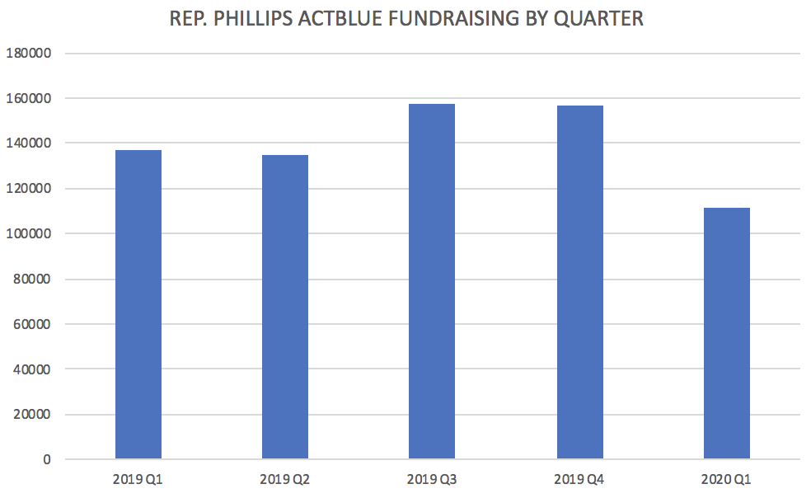

**REP. ALEXANDRIA OCASIO-CORTEZ (D, NY)**

**TOPLINE NUMBERS**

|  |  |
| --- | --- |
| Raised: | $7,996,509 |
| Spent: | $4,852,670 |
| Cash on hand: | $3,511,849 |
| Debts: | $1,025 |

**SOURCE BREAKDOWN**

|  |  |  |
| --- | --- | --- |
| Small Individual Contributions (< $200) | $6,313,162 | 78.28% |
| Large Individual Contributions | $1,731,288 | 21.47% |
| PAC Contributions | $19,690 | 0.24% |
| Candidate self-financing | $0 | 0.00% |
| Other | ($67,630) | -0.83% |

**IN-STATE VERSUS OUTSTATE**

|  |  |  |
| --- | --- | --- |
| In State | $757,684 | 15.63% |
| Out of State | $4,088,553 | 84.37% |
| No State | $0 | 0.00% |

**IN-DISTRICT VERSUS OUT-DISTRICT**

|  |  |  |
| --- | --- | --- |
| In District | $46,370 | 0.96% |
| Out of District | $4,510,080 | 93.06% |
| No District | $289,787 | 5.98% |

ESTIMATED **$7,284,735** RAISED FROM ACTBLUE DONORS (REFUNDS NOT FACTORED)

ESTIMATED **213,000** UNIQUE ACTBLUE DONORS, 2019-2020

**TOP STATES FOR ACTBLUE DONATIONS, 2019-2020**

|  |  |
| --- | --- |
| CA | 22.8% |
| NY | 15.6% |
| WA | 5.3% |
| MA | 4.2% |
| TX | 4.1% |
| FL | 3.6% |
| IL | 3.4% |
| OR | 3.1% |
| PA | 2.7% |
| Other | 34.5% |

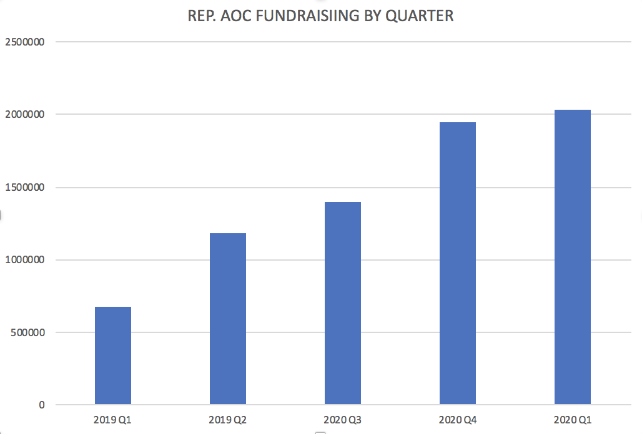

**REP. AYANNA PRESSLEY (D, MA)**

**TOPLINE NUMBERS**

|  |  |
| --- | --- |
| Raised: | $1,132,105 |
| Spent: | $991,890 |
| Cash on hand: | $226,314 |
| Debts: | $0 |

**SOURCE BREAKDOWN**

|  |  |  |
| --- | --- | --- |
| Large Individual Contributions | $537,687 | 47.49% |
| Small Individual Contributions (< $200) | $495,961 | 43.80% |
| PAC Contributions | $89,084 | 7.87% |
| Other | $9,373 | 0.82% |
| Candidate self-financing | $0 | 0.00% |

**IN-STATE VERSUS OUTSTATE**

|  |  |  |
| --- | --- | --- |
| In State | $430,701 | 55.48% |
| Out of State | $345,651 | 44.52% |
| No State | $300 | 0.04% |

**IN-DISTRICT VERSUS OUT-DISTRICT**

|  |  |  |
| --- | --- | --- |
| In District | $109,392 | 14.09% |
| Out of District | $523,930 | 67.46% |
| No District | $143,330 | 18.45% |

ESTIMATED **$865,820** RAISED FROM ACTBLUE DONORS (REFUNDS NOT FACTORED)

ESTIMATED **30,000** UNIQUE ACTBLUE DONORS, 2019-2020

**TOP STATES FOR ACTBLUE DONATIONS, 2019-2020**

|  |  |
| --- | --- |
| MA | 52.1% |
| CA | 13.8% |
| NY | 6.3% |
| WA | 1.9% |
| TX | 1.6% |
| DC | 1.5% |
| IL | 1.4% |
| OR | 1.4% |
| FL | 1.4% |
| Other | 18.5% |

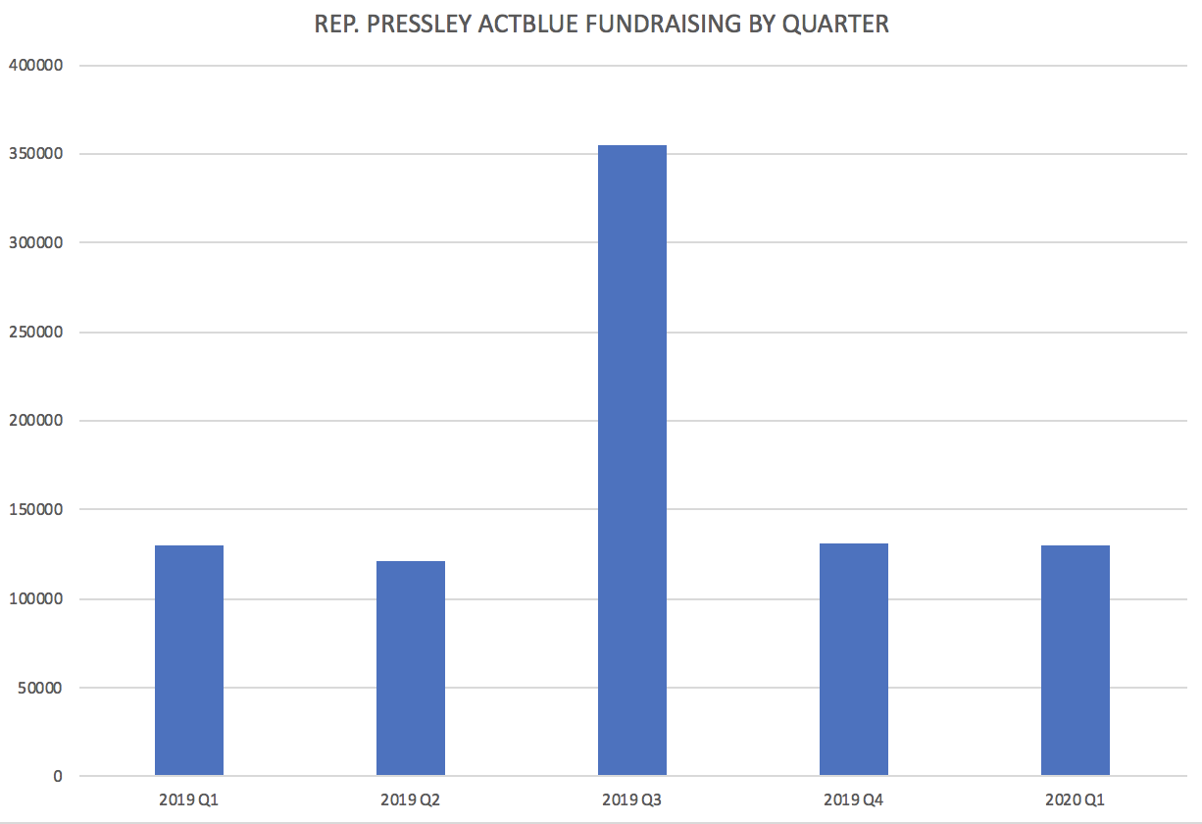

**REP. RASHIDA TLAIB (D, MI)**

**TOPLINE NUMBERS**

|  |  |
| --- | --- |
| Raised: | $2,061,028 |
| Spent: | $693,470 |
| Cash on hand: | $1,435,213 |
| Debts: | $0 |

**SOURCE BREAKDOWN**

|  |  |  |
| --- | --- | --- |
| Large Individual Contributions | $1,285,702 | 62.10% |
| Small Individual Contributions (< $200) | $732,596 | 35.39% |
| PAC Contributions | $51,854 | 2.50% |
| Candidate self-financing | $0 | 0.00% |
| Other | ($9,123) | -0.44% |

**IN-STATE VERSUS OUTSTATE**

|  |  |  |
| --- | --- | --- |
| In State | $139,540 | 8.92% |
| Out of State | $1,423,973 | 91.08% |
| No State | $0 | 0.00% |

**IN-DISTRICT VERSUS OUT-DISTRICT**

|  |  |  |
| --- | --- | --- |
| In District | $12,720 | 0.81% |
| Out of District | $1,205,443 | 77.10% |
| No District | $345,350 | 22.09% |

ESTIMATED **$1,177,865** RAISED FROM ACTBLUE DONORS (REFUNDS NOT FACTORED)

ESTIMATED **39,000** UNIQUE ACTBLUE DONORS, 2019-2020

**TOP STATES FOR ACTBLUE DONATIONS, 2019-2020**

|  |  |
| --- | --- |
| CA | 24.8% |
| NY | 9.4% |
| MI | 8.5% |
| FL | 6.5% |
| MA | 5.2% |
| NJ | 4.7% |
| WA | 4.5% |
| TX | 2.9% |
| IL | 2.9% |
| Other | 30.6% |

