Jeffrey Chao

IST 687 – Homework 2

Date Due: 01/28/2020

Date Submitted:

**Step 1: What is the hp?**

1. *What is the highest hp?*  
   
2. *Which car has the highest hp?*  
   

**Step 2: Explore mpg.**

1. *What is the highest mpg?*   
   
2. *Which car has the highest mpg?*   
   
3. *Create a sorted dataframe, based on mpg.*  
   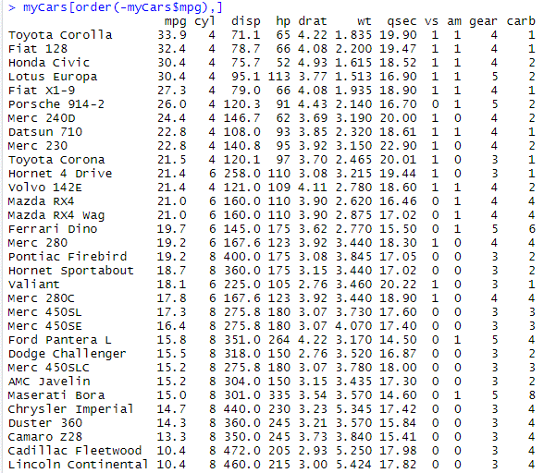  
   **Step 3: Which car has the “best” combination of mpg and hp?**
4. *What logic did you use?*  
   I first calculated the percentile for MPG and HP for each car based on the list of 32 cars. Then, I added these MPG and HP scores together for a total score to evaluate which car had the best combination of MPG and HP compared to the other vehicles listed.
5. *Which car?*

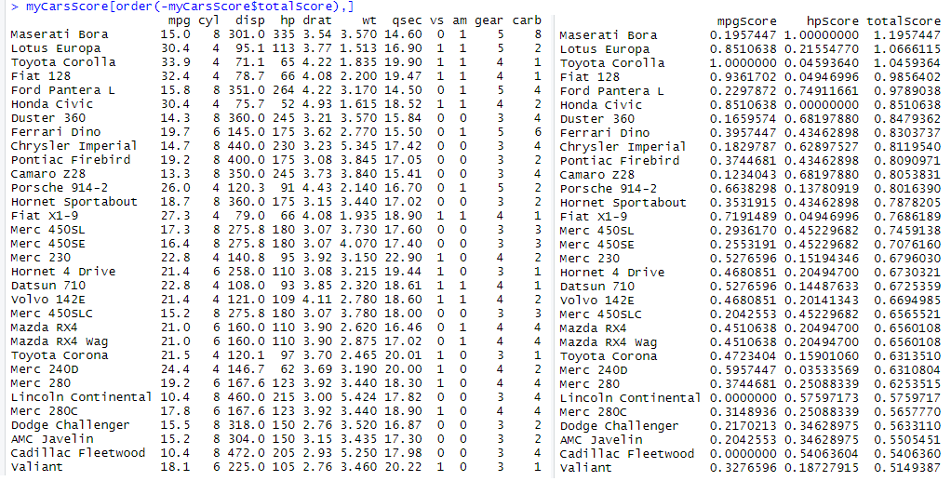

My choice for the “best” car of combination of MPG and HP is the Maserati Bora  
  
**Step 4: Which car has the “best” car combination of mpg and hp where mpg and hp must be given equal weight?**

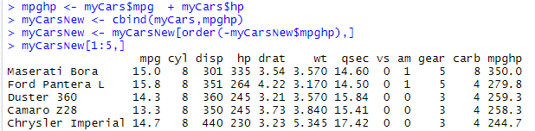

Under this new logic, the Maserati Bora is the “best” car combination of MPG and HP.