Jeffrey Chao

IST 687 – Homework 4

Date Due: 02/11/2020

Date Submitted: 02/08/2020

**Step 1: Write a summarizing function to understand the distribution of a vector**

1. *The function (called ‘printVecInfo’) should take a vector as input*
2. *The function should print mean, median, min, max, std dev, quantiles, and skewness*
3. *Test the function with the vector (1,2,3,4,5,6,7,8,9,10,50).*

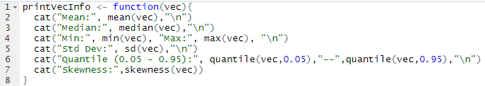

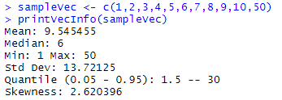

**Step 2: Creating Samples in a Jar**

1. *Create a variable ‘jar’ that has 50 red and 50 blue marbles*
2. *Confirm there are 50 reds by summing the samples that are red* 
3. *Sample 10 ‘marbles’ from the jar. How many are red? What was the percentage red?*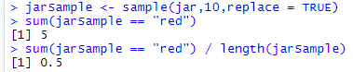
4. *‘Replicate’ the sampling 20 times, use printVecInfo, and generate a histogram*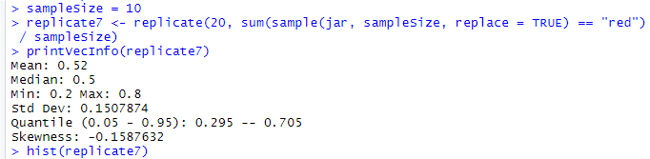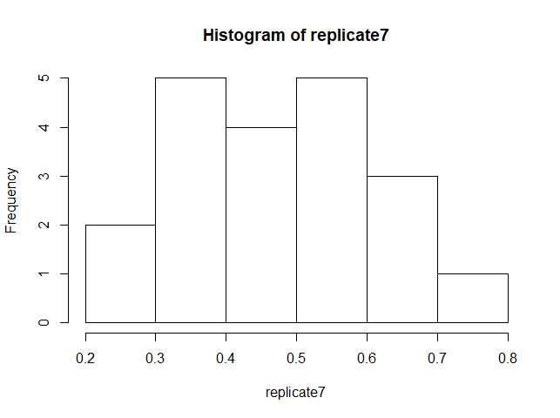
5. *Repeat #7 but this time sample the jar 100 times.*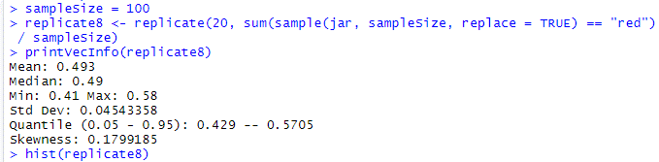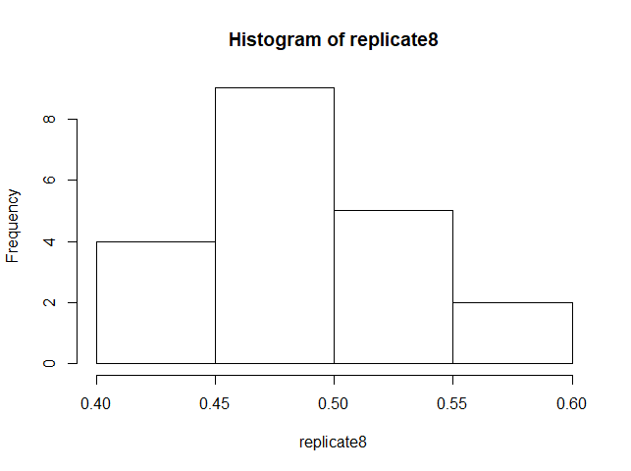
6. *Repeat #8 but this time replicate the sampling 100 times*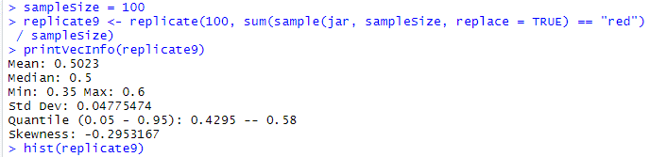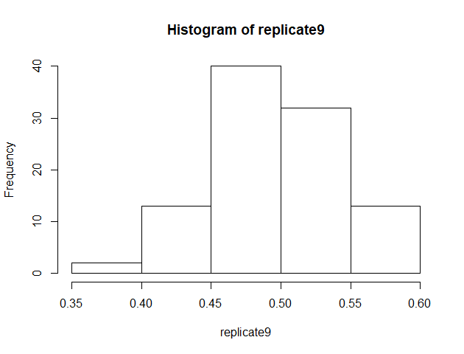

**Step 3: Explore the airquality dataset**

1. *Store the ‘airquality’ dataset into a temporary variable*
2. *Clean the dataset.*
3. *Explore the Ozone, Wind, and Temp by ‘printVecInfo’ as well as histogram.*

