Jeffrey Chao

IST 687 – Homework 5

Date Due: 02/18/2020

Date Submitted: 02/16/2020

**Step 1: Load the data**

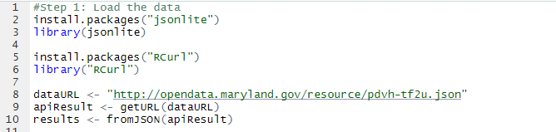

**Step 2: Clean the data**

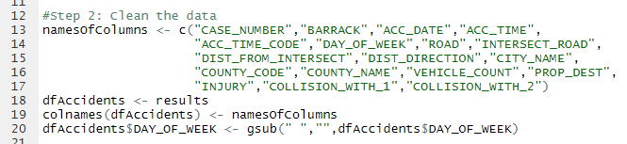

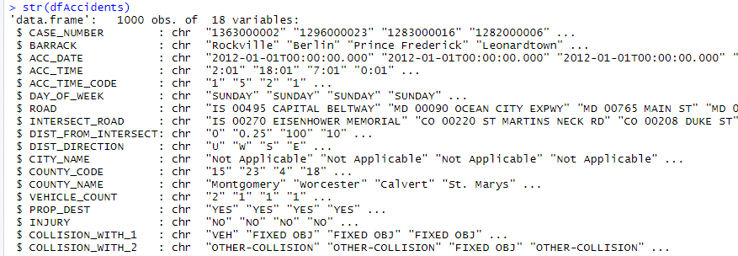

**Step 3: Understand the data using SQL (via SQLDF)**

* *How many accidents happen on SUNDAY?*

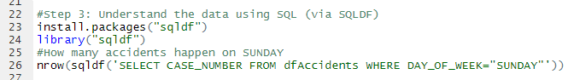



* *How many accidents had injuries?*





* *List the injuries by day*

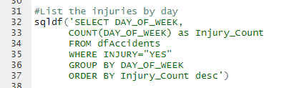

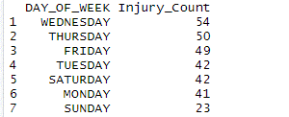

**Step 4: Understand the data using tapply**

* *How many accidents happen on SUNDAY?*





* *How many accidents had injuries?*





* *List the injuries by day*



