# Exercise 2

Pro/Con of each approach

## Stream analytics approach

### Pro

PAAS - operational overhead should be minimal

Opportunity to learn new technology

Easier to troubleshoot - less pieces

### Con

Cost - PAAS systems

Learning curve - new technology to learn

Stream analytics technology didn’t feel like a good fit at this time

Has a focus on IOT technology we wouldn’t be using for this solution

Output lists mostly other Azure resources - want to share data with other AA groups

No control when things go wrong - if there are platform issues it is out of our control

## Service approach

### Pro

Familiar architecture / fits with existing support model

Lower Cost

Flexible public facing interface

Can use Runway

### Con

More operational support and setup required

Possibly some latency due to web calls and layers

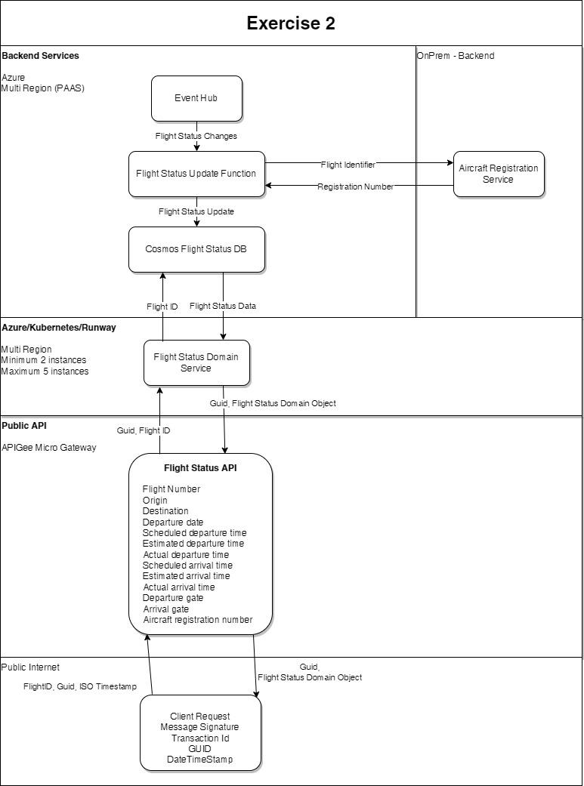

## **Explanation of design:**

Took the best parts of both proposed designs. Backend service functionality was isolated and separated using a function app to populate the data in the database. The database serves as the system of record that will be updated all from the back end.

Because there is no user interaction with the application, an API would be created using Spring Boot to provide access to the data from outside systems. API management (who can and will be calling the API) would be handled by APIGee.

## Backend service layer:

### Function app:

* Kafka connection from the event hub to handle incoming messages
* Hits the on-prem service as needed to get registrations for aircraft - may need to do some APIgee work to get this securely exposed to Azure.
* Scaled abstractly by the platform so any changes in load should be handled automatically

### Data layer:

Cosmos Database which can be multi-region and also will dynamically scale to handle changes in load

### Front end service layer:

#### Kubernetes / Runway:

A scalable multi region spring boot app running in Runway would be hosting the front end API.

### Public Gateway:

#### APIGee would be used for API Management

Provides:

* Security
* Monitoring