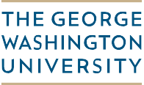

**Joseph Pelzman**

**Professor of Economics, International Affairs and Law**

**Department of Economics**

September 12, 2018

Via Email

Dear Je-Uei Kuo;

I am enclosing your results on the September 2018 field examination. Congratulations on passing your econometrics exam. You have now passed 3 out of the 4 exams. You now have to sit for your second field exam.

On behalf of the faculty of the Department of Economics, I wish you success as you go forwards in the program.



Joseph Pelzman

Professor of Economics, International Affairs and Law

PhD Pre-Candidacy Advisor

jpelz@gwu.edu

2115 G Street, NW | Suite 340 | Washington, DC 20052

**t** 202-994-6150 | **f** 202-994-6147