DAY8 SESSION ASSIGNMENTS

1.When to use (Rapid Application Development) RAD model
When not to use (Rapid Application Development) RAD model
Ans:
RAD model can be used when:
- If there is a requirement of developing the product or application with in 2-3 months and is to be produced in short span of time.
- If there is high availability of expert designers for modelling.
- If there is enough budget is Available to afford the cost of designers and other automated tools
- If the requirements are well defined
- If the there is an availability of Expert Developers(Coders)
- If the customer is availabable through out the project development.
- If the technical risks identified in the project is less.
- If there is a small Testing team is available since it is based on simple testings.
- If the customer only wants the product rather than quality.

RAD model is not to be used when:
- If it is a long term project
- If there is lack of highly expert designers and developers.
- If there is no enough budget to meet the cost of expert designers and other automated softwares.
- If there is no Automated tools are available.
- When the customer strictly wants the quality of product.
- When there is no provisions for the accomodation of customers through out the project. (Such as – Waterflow Approach).

2.Define an ER diagram of a software Organization
with all the relationship model that was discussed in the classroom

Ans: An entity relationship model, also called an entity-relationship (ER) diagram, is a graphical representation of entities and their relationships to each other, typically used in computing in regard to the organization of data within databases or information systems.
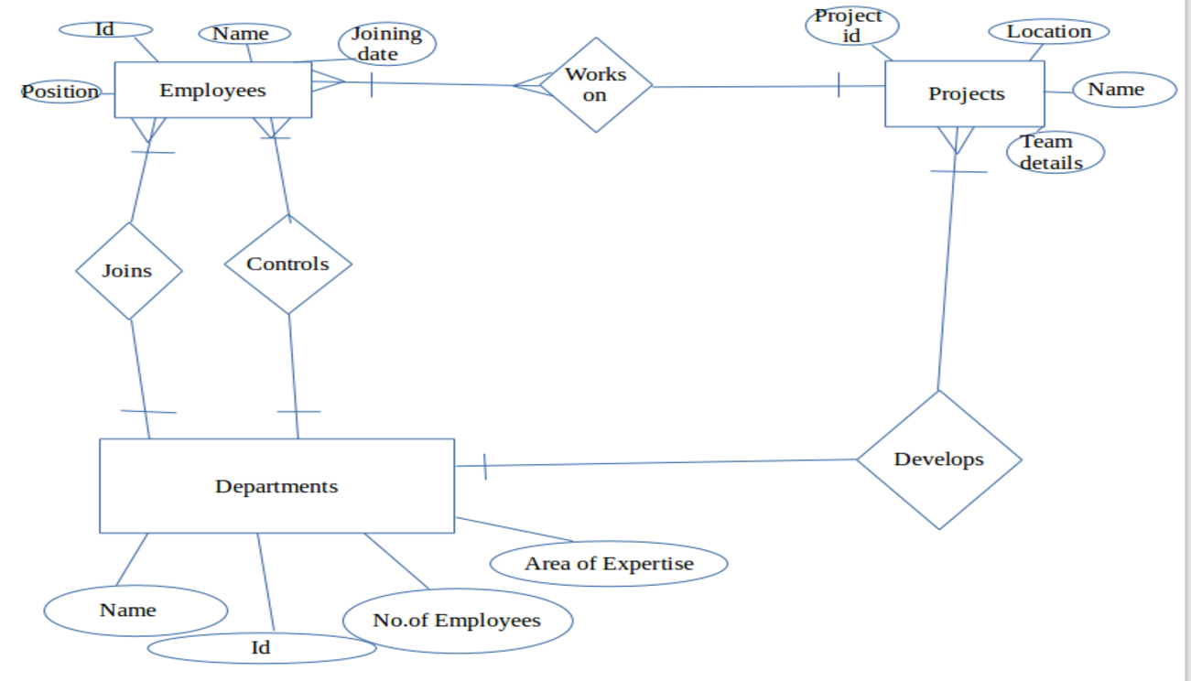

3.Describe the Entity Relationships for the following diagram
Ans: The above ER diagram consist of 4 Entities

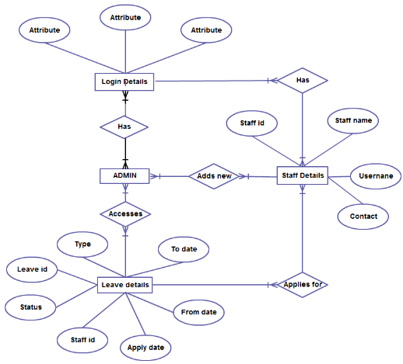

1. Login Details
The login detail consist of 3 attributes, that may be the Username, password, or may be some special login detail such as ‘Biometrics’.
Relation to other entities –
- Login Details is related to 2 other entities that are ADMIN and Staff Details.
1.Relation with ADMIN
It has a many to many relation with the ADMIN.Multiple ADMIN’s are capable of Checking the Multiple Logins. Also the multiple ADMIN’s are capable of Login with their different Login Details.
2.Relation with Staff Details
All the staffs can login to the system. With in a company multiple Staffs have different Login details.
2.ADMIN
There is no attributes for the ADMIN.
Relation to other entities –
- ADMIN is related to 3 other entities that are Login Details,Staff Details and Leave Details
1.Relation with Login Details
The admin can login into the system using their login details.Multiple admins can login into the system.
2.Relation with Staff Details
ADMIN’s can add new Staffs. The details of each staff is available for all the ADMIN’s.
3.Relation with Leave Details
The admins can access the leave details of all the staffs.
3.Staff Details
  - There is 3 attributes for the Staff Details,they are staff name, username, contact,
Relation to other entities –
It is related to 3 other entities.
1.Relation with Login Details
each staff has a single Login Detail.The staffs can login with their login credentials.
2.Relation with ADMIN
The staffs are added by the admins.Admins can add multiple staffs.
3.Relation with Leave Details
It has many to many relation with the Leave Details,ie multiple staffs can apply for leaves also a single leave detail corresponds to a single staff.
4.Leave Details
  - There is 7 attributes are for the Leave Details,they are status,leave id,staff id,apply date, from date, type.
Relation to other entities –
It is related to 2 other entities.
1.Relation with ADMIN
The leave details of all the staffs are accessible to the admins.
2.Relation with Staff Details
The staffs enter their leave details.

