

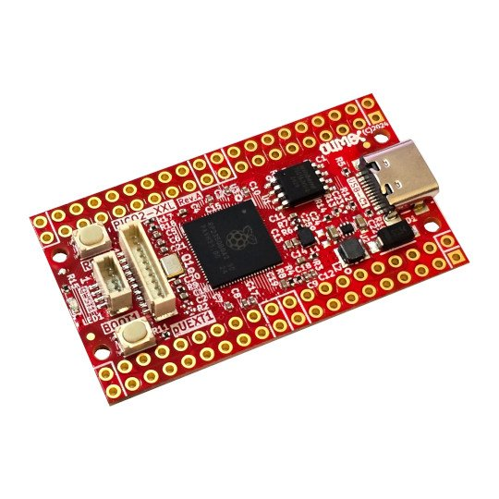
RP2350-PICO2-XL
RP2350-PICO2-XXL
User Manual
Document 2.2 November 2025 www.olimex.com
Table of Contents
Introduction to RP2350-PICO2-XXL 3
Order codes for RP2350-PICO2-XXL and accessories 4
HARDWARE 5
RP2350-PICO2-XXL layout 5
Dimensions 7
RP2350-PICO2-XXL GPIOs 8
RP2350-PICO2-XXL schematics 10
UEXT connector 11
pUEXT signals 12
Qwiic/Stemma connector 13
Micro SD card connector 14
PSRAM connection 15
LED connection 16
SOFTWARE 17
Document Revision History 18

Introduction to RP2350-PICO2-XXL

RP2350-PICO2-XXL is a re-design of the popular “Raspberry Pi Pico 2” board with these improvements:

- RP2350B Dual Cortex-M33 or dual RISC-V @ 150MHz
- All 48 RP2350 GPIOs exposed to the user
- USB-C connector for data and powering – it allows more current to be supplied to the board
- DCDC power supply voltage regulator 3.3V 2A (3A peak)
- 2MB or 16MB flash memory versions (-XL and -XXL variants)
- Extra 8MB PSRAM in the -XXL variant
- Micro SD card connector in the -XXL variant
- BOOT and RESET buttons
- Four-layer board for better noise immunity and USB differential pair routing
- UEXT connector (pUEXT 1.0 mm step connector)
- Qwiic/Stemma connector
- Status LED
- Dimensions: (50 x 28)mm ~ (1.97 x 1.10)"

Notice
The two board variants RP2350-PICO2-XL and RP2350-PICO2-XXL share the same PCB and silksreen! The three differences between -XL and -XXL variants are that:
- the -XXL variant has PSRAM,the -XL variant – no PSRAM;
- the -XXL variant has micro SD card, the -XL variant – no micro SD card connector;
- the -XXL has 16MB of flash memory, the flash memory of the -XL variant is only 2MB.

Order codes for RP2350-PICO2-XXL and accessories

RP2350-PICO2-XL industrial grade RP2350-PICO2 board with 48 GPIOs exposed
RP2350-PICO2-XXL includes everything in XL, bigger flash, extra 8MB PSRAM, and extra microSD card
USB-CABLE-AM-USB3-C high quality USB 3.0 cable with type C connector for power and programming
pUEXT pack of cables pack of 3pcs 200mm pUEXT cables
UEXT-MPQ converter board from pUEXT to UEXT
UEXT-PQ another converter board from pUEXT

HARDWARE

RP2350-PICO2-XXL layout

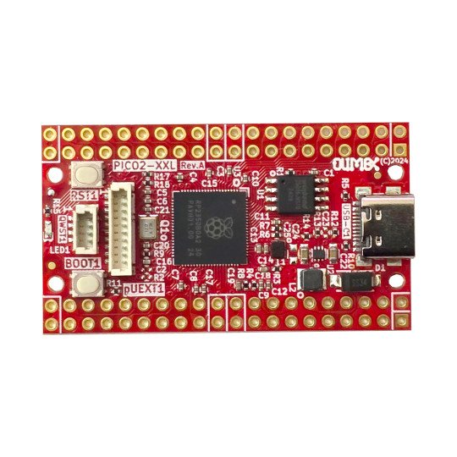
Top view for both -XL and -XXL
Boot button
Qwiic Stemma
LED
RST1 reset button
pUEXT
RP2350B
2MB or 16MB Flash
USB-C
Power supply
Bottom view for -XL variant:
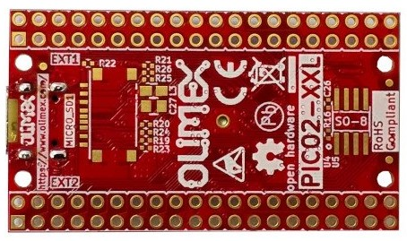
Bottom view for -XXL variant:
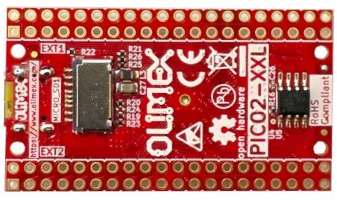
Micro SD card
8MB PSRAM

Dimensions
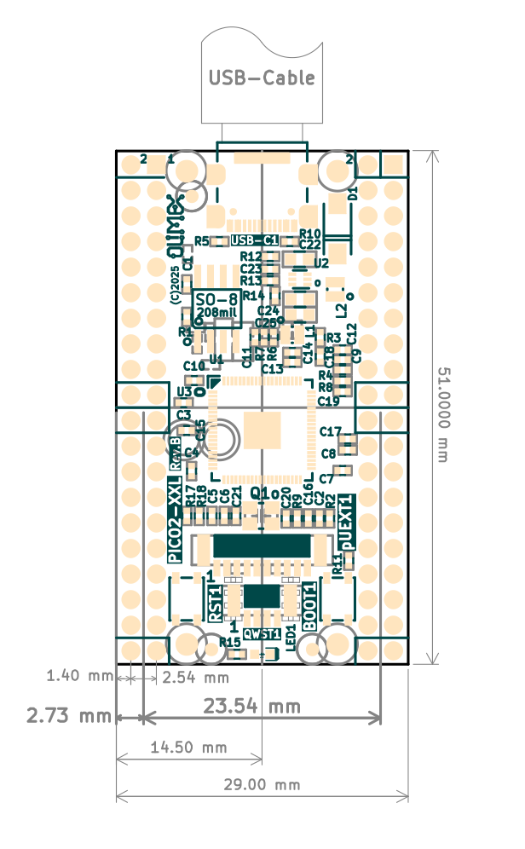

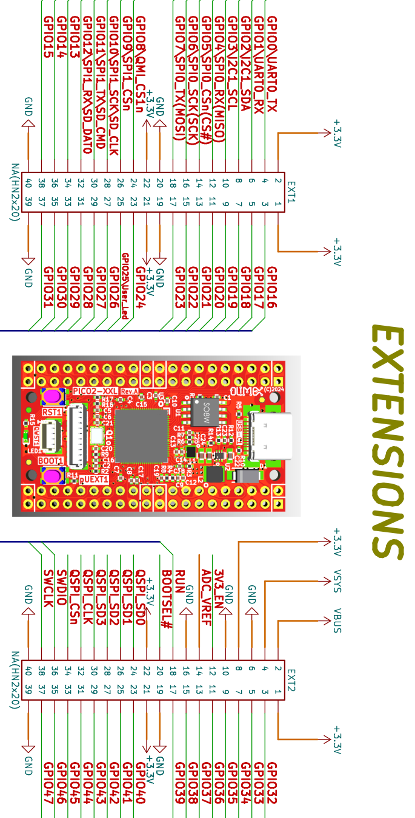
RP2350-PICO2-XXL GPIOs

POWER SUPPLY:

VBUS +5V from, USB-C output
VDD_SYS +5V may be output or input
if you want to use as input i.e. to feed power from external 5V to this line make sure the board is not connected to USB!
when you use it as output i.e. you feed external electronics from it up to 1A @ 5V
+3.3V output which can source up to 2A @ 3.3V
3V3_EN input, when pulled to GND stops the 3.3V DCDC convertor

RP2350-PICO2-XXL schematics

RP2350-PICO2-XXL schematics can be found at GitHub:

https://github.com/OLIMEX/RP2350-PICO2-XXL/tree/main/HARDWARE

The board is open source hardware and you can use free and open KiCAD software to view the design files!

UEXT connector

UEXT connector stands for Universal EXTension connector and contains +3.3V, GND, I2C, SPI, UART signals.
UEXT connector can be in different shapes.
The original UEXT connector is 0.1” 2.54mm step boxed plastic connector. All signals are with 3.3V levels.
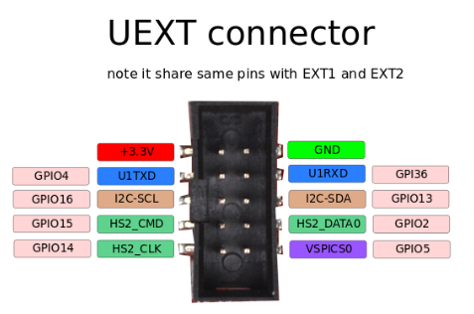

As the boards become smaller and smaller some smaller packages were introduced too beside the original UEXT connector:
- mUEXT is 1.27 mm step boxed header connector which is with same layout as UEXT;
- pUEXT is 1.0 mm single row connector (this is the connector used in RP2040-PICO30).
Olimex has developed number of MODULES with this connector. There are temperature, humidity, pressure, magnetic field, light sensors. Modules with LCDs, LED matrix, Relays, Bluetooth, Zigbee, WiFi, GSM, GPS, RFID, RTC, EKG, sensors and etc.

pUEXT signals

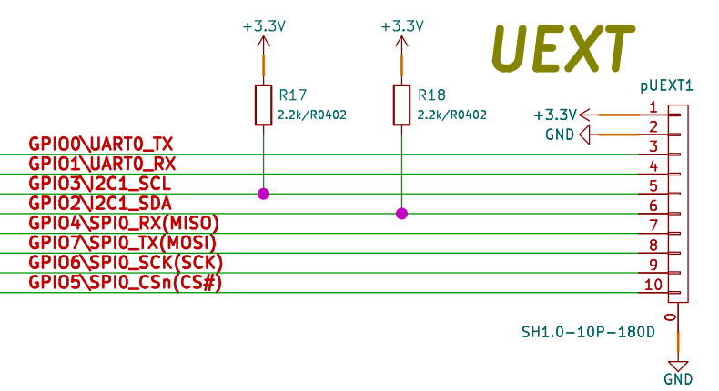

Qwiic/Stemma connector

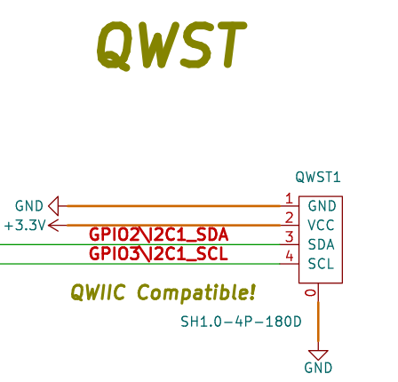

Micro SD card connector

In latest hardware revisions (B and newer) the SD card is connected in SPI data mode:
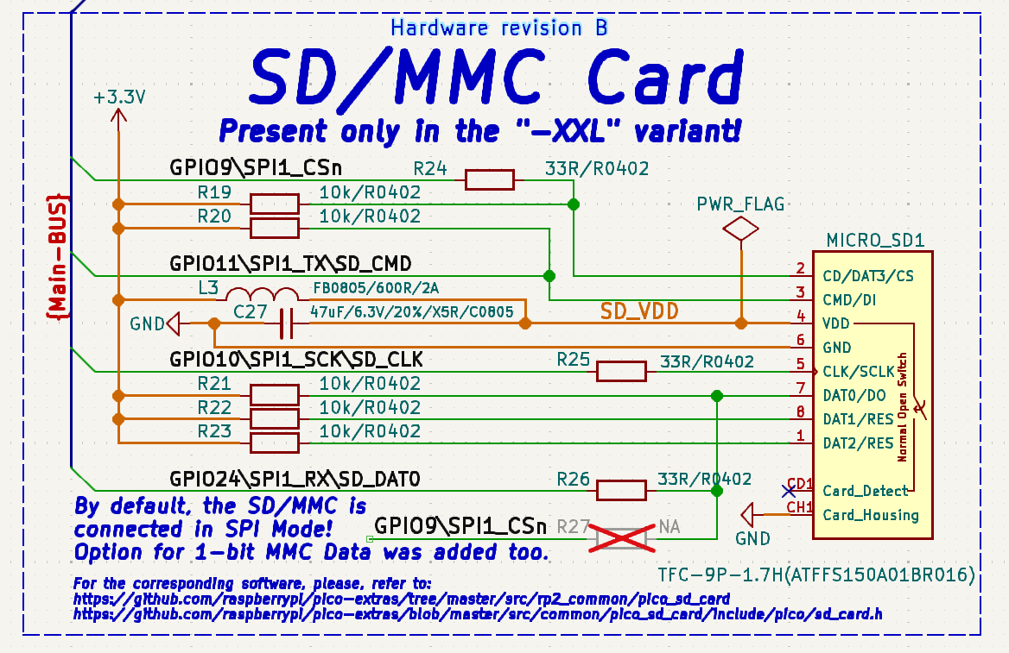
Notice that in hardware revision A the board was connected in 1-bit MMC data mode.

PSRAM connection

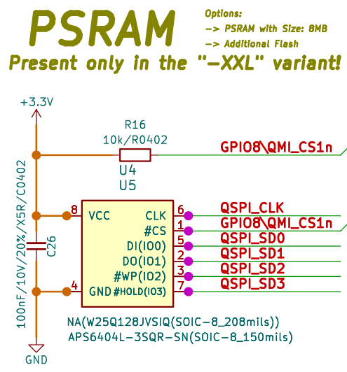

LED connection

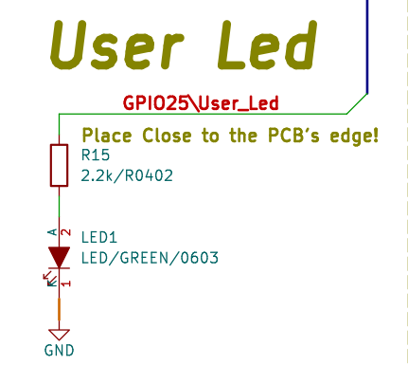

SOFTWARE

RP2350-PICO2-XXL uses same software as PICO2
- Raspberry PI SDK, header can be found at this GitHub link
- MicroPython SDK (note that to the current date RP2350B chip support is not implemented in MicroPython and the access of the GPIO30-47 in MicroPython is not implemented.
- CircuitPython from Adafruit – all 48 GPIOs are implemented.
Original production binaries can be found at the GitHub link here

Document Revision History
Revision 2.2 November 2025
- Added dimensions
Revision 2.1 August 2025
- Improved formatting
Revision 2.0 April 2025
- Added latest schematics
- Improved formatting
Revision 1.0 January 2025

