AngII_1
Paul Cho
2025-12-19
Table of Contents

Loading packages
options(repos = c(CRAN = "https://cloud.r-project.org"))
if (!requireNamespace("remotes", quietly = TRUE)) {
install.packages("remotes")
}
library(remotes)
if (!require("here")) {install.packages("here"); require("here")}
## Loading required package: here
## here() starts at /Users/paulcho/Documents/GitHub/AngII_Project
Datasets <- "Datasets"
Outputs <- "Outputs"
if (!dir.exists(here(Datasets))) {dir.create(here(Datasets))}
if (!dir.exists(here(Outputs))) {dir.create(here(Outputs))}
install.packages("remotes")
##
## The downloaded binary packages are in
## /var/folders/k0/nty70bnn7zz8mjbcfrsm41j80000gn/T//RtmpYzKuiO/downloaded_packages
remotes::install_github('chris-mcginnis-ucsf/DoubletFinder', force = TRUE)
## Downloading GitHub repo chris-mcginnis-ucsf/DoubletFinder@HEAD
##
## ── R CMD build ─────────────────────────────────────────────────────────────────
## checking for file ‘/private/var/folders/k0/nty70bnn7zz8mjbcfrsm41j80000gn/T/RtmpYzKuiO/remotesc68b73e6db13/chris-mcginnis-ucsf-DoubletFinder-1b244d8/DESCRIPTION’ ... ✔ checking for file ‘/private/var/folders/k0/nty70bnn7zz8mjbcfrsm41j80000gn/T/RtmpYzKuiO/remotesc68b73e6db13/chris-mcginnis-ucsf-DoubletFinder-1b244d8/DESCRIPTION’
## ─ preparing ‘DoubletFinder’:
## checking DESCRIPTION meta-information ... ✔ checking DESCRIPTION meta-information
## ─ checking for LF line-endings in source and make files and shell scripts
## ─ checking for empty or unneeded directories
## ─ building ‘DoubletFinder_2.0.6.tar.gz’
##
##
install.packages("devtools")
##
## The downloaded binary packages are in
## /var/folders/k0/nty70bnn7zz8mjbcfrsm41j80000gn/T//RtmpYzKuiO/downloaded_packages
devtools::install_github("davidsjoberg/ggsankey")
## Skipping install of 'ggsankey' from a github remote, the SHA1 (b675d0d5) has not changed since last install.
## Use `force = TRUE` to force installation
if (!require("dplyr")) {install.packages("dplyr"); require("dplyr")}
## Loading required package: dplyr
##
## Attaching package: 'dplyr'
## The following objects are masked from 'package:stats':
##
## filter, lag
## The following objects are masked from 'package:base':
##
## intersect, setdiff, setequal, union
if (!require("Seurat")) {install.packages("Seurat"); require("Seurat")}
## Loading required package: Seurat
## Warning: package 'Seurat' was built under R version 4.5.2
## Loading required package: SeuratObject
## Warning: package 'SeuratObject' was built under R version 4.5.2
## Loading required package: sp
##
## Attaching package: 'SeuratObject'
## The following objects are masked from 'package:base':
##
## intersect, t
if (!require("patchwork")) {install.packages("patchwork"); require("patchwork")}
## Loading required package: patchwork
if (!require("cowplot")) {install.packages("cowplot"); require("cowplot")}
## Loading required package: cowplot
##
## Attaching package: 'cowplot'
## The following object is masked from 'package:patchwork':
##
## align_plots
if (!require("ggpubr")) {install.packages("ggpubr"); require("ggpubr")}
## Loading required package: ggpubr
## Loading required package: ggplot2
## Warning: package 'ggplot2' was built under R version 4.5.2
##
## Attaching package: 'ggpubr'
## The following object is masked from 'package:cowplot':
##
## get_legend
if (!require("plotly")) {install.packages("plotly"); require("plotly")}
## Loading required package: plotly
##
## Attaching package: 'plotly'
## The following object is masked from 'package:ggplot2':
##
## last_plot
## The following object is masked from 'package:stats':
##
## filter
## The following object is masked from 'package:graphics':
##
## layout
if (!require("knitr")) {install.packages("knitr"); require("knitr")}
## Loading required package: knitr
## Warning: package 'knitr' was built under R version 4.5.2
if (!require("htmlwidgets")) {install.packages("htmlwidgets"); require("htmlwidgets")}
## Loading required package: htmlwidgets
##
## Attaching package: 'htmlwidgets'
## The following object is masked from 'package:Seurat':
##
## JS
## The following object is masked from 'package:SeuratObject':
##
## JS
if (!require("tidyverse")) {install.packages("tidyverse"); require("tidyverse")} # for titying up data
## Loading required package: tidyverse
## Warning: package 'tidyr' was built under R version 4.5.2
## ── Attaching core tidyverse packages ──────────────────────── tidyverse 2.0.0 ──
## ✔ forcats 1.0.1 ✔ stringr 1.6.0
## ✔ lubridate 1.9.4 ✔ tibble 3.3.0
## ✔ purrr 1.2.0 ✔ tidyr 1.3.2
## ✔ readr 2.1.5
## ── Conflicts ────────────────────────────────────────── tidyverse_conflicts() ──
## ✖ plotly::filter() masks dplyr::filter(), stats::filter()
## ✖ dplyr::lag() masks stats::lag()
## ✖ lubridate::stamp() masks cowplot::stamp()
## ℹ Use the conflicted package (<http://conflicted.r-lib.org/>) to force all conflicts to become errors
if (!require("RColorBrewer")) {install.packages("RColorBrewer"); require("RColorBrewer")} # for color brewer
## Loading required package: RColorBrewer
if (!require("sctransform")) {install.packages("sctransform"); require("sctransform")} # for data normalization
## Loading required package: sctransform
if (!require("openxlsx")) {install.packages("openxlsx"); require("openxlsx")} # to save .xlsx files
## Loading required package: openxlsx
if (!require("SoupX")) {install.packages("SoupX"); require("SoupX")}
## Loading required package: SoupX
if (!require("readxl")) {install.packages("readxl"); require("readxl")}
## Loading required package: readxl
if (!require("hdf5r")) {install.packages("hdf5r"); require("hdf5r")}
## Loading required package: hdf5r
##
## Attaching package: 'hdf5r'
##
## The following object is masked from 'package:purrr':
##
## flatten_df
if (!require("glmGamPoi")) {BiocManager::install('glmGamPoi'); require("glmGamPoi")} # for data normalization, sctransform
## Loading required package: glmGamPoi
##
## Attaching package: 'glmGamPoi'
##
## The following object is masked from 'package:ggplot2':
##
## vars
##
## The following object is masked from 'package:dplyr':
##
## vars
if (!require("EnhancedVolcano")) {BiocManager::install('EnhancedVolcano'); require("EnhancedVolcano")} # volcano plot
## Loading required package: EnhancedVolcano
## Warning: package 'EnhancedVolcano' was built under R version 4.5.2
## Loading required package: ggrepel
library(ggsankey)
library(DoubletFinder)
set.seed((12345))
here()
## [1] "/Users/paulcho/Documents/GitHub/AngII_Project"
#renv::init()
#renv::install("Seurat@5.2.0")
#renv::install("hdf5r")
#renv::install("chris-mcginnis-ucsf/DoubletFinder")
#renv::snapshot()

Loading the dataset
kidney1 <- "kidney1"
# Create a Soup Channel Object(sc) to use for future filtering of ambient RNA
RawDataset = Read10X_h5(here("datasets", "1_raw_feature_bc_matrix.h5"))
FilteredDataset = Read10X_h5(here("datasets", "1_filtered_feature_bc_matrix.h5"))
# Make a Seurat Object from the filtered control data
filtered_kidney <- Read10X_h5(here("datasets", "1_filtered_feature_bc_matrix.h5"))
filtered_kidney <- CreateSeuratObject(counts = filtered_kidney, project = "Filteredkidney_snRNA")
#SoupX
sc = SoupChannel(RawDataset,FilteredDataset)
# Cluster the Cells with Seurat
filtered_kidney <- SCTransform(filtered_kidney, verbose = F)
filtered_kidney <- RunPCA(filtered_kidney, verbose = F)
filtered_kidney <- RunUMAP(filtered_kidney, dims = 1:30, verbose = F)
## Warning: The default method for RunUMAP has changed from calling Python UMAP via reticulate to the R-native UWOT using the cosine metric
## To use Python UMAP via reticulate, set umap.method to 'umap-learn' and metric to 'correlation'
## This message will be shown once per session
filtered_kidney <- FindNeighbors(filtered_kidney, dims = 1:30, verbose = F)
## Warning: package 'future' was built under R version 4.5.2
filtered_kidney <- FindClusters(filtered_kidney, verbose = F)
meta <- filtered_kidney@meta.data
umap <- filtered_kidney@reductions$umap@cell.embeddings
clusters <- setNames(meta$seurat_clusters, rownames(meta))
#Ensure the two following numbers are equal before continuing
check1 <- length(clusters)
check2 <- nrow(sc$metaData)
sc <- setClusters(sc, clusters)
sc <- setDR(sc, umap)
Calculating contamination fraction:
sc = autoEstCont(sc)
## 1278 genes passed tf-idf cut-off and 348 soup quantile filter. Taking the top 100.
## Using 1260 independent estimates of rho.
## Estimated global rho of 0.02
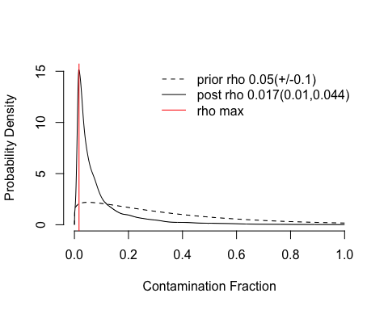 Post rho value is 1.7% (estimated amount of ambient RNA is 1.7%, low)
#Clean the data
filtered_kidney_out = adjustCounts(sc)
## Warning in sparseMatrix(i = out@i[w] + 1, j = out@j[w] + 1, x = out@x[w], :
## 'giveCsparse' is deprecated; setting repr="T" for you
## Expanding counts from 24 clusters to 11830 cells.
#Create a new Seurat Object out of the cleaned data
seurat.obj <- CreateSeuratObject(filtered_kidney_out)
# Remove unused objects in environment to save RAM
#rm(filtered_kidney, filtered_kidney_out, FilteredDataset, RawDataset, sc, meta, check1, check2, clusters, umap, y, Datasets, Outputs)

Doublet filtering
- DoubletFinder: removing doublets(droplets that captured 2+ cells instead of 1)
- After running, look at “DF.class”, which labels each cell as “Doublet” or “Singlet.”
- Visualize results using UMAP.
- pANN score: how doublet-like a cell is. Useful for threshold tuning.
- Manual doublet curation
Start <- ncol(seurat.obj)
p1 <- VlnPlot(seurat.obj, features = c("nFeature_RNA")) + theme(axis.title.x = element_blank()) + theme(legend.position = 'none') + theme(axis.text.x = element_text(angle = 0, hjust = .5))
## Warning: Default search for "data" layer in "RNA" assay yielded no results;
## utilizing "counts" layer instead.
p2 <- VlnPlot(seurat.obj, features = c("nFeature_RNA"), pt.size = 0) + theme(axis.title.x = element_blank()) + theme(legend.position = 'none') + theme(axis.text.x = element_text(angle = 0, hjust = .5))
## Warning: Default search for "data" layer in "RNA" assay yielded no results;
## utilizing "counts" layer instead.
p3 <- VlnPlot(seurat.obj, features = c("nCount_RNA")) + theme(axis.title.x = element_blank()) + theme(legend.position = 'none') + theme(axis.text.x = element_text(angle = 0, hjust = .5))
## Warning: Default search for "data" layer in "RNA" assay yielded no results;
## utilizing "counts" layer instead.
p4 <- VlnPlot(seurat.obj, features = c("nCount_RNA"), pt.size = 0) + theme(axis.title.x = element_blank()) + theme(legend.position = 'none') + theme(axis.text.x = element_text(angle = 0, hjust = .5))
## Warning: Default search for "data" layer in "RNA" assay yielded no results;
## utilizing "counts" layer instead.
cowplot::plot_grid(p1, p2, p3, p4, ncol = 4, scale = .85) + draw_label("Before Filtering", y = .95, size = 22, fontface = "bold")
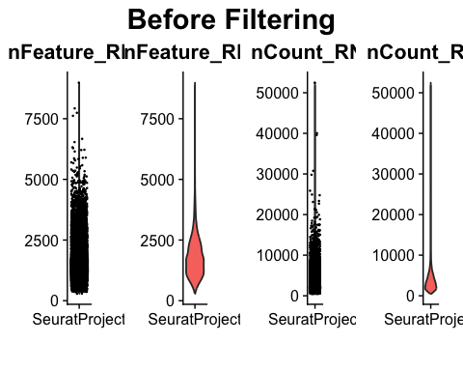
# Minimal filtering of low quality cells
seurat.obj.f <- subset(seurat.obj, nFeature_RNA > 1000)
p1 <- VlnPlot(seurat.obj.f, features = c("nFeature_RNA")) + theme(axis.title.x = element_blank()) + theme(legend.position = 'none') + theme(axis.text.x = element_text(angle = 0, hjust = .5))
## Warning: Default search for "data" layer in "RNA" assay yielded no results;
## utilizing "counts" layer instead.
p2 <- VlnPlot(seurat.obj.f, features = c("nFeature_RNA"), pt.size = 0) + theme(axis.title.x = element_blank()) + theme(legend.position = 'none') + theme(axis.text.x = element_text(angle = 0, hjust = .5))
## Warning: Default search for "data" layer in "RNA" assay yielded no results;
## utilizing "counts" layer instead.
p3 <- VlnPlot(seurat.obj.f, features = c("nCount_RNA")) + theme(axis.title.x = element_blank()) + theme(legend.position = 'none') + theme(axis.text.x = element_text(angle = 0, hjust = .5))
## Warning: Default search for "data" layer in "RNA" assay yielded no results;
## utilizing "counts" layer instead.
p4 <- VlnPlot(seurat.obj.f, features = c("nCount_RNA"), pt.size = 0) + theme(axis.title.x = element_blank()) + theme(legend.position = 'none') + theme(axis.text.x = element_text(angle = 0, hjust = .5))
## Warning: Default search for "data" layer in "RNA" assay yielded no results;
## utilizing "counts" layer instead.
cowplot::plot_grid(p1, p2, p3, p4, ncol = 4, scale = .85) + draw_label("After Filtering Low Complexity Cells", y = .95, size = 22, fontface = "bold")
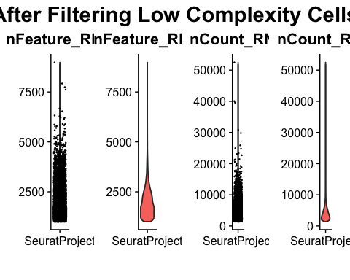
Filter_1 <- ncol(seurat.obj.f)
amountfiltered1 <- Start-Filter_1
#Making a table to display the amount of cells being filtered out with the minimal filtering of low quality cells applied to the snRNAseq dataset.
cell_counts <- data.frame(Phase = c("Before Filtering", "After Filtering", "Amount Filtered"), Cell_Number = c(Start, Filter_1, amountfiltered1))
print(cell_counts)
## Phase Cell_Number
## 1 Before Filtering 11830
## 2 After Filtering 10099
## 3 Amount Filtered 1731
# Remove unused objects in environment to save RAM
#rm(seurat.obj, p1, p2, p3, p4, cell_counts)

High-dimensional superclustering
resolution_value <- 1.5
# Pre-process standard workflow
seurat.obj.f <- NormalizeData(object = seurat.obj.f)
## Normalizing layer: counts
seurat.obj.f <- FindVariableFeatures(object = seurat.obj.f)
## Finding variable features for layer counts
seurat.obj.f <- ScaleData(object = seurat.obj.f)
## Centering and scaling data matrix
seurat.obj.f <- RunPCA(object = seurat.obj.f)
## PC_ 1
## Positive: Ldb2, Meis2, Ebf1, Dlc1, Prkg1, Ptprm, Plpp1, Fmnl2, Tshz2, Emcn
## Eng, Fli1, Flt1, 9530026P05Rik, Cald1, Fbxl7, Adgrl4, Arhgap31, Tek, Prkch
## Ptprb, Rapgef5, Nrp2, Plpp3, Akt3, Dysf, Sp100, Samd12, Prex2, Rapgef4
## Negative: Keg1, Acsm2, Fut9, Slc25a21, Pck1, Abcc2, Acox1, Gm19950, Slc17a3, Them7
## Slc4a4, Nhs, Gcnt1, Hnf4g, Ghr, Slco1a6, Slc13a1, Bnc2, Gm20528, Akr1c21
## Ppara, Cyp4b1, Wdr17, Dab2, Cndp1, Ndrg1, Pah, Gramd1b, Nox4, Sox2ot
## PC_ 2
## Positive: Meis2, Ldb2, Prex2, Ebf1, Dock4, Plpp1, Emcn, Flt1, Zeb1, Eng
## Csgalnact1, Dlc1, Arhgap31, Adgrl4, Zeb2, St6galnac3, Tek, Arhgap26, Ptprb, Prkg1
## Exoc3l2, Dab2, Sema6a, Hecw2, Egfl7, Fgd5, Keg1, Sp100, Acsm2, Nrp2
## Negative: Mecom, Slit2, Slc16a7, Erbb4, Prdm16, Rgs6, Kng2, Sim1, Efna5, Nudt4
## Me3, Tmem72, Abca13, Stk39, Defb1, Tfap2b, Rap1gap2, Nckap5, Efhd1, Lnx1
## Kcnj1, Mrps6, Cdh1, Egf, Tmem52b, Cacnb4, Ppp1r1a, Slc5a3, Kctd1, Srgap3
## PC_ 3
## Positive: Lama2, Cfh, Fbln5, Abca8a, Pdgfra, Pde3a, Fhl2, Kcnt2, Gucy1a2, Pdgfrb
## Svep1, Col14a1, Daam2, Csmd1, Robo2, Slco2b1, Rerg, Frem1, Lhfp, Mrc2
## C7, Ak5, Itih5, Hsd11b1, Gm29683, Adamts5, Egflam, Ripor3, Colec12, Olfr1033
## Negative: Flt1, Adgrl4, Tek, Ptprb, Exoc3l2, Prkch, St6galnac3, Rasgrp3, Egfl7, Cyyr1
## Rapgef4, Pecam1, Shank3, Emcn, Arhgap31, Dysf, D5Ertd615e, Kdr, Ushbp1, Ednrb
## Erg, Chrm3, Limch1, Inpp5d, Cd38, Samd12, Lrrc8c, Fam117b, Mef2c, Plxna4
## PC_ 4
## Positive: Slc6a18, Rnf24, Napsa, Slc7a13, Atp11a, Cyp7b1, Esr1, Slc5a4a, C8a, Slc5a8
## Vmn1r18, Mettl7a2, Mep1b, Slc22a19, Kap, Mep1a, Gm29536, Acsm3, Slc22a13, Kcnma1
## Mat2a, Cyp51, Aadat, Bcat1, 4930533I22Rik, Hsd17b2, Sox2ot, Gpm6a, Mro, Satb2
## Negative: Slc5a12, Slc5a2, Gatm, Slc6a19, Pik3c2g, Gpx3, D630023F18Rik, Magi2, Nox4, Car12
## Gm31718, Enpp2, Slc7a7, Etv1, Alpl, Lipa, Pakap.1, Adra1a, Clec2h, Gldc
## Gabrb3, Slc16a10, Cyp24a1, Prodh2, Epb41l3, Tbxas1, Gm48606, Spp2, Atxn1, Dab2
## PC_ 5
## Positive: Egf, Abca13, Slc12a1, Umod, Ppp1r1a, Esrrb, Kng2, Tmem72, Cacnb4, Gm14002
## Ptger3, Slc16a7, Slc5a3, Lrrc66, Wfdc15b, Erbb4, Gm42697, Bckdhb, Fxyd2, Tenm2
## Stk32b, Gm44588, Casr, Slc2a13, Gm16685, Fndc9, Mrps6, Tfap2b, Fam107a, Dusp15
## Negative: Frmpd4, Grip1, Pde1c, Aqp4, Bmpr1b, Fxyd4, Aqp2, Tmem45b, Slc14a2, Styk1
## Alcam, AC106834.1, Lypd6b, Naaladl2, Mpped2, Tmtc2, Gata3, Kif26b, Tmsb4x, Ehf
## Fam241a, Mgat4c, Wnt4, Plet1, Elf5, Col4a6, Myh10, Crybg1, Apobec3, Coro2a
# ElbowPlot(seurat.obj.f, ndims = 30)
seurat.obj.f <- FindNeighbors(object = seurat.obj.f, dims = 1:30)
## Computing nearest neighbor graph
## Computing SNN
seurat.obj.f <- FindClusters(object = seurat.obj.f, resolution = resolution_value, verbose = F)
# Make a UMAP to visualize the clusters
seurat.obj.f <- RunUMAP(object = seurat.obj.f, dims = 1:30)
## 17:15:32 UMAP embedding parameters a = 0.9922 b = 1.112
## 17:15:32 Read 10099 rows and found 30 numeric columns
## 17:15:32 Using Annoy for neighbor search, n_neighbors = 30
## 17:15:32 Building Annoy index with metric = cosine, n_trees = 50
## 0% 10 20 30 40 50 60 70 80 90 100%
## [----|----|----|----|----|----|----|----|----|----|
## **************************************************|
## 17:15:33 Writing NN index file to temp file /var/folders/k0/nty70bnn7zz8mjbcfrsm41j80000gn/T//RtmpYzKuiO/filec68b44511caf
## 17:15:33 Searching Annoy index using 1 thread, search_k = 3000
## 17:15:35 Annoy recall = 100%
## 17:15:35 Commencing smooth kNN distance calibration using 1 thread with target n_neighbors = 30
## 17:15:36 Initializing from normalized Laplacian + noise (using RSpectra)
## 17:15:36 Commencing optimization for 200 epochs, with 427746 positive edges
## 17:15:36 Using rng type: pcg
## 17:15:40 Optimization finished
DimPlot(seurat.obj.f, reduction = "umap", label = TRUE) +
theme(plot.title = element_text(hjust = 0.5)) +
ggtitle(paste0("Initial Clustering for ", kidney1))
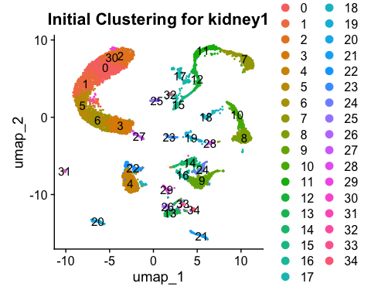

Save excel spreadsheet of DEG List by Cluster
This file can be used to determine the prominent features (highly enriched genes) of each cluster. + will be in the Outputs folder
all_markers <- FindAllMarkers(seurat.obj.f, only.pos = TRUE, min.pct = 0.5, logfc.threshold = 1)
## Calculating cluster 0
## For a (much!) faster implementation of the Wilcoxon Rank Sum Test,
## (default method for FindMarkers) please install the presto package
## --------------------------------------------
## install.packages('devtools')
## devtools::install_github('immunogenomics/presto')
## --------------------------------------------
## After installation of presto, Seurat will automatically use the more
## efficient implementation (no further action necessary).
## This message will be shown once per session
## Calculating cluster 1
## Calculating cluster 2
## Calculating cluster 3
## Calculating cluster 4
## Calculating cluster 5
## Calculating cluster 6
## Calculating cluster 7
## Calculating cluster 8
## Calculating cluster 9
## Calculating cluster 10
## Calculating cluster 11
## Calculating cluster 12
## Calculating cluster 13
## Calculating cluster 14
## Calculating cluster 15
## Calculating cluster 16
## Calculating cluster 17
## Calculating cluster 18
## Calculating cluster 19
## Calculating cluster 20
## Calculating cluster 21
## Calculating cluster 22
## Calculating cluster 23
## Calculating cluster 24
## Calculating cluster 25
## Calculating cluster 26
## Calculating cluster 27
## Calculating cluster 28
## Calculating cluster 29
## Calculating cluster 30
## Calculating cluster 31
## Calculating cluster 32
## Calculating cluster 33
## Calculating cluster 34
# Order by avg_log2FC
all_markers <- all_markers %>%
arrange(desc(avg_log2FC)) %>%
select(gene, everything())
# Split by cluster (ident column)
marker_list <- split(all_markers, all_markers$cluster)
# Sort names alphanumerically
sorted_cluster_names <- names(marker_list)[order(as.numeric(names(marker_list)))]
# Create a workbook
wb <- createWorkbook()
# Add each cluster as a new worksheet
for (cluster_name in sorted_cluster_names) {
addWorksheet(wb, sheetName = cluster_name)
writeData(wb, sheet = cluster_name, marker_list[[cluster_name]])
}
date <- format(Sys.Date(), "%Y%m%d")
# Save workbook
saveWorkbook(wb, here("Outputs", paste0(date, "_", kidney1, "_FindAllMarkers_By_Cluster.xlsx")), overwrite = TRUE)
cell_type_markers_df <- data.frame(
Subclass = c(
"PTS1", "PTS2", "PTS3", "DTL", "TALA", "TALB", "MD", "DCT1", "DCT2", "CNT",
"PC", "ICA", "ICB", "PODO", "PEC", "URO", "EC", "LYMPH", "FIB", "MES", "VSMC", "LYMPHO", "MACRO"
),
Positive_Marker_1 = c(
"Lrp2", "Lrp2", "Lrp2", "Epha7", "Slc12a1", "Slc12a1", "Nos1", "Slc12a3", "Slc12a3", "Slc8a1",
"Aqp2", "Slc4a1", "Slc26a4", "Nphs1", "Ncam1", "Upk1b", "Flt1", "Lyve1", "Pdgfra", "Pdgfrb", "Pdgfrb", "Ptprc", "Ptprc"
),
Positive_Marker_2 = c(
"Slc5a12", "Slc13a3", "Slc16a9", "Cryab", "Cldn16", "Cldn10", "Slc12a1", "Egf", "Slc8a1", NA,
NA, "Kit", NA, NA, NA, NA, "Emcn", "Kdr", "Pdgfrb", "Piezo2", "Acta2", "Skap1", "Cd74"
),
stringsAsFactors = FALSE
)
# Creating a dot plot to cross reference the features with the cell clusters present, seeing the average expression and percent expressed
markers.to.plot1 <- c("Lrp2", # PTS1, PTS2, PTS3
"Slc5a12", # PTS1
"Slc13a3", # PTS2
"Slc16a9", # PTS3
"Epha7", # DTL
"Cryab", # DTL
"Slc12a1", # TALA, TALB, MD
"Cldn16", # TALA
"Cldn10", # TALB
"Nos1", # MD
"Slc12a3", # DCT1, DCT2
"Egf", # DCT1
"Slc8a1", # CNT, DCT2
"Aqp2", # PC
"Slc4a1", # ICA
"Kit", # ICA
"Slc26a4", # ICB
"Nphs1", # PODO
"Ncam1", # PEC
"Upk1b", # URO
"Flt1", # EC
"Emcn", # EC
"Lyve1", # LYMPH
"Kdr", # LYMPH
"Pdgfra", # FIB
"Pdgfrb", # FIB, MES, VSMC
"Piezo2", # MES
"Acta2", # VSMC
"Ptprc", # LYMPHO, MACRO
"Skap1", # LYMPHO
"Cd74" # MACRO
)
p1 <- DotPlot(seurat.obj.f,
features = markers.to.plot1,
dot.scale = 5,
dot.min = 0,
scale.max = 100,
scale.min = 0,
col.min = -2.5,
col.max = 2.5) +
theme(axis.text.x = element_text(angle = 45, hjust = 1)) +
coord_flip() +
labs(x = "Gene Features", y = "Clusters") +
theme(
axis.text.x = element_text(size = 8, angle = 60, hjust = 1, vjust = 1),
axis.text.y = element_text(size = 8),
)
p1
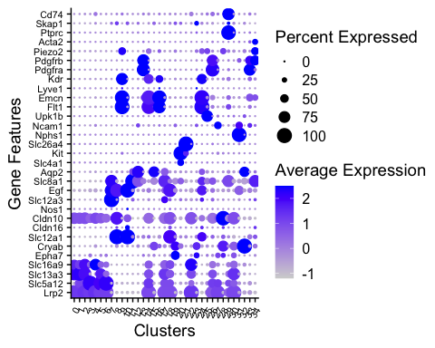

Missing cell types
p2 <- as.data.frame(p1$data)
low_pct_features <- p2 %>%
group_by(features.plot) %>%
filter(all(pct.exp <= 75)) %>%
distinct(features.plot) %>%
pull(features.plot)
# low_pct_features
low_pct_features2 <- as.data.frame(low_pct_features)
markers_long <- cell_type_markers_df %>%
pivot_longer(cols = c(Positive_Marker_1, Positive_Marker_2),
names_to = "marker_type", values_to = "marker") %>%
filter(!is.na(marker)) # remove any NAs in marker
# Step 2: Join with low_pct_features2
low_pct_features2_annotated <- low_pct_features2 %>%
left_join(markers_long, by = c("low_pct_features" = "marker")) %>%
rename(cell_type = Subclass) # rename Subclass to cell_type
missing_cell_types <- unique(na.omit(low_pct_features2_annotated$cell_type))
missing_cell_types
## [1] "DTL" "TALA" "MD" "ICA" "PEC" "URO" "LYMPH" "MES"
## [9] "VSMC" "LYMPHO"
The following features were found to have less than 75% of the cells expressing them in the any clusters (“DTL” “TALA” “MD” “ICA” “URO” “LYMPH” “MES” “VSMC” “LYMPHO”)
See if there are any clusters that are clearly enriched for the cell-type defining markers:
for (i in low_pct_features) {
# Find the subclass (if any) where the marker matches Positive_Marker_1 or _2
subclass_match <- cell_type_markers_df %>%
filter(Positive_Marker_1 == i | Positive_Marker_2 == i) %>%
pull(Subclass)
# If found, use the first match; else NA
subclass_label <- if (length(subclass_match) > 0) subclass_match[1] else NA
# Build the title
title_text <- if (!is.na(subclass_label)) {
paste0(i, " (", subclass_label, ")")
} else {
i
}
# Create plot
p <- FeaturePlot(seurat.obj.f, features = i) &
scale_colour_gradientn(colours = rev(brewer.pal(n = 9, name = "RdYlBu"))) &
ggtitle(title_text)
print(p) # Or save/store as needed
}
## Scale for colour is already present.
## Adding another scale for colour, which will replace the existing scale.
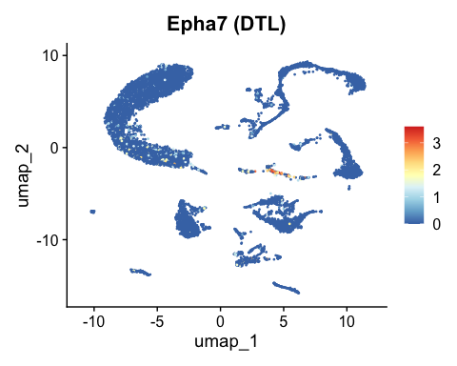
## Scale for colour is already present.
## Adding another scale for colour, which will replace the existing scale.
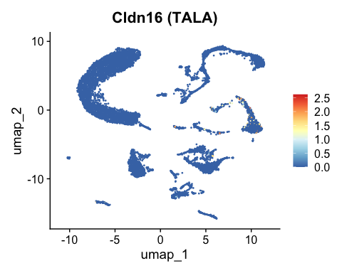
## Scale for colour is already present.
## Adding another scale for colour, which will replace the existing scale.
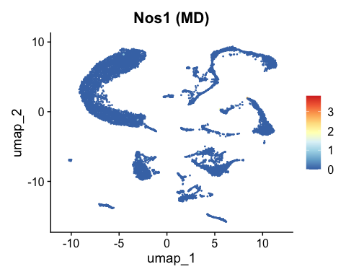
## Scale for colour is already present.
## Adding another scale for colour, which will replace the existing scale.
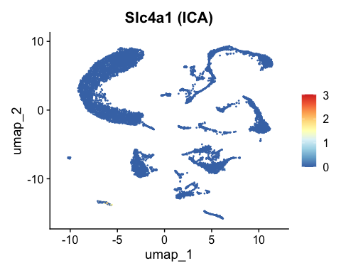
## Scale for colour is already present.
## Adding another scale for colour, which will replace the existing scale.
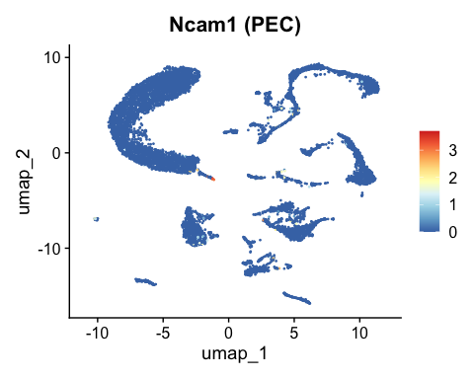
## Scale for colour is already present.
## Adding another scale for colour, which will replace the existing scale.
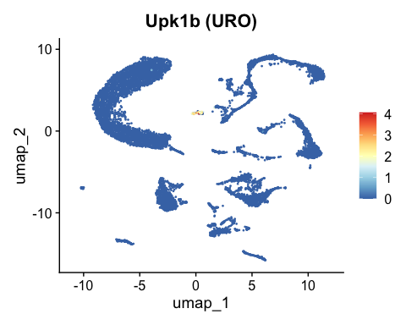
## Scale for colour is already present.
## Adding another scale for colour, which will replace the existing scale.
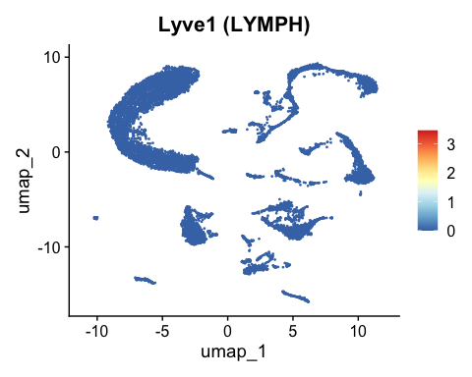
## Scale for colour is already present.
## Adding another scale for colour, which will replace the existing scale.
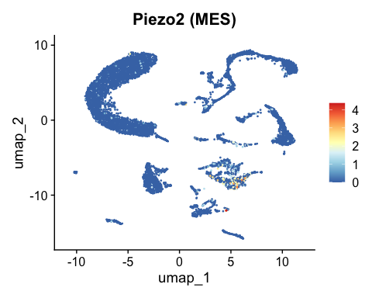
## Scale for colour is already present.
## Adding another scale for colour, which will replace the existing scale.
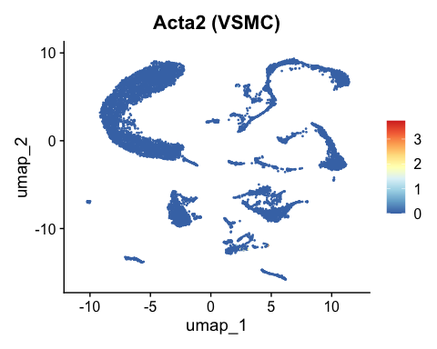
## Scale for colour is already present.
## Adding another scale for colour, which will replace the existing scale.
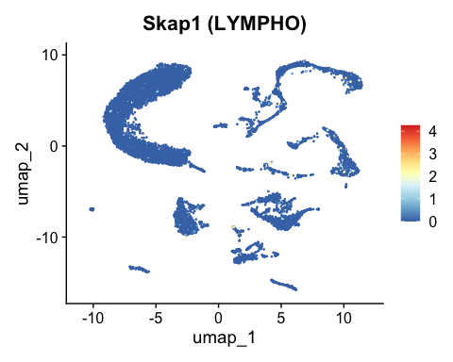 - Signals more scattered = ambient RNA. - Should be near where biology expects.
Upk1b(URO), Piezo2 (MES)

Continue with DoubletFinder
# PCs set to 1:20 since it was between 15-20 on the earlier elbow plot
sweep.res.list_seurat.obj.f <- paramSweep(seurat.obj.f, PCs = 1:20, sct = FALSE)
## [1] "Creating artificial doublets for pN = 5%"
## [1] "Creating Seurat object..."
## [1] "Normalizing Seurat object..."
## Normalizing layer: counts
## [1] "Finding variable genes..."
## Finding variable features for layer counts
## [1] "Scaling data..."
## Centering and scaling data matrix
## [1] "Running PCA..."
## [1] "Calculating PC distance matrix..."
## [1] "Defining neighborhoods..."
## [1] "Computing pANN across all pK..."
## [1] "pK = 0.001..."
## [1] "pK = 0.005..."
## [1] "pK = 0.01..."
## [1] "pK = 0.02..."
## [1] "pK = 0.03..."
## [1] "pK = 0.04..."
## [1] "pK = 0.05..."
## [1] "pK = 0.06..."
## [1] "pK = 0.07..."
## [1] "pK = 0.08..."
## [1] "pK = 0.09..."
## [1] "pK = 0.1..."
## [1] "pK = 0.11..."
## [1] "pK = 0.12..."
## [1] "pK = 0.13..."
## [1] "pK = 0.14..."
## [1] "pK = 0.15..."
## [1] "pK = 0.16..."
## [1] "pK = 0.17..."
## [1] "pK = 0.18..."
## [1] "pK = 0.19..."
## [1] "pK = 0.2..."
## [1] "pK = 0.21..."
## [1] "pK = 0.22..."
## [1] "pK = 0.23..."
## [1] "pK = 0.24..."
## [1] "pK = 0.25..."
## [1] "pK = 0.26..."
## [1] "pK = 0.27..."
## [1] "pK = 0.28..."
## [1] "pK = 0.29..."
## [1] "pK = 0.3..."
## [1] "Creating artificial doublets for pN = 10%"
## [1] "Creating Seurat object..."
## [1] "Normalizing Seurat object..."
## Normalizing layer: counts
## [1] "Finding variable genes..."
## Finding variable features for layer counts
## [1] "Scaling data..."
## Centering and scaling data matrix
## [1] "Running PCA..."
## [1] "Calculating PC distance matrix..."
## [1] "Defining neighborhoods..."
## [1] "Computing pANN across all pK..."
## [1] "pK = 0.001..."
## [1] "pK = 0.005..."
## [1] "pK = 0.01..."
## [1] "pK = 0.02..."
## [1] "pK = 0.03..."
## [1] "pK = 0.04..."
## [1] "pK = 0.05..."
## [1] "pK = 0.06..."
## [1] "pK = 0.07..."
## [1] "pK = 0.08..."
## [1] "pK = 0.09..."
## [1] "pK = 0.1..."
## [1] "pK = 0.11..."
## [1] "pK = 0.12..."
## [1] "pK = 0.13..."
## [1] "pK = 0.14..."
## [1] "pK = 0.15..."
## [1] "pK = 0.16..."
## [1] "pK = 0.17..."
## [1] "pK = 0.18..."
## [1] "pK = 0.19..."
## [1] "pK = 0.2..."
## [1] "pK = 0.21..."
## [1] "pK = 0.22..."
## [1] "pK = 0.23..."
## [1] "pK = 0.24..."
## [1] "pK = 0.25..."
## [1] "pK = 0.26..."
## [1] "pK = 0.27..."
## [1] "pK = 0.28..."
## [1] "pK = 0.29..."
## [1] "pK = 0.3..."
## [1] "Creating artificial doublets for pN = 15%"
## [1] "Creating Seurat object..."
## [1] "Normalizing Seurat object..."
## Normalizing layer: counts
## [1] "Finding variable genes..."
## Finding variable features for layer counts
## [1] "Scaling data..."
## Centering and scaling data matrix
## [1] "Running PCA..."
## [1] "Calculating PC distance matrix..."
## [1] "Defining neighborhoods..."
## [1] "Computing pANN across all pK..."
## [1] "pK = 0.001..."
## [1] "pK = 0.005..."
## [1] "pK = 0.01..."
## [1] "pK = 0.02..."
## [1] "pK = 0.03..."
## [1] "pK = 0.04..."
## [1] "pK = 0.05..."
## [1] "pK = 0.06..."
## [1] "pK = 0.07..."
## [1] "pK = 0.08..."
## [1] "pK = 0.09..."
## [1] "pK = 0.1..."
## [1] "pK = 0.11..."
## [1] "pK = 0.12..."
## [1] "pK = 0.13..."
## [1] "pK = 0.14..."
## [1] "pK = 0.15..."
## [1] "pK = 0.16..."
## [1] "pK = 0.17..."
## [1] "pK = 0.18..."
## [1] "pK = 0.19..."
## [1] "pK = 0.2..."
## [1] "pK = 0.21..."
## [1] "pK = 0.22..."
## [1] "pK = 0.23..."
## [1] "pK = 0.24..."
## [1] "pK = 0.25..."
## [1] "pK = 0.26..."
## [1] "pK = 0.27..."
## [1] "pK = 0.28..."
## [1] "pK = 0.29..."
## [1] "pK = 0.3..."
## [1] "Creating artificial doublets for pN = 20%"
## [1] "Creating Seurat object..."
## [1] "Normalizing Seurat object..."
## Normalizing layer: counts
## [1] "Finding variable genes..."
## Finding variable features for layer counts
## [1] "Scaling data..."
## Centering and scaling data matrix
## [1] "Running PCA..."
## [1] "Calculating PC distance matrix..."
## [1] "Defining neighborhoods..."
## [1] "Computing pANN across all pK..."
## [1] "pK = 0.001..."
## [1] "pK = 0.005..."
## [1] "pK = 0.01..."
## [1] "pK = 0.02..."
## [1] "pK = 0.03..."
## [1] "pK = 0.04..."
## [1] "pK = 0.05..."
## [1] "pK = 0.06..."
## [1] "pK = 0.07..."
## [1] "pK = 0.08..."
## [1] "pK = 0.09..."
## [1] "pK = 0.1..."
## [1] "pK = 0.11..."
## [1] "pK = 0.12..."
## [1] "pK = 0.13..."
## [1] "pK = 0.14..."
## [1] "pK = 0.15..."
## [1] "pK = 0.16..."
## [1] "pK = 0.17..."
## [1] "pK = 0.18..."
## [1] "pK = 0.19..."
## [1] "pK = 0.2..."
## [1] "pK = 0.21..."
## [1] "pK = 0.22..."
## [1] "pK = 0.23..."
## [1] "pK = 0.24..."
## [1] "pK = 0.25..."
## [1] "pK = 0.26..."
## [1] "pK = 0.27..."
## [1] "pK = 0.28..."
## [1] "pK = 0.29..."
## [1] "pK = 0.3..."
## [1] "Creating artificial doublets for pN = 25%"
## [1] "Creating Seurat object..."
## [1] "Normalizing Seurat object..."
## Normalizing layer: counts
## [1] "Finding variable genes..."
## Finding variable features for layer counts
## [1] "Scaling data..."
## Centering and scaling data matrix
## [1] "Running PCA..."
## [1] "Calculating PC distance matrix..."
## [1] "Defining neighborhoods..."
## [1] "Computing pANN across all pK..."
## [1] "pK = 0.001..."
## [1] "pK = 0.005..."
## [1] "pK = 0.01..."
## [1] "pK = 0.02..."
## [1] "pK = 0.03..."
## [1] "pK = 0.04..."
## [1] "pK = 0.05..."
## [1] "pK = 0.06..."
## [1] "pK = 0.07..."
## [1] "pK = 0.08..."
## [1] "pK = 0.09..."
## [1] "pK = 0.1..."
## [1] "pK = 0.11..."
## [1] "pK = 0.12..."
## [1] "pK = 0.13..."
## [1] "pK = 0.14..."
## [1] "pK = 0.15..."
## [1] "pK = 0.16..."
## [1] "pK = 0.17..."
## [1] "pK = 0.18..."
## [1] "pK = 0.19..."
## [1] "pK = 0.2..."
## [1] "pK = 0.21..."
## [1] "pK = 0.22..."
## [1] "pK = 0.23..."
## [1] "pK = 0.24..."
## [1] "pK = 0.25..."
## [1] "pK = 0.26..."
## [1] "pK = 0.27..."
## [1] "pK = 0.28..."
## [1] "pK = 0.29..."
## [1] "pK = 0.3..."
## [1] "Creating artificial doublets for pN = 30%"
## [1] "Creating Seurat object..."
## [1] "Normalizing Seurat object..."
## Normalizing layer: counts
## [1] "Finding variable genes..."
## Finding variable features for layer counts
## [1] "Scaling data..."
## Centering and scaling data matrix
## [1] "Running PCA..."
## [1] "Calculating PC distance matrix..."
## [1] "Defining neighborhoods..."
## [1] "Computing pANN across all pK..."
## [1] "pK = 0.001..."
## [1] "pK = 0.005..."
## [1] "pK = 0.01..."
## [1] "pK = 0.02..."
## [1] "pK = 0.03..."
## [1] "pK = 0.04..."
## [1] "pK = 0.05..."
## [1] "pK = 0.06..."
## [1] "pK = 0.07..."
## [1] "pK = 0.08..."
## [1] "pK = 0.09..."
## [1] "pK = 0.1..."
## [1] "pK = 0.11..."
## [1] "pK = 0.12..."
## [1] "pK = 0.13..."
## [1] "pK = 0.14..."
## [1] "pK = 0.15..."
## [1] "pK = 0.16..."
## [1] "pK = 0.17..."
## [1] "pK = 0.18..."
## [1] "pK = 0.19..."
## [1] "pK = 0.2..."
## [1] "pK = 0.21..."
## [1] "pK = 0.22..."
## [1] "pK = 0.23..."
## [1] "pK = 0.24..."
## [1] "pK = 0.25..."
## [1] "pK = 0.26..."
## [1] "pK = 0.27..."
## [1] "pK = 0.28..."
## [1] "pK = 0.29..."
## [1] "pK = 0.3..."
#Summarize each combination of pN and pK
sweep.stats_seurat.obj.f <- summarizeSweep(sweep.res.list_seurat.obj.f, GT = FALSE)
#Select the pK that corresponds to max bcmvn to optimize doublet detection
bcmvn_seurat.obj.f <- find.pK(sweep.stats_seurat.obj.f)
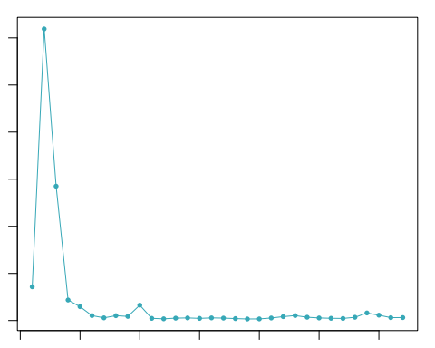
## NULL
pK <- bcmvn_seurat.obj.f %>%
filter(BCmetric == max(BCmetric)) %>%
select(pK)
#See pK in the Values Environment
pK <- as.numeric(as.character(pK[[1]]))
# Homotypic Doublet Proportion Estimate -------------------------------------------------------------------------------------
annotations <- seurat.obj.f@meta.data$seurat_clusters
homotypic.prop <- modelHomotypic(annotations)
# 10X Multiplet Rate Table (the doublet ratio is # of cells recovered divided by 125000) https://kb.10xgenomics.com/hc/en-us/articles/360001378811-What-is-the-maximum-number-of-cells-that-can-be-profiled-
nExp_poi <- round(nrow(seurat.obj.f@meta.data) # To calculate cell number
/125000 # To calculate the doublet ratio
*nrow(seurat.obj.f@meta.data))
nExp_poi_adj <- round(nExp_poi*(1-homotypic.prop))
seurat.obj.f_doublets <- doubletFinder(seurat.obj.f,
PCs = 1:20,
pN = 0.25,
pK = pK,
nExp = nExp_poi_adj,
reuse.pANN = NULL, sct = FALSE)
## [1] "Creating 3366 artificial doublets..."
## [1] "Creating Seurat object..."
## [1] "Normalizing Seurat object..."
## Normalizing layer: counts
## [1] "Finding variable genes..."
## Finding variable features for layer counts
## [1] "Scaling data..."
## Centering and scaling data matrix
## [1] "Running PCA..."
## [1] "Calculating PC distance matrix..."
## [1] "Computing pANN..."
## [1] "Classifying doublets.."
# Change names of columns for future analysis
colnames(seurat.obj.f_doublets@meta.data)[grep("^pANN", colnames(seurat.obj.f_doublets@meta.data))] <- "pANN"
colnames(seurat.obj.f_doublets@meta.data)[grep("^DF.class", colnames(seurat.obj.f_doublets@meta.data))] <- "DF.class"
seurat.obj.f_doublets@meta.data$DF.class <- factor(
seurat.obj.f_doublets@meta.data$DF.class,
levels = c("Singlet", "Doublet")
)
table(seurat.obj.f_doublets@meta.data$DF.class)
##
## Singlet Doublet
## 9325 774
# Make a value for the doublet count to include in the analysis
doublet_count <- table(seurat.obj.f_doublets@meta.data$DF.class)["Doublet"]
p1 <- VlnPlot(seurat.obj.f_doublets, features = c("nFeature_RNA"), group.by = "DF.class") +
theme(axis.title.x = element_blank(),
legend.position = 'none',
axis.text.x = element_text(angle = 0, hjust = .5))
p2 <- VlnPlot(seurat.obj.f_doublets, features = c("nCount_RNA"), group.by = "DF.class") +
theme(axis.title.x = element_blank(),
legend.position = 'none',
axis.text.x = element_text(angle = 0, hjust = .5))
p3 <- DimPlot(seurat.obj.f_doublets, group.by = "DF.class")
grid <- plot_grid(p1, p2, p3, ncol = 3, align = "h", axis = "tb", rel_widths = c(1, 1, 2))
plot_grid(
ggdraw() + draw_label("Violin and Feature Plot by DF.class", fontface = 'bold', size = 22, hjust = 0.5),
grid,
ncol = 1,
rel_heights = c(0.1, 1)
)
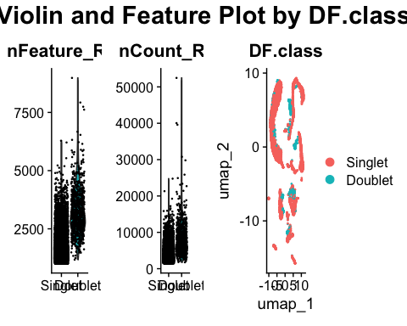
seurat.obj.f_singlets <- subset(seurat.obj.f_doublets, DF.class == "Singlet")
DimPlot(seurat.obj.f_singlets, reduction = "umap", label = T)+
theme(plot.title = element_text(hjust = 0.5)) +
ggtitle(paste0("UMAP for ", kidney1, " after DoubletFinder"))
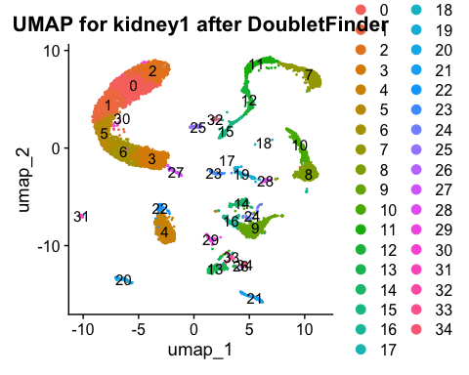
Filter_2 <- ncol(seurat.obj.f_singlets)
amountfiltered2 <- Filter_1-Filter_2
#Making a table to display the amount of cells being filtered out with the minimal filtering of low quality cells applied to the snRNAseq dataset.
cell_counts <- data.frame(Phase = c("Before Filtering", "After Filtering", "Amount Filtered"), Cell_Number = c(Filter_1, Filter_2, amountfiltered2))
print(cell_counts)
## Phase Cell_Number
## 1 Before Filtering 10099
## 2 After Filtering 9325
## 3 Amount Filtered 774
# Remove unused objects in environment to save RAM
# rm(seurat.obj.f, seurat.obj.f_doublets, sweep.res.list_seurat.obj.f, sweep.stats_seurat.obj.f, p, p1, p2)
773 cells were removed after DoubletFinder.

Manual doublet filtering
f1 <- DotPlot(seurat.obj.f_singlets,
features = markers.to.plot1,
dot.scale = 8,
dot.min = 0,
scale.max = 100,
scale.min = 0,
col.min = -2.5,
col.max = 2.5) +
theme(axis.text.x = element_text(angle = 45, hjust = 1)) +
coord_flip() +
labs(x = "Gene Features", y = "Clusters")
f1
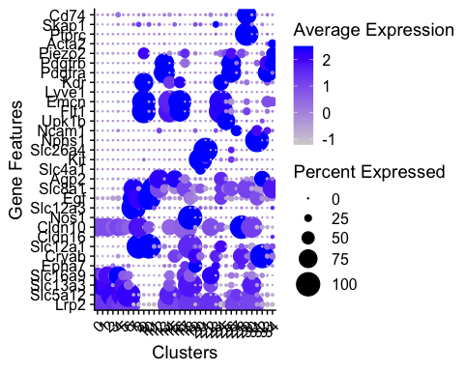

Clusters of concern
f2 <- as.data.frame(f1$data)
maybe_doublets <- f2 %>%
group_by(id) %>%
filter(all(avg.exp.scaled <= 2.0)) %>%
distinct(id) %>%
pull(id)
maybe_doublets
## [1] 2 5 14 17 30
## 35 Levels: 0 1 2 3 4 5 6 7 8 9 10 11 12 13 14 15 16 17 18 19 20 21 22 23 ... 34
# Create color palette: grey for all, color for maybe_doublets
all_clusters <- levels(seurat.obj.f_singlets)
cluster_colors <- setNames(rep("grey80", length(all_clusters)), all_clusters)
cluster_colors[maybe_doublets] <- "red"
# Get UMAP coordinates and cluster assignments
umap_data <- Embeddings(seurat.obj.f_singlets, "umap") %>%
as.data.frame() %>%
mutate(cluster = Idents(seurat.obj.f_singlets))
# Compute cluster centroids
cluster_centroids <- umap_data %>%
group_by(cluster) %>%
summarise(UMAP_1 = mean(umap_1), UMAP_2 = mean(umap_2))
# Keep only centroids for maybe_doublets
label_data <- cluster_centroids %>%
filter(cluster %in% maybe_doublets)
# Plot
DimPlot(seurat.obj.f_singlets, reduction = "umap", cols = cluster_colors) +
ggrepel::geom_text_repel(
data = label_data,
aes(x = UMAP_1, y = UMAP_2, label = cluster),
size = 4,
color = "black",
fontface = "bold",
max.overlaps = Inf,
box.padding = 0.5,
point.padding = 0.5
)
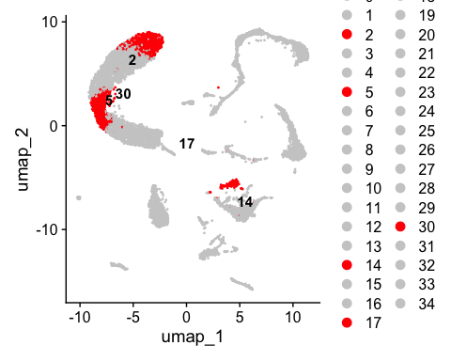
# Add doublet cluster numbers like the code below to classify clusters as doublets
doublet_clusters <- c(2, 5, 14, 17, 30)
# Annotate metadata
seurat.obj.f_singlets@meta.data <- seurat.obj.f_singlets@meta.data %>%
mutate(subclass.doublet = if_else(
seurat_clusters %in% doublet_clusters, "DOUBLET", "SINGLET"
))
# Change the identities to align with new subclass names and make umap
Idents(seurat.obj.f_singlets) <- seurat.obj.f_singlets@meta.data$subclass.doublet
f1 <- DimPlot(seurat.obj.f_singlets, reduction = "umap") +
theme(plot.title = element_text(hjust = 0.5)) +
ggtitle("Before Manual Doublet Filtering")
# Double check the table to ensure SINGLET & DOUBLET cluster appear with this function
table(Idents(seurat.obj.f_singlets))
##
## SINGLET DOUBLET
## 7885 1440
# Clean out the doublets manually that were identified
seurat.obj.f_cleaned <- subset(seurat.obj.f_singlets, idents = "DOUBLET", invert = TRUE)
# Double check that the identity was removed
table(Idents(seurat.obj.f_cleaned))
##
## SINGLET
## 7885
# Make umap to double check removal
f2 <- DimPlot(seurat.obj.f_cleaned, reduction = "umap") +
theme(plot.title = element_text(hjust = 0.5)) +
ggtitle("After Manual Doublet Filtering")
f1+f2
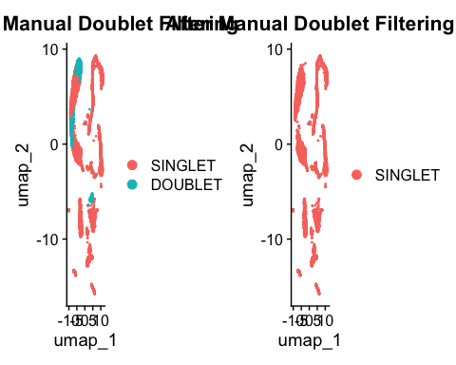
# Remove unused objects in environment to save RAM
rm(seurat.obj.f_singlets)

Cell annotation: Re-cluster singlets
seurat.obj.f_cleaned <- SCTransform(seurat.obj.f_cleaned) %>%
RunPCA() %>%
FindNeighbors(dims = 1:30) %>%
FindClusters(resolution = 2, verbose = FALSE) %>%
RunUMAP(dims = 1:30)
## Running SCTransform on assay: RNA
## vst.flavor='v2' set. Using model with fixed slope and excluding poisson genes.
## Calculating cell attributes from input UMI matrix: log_umi
## Variance stabilizing transformation of count matrix of size 20663 by 7885
## Model formula is y ~ log_umi
## Get Negative Binomial regression parameters per gene
## Using 2000 genes, 5000 cells
## There are 105 estimated thetas smaller than 1e-07 - will be set to 1e-07
## Found 18 outliers - those will be ignored in fitting/regularization step
## Second step: Get residuals using fitted parameters for 20663 genes
## Computing corrected count matrix for 20663 genes
## Calculating gene attributes
## Wall clock passed: Time difference of 27.08062 secs
## Determine variable features
## Centering data matrix
## Place corrected count matrix in counts slot
## Set default assay to SCT
## PC_ 1
## Positive: Keg1, Slc34a1, Ghr, Errfi1, Fut9, Pde4d, Slc5a12, Acsm2, Dab2, Slc4a4
## Gramd1b, Slc27a2, Lrp2, Snhg11, Nhs, Wdr17, Acox1, Zbtb20, Nox4, Slc13a1
## Ndrg1, Snx29, Gk, Slc47a1, Pck1, Pter, Slc25a21, Bnc2, Ptprd, Cyp7b1
## Negative: Slc12a1, Pbx1, Egf, Erbb4, Meis2, Mecom, Slc12a3, Slc8a1, Plpp1, Flt1
## Abca13, Ldb2, Umod, Ptprg, Ebf1, Wnk1, Emcn, Ptprm, Prkg1, Tshz2
## Adgrl4, Plpp3, Tcf4, Slit2, Stox2, Limch1, Pde7b, Cacnb4, Kng2, Dnm3
## PC_ 2
## Positive: Slc12a1, Egf, Erbb4, Slc12a3, Mecom, Abca13, Slc8a1, Umod, Pkhd1, Ank3
## Wnk1, Cacnb4, Kng2, Slit2, Atp1a1, Slc16a7, Fxyd2, Slc5a3, Ppargc1a, Mrps6
## Esrrg, Atp1b1, Malat1, Defb1, Calb1, Me3, Nudt4, Tmem52b, Arhgap6, Rgs6
## Negative: Pbx1, Meis2, Plpp1, Flt1, Ldb2, Ptprg, Emcn, Ebf1, Prkg1, Adgrl4
## Tshz2, Ptprm, Tcf4, Plpp3, Limch1, Tek, St6galnac3, Rapgef4, Chrm3, Dlc1
## Prkch, Ptprb, D5Ertd615e, Rbms1, Arhgap31, Nrp1, Samd12, Fmnl2, Zeb1, 9530026P05Rik
## PC_ 3
## Positive: Slc12a1, Erbb4, Umod, Egf, Slc5a3, Plcb1, Mrps6, Pbx1, Ptger3, Meis2
## mt-Co1, mt-Co3, Cgnl1, Cacnb4, Ghr, Fxyd2, Keg1, Slc34a1, mt-Atp6, Flt1
## Slc9a3, Plpp1, Gm14002, Bckdhb, Ank3, mt-Co2, Arhgap6, Ptprg, Paqr5, Tenm2
## Negative: Slc8a1, Slc12a3, Wnk1, Phactr1, Calb1, Defb1, Trpm6, Tmem52b, Egfem1, Tsc22d1
## Mecom, Abca13, Dach1, Frmpd4, Sgms2, Klhl3, Tox3, Nr3c2, Kl, Cadps2
## Galnt18, Tmem117, Malat1, Arl15, Cdk14, Tsc22d2, Tfcp2l1, Tdrd3, Trpm7, Gls
## PC_ 4
## Positive: Rbms3, Prkg1, Csmd1, Tshz2, Cfh, Rora, Robo2, Lama2, Zeb2, Sox5
## mt-Co3, Rbfox1, mt-Atp6, mt-Co2, Pde3a, Arhgap24, Fbln5, mt-Cytb, mt-Co1, Cald1
## mt-Nd2, Fhl2, Slc14a2, Abca8a, Plcl1, Gucy1a2, Kcnt2, mt-Nd4, Setbp1, Itga1
## Negative: Slc12a3, Pbx1, Egf, Abca13, Flt1, Meis2, Wnk1, Plpp1, Emcn, Slc8a1
## Ptprg, Adgrl4, Trpm6, Limch1, Calb1, Ghr, Tcf4, Keg1, Tek, St6galnac3
## Plpp3, Slc12a1, Chrm3, Rapgef4, Ptprm, Syne1, D5Ertd615e, Tsc22d1, Prkch, Esrrg
## PC_ 5
## Positive: Slc5a12, Slc34a1, Nox4, Dab2, Slc4a4, Errfi1, Ndrg1, Fut9, Slc13a1, Magi2
## Atxn1, Gpx3, Bnc2, Slc5a2, Timp3, Ptprd, Gatm, Plcb1, Nhs, Fhit
## Pik3c2g, Tnfaip8, Slc6a19, Kcnj16, Pakap.1, Maf, Slc16a10, Enpp2, Ass1, Cyp4b1
## Negative: Ghr, Cyp7b1, Gramd1b, Wdr17, Rnf24, Slc7a13, Napsa, Pde4d, Mat2a, Atp11a
## Aadat, Kap, Rbm47, Slc6a18, Tet2, Slco1a6, Sox2ot, Them7, Osbpl8, Trps1
## Etv6, Gpm6a, Chpt1, Zbtb20, Slc27a2, Pter, Mpv17l, Slc5a8, Bcat1, Ccser1
## Computing nearest neighbor graph
## Computing SNN
## 17:21:28 UMAP embedding parameters a = 0.9922 b = 1.112
## 17:21:28 Read 7885 rows and found 30 numeric columns
## 17:21:28 Using Annoy for neighbor search, n_neighbors = 30
## 17:21:28 Building Annoy index with metric = cosine, n_trees = 50
## 0% 10 20 30 40 50 60 70 80 90 100%
## [----|----|----|----|----|----|----|----|----|----|
## **************************************************|
## 17:21:29 Writing NN index file to temp file /var/folders/k0/nty70bnn7zz8mjbcfrsm41j80000gn/T//RtmpYzKuiO/filec68b63c5aa92
## 17:21:29 Searching Annoy index using 1 thread, search_k = 3000
## 17:21:30 Annoy recall = 100%
## 17:21:32 Commencing smooth kNN distance calibration using 1 thread with target n_neighbors = 30
## 17:21:33 Initializing from normalized Laplacian + noise (using RSpectra)
## 17:21:33 Commencing optimization for 500 epochs, with 324982 positive edges
## 17:21:33 Using rng type: pcg
## 17:21:40 Optimization finished
DimPlot(seurat.obj.f_cleaned, reduction = "umap", label = TRUE) +
theme(plot.title = element_text(hjust = 0.5)) +
ggtitle(paste0("Non-annotated Clusters for ", kidney1))
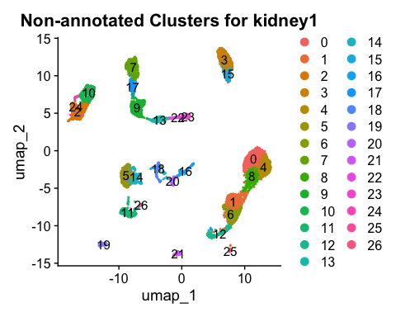
DefaultAssay(seurat.obj.f_cleaned) <- "RNA"
# Make mdd for all removed doublets
DotPlot(seurat.obj.f_cleaned,
features = markers.to.plot1,
dot.scale = 8,
dot.min = 0,
scale.max = 100,
scale.min = 0,
col.min = -2.5,
col.max = 2.5) +
theme(axis.text.x = element_text(angle = 45, hjust = 1)) +
coord_flip() +
labs(x = "Gene Features", y = "Clusters") +
theme(
axis.text.x = element_text(size = 8, angle = 60, hjust = 1, vjust = 1),
axis.text.y = element_text(size = 8),
)
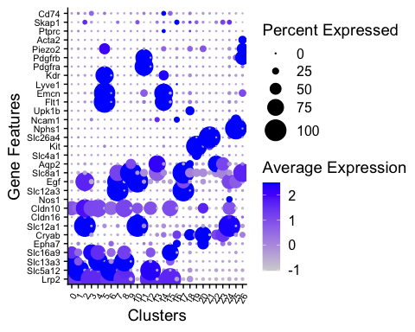
p1
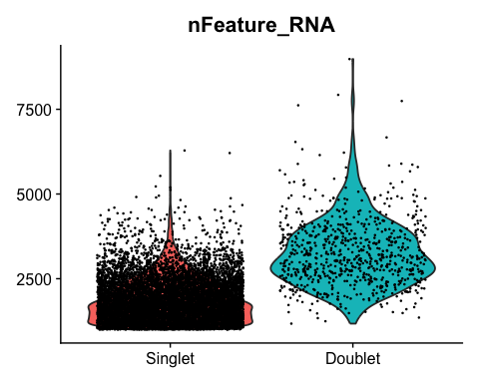
# Cluster 0: Slc13a3 => Lrp2 => Slc16a9: PTS2?
# Cluster 1: Slc5a12 > Lrp2: PTS1
# Cluster 2: Slc12a1 > Egf > Cldn10: TALB?
# Cluster 3: Slc16a9 > Lrp2 > Cldn10: PTS3
# Cluster 4: Slc13a3 > Lrp2 > Cldn10 > Slc16a9: PTS2? more likely (0 and 4 likely both PTS2)
# Cluster 5: Flt1 = Emcn > Kdr > Piezo2: EC
# Cluster 6: Slc5a12 > Lrp2: PTS1? 1 and 6 likely both PTS1
# Cluster 7: Slc12a3 = Egf > Slc8a1: DCT1
# Cluster 8: Slc13a3 > Lrp2 > Cldn10 > Slc5a12: PTS2 (0, 4 and 8 all PTS2?)
# Cluster 9: Slc8a1 > Aqp2 > Slc12a3: CNT? or DCT2 due to presence of Slc12a3
# Cluster 10: Slc12a1 = Egf > Cldn10 > Cldn16: TALB? (2 and 10 likely both TALB, or 10 might be TALA)
# Cluster 11: Pdgfra > Pdgfrb: FIB
# Cluster 12: Slc5a12 > Lrp2 > Cldn10: PTS1 (1, 6 & 12 all PTS1?)
# Cluster 13: Aqp2 > Slc8a1: Likely PC
# Cluster 14: Emcn > Fit1 >> Kdr: EC
# Cluster 15: Slc16a9 > Lrp2 > Cldn10: PTS3
# Cluster 16: Epha7 > Cryab >> Ncam1: DTL
# Cluster 17: Slc12a3 > Slc8a1 > Egf: DCT2
# Cluster 18: Cryab > Upk1b > Slc8a1 > Aqp2: DTL? or URO
# Cluster 19: Kit > Slc4a1 > Slc8a1 > Cryab: ICA
# Cluster 20: Cryab > Epha7 > Cldn10: DTL
# Cluster 21: Slc26a4 > Kit: ICB
# Cluster 22: Aqp2 > Cryab > Slc8a1: PC? or DTL? (13 & 22 llikely both PC)
# Cluster 23: Cryab > Aqp2 > Slc8a1: PC? (13, 22 & 23 all PC?)
# Cluster 24: Slc12a1 >> Egf > Cldn10: TALB(2, 10 & 24 all TALB?)
# Cluster 25: Nphs1 > Egf > Ncam1: PODO
# Cluster 26: Slc8a1 > Pdgfrb > Piezo2 > Acta2: CNT? or VSMC
# Apply names to the clusters by subclass
seurat.obj.f_cleaned@meta.data <- seurat.obj.f_cleaned@meta.data %>% mutate(subclass = dplyr::case_when(
seurat_clusters == 0 ~ "PTS2",
seurat_clusters == 1 ~ "PTS1",
seurat_clusters == 2 ~ "TALB",
seurat_clusters == 3 ~ "PTS3",
seurat_clusters == 4 ~ "PTS2",
seurat_clusters == 5 ~ "EC",
seurat_clusters == 6 ~ "PTS1",
seurat_clusters == 7 ~ "DCT1",
seurat_clusters == 8 ~ "PTS2",
seurat_clusters == 9 ~ "CNT",
seurat_clusters == 10 ~ "TALB",
seurat_clusters == 11 ~ "FIB",
seurat_clusters == 12 ~ "PTS1",
seurat_clusters == 13 ~ "PC",
seurat_clusters == 14 ~ "EC",
seurat_clusters == 15 ~ "PTS3",
seurat_clusters == 16 ~ "DTL",
seurat_clusters == 17 ~ "DCT2",
seurat_clusters == 18 ~ "DTL",
seurat_clusters == 19 ~ "ICA",
seurat_clusters == 20 ~ "DTL",
seurat_clusters == 21 ~ "ICB",
seurat_clusters == 22 ~ "PC",
seurat_clusters == 23 ~ "PC",
seurat_clusters == 24 ~ "TALB",
seurat_clusters == 25 ~ "PODO",
seurat_clusters == 26 ~ "CNT"
))
# Filter out the doublets
seurat.obj.f_cleaned <- subset(seurat.obj.f_cleaned, subset = subclass == "DOUBLET", invert = TRUE)
subclass_order <- c("PTS1", "PTS2", "PTS3", "DTL", "TALA", "TALB", "MD", "DCT1", "DCT2", "CNT", "PC", "ICA", "ICB", "PODO", "PEC", "URO", "EC", "FIB", "MES", "LYMPHO", "MACRO")
seurat.obj.f_cleaned@meta.data$subclass <- factor(seurat.obj.f_cleaned@meta.data$subclass, levels = subclass_order)
# Change the identities to align with new subclass names and make umap
Idents(seurat.obj.f_cleaned) <- seurat.obj.f_cleaned@meta.data$subclass
DimPlot(seurat.obj.f_cleaned, reduction = "umap", label = TRUE, label.size = 4) +
theme(plot.title = element_text(hjust = 0.5)) +
ggtitle(paste0("Subclass Annotation for ", kidney1))
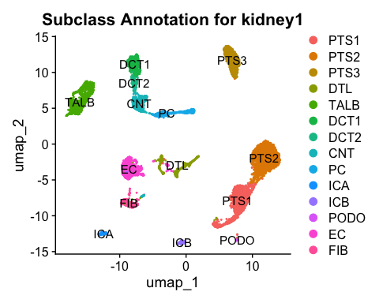

Notes: PTS1/PTS2 together & nearby(?) but distinct PTS3 expresses more distal PT clusters: clear separation shows sufficient sequencing depth

DCT1 => DCT2 => CNT => PC continuu present

Where are TALA & MD?

Shouldn’t DCT1 be ~3x the size of DCT2?

Otherwise looks fine
Filter_3 <- ncol(seurat.obj.f_cleaned)
amountfiltered3 <- Filter_2-Filter_3
#Making a table to display the amount of cells being filtered out with the minimal filtering of low quality cells applied to the snRNAseq dataset.
cell_counts <- data.frame(Phase = c("Before Filtering", "After Filtering", "Amount Filtered"), Cell_Number = c(Filter_2, Filter_3, amountfiltered3))
print(cell_counts)
## Phase Cell_Number
## 1 Before Filtering 9325
## 2 After Filtering 7885
## 3 Amount Filtered 1440
# Step 1: Find markers (grouped by subclass)
all_markers <- FindAllMarkers(
seurat.obj.f_cleaned,
only.pos = TRUE,
min.pct = 0.5,
logfc.threshold = 1,
group.by = "subclass" # grouping by subclass instead of cluster ID
)
## Calculating cluster PTS1
## Calculating cluster PTS2
## Calculating cluster PTS3
## Calculating cluster DTL
## Calculating cluster TALB
## Calculating cluster DCT1
## Calculating cluster DCT2
## Calculating cluster CNT
## Calculating cluster PC
## Calculating cluster ICA
## Calculating cluster ICB
## Calculating cluster PODO
## Calculating cluster EC
## Calculating cluster FIB
# Step 2: Sort markers by descending log2FC, put gene column first
all_markers <- all_markers %>%
arrange(desc(avg_log2FC)) %>%
select(gene, everything())
# Step 3: Split markers by subclass (stored in 'cluster' column still)
marker_list <- split(all_markers, all_markers$cluster)
# Step 4: Reorder the list according to your subclass_order
# First ensure you're only including subclasses that are actually present
valid_subclasses <- subclass_order[subclass_order %in% names(marker_list)]
# Reorder marker_list based on that
marker_list <- marker_list[valid_subclasses]
# Step 5: Write to Excel
wb <- createWorkbook()
for (subclass in names(marker_list)) {
addWorksheet(wb, sheetName = subclass)
writeData(wb, sheet = subclass, marker_list[[subclass]])
}
# Step 6: Save file
date <- format(Sys.Date(), "%Y%m%d")
saveWorkbook(
wb,
here("Outputs", paste0(date, "_", kidney1, "_FindAllMarkers_By_Subclass.xlsx")),
overwrite = TRUE
)
DimPlot(seurat.obj.f_cleaned, reduction = "umap", label = TRUE, label.size = 4) +
theme(plot.title = element_text(hjust = 0.5)) +
ggtitle(paste0("Subclass Annotation for ", kidney1))
# Linear(ish) Dotplot
# Change the order of the identities on the x-axis to create a diagonal on the dotplot, going from top to bottom of the "naming kidney cells" table
DotPlot(seurat.obj.f_cleaned,
features = markers.to.plot1,
group.by = "subclass",
dot.scale = 8,
dot.min = 0,
scale.max = 100,
scale.min = 0,
col.min = -2.5,
col.max = 2.5) +
theme(axis.text.x = element_text(angle = 45, hjust = 1)) +
coord_flip() +
labs(x = "Gene Features", y = "Clusters") +
theme(plot.title = element_text(hjust = 0.5)) +
ggtitle(paste0("Subclass Annotation for ", kidney1))
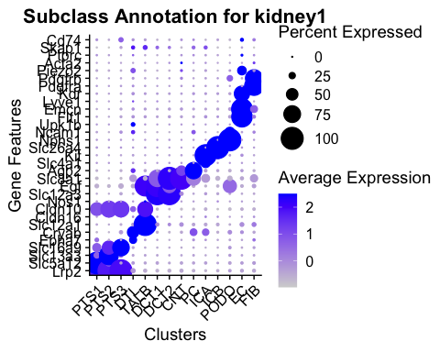

Annotating by class
# Change the specificty of the cells to a lower level and make another UMAP
seurat.obj.f_cleaned@meta.data <- seurat.obj.f_cleaned@meta.data %>%
mutate(class = dplyr::case_when(
subclass %in% c("PTS1", "PTS2", "PTS3") ~ "PT",
subclass == "DTL" ~ "DTL",
subclass %in% c("TALA", "TALB", "MD") ~ "TAL",
subclass %in% c("DCT1", "DCT2") ~ "DCT",
subclass == "CNT" ~ "CNT",
subclass == "PC" ~ "PC",
subclass == "ICA" ~ "ICA",
subclass == "ICB" ~ "ICB",
subclass == "PODO" ~ "PODO",
subclass == "PEC" ~ "PEC",
subclass == "URO" ~ "URO",
subclass %in% c("EC", "ECG", "ECP", "LYMPH") ~ "EC",
subclass == "FIB" ~ "FIB",
subclass == "MES" ~ "MES",
subclass == "VSMC" ~ "VSMC",
subclass %in% c("LYMPHO", "MACRO") ~ "IMMUNE",
))
DimPlot(seurat.obj.f_cleaned, group.by = "class", label = TRUE, label.size = 4) +
theme(plot.title = element_text(hjust = 0.5)) +
ggtitle(paste0("Class Annotation for ", kidney1))
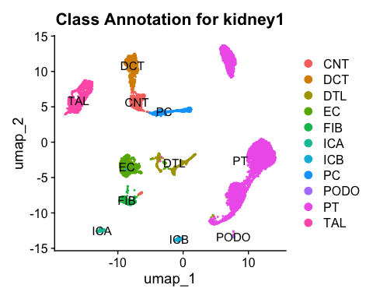
class_order <- c("PT", "DTL", "TAL", "DCT", "CNT", "PC", "ICA", "ICB", "PODO", "PEC", "URO", "EC", "FIB", "MES", "IMMUNE")
seurat.obj.f_cleaned@meta.data$class <- factor(seurat.obj.f_cleaned@meta.data$class, levels = class_order)
markers.to.plot2 <- c("Lrp2", # PTS1, PTS2, PTS3
"Cryab", # DTL
"Slc12a1", # TAL1, TAL2, MD
"Slc12a3", # DCT1, DCT2
"Slc8a1", # CNT
"Aqp2", # PC
"Kit", # ICA
"Slc26a4", # ICB
"Nphs1", # PODO
"Ncam1", # PEC
"Upk1b", # URO
"Flt1", # EC
"Pdgfra", # FIB
"Pdgfrb", # FIB, MES, VSMC
"Piezo2", # MES
"Ptprc" # LYMPHO, MACRO
)
DotPlot(seurat.obj.f_cleaned,
features = markers.to.plot2,
group.by = "class",
dot.scale = 8,
dot.min = 0,
scale.max = 100,
scale.min = 0,
col.min = -2.5,
col.max = 2.5) +
theme(axis.text.x = element_text(angle = 45, hjust = 1)) +
coord_flip() +
labs(x = "Gene Features", y = "Clusters") +
theme(plot.title = element_text(hjust = 0.5)) +
ggtitle(paste0("Class Annotation for ", kidney1))
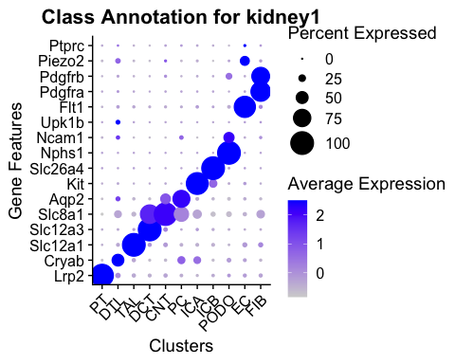

Annotating by Type
# Change the specificty of the cells to a further lower level and make another UMAP
seurat.obj.f_cleaned@meta.data <- seurat.obj.f_cleaned@meta.data %>%
mutate(type = dplyr::case_when(
class %in% c("PT", "DTL", "TAL", "DCT", "CNT", "PC", "ICA", "ICB", "PODO", "PEC", "URO") ~ "EPITHELIAL",
class == "EC" ~ "ENDOTHELIAL",
class %in% c("FIB", "MES", "VSMC") ~ "STROMAL",
class == "IMMUNE" ~ "IMMUNE",
))
type_order <- c("EPITHELIAL", "ENDOTHELIAL", "STROMAL", "IMMUNE")
seurat.obj.f_cleaned@meta.data$type <- factor(seurat.obj.f_cleaned@meta.data$type, levels = type_order)
DimPlot(seurat.obj.f_cleaned, group.by = "type", label = TRUE, label.size = 4) +
theme(plot.title = element_text(hjust = 0.5)) +
ggtitle(paste0("Type Annotation for ", kidney1))
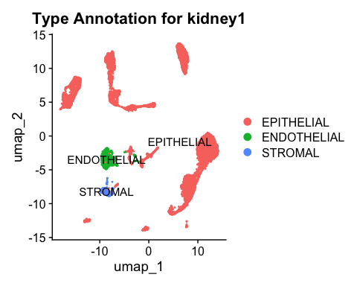 ### Note: Absence of immune cells?
type_order <- c("EPITHELIAL", "ENDOTHELIAL", "STROMAL", "IMMUNE")
seurat.obj.f_cleaned@meta.data$type <- factor(seurat.obj.f_cleaned@meta.data$type, levels = type_order)
markers.to.plot3 <- c("Ank3", # PTS1, PTS2, PTS3, DTL, TAL1, TAL2, MD, DCT1, DCT2, CNT, PC, ICA, ICB, PODO, PEC, URO
"Flt1", # EC
"Pdgfrb", # FIB, MES, VSMC
"Ptprc" # LYMPHO, MACRO
)
DotPlot(seurat.obj.f_cleaned,
features = markers.to.plot3,
group.by = "type",
dot.scale = 8,
dot.min = 0,
scale.max = 100,
scale.min = 0,
col.min = -2.5,
col.max = 2.5) +
theme(axis.text.x = element_text(angle = 45, hjust = 1)) +
coord_flip() +
labs(x = "Gene Features", y = "Clusters") +
theme(plot.title = element_text(hjust = 0.5)) +
ggtitle(paste0("Type Annotation for ", kidney1))
## Warning: Scaling data with a low number of groups may produce misleading
## results
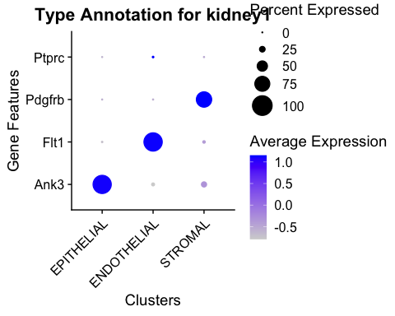

Proportion Plots
t1 <- table(seurat.obj.f_cleaned@meta.data$subclass)
#t1
prop.t1 <- prop.table(t1)
#prop.t1
t2 <- as.data.frame(t1)
colnames(t2) <- c('Cell_type', 'Frequency')
# Original plot
f1a <- ggplot(t2, aes(fill=Cell_type, y=Frequency, x=1)) +
geom_bar(position="fill", stat = "identity", fun.y = "mean", colour="black") +
theme_classic() +
theme(axis.line = element_line(size = 1, colour = "black"),
axis.text.x = element_blank(),
axis.ticks.x = element_blank(),
panel.grid.major.x = element_blank(),
panel.grid.minor.x = element_blank(),
panel.border = element_blank(),
panel.background = element_blank(),
text = element_text(size=20),
axis.line.x = element_blank()) +
labs(fill = "Cell Type") +
xlab(NULL) + ggtitle("Subclass")
## Warning in geom_bar(position = "fill", stat = "identity", fun.y = "mean", :
## Ignoring unknown parameters: `fun.y`
## Warning: The `size` argument of `element_line()` is deprecated as of ggplot2 3.4.0.
## ℹ Please use the `linewidth` argument instead.
## This warning is displayed once per session.
## Call `lifecycle::last_lifecycle_warnings()` to see where this warning was
## generated.
t1 <- table(seurat.obj.f_cleaned@meta.data$class)
#t1
prop.t1 <- prop.table(t1)
#prop.t1
t2 <- as.data.frame(t1)
colnames(t2) <- c('Cell_type', 'Frequency')
# Original plot
f1b <- ggplot(t2, aes(fill=Cell_type, y=Frequency, x=1)) +
geom_bar(position="fill", stat = "identity", fun.y = "mean", colour="black") +
theme_classic() +
theme(axis.line = element_line(size = 1, colour = "black"),
axis.text.x = element_blank(),
axis.ticks.x = element_blank(),
panel.grid.major.x = element_blank(),
panel.grid.minor.x = element_blank(),
panel.border = element_blank(),
panel.background = element_blank(),
text = element_text(size=20),
axis.line.x = element_blank()) +
labs(fill = "Cell Type") +
xlab(NULL) + ggtitle("Class")
## Warning in geom_bar(position = "fill", stat = "identity", fun.y = "mean", :
## Ignoring unknown parameters: `fun.y`
t1 <- table(seurat.obj.f_cleaned@meta.data$type)
#t1
prop.t1 <- prop.table(t1)
#prop.t1
t2 <- as.data.frame(t1)
colnames(t2) <- c('Cell_type', 'Frequency')
# Original plot
f1c <- ggplot(t2, aes(fill = Cell_type, y = Frequency, x = 1)) +
geom_bar(position = "fill", stat = "identity", colour = "black") +
theme_classic() +
theme(
axis.line = element_line(size = 1, colour = "black"),
axis.text.x = element_blank(),
axis.ticks.x = element_blank(),
panel.grid.major.x = element_blank(),
panel.grid.minor.x = element_blank(),
panel.border = element_blank(),
panel.background = element_blank(),
text = element_text(size = 20),
axis.line.x = element_blank()
) +
labs(fill = "Cell Type") +
xlab(NULL) +
ggtitle("Type")
f1a + f1b +f1c
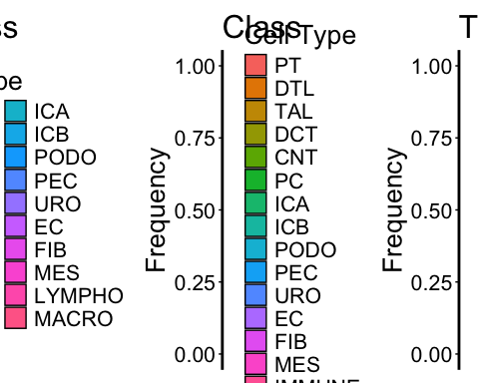 ### Note: How do I get this to look like the manual? Each bar seems to take up the same amount of space

QC Reports: Filtering Progression Sankey Plot
Start_name <- paste0(as.character(Start), " cells")
Filter_1_name <- paste0(as.character(Filter_1), " cells")
Filter_2_name <- paste0(as.character(Filter_2), " cells")
Filter_3_name <- paste0(as.character(Filter_3), " cells")
df_paths2 <- data.frame(
group = c("Pass_All", "Filtered_at_3", "Filtered_at_2", "Filtered_at_1"),
CellRanger = c(Start_name, Start_name, Start_name, Start_name),
nFeature = c(Filter_1_name, Filter_1_name, Filter_1_name, paste0(as.character(Start-Filter_1), " cells removed")),
doubletFinder = c(Filter_2_name, Filter_2_name, paste0(as.character(Filter_1-Filter_2), " cells removed"), NA),
ManualDoublets = c(Filter_3_name, paste0(as.character(Filter_2-Filter_3), " cells removed"), NA, NA),
value = c(Start, Filter_2-Filter_3, Filter_1-Filter_2, Start-Filter_1)
)
df_paths2b <- data.frame(
group = c("Pass_All", "Filtered_at_3", "Filtered_at_2", "Filtered_at_1"),
CellRanger = c(Start_name, Start_name, Start_name, Start_name),
nFeature = c(Filter_1_name, Filter_1_name, Filter_1_name, paste0(as.character(Start - Filter_1), " cells removed")),
doubletFinder = c(Filter_2_name, Filter_2_name, paste0(as.character(Filter_1 - Filter_2), " cells removed"), NA),
ManualDoublets = c(Filter_3_name, paste0(as.character(Filter_2 - Filter_3), " cells removed"), NA, NA),
Final = c(Filter_3_name , NA, NA, NA),
value = c(Start, Filter_2 - Filter_3, Filter_1 - Filter_2, Start - Filter_1)
)
# Convert to long format suitable for ggsankey
df_sankey <- df_paths2b %>%
make_long(CellRanger, nFeature, doubletFinder, ManualDoublets, Final, value = "value")
# make removed nodes gray
orig_levels <- levels(factor(df_sankey$node))
orig_palette <- scales::hue_pal()(length(orig_levels))
names(orig_palette) <- orig_levels
# Override only "removed" nodes to gray
custom_palette <- orig_palette
custom_palette[grepl("removed", names(custom_palette))] <- "gray"
# change font size of removed nodes
df_sankey <- df_sankey %>%
filter(!is.na(node))%>%
mutate(is_removed = grepl("removed", node),
label_size = ifelse(is_removed, 3, 4))
# specify order
df_sankey$node <- factor(df_sankey$node, levels = rev(unique(df_sankey$node)))
df_sankey$next_node <- factor(df_sankey$next_node, levels = rev(unique(df_sankey$node)))
# Do the same for next_node
df_sankey$next_node <- factor(df_sankey$next_node, levels = levels(df_sankey$node))
# Plot
ggplot(df_sankey, aes(x = x,
next_x = next_x,
node = node,
next_node = next_node,
value = value,
fill = factor(node))) +
geom_sankey(flow.alpha = 0.7, node.color = "black") +
geom_sankey_label(aes(label = node, size = label_size), color = "white", show.legend = FALSE) +
scale_fill_manual(values = custom_palette) +
scale_color_identity() +
scale_size_identity() +
theme_classic() +
labs(
title = paste0("Filtering Progression Sankey Plot for ", kidney1),
x = ""
) +
theme(
# Remove Y-axis
axis.text.y = element_blank(),
axis.ticks.y = element_blank(),
axis.line.y = element_blank(),
axis.title.y = element_blank(),
panel.grid.major.y = element_blank(),
panel.grid.minor.y = element_blank(),
# Remove X-axis lines
axis.line.x = element_blank(),
axis.ticks.x = element_blank(),
panel.grid.major.x = element_blank(),
panel.grid.minor.x = element_blank(),
# Enlarge text
axis.text.x = element_text(size = 14),
axis.title.x = element_text(size = 16),
plot.title = element_text(size = 18, face = "bold", hjust = 0.5),
# Hide legend
legend.position = "none"
)
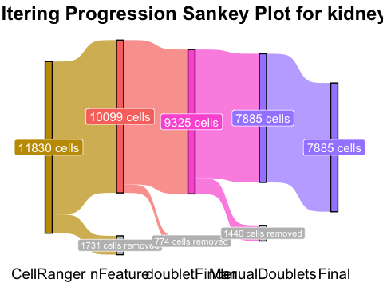

Subclass cell types that were not annotated
list1 <- unique(seurat.obj.f_cleaned$subclass)
list2 <- unique(markers_long$Subclass)
missing_subclass <- setdiff(list2, list1)
missing_subclass
## [1] "TALA" "MD" "PEC" "URO" "LYMPH" "MES" "VSMC" "LYMPHO"
## [9] "MACRO"

TALA, MD, PEC, URO, LYMPH, MES, VSMC, LYMPHO, MACRO were not annotated in this sample

Note: Had trouble w/ saving Seurat object, will receive help in Jan 9th meeting

