8/6 – David Johnston still connected to dfs and Jupiter. Nothing in registry. many application errors, pangp.exe, hyland.office.controls, more but not folder redirection errors

8/1 (and 7/22 [Go To Ticket](https://asrsvinflswp001.sccgov.org/helpdesk/Ticket.aspx?tid=24894))

[Go To Ticket](https://asrsvinflswp001.sccgov.org/helpdesk/Ticket.aspx?tid=25073) Christian Lau

Teams:

*Failed to remove policy and redirect folder "Favorites" to "C:\Users\Christian.Lau\Favorites".  
Removal options=0x20001020.  
The following error occurred: "Failed to build the list of regular subdirectories under "\\asrsvdfs\asr\users\Christian.Lau\Favorites".".  
Error details: "A device attached to the system is not functioning*

*that's from his laptop logs, ASRLT182842*

[25073](https://asrsvinflswp001.sccgov.org/helpdesk/Ticket.aspx?tid=25073) – explorer still slow, laptop replaced 8/5

[Go To Ticket](https://asrsvinflswp001.sccgov.org/helpdesk/Ticket.aspx?tid=24960) – Kristina Seldal

7/24

[Go To Ticket](https://asrsvinflswp001.sccgov.org/helpdesk/Ticket.aspx?tid=24916) - Randle, Michael

[Go To Ticket](https://asrsvinflswp001.sccgov.org/helpdesk/Ticket.aspx?tid=24917) – Tommy Shing

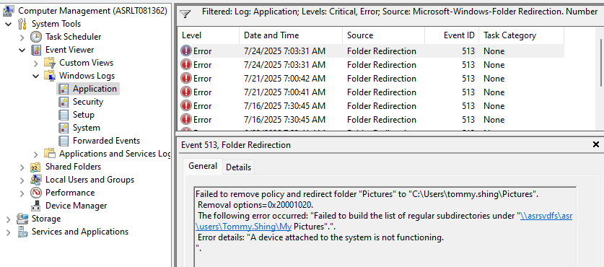

[Go To Ticket](https://asrsvinflswp001.sccgov.org/helpdesk/Ticket.aspx?tid=24929) - Stephanie Su - ASRLT075015

[Go To Ticket](https://asrsvinflswp001.sccgov.org/helpdesk/Ticket.aspx?tid=24923) – Jasmine Ting - ASRLT182848

[Go To Ticket](https://asrsvinflswp001.sccgov.org/helpdesk/Ticket.aspx?tid=24933) – Carol Callahan - ASRLT183982

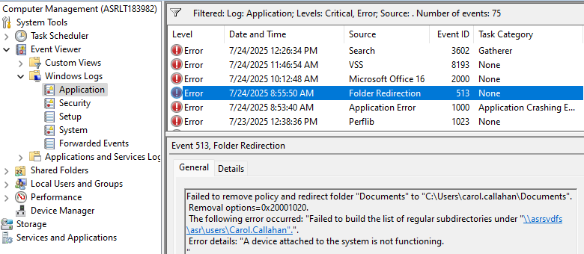

[Go To Ticket](https://asrsvinflswp001.sccgov.org/helpdesk/Ticket.aspx?tid=24931) - Del Real, David - ASRLT186458

[Go To Ticket](https://asrsvinflswp001.sccgov.org/helpdesk/Ticket.aspx?tid=24926) - Richard Leong - ASRLT186627

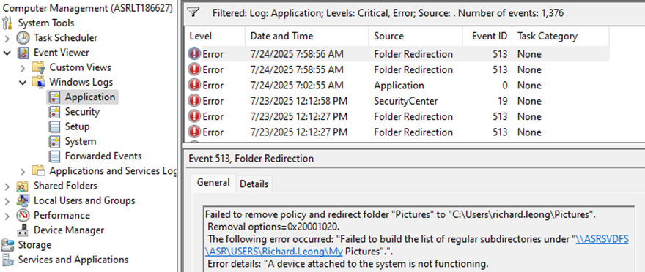

7/23:

[Go To Ticket](https://asrsvinflswp001.sccgov.org/helpdesk/Ticket.aspx?tid=24914) – Stella Hong - ASRLT082897

[Go To Ticket](https://asrsvinflswp001.sccgov.org/helpdesk/Ticket.aspx?tid=25072)  Rodriguez01, Oscar

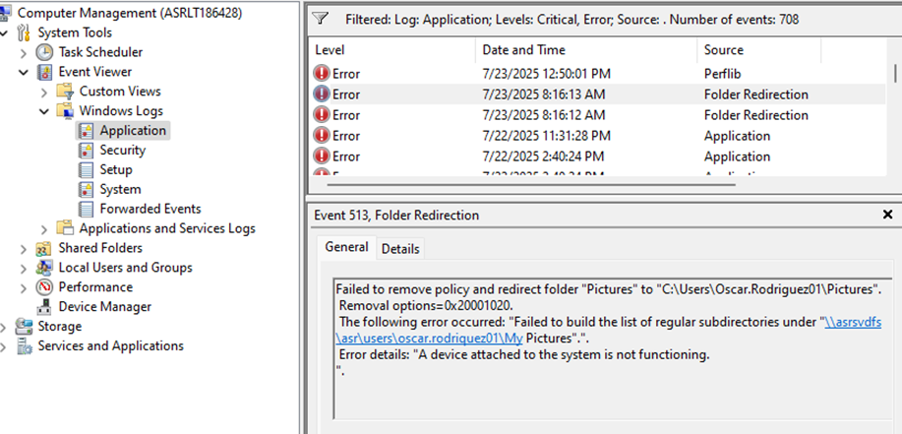

[Go To Ticket](https://asrsvinflswp001.sccgov.org/helpdesk/Ticket.aspx?tid=24911) – Steve Lin - ASRLT186688

[Go To Ticket](https://asrsvinflswp001.sccgov.org/helpdesk/Ticket.aspx?tid=24904) - Brook Haile - ASRLT074888

Failed to remove policy and redirect folder "Documents" to "C:\Users\brook.haile\Documents".

Removal options=0x20001020.

The following error occurred: "Failed to build the list of regular subdirectories under "\\asrsvdfs\ASR\USERS\Brook.Haile".".

Error details: "A device attached to the system is not functioning.

".

[Go To Ticket](https://asrsvinflswp001.sccgov.org/helpdesk/Ticket.aspx?tid=24903) – Bordon Chin - ASRLT186469

[Go To Ticket](https://asrsvinflswp001.sccgov.org/helpdesk/Ticket.aspx?tid=24902) – Jackie Ventimiglia - ASRLT186528

[Go To Ticket](https://asrsvinflswp001.sccgov.org/helpdesk/Ticket.aspx?tid=24899) – Sheryl Schenkman - ASRLT186449

7/22

[Go To Ticket](https://asrsvinflswp001.sccgov.org/helpdesk/Ticket.aspx?tid=24897) - Joseph Garcia - ASRLT186681

[Go To Ticket](https://asrsvinflswp001.sccgov.org/helpdesk/Ticket.aspx?tid=24896) – Tiffany Ming - ASRLT186454

[Go To Ticket](https://asrsvinflswp001.sccgov.org/helpdesk/Ticket.aspx?tid=24895) – Michelle Chou - ASRLT183993

[Go To Ticket](https://asrsvinflswp001.sccgov.org/helpdesk/Ticket.aspx?tid=24893) – Diane Cox - ASRLT182820 – laptop replaced 7/28

[Go To Ticket](https://asrsvinflswp001.sccgov.org/helpdesk/Ticket.aspx?tid=24891) - ASRLT182806 - Roopa Subramanian

[Go To Ticket](https://asrsvinflswp001.sccgov.org/helpdesk/Ticket.aspx?tid=24889) - ASRLT186699 - Jeannie Bauzon

[Go To Ticket](https://asrsvinflswp001.sccgov.org/helpdesk/Ticket.aspx?tid=24888) - ASRWS080801 - Lori Lammle (Larry)

[Go To Ticket](https://asrsvinflswp001.sccgov.org/helpdesk/Ticket.aspx?tid=24886) – ASRLT182813 offline 8/5 - Natalie Tran

[Go To Ticket](https://asrsvinflswp001.sccgov.org/helpdesk/Ticket.aspx?tid=24885) - ASRLT182852 - Chrisman, MaryHelen –

[24953](https://asrsvinflswp001.sccgov.org/helpdesk/Ticket.aspx?tid=24953) – Manuela Gonzalez - ASRLT186455

7/22/2025 10:50:32 AM

Failed to remove policy and redirect folder "Documents" to "C:\Users\Manuela.Gonzalez\Documents".

Removal options=0x20001020.

The following error occurred: "Failed to build the list of regular subdirectories under "\\asrsvdfs\asr\users\manuela.gonzalez".".

Error details: "A device attached to the system is not functioning.

Checked registry and F, J, P mapped to az files

Needed gupdate and restart. Policy change was 7/24 and not all have restarted yet

Failed to remove policy and redirect folder "Pictures" to "C:\Users\marcus.tai\Pictures".

Removal options=0x20001020.

The following error occurred: "Failed to build the list of regular subdirectories under "\\asrsvdfs\ASR\users\marcus.tai\My Pictures".".

Error details: "A device attached to the system is not functioning.

".

7/25 - Michele Boudreau still connected to Jupiter but nothing in registry – users – sid. All to az files

**Maybe has pinned to Quick Access**

Failed to remove policy and redirect folder "Pictures" to "C:\Users\bordon.chin\Pictures".  
Removal options=0x20001020.  
The following error occurred: "Failed to build the list of regular subdirectories under "\\asrsvdfs\ASR\USERS\Bordon.Chin\My Pictures".".  
Error details: "A device attached to the system is not functioning.  
".

Failed to remove policy and redirect folder "Documents" to "C:\Users\steve.lin\Documents".  
Removal options=0x20001020.  
The following error occurred: "Failed to build the list of regular subdirectories under "\\ASRSVDFS\ASR\USERS\steve.lin".".  
Error details: "A device attached to the system is not functioning.  
".

Lori Lammle

Failed to remove policy and redirect folder "Documents" to "C:\Users\larry.stone\Documents".  
Removal options=0x20001020.  
The following error occurred: "Failed to build the list of regular subdirectories under "\\asrsvdfs\asr\users\larry.stone".".  
Error details: "A device attached to the system is not functioning.  
".

Failed to remove policy and redirect folder "Pictures" to "C:\Users\trinh.luu-nguyen\Pictures".  
Removal options=0x20001020.  
The following error occurred: "Failed to build the list of regular subdirectories under "\\ASRSVDFS\asr\users\Trinh.Luu-Nguyen\My Pictures".".  
Error details: "A device attached to the system is not functioning.  
".

Failed to remove policy and redirect folder "Documents" to "C:\Users\tuan.au\Documents".  
Removal options=0x20001020.  
The following error occurred: "Failed to build the list of regular subdirectories under "\\asrsvdfs\asr\users\tuan.au".".  
Error details: "A device attached to the system is not functioning.  
".

Jared was manually mapped to asrsvjupiter, admin\payroll. A few users were mapped to this share.

7/23

7/16

8/6/2025 connections

