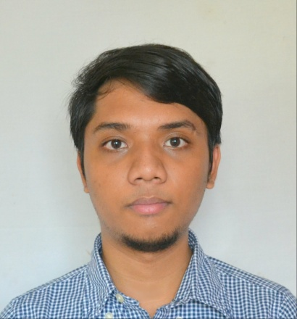**Shane M. Gunawardana**

Phone: 0917-463-1625

Email: shanechioguna@gmail.com

Address: Block 1 Lot 30 A. Pablo Street, Karuhatan

Valenzuela City

Seeking a challenging career with a progressive organization that provides an opportunity to capitalize my technical skills & abilities in the field of information technology (IT).

**Career Objective**

Languages

Oracle PL/SQL

PHP - Laravel Framework

HTML5

CSS3

JavaScript

Java

Database Skills

Oracle 10i and 11g

Visual Fox Pro 6.0

MS SQL

MYSQL

Operating Systems

Unix

MS-DOS

Windows

**Technical Skills**

* Led the pre-implementation technical support and development of Bank of Makati's Core Banking System.
* Primary and main technical support for Finacle Core Banking System in Bank of Makati; both front-end and back-end aspects.
* Project developer for the salary upload interface facility which runs between Payplus System (HR System) and Finacle Core Banking System in Bank of Makati.
* Primary technical support for Promptus 8 Data Management System in Bank of Makati.
* Programming experiences in in-house programs and data extracts with use of PHP, PL/SQL, MYSQL, HTML, CSS and JavaScript.

**Professional**

**Experience**

* Experienced in infrastructure monitoring and emulating tools such as Putty, xFtp and other FTP applications, TOAD sql tool, sqlplus and sql developer tool.

**Professional**

**Experience**

* Excellent written and verbal communication skills
* Highly organized and efficient
* Ability to work independently or as part of a team
* Proven leadership skills and ability to motivate

**Personal Skills**

**Masteral in Information Technology (2014 – present)**

AMA Computer University

**BS in Computer Science (2010 – 2014)**

AMA Computer University

**Education**

Bank of Makati Inc.

Associate Applications Systems Engineer (November 2013 - March 2015)

Bank of Makati Inc.

Application Systems Engineer I (March 2015 to present)

* Responsible for developing Data Extract Reports through use of PL/SQL per requirement of bank users.
* Responsible for developing in-house modules and programs with use of PHP, HTML, CSS and JavaScript.
* Front End and Back End Technical Support for Major Systems : Finacle Core Banking System. Promptus 8 Data Management and PPS-DS Interface Facility.
* Responsible for building Finacle reports through iReport tool. (JRXML and SQL Packages)
* Responsible for building sql queries, views and packages for Promptus 8 report modules.

**Professional**

**Achievements/**

**Responsibilities**

Available upon request.

**REFERENCES:**